UNITED STATES SECURITIES AND EXCHANGE COMMISSION

Washington, D.C. 20549

FORM 10-Q

(Mark One)

☑QUARTERLY REPORT PURSUANT TO SECTION 13 OR 15(d) OF THE SECURITIES EXCHANGE ACT OF 1934

For the quarterly period ended September 30, 2018

or

☐TRANSITION REPORT PURSUANT TO SECTION 13 OR 15(d) OF THE SECURITIES EXCHANGE ACT OF 1934

For the transition period from _________ to _____________

Commission file number: 001-38273

ACM Research, Inc.

(Exact Name of Registrant as Specified in Its Charter)

Delaware | 94-3290283
(State or Other Jurisdiction of Incorporation or Organization) | (I.R.S. Employer Identification No.)
42307 Osgood Road, Suite I
Fremont, California | 94539
(Address of Principal Executive Offices) | (Zip Code)

Registrant’s telephone number, including area code: (510) 445-3700

Indicate by check mark whether the registrant (1) has filed all reports required to be filed by Section 13 or 15(d) of the Securities Exchange Act of 1934 during the preceding 12 months (or for such shorter period that the registrant was required to file such reports), and (2) has been subject to such filing requirements for the past 90 days.

Yes ☑ No ☐

Indicate by check mark whether the registrant has submitted electronically every Interactive Data file required to be submitted pursuant to Rule 405 of Regulation S-T during the preceding 12 months (or for such shorter period that the registrant was required to submit such files). Yes ☑ No ☐

Indicate by check mark whether the registrant is a large accelerated filer, an accelerated filer, a non-accelerated filer, a smaller reporting company or an emerging growth company. See definitions of “large accelerated filer,” “accelerated filer,” “smaller reporting company” and “emerging growth company” in Rule 12b-2 of the Exchange Act.

Large accelerated filer | ☐ | Accelerated filer | ☐
Non-accelerated filer | ☐ (Do not check if a smaller reporting company) | Smaller reporting company | ☑
 |  | Emerging growth company | ☑

If an emerging growth company, indicate by check mark if the registrant has elected not to use the extended transition period for complying with any new or revised financial accounting standards provided pursuant to Section 13(a) of the Exchange Act. ☑

Indicate by check mark whether the registrant is a shell company (as defined in Rule 12b-2 of the Exchange Act). Yes ☐ No ☑

Indicate the number of shares outstanding of each of the registrant’s classes of common stock, as of the latest practicable date.

Class |  | Number of Shares Outstanding
Class A Common Stock, $0.0001 par value |  | 14,085,315 shares outstanding as of November 9, 2018
Class B Common Stock, $0.0001 par value |  | 1,918,423 shares outstanding as of November 9, 2018

 |  |  |  |  |  |  |  |  |  |  |  |  |  | TABLE OF CONTENTS
 | PART I. |  |  |  |  | FINANCIAL INFORMATION |  |  |  |  |  |  |  |  |  |  |  |  |  |  |  |  | 4
 | Item 1. |  |  |  |  | Financial Statements (unaudited) |  |  |  |  |  |  |  |  |  |  |  |  |  |  |  |  | 4
 |  |  |  |  |  | Condensed Consolidated Balance Sheets as of September 30, 2018 and December 31, 2017 |  |  |  |  |  |  |  |  |  |  |  |  |  |  |  |  | 4
 |  |  |  |  |  | Condensed Consolidated Statements of Operations and Comprehensive Income (Loss)
 |  |  |  |  |  | for the Three and Nine Months Ended September 30, 2018 and 2017 |  |  |  |  |  |  |  |  |  |  |  |  |  |  |  |  | 5
 |  |  |  |  |  | Condensed Consolidated Statements of Cash Flows for the Nine Months Ended
 |  |  |  |  |  | September 30, 2018 and 2017 |  |  |  |  |  |  |  |  |  |  |  |  |  |  |  |  | 6
 |  |  |  |  |  | Notes to Condensed Consolidated Financial Statements |  |  |  |  |  |  |  |  |  |  |  |  |  |  |  |  | 7
 | Item 2. |  |  |  |  | Management’s Discussion and Analysis of Financial Condition and Results of Operations |  |  |  |  |  |  |  |  |  |  |  |  |  |  |  |  | 23
 | Item 3. |  |  |  |  | Quantitative and Qualitative Disclosures about Market Risks |  |  |  |  |  |  |  |  |  |  |  |  |  |  |  |  | 37
 | Item 4. |  |  |  |  | Controls and Procedures |  |  |  |  |  |  |  |  |  |  |  |  |  |  |  |  | 37
 | PART II. |  |  |  |  | OTHER INFORMATION |  |  |  |  |  |  |  |  |  |  |  |  |  |  |  |  | 38
 | Item 1A. |  |  |  |  | Risk Factors |  |  |  |  |  |  |  |  |  |  |  |  |  |  |  |  | 38
 | Item 2. |  |  |  |  | Unregistered Sales of Equity Securities and Use of Proceeds |  |  |  |  |  |  |  |  |  |  |  |  |  |  |  |  | 39
 | Item 6. |  |  |  |  | Exhibits |  |  |  |  |  |  |  |  |  |  |  |  |  |  |  |  | 39
 | SIGNATURE |  |  |  |  |  |  |  |  |  |  |  |  |  |  |  |  |  |  |  |  |  | 40

We conduct our business operations principally through ACM Research (Shanghai), Inc., or ACM Shanghai, a subsidiary of ACM Research, Inc., or ACM Research. Unless the context requires otherwise, references in this report to “our company,” “our,” “us,” “we” and similar terms refer to ACM Research, Inc. (including its predecessor prior to its redomestication from California to Delaware in November 2016) and its subsidiaries ( including ACM Shanghai), collectively.

SAPS, TEBO and ULTRA C are our trademarks. For convenience, these trademarks appear in this report without ™ symbols, but that practice does not mean that we will not assert, to the fullest extent under applicable law, our rights to the trademarks. This report also contains other companies’ trademarks, registered marks and trade names, which are the property of those companies.

2

NOTE ABOUT FORWARD-LOOKING STATEMENTS

This report contains forward-looking statements within the meaning of the Private Securities Litigation Reform Act of 1995. All statements, other than statements of historical facts, included in this report regarding our strategy, future operations, future financial position, future revenue, projected costs, prospects, plans and objectives of management are forward-looking statements. In some cases, you can identify forward-looking statements by terms such as “may,” “might,” “will,” “objective,” “intend,” “should,” “could,” “can,” “would,” “expect,” “believe,” “anticipate,” “project,” “target,” “design,” “estimate,” “predict,” “potential,” “plan” or the negative of these terms, and similar expressions intended to identify forward-looking statements. These statements reflect our current views with respect to future events and are based on our management’s belief and assumptions and on information currently available to our management. Although we believe that the expectations reflected in these forward-looking statements are reasonable, these statements relate to future events or our future operational or financial performance, and involve known and unknown risks, uncertainties and other factors, including those described or incorporated by reference in “Item 1A. Risk Factors” of Part II of this report, that may cause our actual results, performance or achievements to be materially different from any future results, performance or achievements expressed or implied by these forward-looking statements.

Any forward-looking statement made by us in this report speaks only as of the date on which it is made. Except as required by law, we assume no obligation to update these statements publicly or to update the reasons actual results could differ materially from those anticipated in these statements, even if new information becomes available in the future.

You should read this report, and the documents that we reference in this report and have filed as exhibits to this report, completely and with the understanding that our actual future results may be materially different from what we expect. We qualify all of our forward-looking statements by these cautionary statements.

3

PART I. FINANCIAL INFORMATION

Item 1. Financial Statements

ACM RESEARCH, INC.

Condensed Consolidated Balance Sheets

 |  |  | September 30, |  | December 31,
 |  |  | 2018 |  |  | 2017
 |  |  | (unaudited)
 |  |  | (in thousands, except share and per
 |  |  | share data)
 | Assets
Current assets:
 | Cash and cash equivalents | $ | 18,238 |  | $ | 17,681
 | Accounts receivable, less allowance for doubtful accounts of $0 as of September 30, 2018 and December 31, 2017 (note
3) |  |  | 30,965 |  |  | 26,762
 | Other receivables |  | 1,591 |  |  | 2,491
 | Inventories (note 4) |  | 29,809 |  |  | 15,388
 | Prepaid expenses |  | 2,142 |  |  | 546
 | Other current assets |  | 32 |  |  | 46
 | Total current assets |  | 82,777 |  |  | 62,914
 | Property, plant and equipment, net (note 5) |  | 3,593 |  |  | 2,340
 | Intangible assets, net |  | 300 |  |  | 106
 | Deferred tax assets (note 15) |  | 1,230 |  |  | 1,294
 | Investment in affiliates, equity method (note 10) |  | 1,472 |  |  | 1,237
 | Other long-term assets |  | 41 |  |  | -
 | Total assets | $ | 89,413 |  | $ | 67,891
 | Liabilities and Stockholders’ Equity
 | Current liabilities:
 | Short-term borrowings (note 6) | $ | 10,163 |  | $ | 5,095
 | Warrant liability (note 8) |  | - |  |  | 3,079
 | Accounts payable |  | 11,991 |  |  | 7,419
 | Advances from customers |  | 3,918 |  |  | 143
 | Income taxes payable |  | 689 |  |  | 44
 | Other payables and accrued expenses (note 7) |  | 8,090 |  |  | 6,037
 | Total current liabilities |  | 34,851 |  |  | 21,817
 | Other long-term liabilities (note 9) |  | 5,230 |  |  | 6,217
 | Total liabilities |  | 40,081 |  |  | 28,034
 | Commitments and contingencies (note 16)
 | Stockholders’ equity:
 | Common stock – Class A, par value $0.0001: 100,000,000 shares authorized as of September 30, 2018 and
 | December 31, 2017. 14,070,065 shares issued and outstanding as of September 30, 2018 and 12,935,546 shares issued
 | and outstanding as of December 31, 2017 (note 13) |  | 1 |  |  | 1
 | Common stock – Class B, par value $0.0001: 7,303,533 shares authorized as of September 30, 2018 and
 | December 31, 2017. 1,918,423 shares issued and outstanding as of September 30, 2018 and 2,409,738 shares
 | issued and outstanding as of December 31, 2017 (note 13) |  | - |  |  | -
 | Additional paid in capital |  | 55,959 |  |  | 49,695
 | Accumulated deficit |  | (5,673) |  |  | (9,961)
 | Accumulated other comprehensive income (loss) |  | (955) |  |  | 122
 | Total stockholders’ equity |  | 49,332 |  |  | 39,857
 | Total liabilities and stockholders’ equity | $ | 89,413 |  | $ | 67,891

The accompanying notes are an integral part of these condensed consolidated financial statements.

4

ACM RESEARCH, INC.

Condensed Consolidated Statements of Operations and Comprehensive Income (Loss)

 |  |  | Three Months Ended |  |  |  |  |  | Nine Months Ended
 |  |  | September 30, |  |  |  |  |  | September 30,
 |  |  | 2018 |  |  | 2017 |  |  | 2018 |  |  | 2017
 |  |  |  |  |  | (unaudited)
 |  |  |  | (in thousands, except share and per share data)
 | Revenue | $ | 23,179 | $ |  | 4,891 |  | $ | 53,795 |  | $ | 19,314
 | Cost of revenue |  | 12,892 |  |  | 2,692 |  |  | 29,662 |  |  | 11,262
 | Gross profit |  | 10,287 |  |  | 2,199 |  |  | 24,133 |  |  | 8,052
 | Operating expenses:
 | Sales and marketing |  | 3,229 |  |  | 1,036 |  |  | 7,766 |  |  | 3,619
 | Research and development |  | 2,264 |  |  | 1,209 |  |  | 6,224 |  |  | 3,076
 | General and administrative |  | 1,390 |  |  | 1,264 |  |  | 6,312 |  |  | 4,422
 | Total operating expenses, net |  | 6,883 |  |  | 3,509 |  |  | 20,302 |  |  | 11,117
 | Income (loss) from operations |  | 3,404 |  |  | (1,310) |  |  | 3,831 |  |  | (3,065)
 | Interest income |  | 3 |  |  | 2 |  |  | 20 |  |  | 7
 | Interest expense |  | (112) |  |  | (33) |  |  | (364) |  |  | (197)
 | Other income (expense), net |  | 902 |  |  | (239) |  |  | 1,213 |  |  | (531)
 | Equity income in net income of affiliates |  | 117 |  |  | 20 |  |  | 235 |  |  | 20
 | Income (loss) before income taxes |  | 4,314 |  |  | (1,560) |  |  | 4,935 |  |  | (3,766)
 | Income tax benefit (expense) (note 15) |  | (461) |  |  | 278 |  |  | (647) |  |  | (471)
 | Net income (loss) |  | 3,853 |  |  | (1,282) |  |  | 4,288 |  |  | (4,237)
 | Less: net loss attributable to non-controlling interests |  | - |  |  | (327) |  |  | - |  |  | (535)
 | Net income (loss) attributable to ACM Research, Inc. | $ | 3,853 |  | $ | (955) |  | $ | 4,288 |  | $ | (3,702)
 | Comprehensive income (loss)
 | Net income (loss) |  | 3,853 |  |  | (1,282) |  |  | 4,288 |  |  | (4,237)
 | Foreign currency translation adjustment |  | (746) |  |  | 228 |  |  | (1,077) |  |  | 492
 | Comprehensive income (loss) |  | 3,107 |  |  | (1,054) |  |  | 3,211 |  |  | (3,745)
 | Less: Comprehensive loss attributable to non-controlling interests |  | - |  |  | (237) |  |  | - |  |  | (347)
 | Total comprehensive income (loss) attributable to ACM Research, Inc.
 | (note 2) | $ | 3,107 | $ |  | (817) |  | $ | 3,211 |  | $ | (3,398)
 | Net income (loss) attributable to ACM Research, Inc. per common share (note 2):
 | Basic | $ | 0.24 |  | $ | (0.17) |  | $ | 0.27 |  | $ | (0.72)
 | Diluted | $ | 0.21 |  | $ | (0.17) |  | $ | 0.24 |  | $ | (0.72)
 | Weighted average common shares outstanding used in computing per share amounts
 | (note 2):
 | Basic |  | 15,915,864 |  |  | 5,581,637 |  |  | 15,714,310 |  |  | 5,148,255
 | Diluted |  | 18,169,807 |  |  | 5,581,637 |  |  | 17,816,101 |  |  | 5,148,255

The accompanying notes are an integral part of these condensed consolidated financial statements.

5

ACM RESEARCH, INC.

Condensed Consolidated Statements of Cash Flows

Nine Months Ended

September 30,

 |  |  | 2018 |  |  | 2017
 |  |  | (unaudited)
 |  |  | (in thousands)
 | Cash flows from operating activities:
 | Net income (loss) | $ | 4,288 |  | $ | (4,237)
 | Adjustments to reconcile net loss from operations to net cash provided by operating activities:
 | Depreciation and amortization |  | 380 |  |  | 183
 | Equity income in net income of affiliates |  | (235) |  |  | (20)
 | Deferred income taxes |  | - |  |  | 491
 | Stock-based compensation |  | 2,771 |  |  | 1,692
 | Net changes in operating assets and liabilities:
 | Restricted cash |  | - |  |  | (433)
 | Accounts receivable |  | (5,526) |  |  | 966
 | Other receivables |  | 781 |  |  | (170)
 | Inventory |  | (15,157) |  |  | (5,933)
 | Prepaid expenses |  | (1,653) |  |  | (20)
 | Other current assets |  | 12 |  |  | (836)
 | Accounts payable |  | 5,165 |  |  | 3,242
 | Advances from customers |  | 3,818 |  |  | (180)
 | Income tax payable |  | 645 |  |  | -
 | Other payables and accrued expenses |  | 2,658 |  |  | 1,099
 | Other long-term liabilities |  | (680) |  |  | (505)
 | Net cash used in operating activities |  | (2,733) |  |  | (4,661)
 | Cash flows from investing activities:
 | Purchase of property and equipment |  | (1,598) |  |  | (149)
 | Purchase of intangible assets |  | (350) |  |  | (37)
 | Loan to related party |  | - |  |  | (946)
 | Purchase of non-controlling interest |  | - |  |  | (6,154)
 | Purchase of intangible assets |  | - |  |  | (1,200)
 | Net cash used in investing activities |  | (1,948) |  |  | (8,486)
 | Cash flows from financing activities:
 | Proceeds from short-term borrowings |  | 13,065 |  |  | 8,153
 | Repayments of short-term borrowings |  | (7,962) |  |  | (9,643)
 | Proceeds from stock option exercise to common stock |  | 511 |  |  | 396
 | Proceeds from issuance of Series F preferred stock |  | - |  |  | 5,800
 | Proceeds from issuance of common stock |  | - |  |  | 15,300
 | Net cash provided by financing activities |  | 5,614 |  |  | 20,006
 | Effect of exchange rate changes on cash and cash equivalents | $ | (376) |  | $ | 96
 | Net increase in cash, cash equivalents, and restricted cash | $ | 557 |  | $ | 6,955
 | Cash, cash equivalents, and restricted cash at beginning of period |  | 17,681 |  |  | 10,119
 | Cash, cash equivalents and restricted cash at end of period | $ | 18,238 |  | $ | 17,074
 | Supplemental disclosure of cash flow information:
 | Interest paid | $ | 364 |  | $ | 196

The accompanying notes are an integral part of these condensed consolidated financial statements.

6

ACM RESEARCH, INC.

Notes to Condensed Consolidated Financial Statements (unaudited)

(in thousands, except share and per share data)

NOTE 1 – DESCRIPTION OF BUSINESS

ACM Research, Inc. (“ACM”) and its subsidiaries (collectively with ACM, the “Company”) develop, manufacture and sell single-wafer wet cleaning equipment used to improve the manufacturing process and yield for advanced integrated chips. The Company markets and sells its single-wafer wet-cleaning equipment, under the brand name “Ultra C,” based on the Company’s proprietary Space Alternated Phase Shift (“SAPS”) and Timely Energized Bubble Oscillation (“TEBO”) technologies. These tools are designed to remove random defects from a wafer surface efficiently, without damaging the wafer or its features, even at increasingly advanced process nodes.

ACM was incorporated in California in 1998, and it initially focused on developing tools for manufacturing process steps involving the integration of ultra low-K materials and copper. The Company’s early efforts focused on stress-free copper-polishing technology, and it sold tools based on that technology in the early 2000s.

In 2006 the Company established its operational center in Shanghai in the People’s Republic of China (the “PRC”), where it operates through ACM’s subsidiary ACM Research (Shanghai), Inc. (“ACM Shanghai”). ACM Shanghai was formed to help establish and build relationships with integrated circuit manufacturers in the PRC, and the Company initially financed its Shanghai operations in part through sales of non-controlling equity interests in ACM Shanghai.

In 2007 the Company began to focus its development efforts on single-wafer wet-cleaning solutions for the front-end chip fabrication process. The Company introduced its SAPS megasonic technology, which can be applied in wet wafer cleaning at numerous steps during the chip fabrication process, in 2009. It introduced its TEBO technology, which can be applied at numerous steps during the fabrication of small node two-dimensional conventional and three-dimensional patterned wafers, in March 2016. The Company has designed its equipment models for SAPS and TEBO solutions using a modular configuration that enables it to create a wet-cleaning tool meeting the specific requirements of a customer, while using pre-existing designs for chamber, electrical, chemical delivery and other modules. In August 2018, the Company introduced its Ultra-C Tahoe wafer cleaning tool, which can deliver high cleaning performance with significantly less sulfuric acid than typically consumed by conventional high-temperature single-wafer cleaning tools. The Company also offers a range of custom-made equipment, including cleaners, coaters and developers, to back-end wafer assembly and packaging factories, principally in the PRC.

In 2011 ACM Shanghai formed a wholly owned subsidiary in the PRC, ACM Research (Wuxi), Inc. (“ACM Wuxi”), to manage sales and service operations.

In November 2016 ACM redomesticated from California to Delaware pursuant to a merger in which ACM Research, Inc., a California corporation, was merged into a newly formed, wholly owned Delaware subsidiary, also named ACM Research, Inc.

In June 2017 ACM formed a wholly owned subsidiary in Hong Kong, CleanChip Technologies Limited (“CleanChip”), to act on the Company’s behalf in Asian markets outside the PRC by, for example, serving as a trading partner between ACM Shanghai and its customers, procuring raw materials and components, performing sales and marketing activities, and making strategic investments.

In August 2017 ACM purchased 18.77% of ACM Shanghai’s equity interests held by Shanghai Science and Technology Venture Capital Co., Ltd. On November 8, 2017, ACM purchased the remaining 18.36% of ACM Shanghai’s equity interest held by third parties, Shanghai Pudong High-Tech Investment Co., Ltd. (“PDHTI”) and Shanghai Zhangjiang Science & Technology Venture Capital Co., Ltd. (“ZSTVC”). At December 31, 2017, ACM owned all of the outstanding equity interests of ACM Shanghai, and indirectly through ACM Shanghai, owned all of the outstanding equity interests of ACM Wuxi.

7

ACM RESEARCH, INC.

Notes to Condensed Consolidated Financial Statements (unaudited)

(in thousands, except share and per share data)

On September 13, 2017, ACM effectuated a 1-for-3 reverse stock split of Class A and Class B common stock. Unless otherwise indicated, all share numbers, per share amount, share prices, exercise prices and conversion rates set forth in these notes and the accompanying condensed consolidated financial statements have been adjusted retrospectively to reflect the reverse stock split.

On November 2, 2017, the Registration Statement on Form S-1 (File No. 333- 220451) for ACM’s initial public offering of Class A common stock (the “IPO”) was declared effective by the U.S. Securities and Exchange Commission (“SEC”). Shares of Class A common stock began trading on the Nasdaq Global Market on November 3, 2017, and the closing for the IPO was held on November 7, 2017.

In December 2017 ACM formed a wholly owned subsidiary in the Republic of Korea, ACM Research Korea CO., LTD. (“ACM Korea”), to serve customers based in Republic of Korea and perform sales, marketing, research and development activities for new products and solutions.

NOTE 2 – SIGNIFICANT ACCOUNTING POLICIES

Basis of Presentation and Principles of Consolidation

The consolidated accounts include ACM and its subsidiaries, ACM Shanghai, ACM Wuxi, CleanChip and ACM Korea. Subsidiaries are those entities in which ACM, directly and indirectly, controls more than one half of the voting power. All significant intercompany transactions and balances have been eliminated upon consolidation.

The accompanying condensed consolidated financial statements of the Company have been prepared in accordance with accounting principles generally accepted in the United States of America (“GAAP”) for interim financial information and the rules and regulations of the SEC for reporting on Form 10-Q. Accordingly, they do not include all the information and footnotes required by GAAP for complete financial statements herein. The unaudited condensed consolidated financial statements herein should be read in conjunction with the historical consolidated financial statements of the Company for the year ended December 31, 2017 included in the Company’s Annual Report on Form 10-K for the year ended December 31, 2017.

The accompanying condensed consolidated balance sheet as of September 30, 2018, the condensed consolidated statements of operations and comprehensive income (loss) for the three and nine months ended September 30, 2018 and 2017, and the condensed consolidated statements of cash flows for the nine months ended September 30, 2018 and 2017 are unaudited. In the opinion of management, the unaudited condensed consolidated financial statements of the Company reflect all adjustments that are necessary for a fair presentation of the Company’s financial position and results of operations. Such adjustments are of a normal recurring nature, unless otherwise noted. The balance sheet as of September 30, 2018 and the results of operations for the three months and nine months ended September 30, 2018 are not necessarily indicative of the results to be expected for any future period.

Use of Estimates

The preparation of condensed consolidated financial statements in conformity with GAAP requires management to make estimates and assumptions that affect the reported amounts of assets and liabilities and disclosure of contingent assets and liabilities at the balance sheet date and the reported revenue and expenses during the reported period in the condensed consolidated financial statements and accompanying notes. The Company’s significant accounting estimates and assumptions include, but are not limited to, those used for the valuation and recognition of stock-based compensation arrangements and warrant liability, realization of deferred tax assets, assessment for impairment of long-lived assets, allowance for doubtful accounts, inventory valuation for excess and obsolete inventories, lower of cost and market value or net realizable value of inventories, depreciable lives of property and equipment, and useful life of intangible assets. Management of the Company believes that the estimates, judgments and assumptions are reasonable, based on information available at the time they are made. Actual results could differ materially from those estimates.

8

ACM RESEARCH, INC.

Notes to Condensed Consolidated Financial Statements (unaudited)

(in thousands, except share and per share data)

Basic and Diluted Net Income (Loss) Attributable to ACM per Common Share

Basic and diluted net income (loss) attributable to ACM per common share is calculated as follows:

 |  | Three Months Ended |  |  |  |  |  | Nine Months Ended
 |  | September 30, |  |  |  |  |  | September 30,
 |  | 2018 |  |  | 2017 |  |  | 2018 |  |  | 2017
Numerator:
Net income (loss) | $ | 3,853 | $ |  | (1,282) |  | $ | 4,288 | $ |  | (4,237)
Net income (loss) attributable to non-controlling interest |  | - |  |  | (327) |  |  | - |  |  | (535)
Net income (loss) attributable to ACM, basic and diluted |  | 3,853 |  |  | (955) |  |  | 4,288 |  |  | (3,702)
Denominator:
Weighted average shares outstanding, basic |  | 15,915,864 |  |  | 5,581,637 |  |  | 15,714,310 |  |  | 5,148,255
Effect of dilutive securities |  | 2,253,943 |  |  | - |  |  | 2,101,791 |  |  | -
Weighted average shares outstanding, diluted |  | 18,169,807 |  |  | 5,581,637 |  |  | 17,816,101 |  |  | 5,148,255
Net income (loss) attributable to ACM per common share:
Basic | $ | 0.24 | $ |  | (0.17) |  | $ | 0.27 | $ |  | (0.72)
Diluted | $ | 0.21 |  | $ | (0.17) |  | $ | 0.24 | $ |  | (0.72)

ACM has been authorized to issue Class A and Class B common stock since redomesticating in Delaware in November 2016. The two classes of common stock are substantially identical in all material respects, except for voting rights. Since ACM did not declare any dividends during the three and nine months ended September 30, 2018 and 2017, the net income (loss) per common share attributable to each class is the same under the “two-class” method. As such, the two classes of common stock have been presented on a combined basis in the condensed consolidated statements of operations and comprehensive income (loss) and in the above computation of net income (loss) per common share.

Diluted net income (loss) per common share reflects the potential dilution from securities that could share in ACM’s earnings. ACM’s potential dilutive securities consist of convertible preferred stocks, warrants and stock options for the three and nine months ended September 30, 2018 and 2017. Certain potential dilutive securities were excluded from the net income (loss) per share calculation because the impact would be anti-dilutive.

Recent Accounting Pronouncements

Recently Adopted Accounting Pronouncements

In May 2017, the Financial Accounting Standards Board (“FASB”) issued Accounting Standards Update (“ASU”) No. 2017-09, Compensation—Stock Compensation (Topic 718): Scope of Modification Accounting (“ASU 2017-09”), which provides guidance on determining which changes to the terms and conditions of share-based payment awards require an entity to apply modification accounting under Topic 718. The amendments in this ASU are effective for all entities for annual periods, and interim periods within those annual periods, beginning after December 15, 2017. Early adoption is permitted, including adoption in any interim period, for (1) public business entities for reporting periods for which financial statements have not yet been issued and (2) all other entities for reporting periods for which financial statements have not yet been made available for issuance. The amendments in this ASU should be applied prospectively to an award modified on or after the adoption date. The adoption of ASU 2017-09 did not have a material impact on the Company’s consolidated financial statements.

9

ACM RESEARCH, INC.

Notes to Condensed Consolidated Financial Statements (unaudited)

(in thousands, except share and per share data)

In February 2017, the FASB issued ASU No. 2017-05, Other Income—Gains and Losses from the Derecognition of Nonfinancial Assets (Subtopic 610-20): Clarifying the Scope of Asset Derecognition Guidance and Accounting for Partial Sales of Nonfinancial Assets (“ASU 2017-05”), which clarifies the scope of nonfinancial asset guidance in Subtopic 610-20. This ASU also clarifies that derecognition of all businesses and nonprofit activities (except those related to conveyances of oil and gas mineral rights or contracts with customers) should be accounted for in accordance with the derecognition and deconsolidation guidance in Subtopic 810-10. The amendments in this ASU also provide guidance on the accounting for so-called “partial sales” of nonfinancial assets within the scope of Subtopic 610-20 and contributions of nonfinancial assets to a joint venture or other noncontrolled investee. The amendments in this ASU are effective for annual reporting reports beginning after December 15, 2017, including interim reporting periods within that reporting period. The adoption of ASU 2017-05 did not have a material impact on the Company’s consolidated financial statements.

In November 2016, the FASB issued ASU No. 2016-18, Statement of Cash Flows (Topic 230): Restricted Cash (“ASU 2016-18”), which requires that a statement of cash flows explain the change during the period in the total of cash, cash equivalents, and amounts generally described as restricted cash or restricted cash equivalents. Therefore, amounts generally described as restricted cash and restricted cash equivalents should be included with cash and cash equivalents when reconciling the beginning-of-period and end-of-period total amounts shown on the statement of cash flows. The amendments in this ASU do not provide a definition of restricted cash or restricted cash equivalents. The amendments in this ASU are effective for public business entities for fiscal years beginning after December 15, 2017, and interim periods within those fiscal years. Early adoption is permitted, including adoption in an interim period. The adoption of ASU 2016-18 did not have a material impact on the Company’s consolidated financial statements.

In August 2016, the FASB issued ASU No. 2016-15, Statement of Cash Flows (Topic 230): Classification of Certain Cash Receipts and Cash Payments (“ASU 2016-15”), which addresses the following cash flow issues: (1) debt prepayment or debt extinguishment costs; (2) settlement of zero-coupon debt instruments or other debt instruments with coupon interest rates that are insignificant in relation to the effective interest rate of the borrowing; (3) contingent consideration payments made after a business combination; (4) proceeds from the settlement of insurance claims; (5) proceeds from the settlement of corporate-owned life insurance policies, including bank-owned life insurance policies; (6) distributions received from equity method investees; (7) beneficial interests in securitization transactions; and (8) separately identifiable cash flows and application of the predominance principle. The amendments in this ASU are effective for public business entities for fiscal years beginning after December 15, 2017 and interim periods within those fiscal years and are effective for all other entities for fiscal years beginning after December 15, 2018 and interim periods within fiscal years beginning after December 15, 2019. Early adoption is permitted, including adoption in an interim period. The adoption of ASU 2016-15 did not have material impact on the Company’s consolidated financial statements.

In January 2016, the FASB issued ASU No. 2016-01, “Financial Instruments – Overall (Subtopic 825-10): Recognition and Measurement of Financial Assets and Financial Liabilities” (“ASU 2016-01”). The amendments in this update require all equity investments to be measured at fair value with changes in the fair value recognized through net income (other than those accounted for under the equity method of accounting or those that result in consolidation of the investee). The amendments in this update also require an entity to present separately in other comprehensive income the portion of the total change in the fair value of a liability resulting from a change in the instrument-specific credit risk when the entity has elected to measure the liability at fair value in accordance with the fair value option for financial instruments. In addition, the amendments in this update eliminate the requirement to disclose the method(s) and significant assumptions used to estimate the fair value that is required to be disclosed for financial instruments measured at amortized cost on the balance sheet for public entities. For public business entities, the amendments in ASU 2016-01 are effective for fiscal years beginning after December 15, 2017, including interim periods within those fiscal years. Except for the early application guidance discussed in ASU 2016-01, early adoption of the amendments in this update is not permitted. The adoption of the ASU 2016-01 did not have a material impact on the Company’s consolidated financial statements.

10

ACM RESEARCH, INC.

Notes to Condensed Consolidated Financial Statements (unaudited)

(in thousands, except share and per share data)

In May 2014, the FASB issued ASU No. 2014-09, Revenue from Contracts with Customers (Topic 606) (“ASU 2014-09”), which amended the existing accounting standards for revenue recognition. ASU 2014-09 establishes principles for recognizing revenue upon the transfer of promised goods or services to customers, in an amount that reflects the expected consideration received in exchange for those goods or services. ASU 2014-09 and its related clarifying ASUs are effective for annual reporting periods beginning after December 15, 2017 and interim periods within those annual periods.

On January 1, 2018, the Company adopted ASC Topic 606, Revenue from Contracts with Customers, and all the related amendments (the “New Revenue Standard”) to all contracts which were not completed as of January 1, 2018 using the modified retrospective method. The Company does not have open contracts that may result in any changes to revenues applying the New Revenue Standard.

The Company derives revenue principally from the sale of single-wafer wet cleaning equipment. Revenue from contracts with customers is recognized using the following five steps pursuant to the New Revenue Standard:

- Identify the contract(s) with a customer;

- Identify the performance obligations in the contract;

- Determine the transaction price;

- Allocate the transaction price to the performance obligations in the contract; and

- Recognize revenue when (or as) the entity satisfies a performance obligation.

A contract contains a promise (or promises) to transfer goods or services to a customer. A performance obligation is a promise (or a group of promises) that is distinct. The transaction price is the amount of consideration a company expects to be entitled from a customer in exchange for providing the goods or services.

The unit of account for revenue recognition is a performance obligation (a good or service). A contract may contain one or more performance obligations. Performance obligations are accounted for separately if they are distinct. A good or service is distinct if the customer can benefit from the good or service either on its own or together with other resources that are readily available to the customer, and the good or service is distinct in the context of the contract. Otherwise performance obligations are combined with other promised goods or services until the Company identifies a bundle of goods or services that is distinct.Promises in contracts which do not result in the transfer of a good or service are not performance obligations, as well as those promises that are administrative in nature, or are immaterial in the context of the contract. The Company has addressed whether various goods and services promised to the customer represent distinct performance obligations. The Company applied the guidance of ASC Topic 606-10-25-16 through 18 in order to verify which promises should be assessed for classification as distinct performance obligations. The Company’s contracts with customers include more than one performance obligation. For example, the delivery of a piece of equipment generally includes the promise to install the equipment in the customer’s facility. The Company’s performance obligations in connection with a sale of equipment generally include production, delivery and installation, together with the provision of a warranty.

The transaction price is allocated to all the separate performance obligations in an arrangement. It reflects the amount of consideration to which the Company expects to be entitled in exchange for transferring goods or services, which may include an estimate of variable consideration to the extent that it is probable of not being subject to significant reversals in the future based on the Company’s experience with similar arrangements. The transaction price excludes amounts collected on behalf of third parties, such as sales taxes. This is done on a relative selling price basis using standalone selling prices (“SSP”). The SSP represents the price at which the Company would sell that good or service on a standalone basis at the inception of the contract. Given the requirement for establishing SSP for all performance obligations, if the SSP is directly observable through standalone sales, then such sales should be considered in the establishment of the SSP for the performance obligation. All of the Company’s products were sold in stand-alone arrangements, the Company does not have observable SSPs for most performance obligations as they are not regularly sold on a standalone basis. Production, delivery and installation of a product, together with provision of a warranty, are a single unit of accounting.

11

ACM RESEARCH, INC.

Notes to Condensed Consolidated Financial Statements (unaudited)

(in thousands, except share and per share data)

Revenue is recognized when the Company satisfies each performance obligation by transferring control of the promised goods or services to the customer. Goods or services can transfer at a point in time (upon the acceptance of the products or upon the arrival at the destination as stipulated in the shipment terms) in a sale arrangement. In general, the Company recognizes revenue when a tool has been demonstrated to meet the customer’s predetermined specifications and is accepted by the customer. If terms of the sale provide for a lapsing customer acceptance period, the Company recognizes revenue as of the earlier of the expiration of the lapsing acceptance period and customer acceptance. In the following circumstances, however, the Company recognizes revenue upon shipment or delivery, when legal title to the tool is passed to a customer as follows:

- When the customer has previously accepted the same tool with the same specifications and the Company can objectively demonstrate that the tool meets all of the required acceptance criteria;

- When the sales contract or purchase order contains no acceptance agreement or lapsing acceptance provision and the Company can objectively demonstrate that the tool meets all of the required acceptance criteria;

- When the customer withholds acceptance due to issues unrelated to product performance, in which case revenue is recognized when the system is performing as intended and meets predetermined specifications; or

- When the Company’s sales arrangements do not include a general right of return.

The Company offers post-warranty period services, which consist principally of the installation and replacement of parts and small-scale modifications to the equipment. The related revenue and costs of revenue are recognized when parts have been delivered and installed, risk of loss has passed to the customer, and collection is probable. The Company does not expect revenue from extended maintenance service contracts to represent a material portion of its revenue in the future. As such, the Company has concluded that its revenue recognition under the adoption of the New Revenue Standard will remain the same as previously reported and will not have material impacts to its condensed consolidated financial statements.

The Company incurs costs related to the acquisition of its contracts with customers in the form of sales commissions. Sales commissions are paid to third party representatives and distributors. Contractual agreements with these parties outline commission structures and rates to be paid. Generally speaking, the contracts are all individual procurement decisions by the customers and are not for significant periods of time, nor do they include renewal provisions. As such, all contracts have an economic life of significantly less than a year. Accordingly, the Company expenses sales commissions when incurred in accordance with the practical expedient in the New Revenue Standard when the underlying contract asset is less than one year. These costs are recorded within sales and marketing expenses.

Generally, all contracts have expected durations of one year or less. Accordingly, the Company applies the practical expedient allowed in the New Revenue Standard and does not disclose information about remaining performance obligations that have original expected durations of one year or less.

The Company does not incur any costs to fulfill the contracts with customers that are not already reported in compliance with another applicable standard (for example, inventory or plant, property and equipment).

Recent Accounting Pronouncements Not Yet Adopted

In June 2018, the FASB issued ASU 2018-07, Compensation — Stock Compensation (Topic 718) — Improvements to Nonemployee Share-Based Payment Accounting (“ASU 2018-07”), which simplifies several aspects of the accounting for nonemployee share-based payment transactions resulting from expanding the scope of Topic 718, Compensation-Stock Compensation, to include share-based payment transactions for acquiring goods and services from nonemployees. Some of the areas for simplification apply only to nonpublic entities. ASU 2018 07 specifies that Topic 718 applies to all share-based payment transactions in which a grantor acquires goods or services to be used or consumed in a grantor’s own operations by issuing share-based payment awards. ASU 2018-07 also clarify that Topic 718 does not apply to share-based payments used to effectively provide (1) financing to the issuer or (2) awards granted in conjunction with selling goods or services to customers as part of a contract accounted for under the New Revenue Standard. ASU 2018-07 is effective for public business entities for fiscal years beginning after December 15, 2018, including interim periods within that fiscal year. Early adoption is permitted. The Company does not expect the adoption of ASU 2018-07 to have a material impact on its consolidated financial statements and related disclosures.

12

ACM RESEARCH, INC.

Notes to Condensed Consolidated Financial Statements (unaudited)

(in thousands, except share and per share data)

In February 2018, the FASB issued ASU No. 2018-02, Income Statement—Reporting Comprehensive Income (Topic 220): Reclassification of Certain Tax Effects from Accumulated Other Comprehensive Income (“ASU 2018-02”), which provides financial statement preparers with an option to reclassify stranded tax effects within accumulated other comprehensive income to retained earnings in each period in which the effect of the change in the U.S. federal corporate income tax rate in the Tax Cuts and Jobs Act (or portion thereof) is recorded. The amendments in ASU 2018-02 are effective for all entities for fiscal years beginning after December 15, 2018, and interim periods within those fiscal years. Early adoption of ASU 2018-02 is permitted, including adoption in any interim period for the public business entities for reporting periods for which financial statements have not yet been issued. The amendments in ASU 2018-02 should be applied either in the period of adoption or retrospectively to each period (or periods) in which the effect of the change in the U.S. federal corporate income tax rate in the Tax Cuts and Jobs Act is recognized. The Company is evaluating the impact of the adoption of ASU 2018-02 on its consolidated financial statements.

In July 2017, the FASB issued ASU No. 2017-11, Earnings Per Share (Topic 260); Distinguishing Liabilities from Equity (Topic 480); Derivatives and Hedging (Topic 815): (Part I) Accounting for Certain Financial Instruments with Down Round Features, (Part II) Replacement of the Indefinite Deferral for Mandatorily Redeemable Financial Instruments of Certain Nonpublic Entities and Certain Mandatorily Redeemable Noncontrolling Interests with a Scope Exception (“ASU 2017-11”), which addresses the complexity of accounting for certain financial instruments with down round features. Down round features are features of certain equity-linked instruments (or embedded features) that result in the strike price being reduced on the basis of the pricing of future equity offerings. Current accounting guidance creates cost and complexity for entities that issue financial instruments (such as warrants and convertible instruments) with down round features that require fair value measurement of the entire instrument or conversion option. For public business entities, the amendments in Part I of ASU 2017-11 are effective for fiscal years, and interim periods within those fiscal years, beginning after December 15, 2018. For all other entities, the amendments in Part I of ASU 2017-11 are effective for fiscal years beginning after December 15, 2019, and interim periods within fiscal years beginning after December 15, 2020. The Company is evaluating the impact of the adoption of ASU 2017-11 on its consolidated financial statements.

In January 2017, the FASB issued ASU No. 2017-04, Intangibles—Goodwill and Other (Topic 350): Simplifying the Test for Goodwill Impairment (“ASU 2017-04”), which removes Step 2 from the goodwill impairment test. An entity will apply a one-step quantitative test and record the amount of goodwill impairment as the excess of a reporting unit’s carrying amount over its fair value, not to exceed the total amount of goodwill allocated to the reporting unit. ASU 2017-04 does not amend the optional qualitative assessment of goodwill impairment. A business entity that is an SEC filer must adopt the amendments in ASU 2017-04 for its annual or any interim goodwill impairment test in fiscal years beginning after December 15, 2019. Early adoption is permitted for interim or annual goodwill impairment tests performed on testing dates after January 1, 2017. The Company is evaluating the impact of the adoption of ASU 2017-04 on its consolidated financial statements.

In February 2016, the FASB issued ASU No. 2016-02, Leases (Topic 842) (“ASU 2016-02”). The amendments in ASU 2016-02 create Topic 842, Leases, and supersede the leases requirements in Topic 840, Leases. Topic 842 specifies the accounting for leases. The objective of Topic 842 is to establish the principles that lessees and lessors shall apply to report useful information to users of financial statements about the amount, timing, and uncertainty of cash flows arising from a lease. The main difference between Topic 842 and Topic 840 is the recognition of lease assets and lease liabilities for those leases classified as operating leases under Topic 840. Topic 842 retains a distinction between finance leases and operating leases. The classification criteria for distinguishing between finance leases and operating leases are substantially similar to the classification criteria for distinguishing between capital leases and operating leases in the previous lease guidance. The result of retaining a distinction between finance leases and operating leases is that under the lessee accounting model in Topic 842, the effect of leases in the statement of comprehensive income and the statement of cash flows is largely unchanged from previous GAAP. The amendments in ASU 2016-02 are effective for fiscal years beginning after December 15, 2018, including interim periods within those fiscal years for public business entities. Early application of the amendments in ASU 2016-02 is permitted. The Company is evaluating the impact of the adoption of ASU 2016-02 on its consolidated financial statements.

13

ACM RESEARCH, INC.

Notes to Condensed Consolidated Financial Statements (unaudited)

(in thousands, except share and per share data)

NOTE 3 – ACCOUNTS RECEIVABLE

At September 30, 2018 and December 31, 2017, accounts receivable consisted of the following:

 |  |  | September 30, |  |  | December 31,
 |  |  | 2018 |  |  | 2017
 | Accounts receivable | $ | 30,965 | $ |  | 26,762
 | Less: Allowance for doubtful accounts |  | - |  |  | -
 | Total | $ | 30,965 | $ |  | 26,762

The Company reviews accounts receivable on a periodic basis and makes general and specific allowances when there is doubt as to the collectability of individual balances. No allowance for doubtful accounts was considered necessary at September 30, 2018 or December 31, 2017. At September 30, 2018 and December 31, 2017, accounts receivable of $2,181 and $1,805, respectively, were pledged as collateral for borrowings from financial institutions.

NOTE 4 – INVENTORIES

At September 30, 2018 and December 31, 2017, inventory consisted of the following:

 |  |  | September 30, |  |  | December 31,
 |  |  | 2018 |  |  | 2017
 | Raw materials | $ | 11,255 | $ |  | 6,181
 | Work in process |  | 8,452 |  |  | 4,328
 | Finished goods |  | 10,102 |  |  | 4,879
 | Total inventory, gross |  | 29,809 |  |  | 15,388
 | Inventory reserve |  | - |  |  | -
 | Total inventory, net | $ | 29,809 | $ |  | 15,388

At September 30, 2018 and December 31, 2017, the Company did not have an inventory reserve and no inventory was pledged as collateral for borrowings from financial institutions. System shipments of first-tools to an existing or prospective customer, for which ownership does not transfer until customer acceptance, are classified as finished goods inventory and carried at cost until ownership is transferred.

NOTE 5 – PROPERTY, PLANT AND EQUIPMENT, NET

At September 30, 2018 and December 31, 2017, property, plant and equipment consisted of the following:

 |  |  | September 30, |  |  | December 31,
 |  |  | 2018 |  |  | 2017
 | Manufacturing equipment | $ | 9,588 |  | $ | 9,660
 | Office equipment |  | 501 |  |  | 463
 | Transportation equipment |  | 193 |  |  | 203
 | Leasehold improvement |  | 236 |  |  | 277
 | Total cost |  | 10,518 |  |  | 10,603
 | Less: Total accumulated depreciation |  | (8,035) |  |  | (8,263)
 | Construction in progress |  | 1,110 |  |  | -
 | Total property, plant and equipment, net | $ | 3,593 |  | $ | 2,340

Depreciation expense was $84 and $55 for the three months ended September 30, 2018 and 2017, respectively, and $257 and $162 for the nine months ended September 30, 2018 and 2017, respectively.

14

ACM RESEARCH, INC.

Notes to Condensed Consolidated Financial Statements (unaudited)

(in thousands, except share and per share data)

NOTE 6 – SHORT-TERM BORROWINGS

At September 30, 2018 and December 31, 2017, short-term borrowings consisted of the following:

 |  |  | September 30, |  |  | December 31,
 |  |  | 2018 |  |  | 2017
 | Line of credit up to $30 million RMB from Bank of China Pudong Branch, due on March 5, 2018 with annual interest rate
 | of 5.69%, secured by certain of the Company’s intellectual property and fully repaid on March 5, 2018. | $ | - | $ |  | 2,219
 | Line of credit up to $30 million RMB from Bank of China Pudong Branch, due on March 13, 2019 with annual interest
rate of 5.22%, secured by certain of the Company’s intellectual property and the Company’s CEO. |  |  | 1,454 |  |  | -
 | Line of credit up to $30 million RMB from Bank of China Pudong Branch, due on March 27, 2019 with annual interest
 | rate of 5.22%, secured by certain of the Company’s intellectual property and the Company’s CEO. |  | 1,454 |  |  | -
 | Line of credit up to $25 million RMB from Bank of Shanghai Pudong Branch, due on various dates of October 2018 with
an annual interest rate of 5.66%, guaranteed by the Company’s CEO and fully repaid on May 8, 2018. |  |  | - |  |  | 2,111
 | Line of credit up to $50 million RMB from Bank of Shanghai Pudong Branch, due on April 17, 2019 with an annual
 | interest rate of 4.99%, guaranteed by the Company’s CEO. |  | 3,135 |  |  | -
 | Line of credit up to $50 million RMB from Bank of Shanghai Pudong Branch, due on February 14, 2019 with an annual
interest rate of 5.15%, guaranteed by the Company’s CEO. |  |  | 485 |  |  | -
 | Line of credit up to $5 million RMB from Shanghai Rural Commercial Bank, due on November 21, 2018 with an annual
 | interest rate of 5.44%, guaranteed by the Company’s CEO and pledged by accounts receivable. |  | 727 |  |  | 765
 | Line of credit up to $10 million RMB from Shanghai Rural Commercial Bank, due on January 23, 2019 with an annual
interest rate of 5.44%, guaranteed by the Company’s CEO and pledged by accounts receivable. |  |  | 1,454 |  |  | -
 | Line of credit up to $10 million RMB from Bank of Communications, due on December 28, 2018 with an annual interest
 | rate of 5.66%. |  | 1,454 |  |  | -
 | Total | $ | 10,163 | $ |  | 5,095

Interest expense related to short-term borrowings amounted to $112 and $33 for the three months ended September 30, 2018 and 2017, respectively, and $364 and $196, for the nine months ended September 30, 2018 and 2017, respectively.

15

ACM RESEARCH, INC.

Notes to Condensed Consolidated Financial Statements (unaudited)

(in thousands, except share and per share data)

NOTE 7 – OTHER PAYABLE AND ACCRUED EXPENSES

At September 30, 2018 and December 31, 2017, other payable and accrued expenses consisted of the following:

 |  |  | September 30, |  |  | December 31,
 |  |  | 2018 |  |  | 2017
 | Lease expenses and payable for leasehold improvement due to a related party (note 11) | $ | - | $ |  | 2,024
 | Accrued commissions |  | 2,466 |  |  | 836
 | Accrued warranty |  | 1,581 |  |  | 839
 | Accrued payroll |  | 444 |  |  | 745
 | Accrued professional fees |  | 113 |  |  | 60
 | Accrued machine testing fees |  | 1,793 |  |  | 684
 | Others |  | 1,693 |  |  | 849
 | Total | $ | 8,090 | $ |  | 6,037

NOTE 8 – WARRANT LIABILITY

On December 9, 2016, Shengxin (Shanghai) Management Consulting Limited Partnership (“SMC”), a related party (note 11), delivered RMB 20,124 (approximately $2,981 as of the close of business on such date) in cash (the “SMC Investment”) to ACM Shanghai for potential investment pursuant to terms to be subsequently negotiated

On March 14, 2017, ACM, ACM Shanghai and SMC entered into a securities purchase agreement (the “SMC Agreement”) pursuant to which, in exchange for the SMC Investment, ACM issued to SMC a warrant exercisable, for cash or on a cashless basis, to purchase, at any time on or before May 17, 2023, all, but not less than all, of 397,502 shares of Class A common stock at a price of $7.50 per share.

The warrant issued to SMC, while outstanding as of December 31, 2017, was classified as a liability as it was conditionally puttable in accordance with FASB ASC 480, Distinguishing Liabilities from Equity. The fair value of the warrant was adjusted for changes in fair value at each reporting period but could not be lower than the proceeds of the SMC Investment. The corresponding non-cash gain or loss of the changes in fair value was recorded in earnings. The methodology used to value the warrant was the Black-Scholes valuation model.

On March 30, 2018, ACM entered into a warrant exercise agreement with ACM Shanghai and SMC pursuant to which SMC exercised its warrant in full by issuing to ACM a senior secured promissory note in the principal amount of approximately $3,000. ACM then transferred the SMC note to ACM Shanghai in exchange for an intercompany promissory note of ACM Shanghai in the principal amount of approximately $3,000. Each of the two notes bears interest at a rate of 3.01% per annum and matures on August 17, 2023. As security for its performance of its obligations under its note, SMC granted to ACM Shanghai a security interest in the 397,502 shares of Class A common stock issued to SMC upon its exercise of the warrant. Upon the issuance of 397,502 shares of Class A common stock to SMC, the senior secured promissory note issued to AMC by SMC was offset against the SMC investment.

NOTE 9 – OTHER LONG-TERM LIABILITIES

Other long-term liabilities represent government subsidies received from PRC governmental authorities for development and commercialization of certain technology but not yet recognized. As of September 30, 2018, and December 31, 2017, other long-term liabilities consisted of the following unearned government subsidies:

 |  |  |  | September 30, |  |  | December 31,
 |  |  |  | 2018 |  |  | 2017
 | Subsidies to Stress Free Polishing project, commenced in 2008 and 2017 | $ |  | 1,538 | $ |  | 1,952
 | Subsidies to Electro Copper Plating project, commenced in 2014 |  |  | 3,504 |  |  | 4,265
 | Subsidies to Polytetrafluoroethylene, commenced in 2018 |  |  | 188 |  |  | -
 | Total | $ |  | 5,230 | $ |  | 6,217
 |  | 16

ACM RESEARCH, INC.

Notes to Condensed Consolidated Financial Statements (unaudited)

(in thousands, except share and per share data)

NOTE 10 – EQUITY METHOD INVESTMENT

On September 6, 2017, ACM and Ninebell Co., Ltd. (“Ninebell”), a Korean company that is one of the Company’s principal materials suppliers, entered into an ordinary share purchase agreement, effective as of September 11, 2017, pursuant to which Ninebell issued to ACM ordinary shares representing 20% of Ninebell’s post-closing equity for a purchase price of $1,200, and a common stock purchase agreement, effective as of September 11, 2017, pursuant to which ACM issued 133,334 shares of Class A common stock to Ninebell for a purchase price of $1,000 at $7.50 per share. The investment in Ninebell is accounted for under the equity method.

NOTE 11– RELATED PARTY BALANCES AND TRANSACTIONS

On August 18, 2017, ACM and Ninebell, its equity method investment affiliate (note 10), entered into a loan agreement pursuant to which ACM made an interest-free loan of $946 to Ninebell, payable in 180 days or automatically extended another 180 days if in default. The loan was secured by a pledge of Ninebell’s accounts receivable due from ACM and all money that Ninebell received from ACM. Ninebell repaid the loan in March 2018. ACM purchased materials from Ninebell amounting to $2,529 and $807 during the three months ended September 30, 2018 and 2017, and $5,364 and $2,624 during the nine months ended September 30, 2018 and 2017, respectively. As of September 30, 2018 and December 31, 2017, accounts payable due to Ninebell were $1,539 and $2,123, respectively, and prepaid to Ninebell for material purchases were $1,049 and $229, respectively.

In 2007 ACM Shanghai entered into an operating lease agreement with Shanghai Zhangjiang Group Co., Ltd. (“Zhangjiang Group”) to lease manufacturing and office space located in Shanghai, China. An affiliate of Zhangjiang Group holds 787,098 shares of Class A common stock that it acquired in September 2017 for $5,903. Pursuant to the lease agreement, Zhangjiang Group provided $771 to ACM Shanghai for leasehold improvements. In September 2016 the lease agreement was amended to modify payment terms and extend the lease through December 31, 2017. From January 1 to April 25, 2018, ACM Shanghai leased the property on a month-to-month basis. On April 26, 2018, ACM Shanghai entered into a renewed lease with Zhangjiang Group for the period from January 1, 2018 through December 31, 2022. Under the lease, ACM Shanghai would pay a monthly rental fee of approximately RMB 366 (equivalent to $55). The required security deposit is RMB 1,077 (equivalent to $163). The Company incurred leasing expenses under the lease agreement of $152 and $130 during the three months ended September 30, 2018 and 2017, respectively, and $471 and $451 during the nine months ended September 30, 2018 and 2017, respectively. As of September 30, 2018 and December 31, 2017, payables to Zhangjiang Group for lease expenses and leasehold improvements recorded as other payables and accrued expenses amounted to $0 and $2,024, respectively (note 7).

On December 9, 2016, ACM Shanghai received the SMC Investment from SMC for potential investment pursuant to terms to be subsequently negotiated (note 8). SMC is a limited partnership incorporated in the PRC, whose partners consist of employees of ACM Shanghai. On March 14, 2017, ACM, ACM Shanghai and SMC entered into a securities purchase agreement (the “SMC Agreement”) pursuant to which, in exchange for the SMC Investment, ACM issued to SMC a warrant exercisable, for cash or on a cashless basis, to purchase, at any time on or before May 17, 2023, all, but not less than all, of 397,502 shares of Class A common stock at a price of $7.50 per share, for a total exercise price of $2,981. On March 30, 2018, SMC exercised the warrant and purchased 397,502 shares of Class A common stock (note 8).

NOTE 12 – LEASES

ACM leases its administrative, research and development and manufacturing facilities under various operating leases. Future minimum lease payments under non-cancelable lease agreements as of September 30, 2018 and December 31, 2017 were as follows:

 |  |  |  | September 30, |  |  | December 31,
 |  |  |  | 2018 |  |  | 2017
 | 2018 | $ |  | 360 | $ |  | 50
 | 2019 |  |  | 1,353 |  |  | 22
 | 2020 |  |  | 1,331 |  |  | -
 | 2021 |  |  | 1,360 |  |  | -
 | 2022 |  |  | 1,395 |  |  | -
 | Total | $ |  | 5,799 | $ |  | 72
 |  | 17

ACM RESEARCH, INC.

Notes to Condensed Consolidated Financial Statements (unaudited)

(in thousands, except share and per share data)

Total lease expense was $443 and $140 for the three months ended September 30, 2018 and 2017, respectively, and $1,501 and $476 for the nine months ended September 30, 2018 and 2017, respectively.

NOTE 13 – COMMON STOCK

ACM is authorized to issue 100,000,000 shares of Class A common stock and 7,303,533 shares of Class B common stock, each with a par value of $0.0001. Each share of Class A common stock is entitled to one vote, and each share of Class B common stock is entitled to twenty votes and is convertible at any time into one share of Class A common stock. Shares of Class A common stock and Class B common stock are treated equally, identically and ratably with respect to any dividends declared by the Board of Directors unless the Board of Directors declares different dividends to the Class A common stock and Class B common stock by getting approval from a majority of common stock holders.

In August 2017 ACM entered into a securities purchase agreement with PDHTI and its subsidiary Pudong Science and Technology (Cayman) Co., Ltd. (“PST”), in which ACM agreed to bid, in an auction process mandated by PRC regulations, to purchase PDHTI’s 10.78% equity interest in ACM Shanghai and to sell shares of Class A common stock to PST. On September 8, 2017, ACM issued 1,119,576 shares of Class A common stock to PST for a purchase price of $7.50 per share, representing an aggregate purchase price of $8,397.

In August 2017 ACM entered into a securities purchase agreement with ZSTVC and its subsidiary Zhangjiang AJ Company Limited (“ZJAJ”), in which ACM agreed to bid, in an auction process mandated by PRC regulations, to purchase ZSTVC’s 7.58% equity interest in ACM Shanghai and to sell shares of Class A common stock to ZJAJ. On September 8, 2017, ACM issued 787,098 shares of Class A common stock to ZJAJ for a purchase price of $7.50 per share, or an aggregate purchase price of $5,903.

In September 2017 ACM issued 133,334 shares of Class A common stock to Ninebell for a purchase price of $7.50 per share, or an aggregate purchase price of $1,000 (note 10).

In November 2017 ACM issued 2,233,000 shares of Class A common stock and received net proceeds of $11,664 from the IPO and concurrently ACM issued an additional 1,333,334 shares of Class A common stock in a private placement for net proceeds of $7,053.

Upon the completion of the IPO on November 2, 2017, the Company issued a five-year warrant (the “Underwriter's Warrant”) to Roth Capital Partners, LLC, the lead underwriter of the IPO, for the purchase of up to 80,000 shares of Class A common stock at an exercise price of $6.16 per share. The Underwriter’s Warrant was immediately exercisable and expires on November 1, 2022. The Underwriter's Warrant is equity classified and its fair value was $137 at the IPO closing date, using the Black Scholes model with the following assumptions: volatility of 28.26%, a dividend rate of 0%, and a risk-free discount rate of 2%.

In September 2017 ACM issued 133,334 shares of Class A common stock to Ninebell for a purchase price of $7.50 per share, or an aggregate purchase price of $1,000 (note 10).

At various dates during 2017, ACM issued 472,889 shares of Class A common stock upon options exercises by certain employees and non-employees. During the three months and nine months ended September 30, 2018, the Company issued 110,976 and 245,702 shares of Class A common stock, respectively, upon options exercises by certain employees and non-employees.

On March 30, 2018, SMC exercised its warrant (note 8) and purchased 397,502 shares of Class A common stock.

At September 30, 2018 and December 31, 2017, the number of shares of Class A common stock issued and outstanding was 14,070,065 and 12,935,546, respectively. At September 30, 2018 and December 31, 2017, the number of shares of Class B common stock issued and outstanding was 1,918,423 and 2,409,738, respectively. During the three months and nine months ended September 30, 2018, 1,750 and 491,315 shares of Class B common stock, respectively, were converted into Class A common stock.

18

ACM RESEARCH, INC.

Notes to Condensed Consolidated Financial Statements (unaudited)

(in thousands, except share and per share data)

NOTE 14– STOCK-BASED COMPENSATION

ACM’s stock-based compensation awards consisting of employee and non-employee awards were issued under the 1998 Stock Option Plan and 2016 Omnibus Incentive Plan and as standalone options.

Employee Awards

The following table summarizes the Company’s employee share option activities during the nine months ended September 30, 2018:

 |  |  |  |  |  |  |  |  | Weighted
 |  |  |  |  |  |  |  |  | Average
 |  |  |  | Weighted |  |  | Weighted |  | Remaining
 | Number of |  | Average Grant |  |  | Average Exercise |  |  | Contractual
 | Option Shares |  | Date Fair Value |  |  |  | Price |  | Term
Outstanding at December 31, 2017 | 2,045,616 |  | $ | 0.66 | $ |  | 2.46 |  | 7.57 years
Granted | 745,700 |  |  | 1.52 |  |  | 8.12
Exercised | (146,398) |  |  | 0.53 |  |  | 2.07
Expired | (4,312) |  |  | 0.55 |  |  | 3.00
Forfeited | (114,475) |  |  | 0.86 |  |  | 3.47
Outstanding at September 30, 2018 | 2,526,131 |  |  | 0.91 |  |  | 4.10 |  | 7.56 years
Vested and exercisable at September 30, 2018 | 1,232,799

During the three months ended September 30, 2018 and 2017, the Company recognized employee stock-based compensation expense of $195 and $72, respectively. During the nine months ended September 30, 2018 and 2017, the Company recognized employee stock-based compensation expense of $458 and $200, respectively. As of September 30, 2018 and December 31, 2017, $2,693 and $1,690, respectively, of total unrecognized employee stock-based compensation expense, net of estimated forfeitures, related to stock-based awards were expected to be recognized over a weighted-average period of 1.85 years and 1.77 years, respectively. Total recognized compensation cost may be adjusted for future changes in estimated forfeitures.

The fair values of each option granted to employees during the nine months ended September 30, 2018 were estimated on the grant dates using the Black-Scholes valuation model with the following assumptions. A total of 245,700 shares and 745,700 shares were granted to employees during the three month and nine month ended September 30, 2018, respectively.

 | Nine Months
 | Ended
 | September 30,
 | 2018
Fair value of common share(1) | $5.31- 13.85
Expected term in years(2) | 6.25
 | 39.14%-
Volatility(3) | 43.00%
Risk-free interest rate(4) | 2.55%- 2.96%
Expected dividend(5) | 0.00%

- Exercise price is market close price of Class A common stock at grant dates.

- Expected term of share options is based on the average of the vesting period and the contractual term for each grant, in accordance with Staff Accounting Bulletin 110.
- Volatility is calculated based on the historical volatility of comparable companies in the period equal to the expected term of each grant.

- Risk-free interest rate is based on the yields of U.S. Treasury securities with maturities similar to the expected term of the share options in effect at the time of grant.
- Expected dividend is assumed to be 0% as ACM has no history or expectation of paying dividends on its common stock.

19

ACM RESEARCH, INC.

Notes to Condensed Consolidated Financial Statements (unaudited)

(in thousands, except share and per share data)

Non-employee Awards

The following table summarizes the Company’s non-employee share option activities during the nine months ended September 30, 2018:

 |  |  |  |  |  |  |  | Weighted
 |  |  |  |  |  |  |  | Average
 |  |  |  | Weighted |  | Weighted |  | Remaining
 | Number of |  | Average Grant |  |  | Average Exercise |  | Contractual
 | Option Shares |  | Date Fair Value |  |  | Price |  | Term
Outstanding at December 31, 2017 | 1,326,676 |  | $ | 0.78 | 2.52 |  |  | 7.54 years
Granted | - |  |  | - | - |  | -
Exercised | (99,304) |  |  | 0.45 | 2.09 |  | -
Expired | - |  |  | - | - |  | -
Forfeited | - |  |  | - | - |  | -
Outstanding at September 30, 2018 | 1,227,372 |  | $ | 0.78 | 2.55 |  |  | 6.86 years
Vested and exercisable at September 30, 2018 | 876,478

During the three months ended September 30, 2018 and 2017, the Company recognized non-employee stock-based compensation expense of $216 and $272, respectively. During the nine months ended September 30, 2018 and 2017, the Company recognized non-employee stock-based compensation expense of $2,313 and $1,492.

The fair value of each option granted to a non-employee during the nine months ended September 30, 2018 was calculated by application of the Black-Scholes valuation model with the following assumptions. No options were granted to any non-employee during the nine months ended September 30, 2018.

 |  |  | Nine Months
 |  |  | Ended
 |  |  | September 30,
 |  |  | 2018
 | Fair value of common share(1) | $ | 11.07
 | Expected term in years(2) |  | 3.08-5.36
 | Volatility(3) |  | 41.53-45.48%
 | Risk free interest rate(4) |  | 2.39%-2.94%
 | Expected dividend(5) |  | 0.00%

- Exercise price was market close price of Class A common stock at September 30, 2018.

- Expected term of share options is based on the average of the vesting period and the contractual term for each grant, in accordance with Staff Accounting Bulletin 110.
- Volatility is calculated based on the historical volatility of comparable companies in the period equal to the expected term of each grant.

- Risk-free interest rate is based on the yields of U.S. Treasury securities with maturities similar to the expected term of the share options in effect at the time of grant.
- Expected dividend is assumed to be 0% as ACM has no history or expectation of paying a dividend on its common stock.

NOTE 15 – INCOME TAXES

Income taxes are accounted for under the asset and liability method. Deferred tax assets and liabilities are recognized for the future tax consequences attributable to differences between the financial statement carrying amounts of existing assets and liabilities and their respective tax bases and operating loss and tax credit carry-forwards. Deferred tax assets and liabilities are measured using enacted tax rates expected to apply to taxable income in the years in which those temporary differences are expected to be recovered or settled. The effect of a change in tax rates on deferred tax assets and liabilities is recognized in income in the period during which such rates are enacted.

20

ACM RESEARCH, INC.

Notes to Condensed Consolidated Financial Statements (unaudited)

(in thousands, except share and per share data)

The Company considers all available evidence to determine whether it is more likely than not that some portion or all of the deferred tax assets will be realized. The ultimate realization of deferred tax assets is dependent upon the generation of future taxable income during the periods in which those temporary differences become realizable. Management considers the scheduled reversal of deferred tax liabilities (including the impact of available carryback and carry-forward periods), and projected taxable income in assessing the realizability of deferred tax assets. In making such judgments, significant weight is given to evidence that can be objectively verified. Based on all available evidence, in particular the Company’s three-year historical cumulative losses, recent operating results and U.S. pre-tax loss for the nine months ended September 30, 2018, the Company recorded a valuation allowance against its U.S. net deferred tax assets. In order to fully realize the U.S. deferred tax assets, the Company will need to generate sufficient taxable income in future periods before the expiration of the deferred tax assets governed by the tax code.

In each period since inception, the Company has recorded a valuation allowance for the full amount of net deferred tax assets in the United States, as the realization of deferred tax assets is uncertain. ACM Shanghai has shown a three-year historical cumulative profit and has projections of future income. As a result, the Company maintained a partial consolidated valuation allowance for the three and nine months ended September 30, 2018 and December 31, 2017.

The Company accounts for uncertain tax positions in accordance with the authoritative guidance on income taxes under which the Company may only recognize or continue to recognize tax positions that meet a "more likely than not" threshold. The Company recognizes accrued interest and penalties related to unrecognized tax benefits as a component of the provision for income taxes.

The Company’s effective tax rate differs from statutory rates of 21% for U.S. federal income tax purposes and 15% to 25% for Chinese income tax purposes due to the effects of the valuation allowance and certain permanent differences from book-tax differences. As a result, the Company recorded income tax expense of $461 and income tax benefit of $278 during the three months ended September 30, 2018 and 2017, respectively. For the nine months ended September 30, 2018 and 2017, the Company recorded income tax expense of $647 and $471, respectively.

As of September 30, 2018, the Company's total unrecognized tax benefits were approximately $44, which would not affect the effective tax rate if recognized. The Company will recognize interest and penalties, when they occur, related to uncertain tax provisions as a component of tax expense. No interest or penalties were recognized for the three and nine months ended September 30, 2018.

The Company files income tax returns in the United States, and state and foreign jurisdictions. The federal, state and foreign income tax returns are under the statute of limitations subject to tax examinations for the tax years ended December 31, 2009 through December 31, 2017. To the extent the Company has tax attribute carry-forwards, the tax years in which the attribute was generated may still be adjusted upon examination by the U.S. Internal Revenue Service, state or foreign tax authorities to the extent utilized in a future period. The Tax Cuts and Jobs Act (the "Tax Act"), enacted on December 22, 2017, introduced significant changes to U.S. income tax law. Effective January 1, 2018, the Tax Act reduced the U.S. statutory tax rate from 35% to 21% and created new taxes on certain foreign-sourced earnings and certain intercompany payments. Due to the timing of the enactment and the complexity involved in applying the provisions of the Tax Act, the Company made reasonable estimates of the effects and recorded provisional amounts in its financial statements as of December 31, 2017. As the Company collects and prepares necessary data, and interprets the Tax Act and any additional guidance issued by the U.S. Treasury Department, the U.S. Internal Revenue Service and other standard-setting bodies, the Company may make adjustments to the provisional amounts. Those adjustments may materially affect the Company’s provision for income taxes and effective tax rate in the period in which the adjustments are made. There were no adjustments made in the three and nine months ended September 30, 2018. The accounting for the tax effects of the Tax Act will be completed later in 2018.

21

ACM RESEARCH, INC.

Notes to Condensed Consolidated Financial Statements (unaudited)

(in thousands, except share and per share data)

NOTE 16 – COMMITMENTS AND CONTINGENCIES

The Company leases offices under non-cancelable operating lease agreements. See note 12 for future minimum lease payments under non-cancelable operating lease agreements with initial terms of one year or more.

As of September 30, 2018, the Company was part to several contracts for construction of equipment and facilities. Total outstanding commitments under these contracts were $264 and $0 at September 30, 2018 and December 31, 2017, respectively. The Company expects to pay off all the balances within a year.

From time to time the Company is subject to legal proceedings, including claims in the ordinary course of business and claims with respect to patent infringements. As of September 30, 2018, the Company did not have any legal proceedings.

22

Item 2. Management’s Discussion and Analysis of Financial Condition and Results of Operations

You should read the following discussion of our financial condition and results of operations together with our condensed consolidated financial statements and the related notes and other financial information included elsewhere in this report and our Annual Report on Form 10-K for the fiscal year ended December 31, 2017, or our Annual Report. The following discussion contains forward‑looking statements that reflect our plans, estimates, and beliefs. Our actual results could differ materially from those discussed in the forward‑looking statements. Factors that could cause or contribute to these differences include those discussed below and elsewhere in this report, particularly in the section titled “Item 1A. Risk Factors” in Part II below.

Overview

We develop, manufacture and sell single-wafer wet cleaning equipment, which semiconductor manufacturers can use in numerous manufacturing steps to remove particles, contaminants and other random defects, and thereby improve product yield, in fabricating advanced integrated circuits, or chips. Our Ultra C equipment is designed to remove random defects from a wafer surface effectively, without damaging a wafer or its features, even at an increasingly advanced process node (the minimum line width on a chip) of 22 nanometers, or nm, or less. Our equipment is based on our innovative, proprietary Space Alternated Phase Shift, or SAPS, and Timely Energized Bubble Oscillation, or TEBO, technologies. We developed our proprietary technologies to enable manufacturers to produce chips that reach their ultimate physical limitations while maintaining product yield, which is the percentage of chips on a wafer that meet manufacturing specifications

We seek to market our wet processing equipment by establishing a referenceable base of leading logic and memory chip makers, whose use of our products can influence decisions by other manufacturers. We believe this process will help us to penetrate the mature integrated circuit manufacturing markets and to build credibility with industry leaders. We have placed evaluation SAPS equipment with selected memory and logic chip customers since 2009 and recognized revenue from SAPS equipment since 2011. Using a similar “demo-to-sales” process, we began placing TEBO evaluation equipment with selected customers in 2016 and recognized revenue from our initial sale of TEBO equipment in December 2017. In August 2018, we introduced our Ultra-C Tahoe wafer cleaning tool, which can deliver high cleaning performance with significantly less sulfuric acid than typically consumed by conventional high-temperature single-wafer cleaning tools.

Our primary customers for single-wafer wet-cleaning equipment include: Semiconductor Manufacturing International Corporation, a leading foundry in the People’s Republic of China or PRC, Shanghai Huali Microelectronics Corporation, a leading PRC foundry, SK Hynix Inc., a leading Korean memory chip company, and Yangtze Memory Technologies Co., Ltd., a leading PRC memory chip company. As of September 30, 2018, we had delivered more than 50 single-wafer wet cleaning tools to customers since our inception, of which the majority of those tools had been accepted by customers, resulting in revenue to us, and the other remaining tools were awaiting customer acceptance for revenue recognition in future quarters should contractual conditions be met. We recognized revenue from sales of single-wafer wet cleaning equipment totaling $51.6 million, or 96.0% of total revenue, for the first nine months of 2018 and $14.8 million, or 76.6% of total revenue, for the first nine months of 2017.

We market and sell our products worldwide using a combination of our direct sales force and third-party representatives. We employ direct sales teams in Asia, Europe and North America, and have located these teams near our customers, primarily in the PRC, Korea, Taiwan and the United States. To supplement our direct sales teams, we have contacts with several independent sales representatives in the PRC, Taiwan and Korea. We also provide after-sales services to our customers by installing new replacement parts as well as making small scale modifications to improve our customers’ product yields.

We established our operational center in Shanghai in 2006 to help us establish and build relationships with chip manufacturers in China and throughout Asia. In addition to our SAPS, TEBO and Tahoe tools, we offer a range of custom-made wafer assembly and packaging equipment, such as coaters and developers, to wafer assembly and packaging factories, principally in the PRC.

23

Corporate Background

We incorporated in California in 1998 and redomesticated to Delaware in November 2016. Initially we focused on developing tools for semiconductor manufacturing process steps involving the integration of ultra-low-K materials and copper. In the early 2000s we sold tools based on stress-free copper-polishing technology.

In 2006 we moved our operational center to Shanghai, where we began to conduct our business through our subsidiary ACM Shanghai. This move was made to help us establish and build relationships with chip manufacturers in the PRC. In 2007 we began to focus our development efforts on single-wafer wet-cleaning solutions for the front-end chip fabrication process. In 2009 we introduced SAPS megasonic technology, which can be applied in wet wafer cleaning at numerous steps during the chip fabrication process. In 2016 we introduced TEBO technology, which can be applied at numerous steps during the fabrication of small node conventional two-dimensional and three-dimensional patterned wafers. In August 2018, we introduced the Ultra-C Tahoe wafer cleaning tool, which delivers high cleaning performance with significantly less sulfuric acid than typically consumed by conventional high temperature single-wafer cleaning tools.

In 2011 ACM Shanghai formed a wholly owned subsidiary in the PRC, ACM Research (Wuxi), Inc., to manage sales and service operations. In June 2017 we formed a wholly owned subsidiary in Hong Kong, CleanChip Technologies Limited, to act on our behalf in Asian markets outside the PRC by, for example, serving as a trading partner between ACM Shanghai and its customers, procuring raw materials and components, performing sales and marketing activities, and making strategic investments. In December 2017 we formed a wholly owned subsidiary in the Republic of Korea, ACM Research Korea CO., LTD., to serve our customers based in the Republic of Korea and perform sales, marketing, research and development activities.

In September 2018, we announced the grand opening of a second factory in the Pudong region of Shanghai. The new facility has a total of 50,000 square feet of available floor space. This is in addition to our first factory in the Pudong Region of Shanghai which has a total of 36,000 square feet of available floor space.

PRC Government Research and Development Funding

ACM Shanghai has received four grants from local and central governmental authorities in the PRC. The first grant, which was awarded in 2008, relates to the development and commercialization of 65nm to 45nm stress-free polishing technology. The second grant was awarded in 2009 to fund interest expense on short-term borrowings. The third grant was made in 2014 and relates to the development of electro copper-plating technology. The fourth grant was made in June 2018 and related to development of polytetrafluoroethylene. PRC governmental authorities provide the majority of the funding, although ACM Shanghai is also required to invest certain amounts in the projects.

The PRC governmental grants contain certain operating conditions, and we are required to go through a government due diligence process once the project is complete. The grants therefore are recorded as long-term liabilities upon receipt, although we are not required to return any funds we receive. Grant amounts are recognized in our statements of operations and comprehensive income as follows:

- Government subsidies relating to current expenses are reflected as reductions of those expenses in the periods in which they are reported. Those reductions totaled $820,000 in the first nine months of 2018, compared to $2.8 million in the first nine months of 2017.

- Government subsidies for interest on short-term borrowings are reported as reductions of interest expense in the periods the interest is accrued. We had no such reductions of interest expense in the first nine months of 2018 or the first nine months of 2017.

- Government grants used to acquire depreciable assets are transferred from long-term liabilities to property, plant and equipment when the assets are acquired and then the recorded amounts of the assets are credited to other income over the useful lives of the assets. Related government subsidies recognized as other income totaled $109,000 in the first nine months of 2018 and $99,000 in the first nine months of 2017.

24

How We Evaluate Our Operations

We present information below with respect to four measures of financial performance:

- We define “shipments” of tools to include (a) a “repeat” delivery to a customer of a type of tool that the customer has previously accepted, for which we recognize revenue upon delivery, and (b) a “first-time” delivery of a tool to a customer on an approval basis, for which we may recognize revenue in the future if contractual conditions are met and customer acceptance is received.

- We define “adjusted EBITDA” as our net income excluding interest expense (net), income tax benefit (expense), depreciation and amortization, and stock-based compensation. We define adjusted EBITDA to also exclude restructuring costs, although we have not incurred any such costs to date.

- We define “free cash flow” as net cash provided by operating activities less purchases of property and equipment (net of proceeds from disposals) and of intangible assets.

- We define “adjusted operating income (loss)” as our income (loss) from operations excluding stock-based compensation.

These financial measures are not based on any standardized methodologies prescribed by accounting principles generally accepted in the United States, or GAAP, and are not necessarily comparable to similarly titled measures presented by other companies.

We have presented shipments, adjusted EBITDA, free cash flow and adjusted operating income (loss) because they are key measures used by our management and board of directors to understand and evaluate our operating performance, to establish budgets and to develop operational goals for managing our business. We believe that these financial measures help identify underlying trends in our business that could otherwise be masked by the effect of the expenses that we exclude. In particular, we believe that the exclusion of the expenses eliminated in calculating adjusted EBITDA and adjusted operating income (loss) can provide useful measures for period-to-period comparisons of our core operating performance and that the exclusion of property and equipment purchases from operating cash flow can provide a usual means to gauge our capability to generate cash. Accordingly, we believe that these financial measures provide useful information to investors and others in understanding and evaluating our operating results, enhancing the overall understanding of our past performance and future prospects, and allowing for greater transparency with respect to key financial metrics used by our management in its financial and operational decision-making.

Shipments, adjusted EBITDA, free cash flow and adjusted operating income (loss) are not prepared in accordance with GAAP, and should not be considered in isolation of, or as an alternative to, measures prepared in accordance with GAAP.

Shipments

Shipments during a quarter consist of two components:

- A “repeat” shipment to a customer involves our delivery during the quarter of a type of tool that the customer has previously-accepted. Because a repeat delivery is not subject to customer acceptance, we recognize revenue from the sale of the tool when the tool is delivered and ownership of the tool is transferred to the customer.

- A “first-tool” shipment to a customer involves our delivery during the quarter of a type of tool that the customer has not received and evaluated previously. A first-tool shipment can be made either to an existing customer that has not previously received and accepted that specific type of tool in the past ─ for example, a delivery of a SAPS V tool to a customer that previously had received only SAPS II tools ─ or to a new customer that has never purchased any type of tool from us. Because a first-tool shipment is subject to customer acceptance, no revenue is recorded in connection with the delivery of the tool. We may recognize revenue at a later date, subject to the customer’s acceptance of the tool upon the tool’s satisfaction of applicable contractual requirements.

The dollar amount attributable to a first-tool shipment equals the consideration we expect to recognize if any and all contractual requirements are satisfied and the customer accepts the tool. There are a number of limitations related to the use of shipments in evaluating our business, including that customers have significant discretion in determining whether to accept our tools and their decision not to accept delivered tools is likely to result in our inability to recognize revenue from the delivered tools.

25

Shipments in the three months ended September 30, 2018 totaled $32 million, versus $11 million in the three months ended September 30, 2017 and $21 million in the three months ended June 30, 2018. The higher level of shipments versus revenue for the three months ended September 30, 2018 resulted from first-time tool deliveries of SAPS single-wafer wet-cleaning tools and other advanced wafer processing tools, net of a first tool delivered in a prior quarter and accepted by the customer in the three months ended September 30, 2018. Shipments in the nine months ending September 30, 2018 totaled $63 million, versus $27 million in the nine months ended September 30, 2017.

As of September 30, 2018, we had delivered more than 50 single-wafer wet cleaning tools, principally SAPS tools, to customers since our inception. The majority of these tools had been accepted by customers, and we recognized revenue upon acceptance. Any first-tool shipment that has not yet been accepted by a customer is reflected, at cost, as finished goods inventory on our balance sheet. If and when the customer accepts the tool and ownership of the tool is transferred to the customer, we recognize revenue from the sale of the tool. Finished goods inventory was $10.1 million as of September 30, 2018, versus $5.5 million as of June 30, 2018 and $4.9 million as of December 31, 2017. The $4.6 million quarter-on-quarter increase in finished goods inventory reflected the increased costs associated with first tools delivered to customers during the three months ended September 30, 2018, less the cost associated with the previously delivered first tool for which revenue was recognized upon customer acceptance during the three months ended September 30, 2018.

We are beginning to report shipments because we believe quarterly shipment information may be useful to investors in understanding and evaluating our operating results and future prospects and in identifying underlying trends in our core operating performance. A first-tool shipment represents a critical step in our sales process, as we move a specific opportunity from high-level discussions, analysis and, in many cases, wafer testing in our clean room, to a more comprehensive customer evaluation phase. The customer receiving the first-tool shipment commits resources to confirm and validate the benefits of our technology in the customer’s own production environment. This commitment not only gives us confidence that we are closer to moving forward to a sale of the first-tool equipment, but also indicates that we should look to establish or expand our relationship with the customer in order to identify a a larger long-term business opportunity.

Adjusted EBITDA

There are a number of limitations related to the use of adjusted EBITDA rather than net income (loss), which is the nearest GAAP equivalent. Some of these limitations are:

- adjusted EBITDA excludes depreciation and amortization and, although these are non-cash expenses, the assets being depreciated or amortized may have to be replaced in the future;

- we exclude stock-based compensation expense from adjusted EBITDA and adjusted operating income (loss), although (a) it has been, and will continue to be for the foreseeable future, a significant recurring expense for our business and an important part of our compensation strategy and (b) if we did not pay out a portion of our compensation in the form of stock-based compensation, the cash salary expense included in operating expenses would be higher, which would affect our cash position;

- the expenses and other items that we exclude in our calculation of adjusted EBITDA may differ from the expenses and other items, if any, that other companies may exclude from adjusted EBITDA when they report their operating results;

- adjusted EBITDA does not reflect changes in, or cash requirements for, working capital needs;

- adjusted EBITDA does not reflect interest expense, or the requirements necessary to service interest or principal payments on debt;

- adjusted EBITDA does not reflect income tax expense (benefit) or the cash requirements to pay taxes;

- adjusted EBITDA does not reflect historical cash expenditures or future requirements for capital expenditures or contractual commitments;

- although depreciation and amortization charges are non-cash charges, the assets being depreciated and amortized will often have to be replaced in the future, and adjusted EBITDA does not reflect any cash requirements for such replacements; and

- adjusted EBITDA includes expense reductions and non-operating other income attributable to PRC governmental grants, which may mask the effect of underlying developments in net income (loss), including trends in current expenses and interest expense, and free cash flow includes the PRC governmental grants, the amount and timing of which can be difficult to predict and are outside our control.

26

The following table reconciles net income (loss), the most directly comparable GAAP financial measure, to adjusted EBITDA:

 |  | Nine Months Ended September 30,
 |  | 2018 |  |  |  | 2017
 |  |  | in thousands
 | Adjusted EBITDA Data:
 | Net income (loss) attributable to ACM Research, Inc. | $ | 4,288 | $ |  | (3,702)
 | Interest expense, net |  | 344 |  |  | 190
 | Income tax expense |  | 647 |  |  | 471
 | Depreciation and amortization |  | 380 |  |  | 183
 | Stock-based compensation |  | 2,771 |  |  | 1,692
 | Adjusted EBITDA | $ | 8,430 | $ |  | (1,166)

Adjusted EBITDA in the nine months of 2018, as compared with the comparable period in 2017, reflected an increase of $7,990 in net operations, $154 in interest expense, $176 increase in income tax expense, $197 increase in depreciation and amortization, and $1,079 increase in stock-based compensation expense. We do not exclude from adjusted EBITDA expense reductions and non-operating other income attributable to PRC governmental grants because we consider and incorporate the expected amounts and timing of those grants in incurring expenses and capital expenditures. If we did not receive the grants, our cash expenses therefore would be lower, and our cash position would not be affected, to the extent we have accurately anticipated the amounts of the grants. For additional information regarding our PRC grants, please see “—Key Components of Results of Operations—PRC Government Research and Development Funding.”

Free Cash Flow

The following table reconciles net cash provided by operating activities, the most directly comparable GAAP financial measure, to free cash flow:

 |  |  | Nine Months Ended September 30,
 |  |  | 2018 |  |  | 2017
 |  |  | in thousands
 | Free Cash Flow Data:
 | Net cash used in by operating activities | $ | (2,733) |  | $ | (4,661)
 | Purchase of property and equipment |  | (1,598) |  |  | (149)
 | Purchase of intangible assets |  | (350) |  |  | (37)
 | Free cash flow | $ | (4,681) |  | $ | (4,847)

Free cash flow in the nine months of 2018, as compared with the comparable period in 2017, reflected the factors driving net cash used in operating activities, principally increase in net income, accounts payables, stock-based compensation expense, and customer advance payment offset by increases in accounts receivable, inventory and prepaid expenses. Consistent with our methodology for calculating adjusted EBITDA, we do not adjust free cash flow for the effects of PRC government subsidies, because we take those subsidies into account in incurring expenses and capital expenditures.

27

Adjusted Operating Income (Loss)

Adjusted operating income (loss) excludes stock-based compensation from income (loss) from operations. Although stock-based compensation is an important aspect of the compensation of our employees and executives, determining the fair value of certain of the stock-based instruments we utilize involves a high degree of judgment and estimation and the expense recorded may bear little resemblance to the actual value realized upon the vesting or future exercise of the related stock-based awards. Furthermore, unlike cash compensation, the value of stock options, which is an element of our ongoing stock-based compensation expense, is determined using a complex formula that incorporates factors, such as market volatility, that are beyond our control. Management believes it is useful to exclude stock-based compensation in order to better understand the long-term performance of our core business and to facilitate comparison of our results to those of peer companies. The use of non-GAAP financial measures excluding stock-based compensation has limitations, however. If we did not pay out a portion of our compensation in the form of stock-based compensation, the cash salary expense included in operating expenses would be higher and our cash holdings would be less. The following tables reflect the exclusion of stock-based compensation, or SBC, from line items comprising income (loss) from operations:

 |  |  |  |  |  |  |  | Three Months Ended September 30,
 |  |  |  |  |  |  | 2018 |  |  |  |  |  |  |  |  | 2017
 |  |  |  |  |  |  |  |  |  | Adjusted |  |  |  |  |  |  |  |  | Adjusted
 |  | Actual(GAAP) |  |  |  |  | SBC |  | (Non-GAAP) |  |  | Actual(GAAP) |  |  |  | SBC |  | (Non-GAAP)
 |  |  |  |  |  |  |  |  |  | (in thousands)
 | Adjusted Operating Income (Loss):
 | Revenue | $ | 23,179 |  | $ |  | - | $ |  | 23,179 |  | $ | 4,891 |  | $ | - |  | $ | 4,891
 | Cost of revenue |  | (12,892) |  |  |  | (25) |  |  | (12,867) |  |  | (2,692) |  |  | (5) |  |  | (2,687)
 | Gross profit |  | 10,287 |  |  |  | (25) |  |  | 10,312 |  |  | 2,199 |  |  | (5) |  |  | 2,204
 | Operating expenses:
 | Sales and marketing |  | (3,229) |  |  |  | (42) |  |  | (3,187) |  |  | (1,036) |  |  | (17) |  |  | (1,019)
 | Research and development |  | (2,264) |  |  |  | (64) |  |  | (2,200) |  |  | (1,209) |  |  | (13) |  |  | (1,196)
 | General and administrative |  | (1,390) |  |  |  | (280) |  |  | (1,110) |  |  | (1,264) |  |  | (308) |  |  | (956)
 | Income (loss) from operations | $ | 3,404 |  | $ |  | (411) | $ |  | 3,815 |  | $ | (1,310) |  | $ | (343) |  | $ | (967)

Adjusted operating income for the three months ended on September 30, 2018, as compared with the comparable period in 2017, reflected a $68,000 increase in stock-based compensation expense.

 |  |  |  |  |  |  |  |  | Nine Months Ended September 30,
 |  |  |  |  |  |  | 2018 |  |  |  |  |  |  |  |  |  | 2017
 |  |  |  |  |  |  |  |  |  |  | Adjusted |  |  |  |  |  |  |  |  | Adjusted
 |  | Actual(GAAP) |  |  |  |  | SBC |  |  | (Non-GAAP) |  |  | Actual(GAAP) |  |  |  | SBC |  | (Non-GAAP)
 |  |  |  |  |  |  |  |  |  |  | (in thousands)
 | Adjusted Operating Income (Loss):
 | Revenue | $ | 53,795 |  | $ |  | - |  | $ |  | 53,795 |  | $ | 19,314 |  | $ | - |  | $ | 19,314
 | Cost of revenue |  | (29,662) |  |  |  | (44) |  |  |  | (29,618) |  |  | (11,262) |  |  | (15) |  |  | (11,247)
 | Gross profit |  | 24,133 |  |  |  | (44) |  |  |  | 24,177 |  |  | 8,052 |  |  | (15) |  |  | 8,067
 | Operating expenses:
 | Sales and marketing |  | (7,766) |  |  |  | (115) |  |  |  | (7,651) |  |  | (3,619) |  |  | (35) |  |  | (3,584)
 | Research and development |  | (6,224) |  |  |  | (131) |  |  |  | (6,093) |  |  | (3,076) |  |  | (38) |  |  | (3,038)
 | General and administrative |  | (6,312) |  |  |  | (2,481) |  |  |  | (3,831) |  |  | (4,422) |  |  | (1,604) |  |  | (2,818)
 | Income (loss) from operations | $ | 3,831 |  | $ |  | (2,771) |  | $ |  | 6,602 |  | $ | (3,065) |  | $ | (1,692) |  | $ | (1,373)

Adjusted operating income in the nine months of 2018, as compared with the comparable period in 2017, reflected an increase of $1.1 million in stock-based compensation expense

28

Critical Accounting Policies and Significant Judgments and Estimates

The preparation of our consolidated financial statements in conformity with GAAP requires management to make estimates and assumptions in applying our accounting policies that affect the reported amounts of assets, liabilities, revenue and expenses, and related disclosures of contingent assets and liabilities. We base these estimates and assumptions on historical experience, and evaluate them on an on-going basis to ensure that they remain reasonable under current conditions. Actual results could differ from those estimates. There were no significant changes in our critical accounting estimates during the first nine months of 2018 to augment the critical accounting estimates disclosed in “Item 7. Management’s Discussion and Analysis of Financial Condition and Results of Operations

- Critical Accounting Policies and Significant Judgments and Estimates” included in our Annual Report, except we note that:

  - Revenue Recognition: Effective January 1, 2018, we adopted Accounting Standards Codification Topic 606, Revenue from Contracts with Customers, of the Financial Accounting Standards Board regarding the recognition, presentation and disclosure of revenue in our financial statements. Adoption of this new revenue standard did not impact our financial statements presented previously. We recognize revenue when control of the promised goods or services is transferred to a customer, in an amount that reflects the consideration we expect to be entitled to in exchange for those goods or services. For additional information with respect to Topic 606, please see “Recent Accounting Pronouncements─Recently Adopted Accounting Pronouncements’ in note 2 to our condensed consolidated financial statements included elsewhere in this report.

  - Stock-Based Compensation: Please see note 14 to our condensed consolidated financial statements included elsewhere in this report for, among other things, a presentation of weighted-average assumptions used in the Black-Scholes option pricing model to determine the fair value of stock option grants made during the first nine months of 2018.

Results of Operations

The following table sets forth our results of operations for the periods presented, as percentages of revenue.

 |  | Three Months Ended |  |  |  |  |  | Nine Months Ended
 |  |  | September 30, |  |  |  |  | September 30,
 |  | 2018 |  |  | 2017 |  |  | 2018 |  |  | 2017
 | Revenue |  | 100.0% |  |  | 100.0% |  | 100.0% |  |  | 100.0%
 | Cost of revenue |  | 55.6 |  |  | 55.0 |  | 55.1 |  |  | 58.3
 | Gross margin |  | 44.4 |  |  | 45.0 |  | 44.9 |  |  | 41.7
 | Operating expenses:
 | Sales and marketing |  | 13.9 |  |  | 21.2 |  | 14.4 |  |  | 18.7
 | Research and development |  | 9.8 |  |  | 24.7 |  | 11.6 |  |  | 15.9
 | General and administrative |  | 6.0 |  |  | 25.8 |  | 11.7 |  |  | 22.9
 | Total operating expenses, net |  | 29.7 |  |  | 71.7 |  | 37.7 |  |  | 57.5
 | Income (loss) from operations |  | 14.7 |  |  | (26.7) |  | 7.2 |  |  | (15.8)
 | Interest expense, net |  | (0.5) |  |  | (0.7) |  | (0.6) |  |  | (1.0)
 | Other income (expense), net |  | 3.9 |  |  | (4.9) |  | 2.3 |  |  | (2.7)
 | Equity income in net income of affiliates |  | 0.5 |  |  | 0.4 |  | 0.4 |  |  | 0.1
 | Income (loss) before income taxes |  | 18.6 |  |  | (31.9) |  | 9.3 |  |  | (19.4)
 | Income tax (expense) benefit |  | (2.0) |  |  | 5.7 |  | (1.2) |  |  | (2.4)
 | Net income (loss) |  | 16.6 |  |  | (26.2) |  | 8.1 |  |  | (21.8)
 | Less: Net income (loss) attributable to non-controlling interests |  | 0 |  |  | (6.7) |  | 0 |  |  | (2.8)
 | Net income (loss) attributable to ACM Research, Inc. |  | 16.6% |  |  | (19.5)% |  | 8.1% |  |  | (19.0)%
 | 29

Comparison of Three Months Ended September 30, 2018 and 2017

Revenue

 |  | Three Months Ended
 |  | September 30, |  |  |  |  | % Change
 |  | 2018 |  |  | 2017 |  | 2017 v 2018
 |  | (in | thousands)
Revenue | $ | 23,179 | $ |  | 4,891 | 373.9%

The increase in revenue of $18.2 million in the three months ended September 30, 2018 as compared to the same period in 2017 reflected increases in revenue from existing customers of $18.6 million from single-wafer cleaning equipment, offset in part by a $302,000 decrease in revenue from service and parts. The revenue increase reflected an increased number of tools shipped, coupled with higher selling prices associated with the equipment sold and a customer acceptance from prior period shipment received and recognized as revenue during the three month ended September 30, 2018. All of the revenue in the three months ended September 30, 2018 was from existing customers, as compared to $1.2 million from a new customer in the comparable period in 2017.

Cost of Revenue and Gross Margin

 |  |  | Three Months Ended
 |  |  | September 30, |  |  |  |  | % Change
 |  |  | 2018 |  |  | 2017 |  | 2017 v 2018
 |  |  | (dollars in thousands)
 | Cost of revenue | $ | 12,892 |  | $ | 2,692 |  | 378.9%
 | Gross profit |  | 10,287 |  |  | 2,199 |  | 367.8
 | Gross margin |  | 44.38% |  |  | 44.96% |  | (0.58)

Cost of revenue increased $10.2 million and gross profit increased $8.1 million in the three months ended September 30, 2018, as compared to the corresponding period in 2017, primarily due to increased sales volume. Gross margin remained roughly constant during the three months ended September 30, 2018, from the comparable period in 2017.

Gross margin may vary from period to period, primarily related to the level of utilization and the timing and mix of purchase orders. We expect gross margin to be between 40.0% and 45.0% for the foreseeable future, with direct manufacturing costs approximating 50.0% to 55.0% of revenue and overhead costs totaling 5.0% of revenue.

Operating Expenses

 |  | Three Months Ended
 |  |  | September 30, |  |  |  |  | % Change
 |  | 2018 |  |  | 2017 |  |  | 2017 v 2018
 |  |  | (in thousands)
 | Sales and marketing expense | $ | 3,229 | $ |  | 1,036 | 211.7%
 | Research and development expense |  | 2,264 |  |  | 1,209 | 87.3
 | General and administrative expense |  | 1,390 |  |  | 1,264 |  | 10.0
 | Total operating expenses | $ | 6,883 | $ |  | 3,509 | 96.2

Sales and marketing expense increased $2.2 million in the three months ended September 30, 2018, as compared to the corresponding period in 2017, primarily due to increases in personnel costs and sales commissions. Sales and marketing expense consists primarily of:

- compensation of personnel associated with pre and aftersales support and other sales and marketing activities, including stock-based compensation;

- sales commissions paid to independent sales representatives;

- fees paid to sales consultants;

- shipping and handling costs for transportation of products to customers;

30

- cost of trade shows;

- travel and entertainment; and

- allocated overhead for rent and utilities.

Research and development expense increased $1.1 million in the three months ended September 30, 2018 as compared to the corresponding period in 2017, principally as a result of increases in testing fees and personnel costs. Research and development expense represented 9.8% and 24.7% of our revenue in the three months ended September 30, 2018 and 2017, respectively. Without reduction by grant amounts received from PRC governmental authorities (see “—Key Components of Results of Operations—PRC Government Research and Development Funding”), gross research and development expense totaled $2.6 million, or 11.5% of revenue, in the three months ended September 30, 2018 and $1.2 million, or 25.2% of revenue, in the three months ended September 30, 2017. Research and development expense relates to the development of new products and processes and encompasses our research, development and customer support activities. Research and development expense consists primarily of:

- compensation of personnel associated with our research and development activities, including stock based compensation;

- costs of components and other research and development supplies;

- travel expense associated with customer support;

- amortization of costs of software used for research and development purposes; and

- allocated overhead for rent and utilities.

General and administrative expense increased slightly in the three months ended September 30, 2018 as compared to the corresponding period in 2017.

Expenses in the third quarter of 2017 were elevated in part due to IPO-related expenses. General and administrative expense consists primarily of:

- compensation of executive, accounting and finance, human resources, information technology, and other administrative personnel, including stockbased compensation;

- professional fees, including accounting and legal fees;

- other corporate expenses; and

- allocated overhead for rent and utilities.

We expect that, for the foreseeable future, general and administrative expenses will increase in absolute dollars, as we incur additional costs associated with growing our business and operating as a public company

Other Income and Expenses

 | Three Months Ended
 |  | September 30, |  |  |  |  | % Change
 | 2018 |  |  | 2017 |  |  | 2017 v 2018
 |  | (in | thousands)
Interest expense, net | $ | (109) |  | $ | (31) |  | 251.6%
Other income (expense), net |  | 902 |  |  | (239) |  | (477.4)

Interest expense consists of interest incurred from outstanding short-term borrowings. Interest expense increased by $78,000 in the three months ended September 30, 2018 from $31,000 in the three months ended September 30, 2017, principally as a result of increased borrowings under short-term bank loans. We earn interest income from depositary accounts. Interest income was nominal in the three months ended September 30, 2018 and 2017.

31

Non-operating income (expense), net primarily reflects (a) gains or losses recognized from the effect of exchange rates on our foreign currency-denominated asset and liability balances and (b) depreciation of assets acquired with government subsidies, as described under “—Key Components of Results of Operations— PRC Government Research and Development Funding” above. Our non-operating income was $902,000 in the three months ended September 30, 2018 due to a weaker RMB to US dollar exchange rate, compared to a $239,000 loss in the three months ended September 30, 2017 due to a stronger RMB to US dollar exchange rate.

Income Tax Expense

The following presents components of income tax expense for the indicated periods:

 |  | Three Months Ended September 30,
 |  | 2018 |  |  |  | 2017
 |  |  | (in thousands)
 | Current:
 | U.S. federal | $ | - |  | $ | -
 | U.S. state |  |  |  |  | -
 | Foreign |  | (461) |  |  | -
 | Total current income tax expense |  | (461) |  |  | -
 | Deferred:
 | U.S. federal |  | - |  |  | -
 | U.S. state
 | Foreign |  | - |  |  | 278
 | Total deferred income benefit |  | - |  |  | 278
 | Total current income tax (expense) benefit | $ | (461) |  | $ | 278

On December 22, 2017, the Tax Cuts and Jobs Act, or the Tax Act, was enacted into law. The new legislation contains several key tax provisions that affect us, including a one-time mandatory transition tax on accumulated foreign earnings and a reduction of the corporate income tax rate to 21% effective January 1, 2018. Due to the timing of the enactment and the complexity involved in applying the provisions of the Tax Act, we made reasonable estimates of the effects and recorded provisional amounts in our financial statements as of December 31, 2017.

As we collect and prepare necessary data, and interpret the Tax Act and any additional guidance issued by the U.S. Treasury Department, the Internal Revenue Service, and other standard-setting bodies, we may make adjustments to the provisional amounts. Those adjustments may materially affect our provision for income taxes and effective tax rate in the period in which the adjustments are made. There were no adjustments made in the first nine months of 2018.

Our effective tax rate differs from statutory rates of 21% for U.S. federal income tax purposes and 15% to 25% for Chinese income tax purposes due to the effects of the valuation allowance and certain permanent differences as it pertains to book-tax differences in the value of client equity securities received for services. Our two PRC subsidiaries, ACM Shanghai and ACM Wuxi, are liable for PRC corporate income taxes at the rates of 15% and 25%, respectively. Pursuant to the Corporate Income Tax Law of the PRC, our PRC subsidiaries generally would be liable for PRC corporate income taxes as a rate of 25%. According to Guoshuihan 2009 No. 203, an entity certified as an “advanced and new technology enterprise” is entitled to a preferential income tax rate of 15%. ACM Shanghai was certified as an “advanced and new technology enterprise” in 2012 and again in 2016, with an effective period of three years.

We file income tax returns in the United States and state and foreign jurisdictions. Those federal, state and foreign income tax returns are under the statute of limitations subject to tax examinations for 2009 through 2016. To the extent we have tax attribute carryforwards, the tax years in which the attribute was generated may still be adjusted upon examination by the Internal Revenue Service or state or foreign tax authorities to the extent utilized in a future period.

32

Comparison of Nine Months Ended September 30, 2018 and 2017

Revenue

 |  | Nine Months Ended September 30, |  |  |  |  | % Change
 |  | 2018 |  |  | 2017 |  | 2017 v 2018
 |  | (in | thousands)
Revenue | $ | 53,795 | $ |  | 19,314 | 178.5%

The increase in revenue of $34.4 million in the nine months ended September 30, 2018 reflected increased revenue from single-wafer cleaning equipment of $36.8 million, offset in part by a $2.3 million decrease in revenue from service and parts. We recognized revenue from sales of single-wafer wet cleaning equipment totaling $51.6 million, or 96.0% of total revenue, for the first nine months of 2018 and $14.8 million, or 76.6% of total revenue, for the nine months of 2017. The increases are from our existing customers.

We have generated most of our revenue from a limited number of customers as the result of our strategy of initially placing SAPS- and TEBO-based equipment with a small number of leading chip manufacturers that are driving technology trends and key capability implementation. Please see “Item 1A. Risk Factors—Business—We depend on a small number of customers for a substantial portion of our revenue, and the loss of, or a significant reduction in orders from, one or more of our major customers could have a material adverse effect on our revenue and operating results. There are also a limited number of potential customers for our products” of our Annual Report.

All of our sales in 2017 and the first nine months of 2018 were to customers located in Asia, and we anticipate that a substantial majority of our revenue will continue to come from customers located in this region for the near future. We have increased our sales efforts to penetrate the markets in North America and Western Europe.

Cost of Revenue and Gross Margin

 |  | Nine Months Ended September 30, |  |  |  |  | % Change
 |  | 2018 |  |  | 2017 |  | 2017 v 2018
 |  | (in | thousands)
Cost of revenue | $ | 29,662 |  | $ | 11,262 |  | 163.4%
Gross profit |  | 24,133 |  |  | 8,052 |  | 199.7
Gross margin |  | 44.86% |  |  | 41.69% |  | 3.2

Cost of revenue increased $18.4 million, and gross profit increased $16.1 million, for the nine months ended September 30, 2018, as compared to the corresponding period in 2017. The increase in gross margin resulted primarily due to the sale of higher-margin SAPS tools and manufacturing efficiency in the three months ended September 30, 2018 as compared to the corresponding period in 2017.

Operating Expenses

 |  |  | Nine Months Ended September 30, |  |  |  |  | % Change
 |  |  | 2018 |  |  | 2017 |  | 2017 v 2018
 |  |  | (in | thousands)
 | Sales and marketing expense | $ | 7,766 | $ |  | 3,619 | 114.6%
 | Research and development expense |  | 6,224 |  |  | 3,076 | 102.3
 | General and administrative expense | $ | 6,312 |  | $ | 4,422 |  | 42.7
 | Total operating expenses | $ | 20,302 | $ |  | 11,117 | 82.6

Sales and marketing expense increased $4.1 million the nine months ended September 30, 2018 as compared to the corresponding period in 2017, primarily due to increases in service expenses, personnel costs and sales commissions.

33

Research and development expense increased $3.1 million in the nine months ended September 30, 2018 as compared to the corresponding period in 2017, principally as a result of increases in testing fees and personnel costs. Research and development expense represented 11.6% and 15.9% of our revenue in the nine months of each of 2018 and 2017, respectively. Without reduction by grant amounts received from PRC governmental authorities (see “—Key Components of Results of Operations—PRC Government Research and Development Funding”), gross research and development expense totaled $7.0 million, or 13.4% of revenue, in the nine months ended September 30, 2018 and $5.5 million, or 28.5% of revenue, in the nine months ended September 30, 2017.

General and administrative expense increased $1.9 million in the nine months ended September 30, 2018 as compared to the corresponding period in 2017, principally resulting from a $877,000 increase in stock-based compensation expenses and from expenses associated with being a publicly traded company. General and administrative expense consists primarily of:

- compensation of executive, accounting and finance, human resources, information technology, and other administrative personnel, including stock-based compensation;

- professional fees, including accounting and legal fees;

- other corporate expenses; and

- allocated overhead for rent and utilities.

Other Income and Expenses

 |  | Nine Months Ended September 30, |  |  |  |  | % Change
 |  | 2018 |  |  | 2017 |  | 2017 v 2018
 |  | (in | thousands)
Interest expense, net | $ | (344) |  | $ | (190) |  | 81.1%
Other income (expense), net | $ | 1,213 |  | $ | (531) |  | (328.4)

Interest expense consists of interest incurred from outstanding short-term borrowings. Interest expense increased by $154,000 in the nine months ended

September 30, 2018 from $190,000 in the nine months ended September 30, 2017, principally as a result of increased borrowings under short-term bank loans.

We earn interest income from depositary accounts. Interest income was nominal in the nine months ended September 30, 2018 and 2017.

Income Tax Expense

The following presents components of income tax expense for the indicated periods:

 |  |  | Nine Months Ended September 30,
 |  |  | 2018 |  |  |  | 2017
 |  |  |  | (in | thousands)
Current:
 | U.S. federal | $ |  | - | $ |  | -
 | U.S. state |  |  |  |  |  | -
 | Foreign |  |  | 647 |  |  | -
 | Total current income tax expense |  |  | 647 |  |  | -
 | Deferred:
 | U.S. federal |  |  |  |  |  | -
 | U.S. state
 | Foreign |  |  |  |  |  | 471
 | Total deferred income expense |  |  | - |  |  | 471
 | Total current income tax expense | $ |  | 647 | $ |  | 471
 |  | 34

Liquidity and Capital Resources

During the first nine months of 2018, we funded our technology development and operations principally through application of proceeds from the IPO and concurrent private placements in November 2017 and, to a lesser extent, from short-term borrowings by ACM Shanghai from local financial institutions. During the nine-month period, our operations used cash flow of $2.7 million and we did not receive any research and development grants from local and central PRC governmental authorities.

We believe our existing cash and cash equivalents, our cash flow from operating activities, and short-term bank borrowings by ACM Shanghai will be sufficient to meet our anticipated cash needs for at least the next twelve months. We do not expect that our anticipated cash needs for the next twelve months will require our receipt of any PRC government subsidies. Our future working capital needs will depend on many factors, including the rate of our business and revenue growth, the payment schedules of our customers, and the timing of investment in our research and development as well as sales and marketing. To the extent our cash and cash equivalents, cash flow from operating activities and short-term bank borrowings are insufficient to fund our future activities in accordance with our strategic plan, we may determine to raise additional funds through public or private debt or equity financings or additional bank credit arrangements. We also may need to raise additional funds in the event we determine in the future to effect one or more acquisitions of businesses, technologies and products. If additional funding is necessary or desirable, we may not be able to obtain bank credit arrangements or to affect an equity or debt financing on terms acceptable to us or at all.

Sources of Funds

Equity and Equity-Related Securities. During the first nine months of 2018, we received proceeds of $511,000 from sales of common stock pursuant to option exercises.

Indebtedness. ACM Shanghai is a party to lines of credit with four banks, as follows:

 |  |  |  |  |  |  |  |  |  |  |  | Amount
 |  |  |  |  |  |  |  |  | Maximum |  |  | Outstanding
 |  |  |  |  |  | Annual Interest |  |  | Borrowing |  | at September 30,
Lender |  | Agreement Date |  | Maturity Date |  | Rate |  |  | Amount(1) |  |  | 2018
 |  |  |  |  |  |  |  |  | (in | thousands)
Bank of China Pudong Branch |  | August 2018 |  | August 2019 | 5.22% |  |  |  | RMB30,000 |  |  | RMB20,000
 |  |  |  |  | $ |  |  |  | 4,362 | $ |  | 2,908
Bank of Shanghai Pudong Branch |  | February 2018 |  | January 2019 | 5.15% |  |  |  | RMB50,000 |  |  | RMB24,893
 |  |  |  |  | $ |  |  |  | 7,800 | $ |  | 3,620
Shanghai Rural Commercial Bank |  | September 2017 |  | September 2018 | 5.44% |  |  |  | RMB 5,000 |  |  | RMB 5,000
 |  |  |  |  | $ |  |  |  | 727 | $ |  | 727
 |  | January 2018 |  | January 2019 | 5.44% |  |  |  | RMB10,000 |  |  | RMB10,000
 |  |  |  |  | $ |  |  |  | 1,454 | $ |  | 1,454
Bank of Communications |  | December 2017 |  | December 2018 | 5.66% |  |  |  | RMB10,000 |  |  | RMB10,000
 |  |  |  |  | $ |  |  |  | 1,454 | $ |  | 1,454
 |  |  |  |  |  |  |  |  | RMB105,000 |  |  | RMB69,893
 |  |  |  |  | $ |  |  |  | 15,797 | $ |  | 10,163
- Converted from RMB to dollars as of September 30, 2018.

All of the amounts owing under the line of credit with Bank of China Pudong Branch are secured by ACM Shanghai’s intellectual property and guaranteed by Dr. David Wang, our Chair of the Board, Chief Executive Officer and President. All of the amounts owing under the lines of credit with Bank of Shanghai Pudong Branch are guaranteed by Dr. Wang. All of the amounts owing under the line of credit with Shanghai Rural Commercial Bank are secured by accounts receivable and guaranteed by Dr. Wang.

Working Capital. The following table sets forth selected working capital information:

 |  |  |  | September 30,
 |  |  |  | 2018
 | Cash and cash equivalents | $ |  | 18,238
 | Accounts receivable, less allowance for doubtful amounts |  |  | 30,965
 | Inventory |  |  | 29,809
 | Total selected working capital | $ |  | 79,012
 |  | 35

Our cash and cash equivalents at September 30, 2018 were unrestricted and held for working capital purposes. ACM Shanghai, our only direct PRC subsidiary, is, however, subject to PRC restrictions on distributions to equity holders. We currently intend for ACM Shanghai to retain all available funds any future earnings for use in the operation of its business and do not anticipate its paying any cash dividends. We have not entered into, and do not expect to enter into, investments for trading or speculative purposes. Our accounts receivable balance fluctuates from period to period, which affects our cash flow from operating activities. Fluctuations vary depending on cash collections, client mix, and the timing of shipment and acceptance of our tools.

Uses of Funds

Cash Flow for Operating Activities. Our operations used cash flow of $2.7 million in the nine months of 2018. Our cash flow from operating activities is influenced by (a) the amount of cash we invest in personnel and technology development to support anticipated future growth in our business, (b) increases in the number of customers using our products, and (c) the amount and timing of payments by customers.

Capital Expenditures. We estimate that our capital expenditures in 2018 will total $2.8 million. We have entered into certain capital purchase contracts related to future capital expenditures. During the nine months ended September 30, 2018, we incurred $1.9 million of capital expenditures and had unpaid capital commitment of $264,000 as of September 30, 2018.

Contractual Obligations and Requirements. Our contractual obligations and other commercial commitments are summarized in the section captioned “Item 7. Management’s Discussion and Analysis of Financial Condition and Results of Operations—Liquidity and Capital Resources—Contractual Obligations and Requirements” in our Annual Report. Other than changes that occurred in the ordinary course of business, we had no material changes to our contractual obligations reported in our Annual Report during the first nine months of 2018. For additional discussion, see note 16 to our condensed consolidated financial statements included elsewhere in this report.

Effects of Inflation

Inflation and changing prices have not had a material effect on our business, and we do not expect that they will materially affect our business in the foreseeable future. Any impact of inflation on cost of revenue and operating expenses, especially employee compensation costs, may not be readily recoverable in the price of our product offerings.

Off-Balance Sheet Arrangements

As of September 30, 2018, we did not have any significant off-balance sheet arrangements, as defined in Item 303(a)(4)(ii) of Regulation S-K of the Securities and Exchange Commission or SEC, except the operating lease commitment disclosed in the unaudited condensed consolidated financial statements.

Emerging Growth Company Status

We are an “emerging growth company” as defined in the Jumpstart Our Business Startups Act, or JOBS Act, and may take advantage of provisions that reduce our reporting and other obligations from those otherwise generally applicable to public companies. We may take advantage of these provisions until the earliest of December 31, 2022 or such time that we have annual revenue greater than $1.0 billion, the market value of our capital stock held by non-affiliates exceeds $700 million or we have issued more than $1.0 billion of non-convertible debt in a three-year period. We have chosen to take advantage of some of these provisions, and as a result we may not provide stockholders with all of the information that is provided by other public companies. We have, however, irrevocably elected not to avail ourselves, as would have been permitted by Section 107 of the JOBS Act, of the extended transition period provided in Section 7(a)(2)(B) of the Securities Act of 1933 for complying with new or revised accounting standards, and we therefore will be subject to the same new or revised accounting standards as public companies that are not emerging growth companies

36

Item 3. Quantitative and Qualitative Disclosures about Market Risks

Market risk represents the risk of loss that may impact our financial position due to adverse changes in financial market prices and rates. Our market risk exposure is primarily the result of fluctuations in foreign exchange rates and interest rates. We do not hold or issue financial instruments for trading purposes.

Foreign Exchange Risk

Although our financial statements and product pricing are denominated in U.S. dollars, a sizable portion of our costs are denominated in other currencies, primarily the Renminbi. The Renminbi is not freely convertible into foreign currencies for capital account transactions. The value of the Renminbi against the U.S. dollar and other currencies is affected by changes in the PRC’s political and economic conditions and by the PRC’s foreign exchange policies, among other things. In July 2005, the PRC government changed its decades-old policy of pegging the value of the Renminbi to the U.S. dollar, and the Renminbi appreciated more than 20% against the U.S. dollar over the following three years. Between July 2008 and September 2010, this appreciation subsided and the exchange rate between the Renminbi and the U.S. dollar remained within a narrow band. Since September 2010, the Renminbi has fluctuated against the U.S. dollar, at times significantly and unpredictably. It is difficult to predict how market forces or PRC or U.S. government policy may impact the exchange rate between the Renminbi and the U.S. dollar in the future. To date, we have not entered into any hedging transactions in an effort to reduce our exposure to foreign currency exchange risk.

Interest Rate Risk

At September 30, 2018, we had unrestricted cash and cash equivalents totaling $18.2 million. These amounts were held for working capital purposes and were held primarily in checking accounts of various banks. We believe we do not have any material exposure to changes in our cash balance as a result of changes in interest rates. Declines in interest rates, however, would reduce future interest income.

Item 4. Controls and Procedures

Disclosure Controls and Procedures

Our management, with the participation of our chief executive officer and interim chief financial officer, evaluated the effectiveness of our disclosure controls and procedures as of September 30, 2018. The term “disclosure controls and procedures,” as defined in Rules 13a-15(e) and 15d-15(e) under the Securities Exchange Act of 1934, means controls and other procedures of a company that are designed to ensure that information required to be disclosed by a company in the reports that it files or submits under the Securities Exchange Act of 1934 is recorded, processed, summarized and reported, within the time periods specified in the SEC’s rules and forms. Disclosure controls and procedures include controls and procedures designed to ensure that information required to be disclosed by a company in the reports that it files or submits under the Securities Exchange Act of 1934 is accumulated and communicated to the company’s management, including its principal executive and principal financial officers, as appropriate to allow timely decisions regarding required disclosure. Management recognizes that any controls and procedures, no matter how well designed and operated, can provide only reasonable assurance of achieving their objectives and management necessarily applies its judgment in evaluating the cost-benefit relationship of possible controls and procedures. Based on the evaluation of our disclosure controls and procedures as of September 30, 2018, our chief executive officer and interim chief financial officer concluded that, as of such date, our disclosure controls and procedures over financial reporting were effective.

Changes in Internal Control over Financial Reporting and Remediation Efforts

During the three months ended September 30, 2018, we hired additional accounting and finance personnel and engaged outside consulting firms in order to improve our internal control over the financial reporting process and to complete remediation of a material weakness identified by BDO China Shu Lun Pan Certified Public Accountants LLP in connection with its audit of our consolidated financial statements as of, and for the year ended, December 31, 2017. The material weakness in our internal control over financial reporting had related to our lack of sufficient qualified financial reporting and accounting personnel with an appropriate level of expertise to properly address complex accounting issues under GAAP and to prepare and review our consolidated financial statements and related disclosures to fulfill GAAP and SEC financial reporting requirements.

37

PART II. OTHER INFORMATION

Item 1A. Risk Factors

Investing in Class A common stock involves a high degree of risk. You should consider and read carefully all of the information contained in this report, including the consolidated financial statements and related notes set forth in “Item 1. Financial Statements” of Part I above, before making an investment decision. You should also review carefully the risk factors set forth below, as well as the risk factors set forth in “Item 1A. Risk Factors” of Part I of our Annual Report. Other than as set forth below, there have been no material changes to those risk factors since the filing of our Annual Report with the SEC on March 23, 2018. The occurrence of any of the risks described below or in our Annual Report, or additional risks and uncertainties not presently known to us or that we currently believe to be immaterial, could materially and adversely affect our business, financial condition, results of operations or cash flows. In any such case, the trading price of Class A common stock could decline, and you may lose all or part of your investment.

Changes in government trade policies could limit the demand for our tools and increase the cost of our tools.

General trade tensions between the U.S. and China have been escalating in 2018. In each of July, August and September 2018, the U.S. government imposed a round of new or higher tariffs on specified imported products originating from the PRC in response to what the U.S. government characterizes as unfair trade practices. The PRC government responded to each of these three rounds of U.S. tariff changes by imposing new or higher tariffs on specified products imported from the United States. More recently, higher duties on existing tariffs and further rounds of tariffs have been announced or threatened by U.S. and PRC leaders.

The imposition of tariffs by the U.S. and PRC governments and the surrounding economic uncertainty may negatively impact the semiconductor industry, including reducing the demand of fabricators for capital equipment such as our tools. Further changes in trade policy, tariffs, additional taxes, restrictions on exports or other trade barriers, or restrictions on supplies, equipment, and raw materials including rare earth minerals, may limit the ability of our customers to manufacture or sell semiconductors or to make the manufacture or sale of semiconductors more expensive and less profitable, which could lead those customers to fabricate fewer semiconductors and to invest less in capital equipment such as our tools. In addition, if the PRC were to impose additional tariffs on raw materials, subsystems or other supplies that we source from the United States, our cost for those supplies would increase. As a result of any of the foregoing events,the imposition or new or additional tariffs may limit our ability to manufacture tools, increase our selling and/or manufacturing costs, decrease margins, or inhibit our ability to sell tools or to purchase necessary equipment and supplies, which could have a material adverse effect on our business, results of operations, or financial conditions.

[The following risk factor replaces the risk factor in our Annual Report entitled “Our management and auditors identified a material weakness in our internal control over financial reporting that, if not properly remediated, could result in material misstatements in our consolidated financial statements that could cause investors to lose confidence in our reported financial information and have a negative effect on the trading price of our stock.”]

In connection with the audit of our consolidated financial statements for 2017, our management and auditors identified a material weakness in our internal control over financial reporting that, even after remediation, could cause investors to lose confidence in our reported financial information and have a negative effect on the trading price of our stock.

Neither we nor BDO China Shu Lun Pan Certified Public Accountants LLP, or BDO China, our independent registered public accounting firm, has performed a comprehensive assessment of our internal control over financial reporting, as defined by the American Institute of Certified Public Accountants, for purposes of identifying and reporting material weaknesses and other control deficiencies. We are not currently required to comply with Section 404 of the Sarbanes-Oxley Act and therefore are not required to assess the effectiveness of our internal control over financial reporting. Further, BDO China has not been engaged to express, nor has it expressed, an opinion on the effectiveness of our internal control over financial reporting.

In connection with its audit of our consolidated financial statements as of, and for the year ended, December 31, 2016, BDO China informed us that it had identified a material weakness in our internal control over financial reporting relating to our lack of sufficient qualified financial reporting and accounting personnel with an appropriate level of expertise to properly address complex accounting issues under accounting principles generally accepted in the United States, or GAAP, and to prepare and review our consolidated financial statements and related disclosures to fulfill GAAP and SEC financial reporting requirements. During the nine months ended September 30, 2018, we took remedial measures to improve the effectiveness of our controls, including by hiring additional accounting and finance personnel and by engaging outside consulting firms, which our management considered, as of September 30, 2018, to have fully remediated the identified material weakness.

The existence of material weaknesses is an indication that there is a more than remote likelihood that a material misstatement of our financial statements will not be prevented or detected in a future period, and the process of designing and implementing effective internal controls and procedures will be a continual effort that may require us to expend significant resources to establish and maintain a system of controls that is adequate to satisfy our reporting obligations as a public company. We cannot assure you that we will implement and maintain adequate controls over our financial processes and reporting in the future in order to avoid additional material weaknesses or controlled deficiencies in our internal control over financing reporting. If other material weaknesses or control deficiencies occur in the future, we may be unable to report our financial results accurately or on a timely basis, which could cause our reported financial results to be materially misstated and result in the loss of investor confidence and cause the trading price of Class A common stock to decline. Moreover, ineffective controls could significantly hinder our ability to prevent fraud.

38

Item 2. Unregistered Sales of Equity Securities and Use of Proceeds

Recent Sales of Unregistered Equity Securities

In August and September 2018 we issued and sold to employees and consultants an aggregate of 57,779 unregistered shares of Class A common stock upon the exercise of stock options at per share exercise prices between $0.75 and $1.50. These transactions did not involve any underwriters, any underwriting discounts or commissions, or any public offering. We believe the offers, sales and issuances of these shares were exempt from registration under the Securities Act of 1933 by virtue of Section 4(a)(2) thereof (or Regulation D promulgated thereunder) because the issuance of securities to the recipients did not involve a public offering or in reliance on Rule 701 under said Act because the transactions were pursuant to a contract relating to compensation as provided under such rule. The recipients of the shares represented their intentions to acquire the securities for investment only and not with a view to or for sale in connection with any distribution thereof, and appropriate legends were placed upon the shares issued in these transactions. The recipients had adequate access, through a relationship with us, to information about us. The sales of these shares were made without any general solicitation or advertising.

Use of IPO Proceeds

The net proceeds of the IPO, after deducting underwriting discounts and commissions and offering expenses, were $17.3 million. There has been no material change in the planned use of IPO proceeds from that described in the final prospectus filed with the SEC pursuant to Rule 424(b)(4) under the Securities Act of 1933 on November 3, 2017. To date we have applied $10.8 million of the IPO proceeds to purchase inventory and an additional $2.5 million in the ordinary course of business operations.

Item 6. Exhibits

The following exhibits are being filed as part of this report:

 | Exhibit
 | Number |  |  |  | Description
 | 10.1 |  |  | Line of Credit Agreement dated January 19, 2018 between ACM Research (Shanghai), Inc. and Shanghai Rural Commercial Bank
 | 10.2 |  |  | Line of Credit Agreement dated February 2, 2018 between ACM Research (Shanghai), Inc. and Bank of Shanghai Pudong Branch
 | 10.3 |  |  | Line of Credit Agreement dated August 24, 2018 between ACM Research (Shanghai), Inc. and Bank of China Shanghai Pudong Branch
 | 31.01 |  |  | Certification of Principal Executive Officer Pursuant to Section 302 of the Sarbanes-Oxley Act of 2002
 | 31.02 |  |  | Certification of Principal Financial Officer Pursuant to Section 302 of the Sarbanes-Oxley Act of 2002
 | 32.01 |  |  | Certification of Principal Executive Officer and Principal Financial Officer Pursuant to Section 906 of the Sarbanes-Oxley Act of 2002
 | 101.INS |  |  | XBRL Instance Document
 | 101.SCH |  |  | XBRL Taxonomy Extension Schema Document
 | 101.CAL |  |  | XBRL Taxonomy Extension Calculation Linkbase Document
 | 101.DEF |  |  | XBRL Taxonomy Extension Definition Linkbase Document
 | 101.LAB |  |  | XBRL Taxonomy Extension Label Linkbase Document
 | 101.PRE |  |  | XBRL Taxonomy Extension Presentation Linkbase Document
 |  |  |  | 39

SIGNATURE

Pursuant to the requirements of the Securities Exchange Act of 1934, the registrant has duly caused this report to be signed on its behalf by the undersigned, thereunto duly authorized.

ACM RESEARCH, INC.

Date: November 14, 2018 By: /s/ Lisa Feng

Lisa Feng

Interim Chief Financial Officer, Chief Accounting

Officer and Treasurer (Principal Financial Officer)

40

Exhibit 10.1


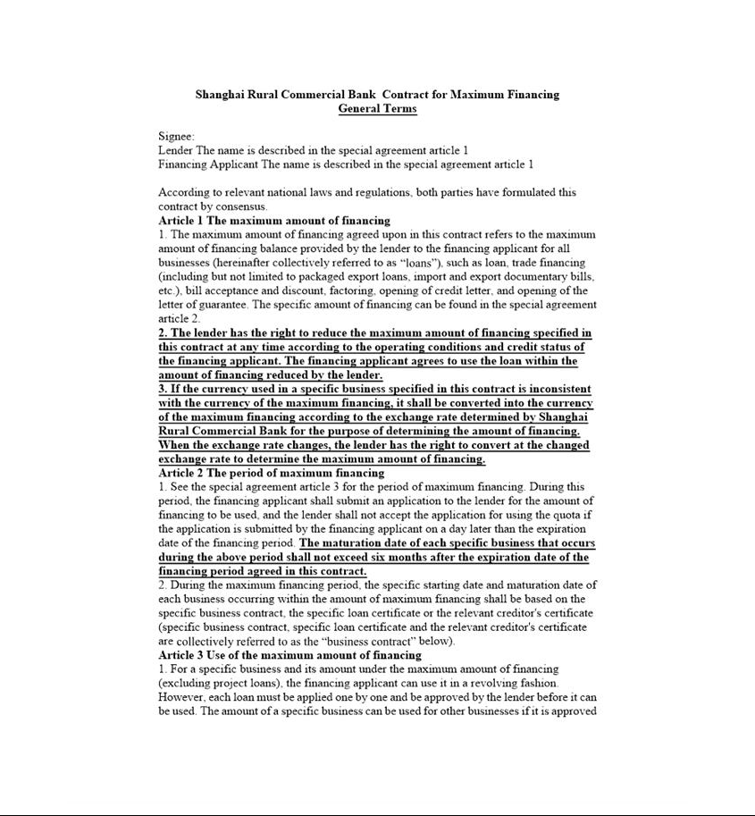

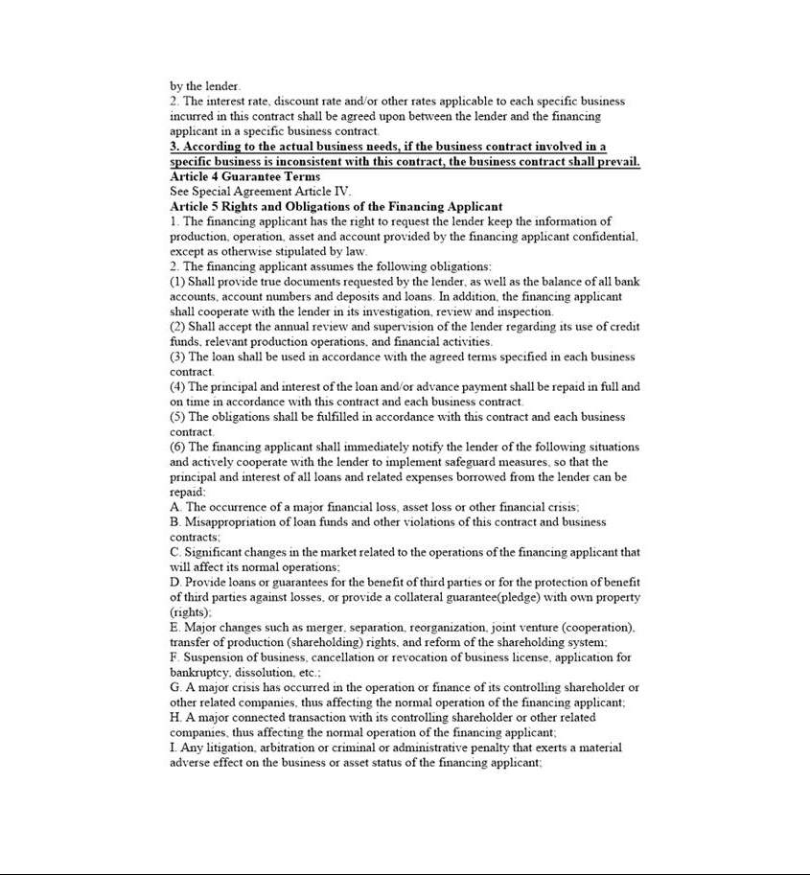

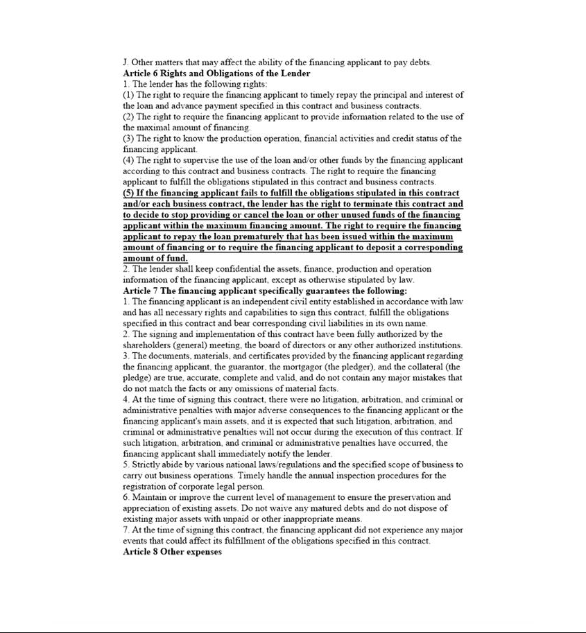

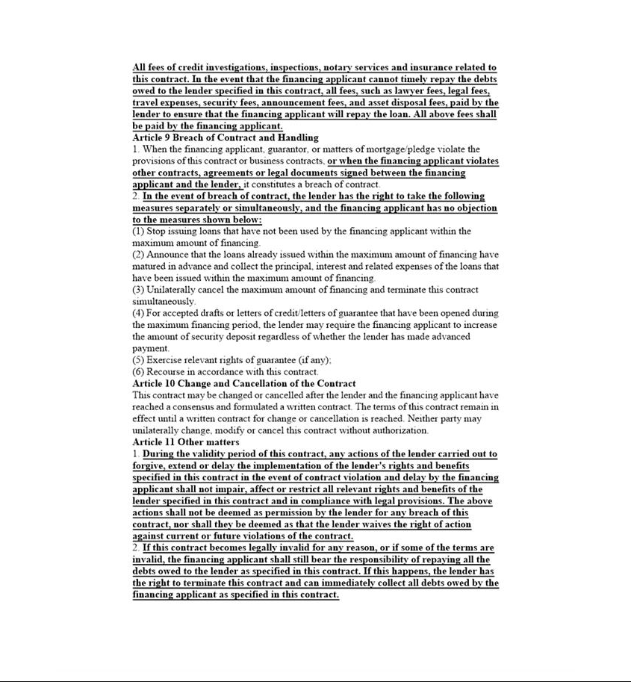

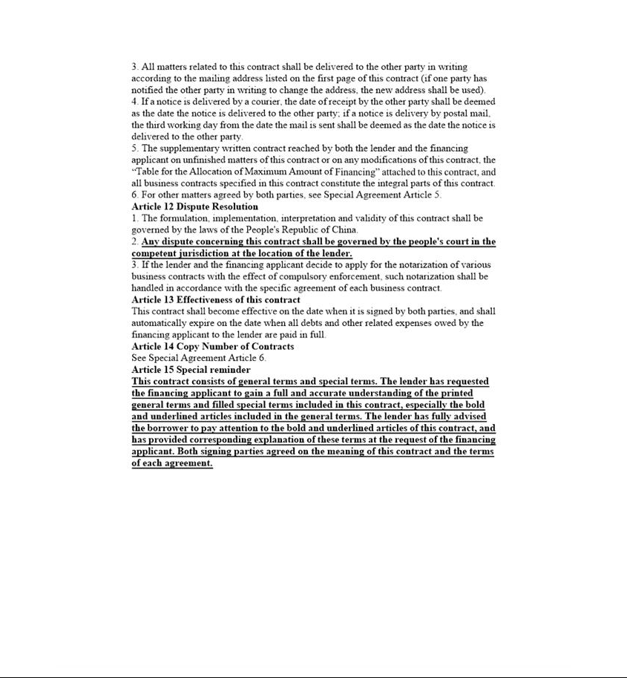

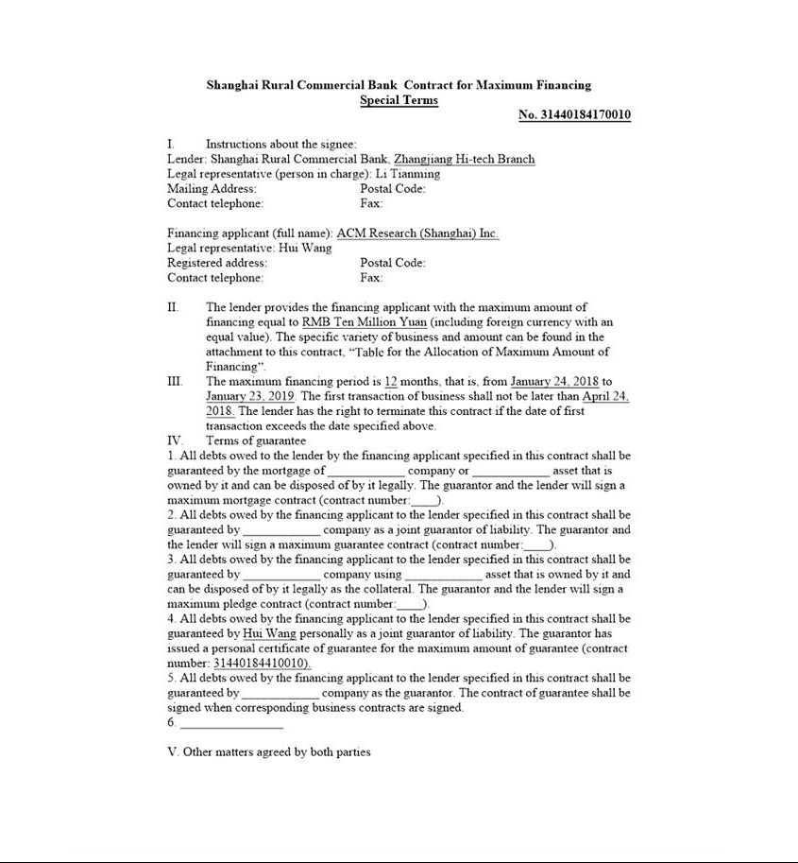

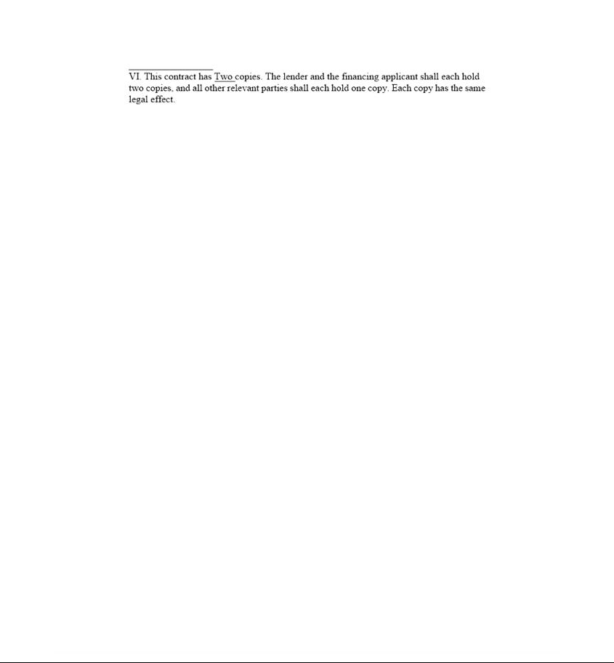

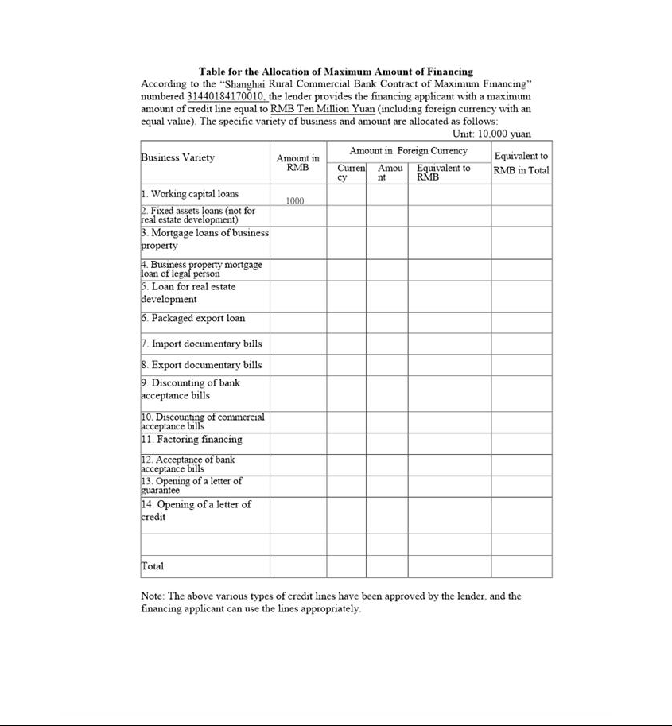

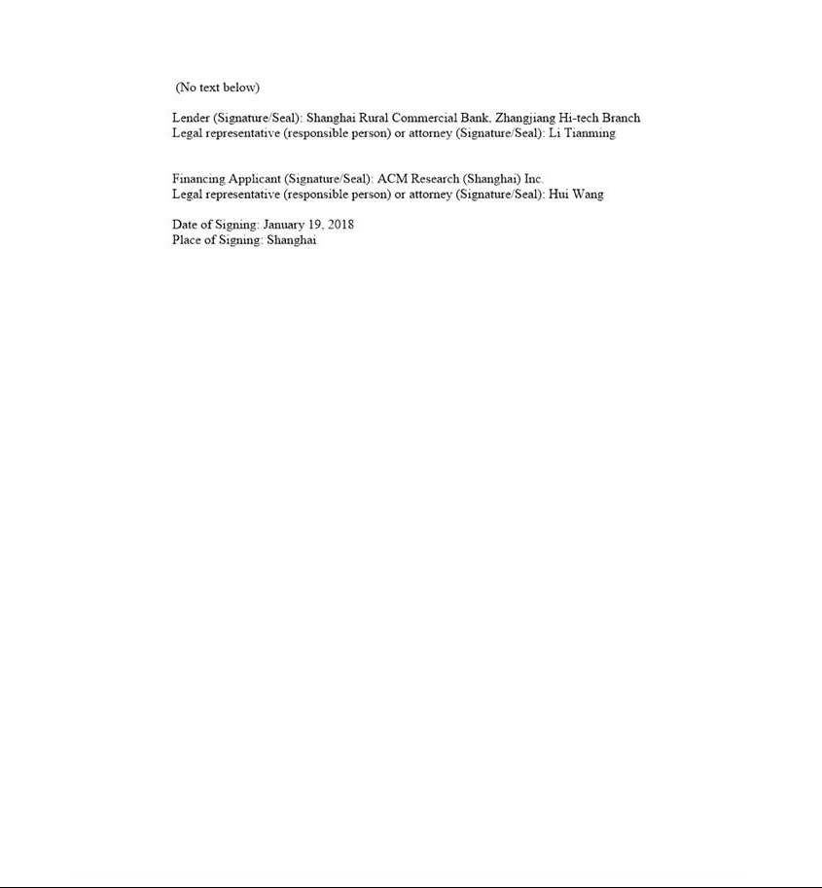

Exhibit 10.2


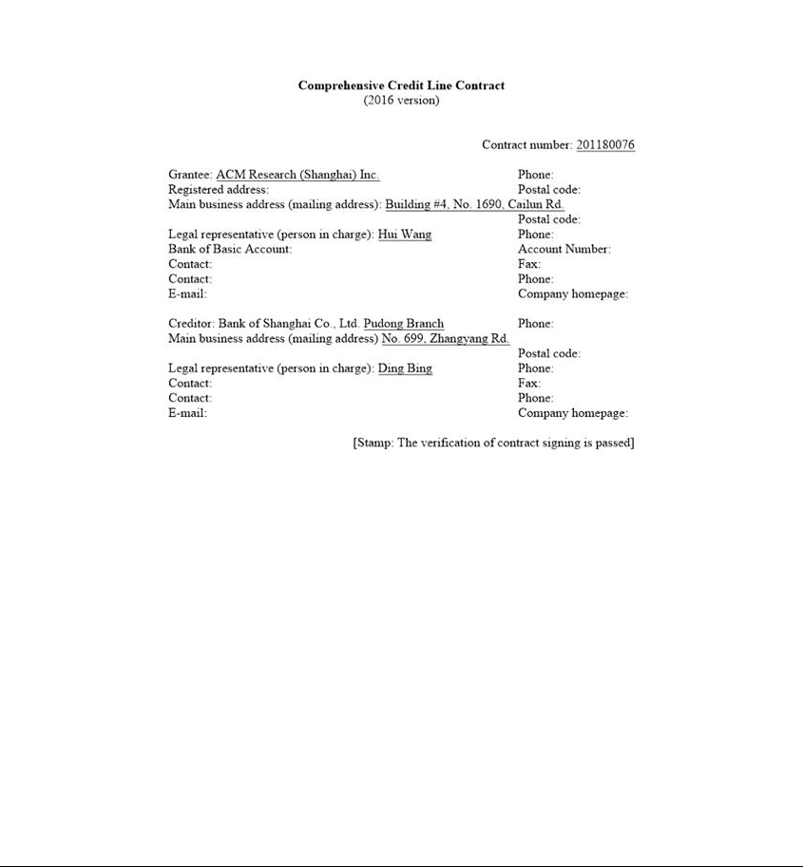

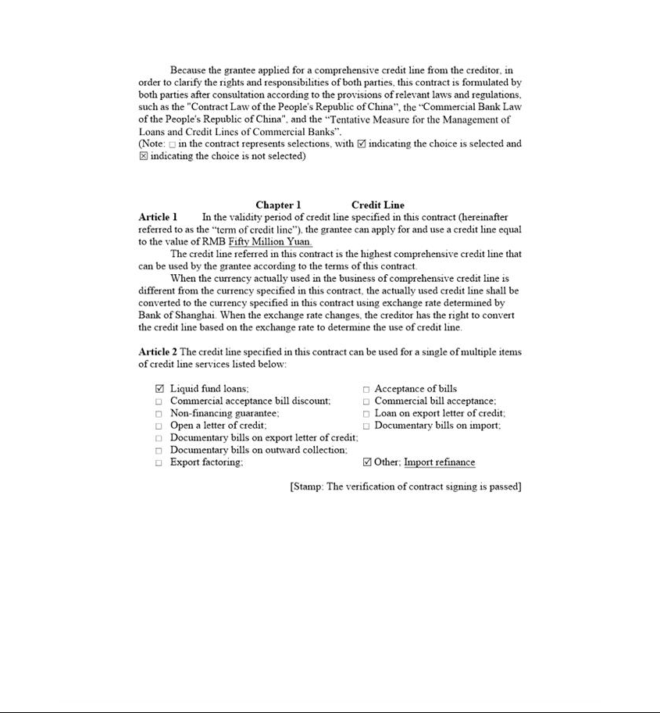

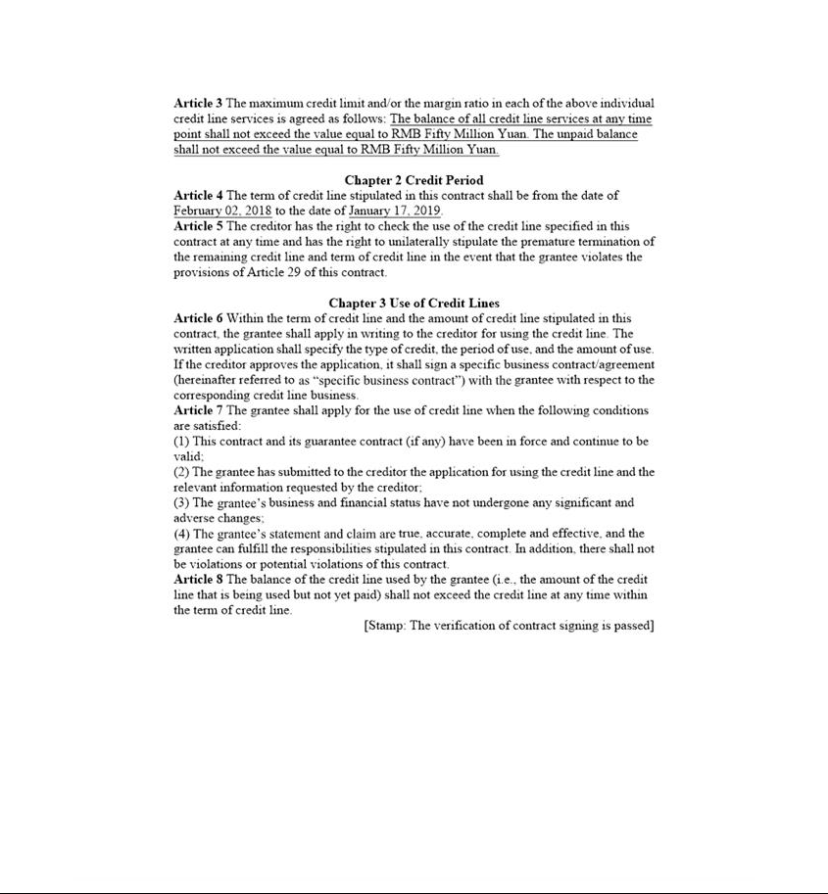

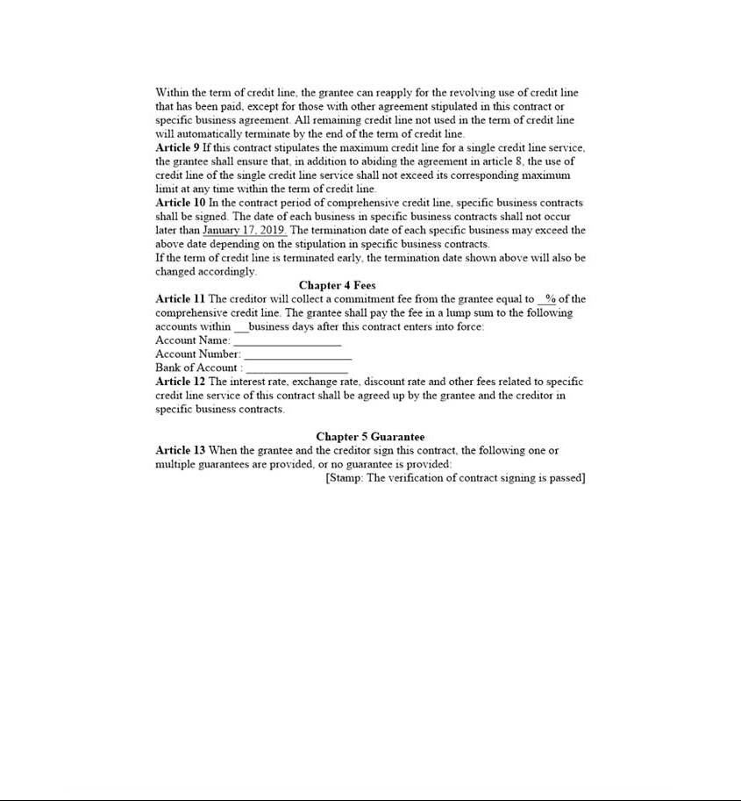

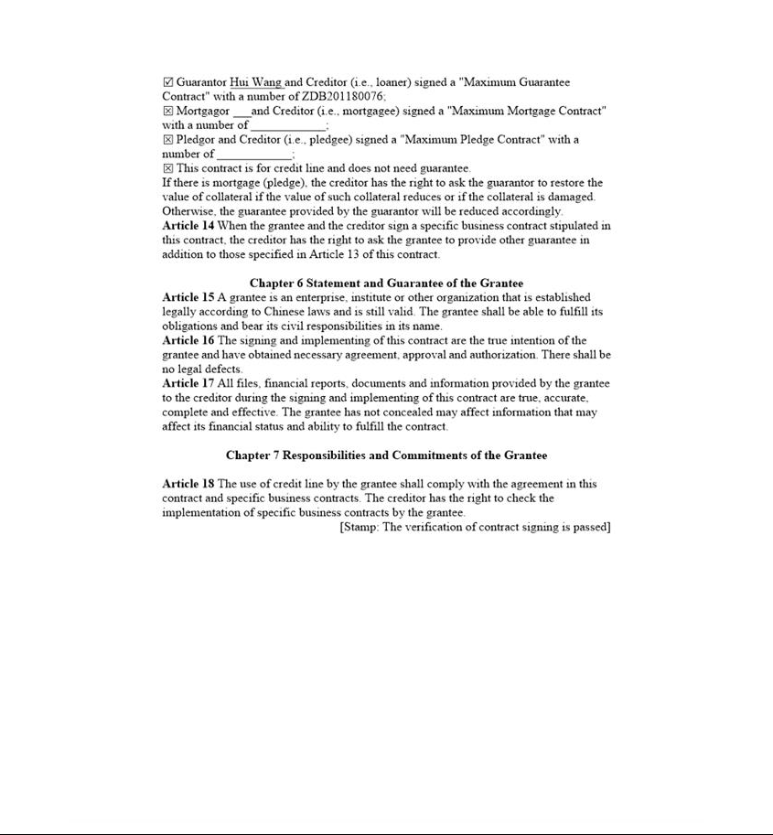

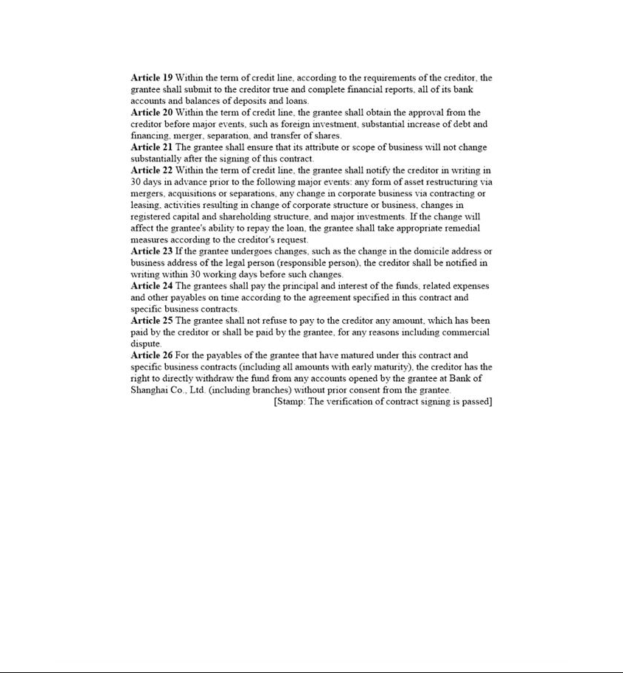

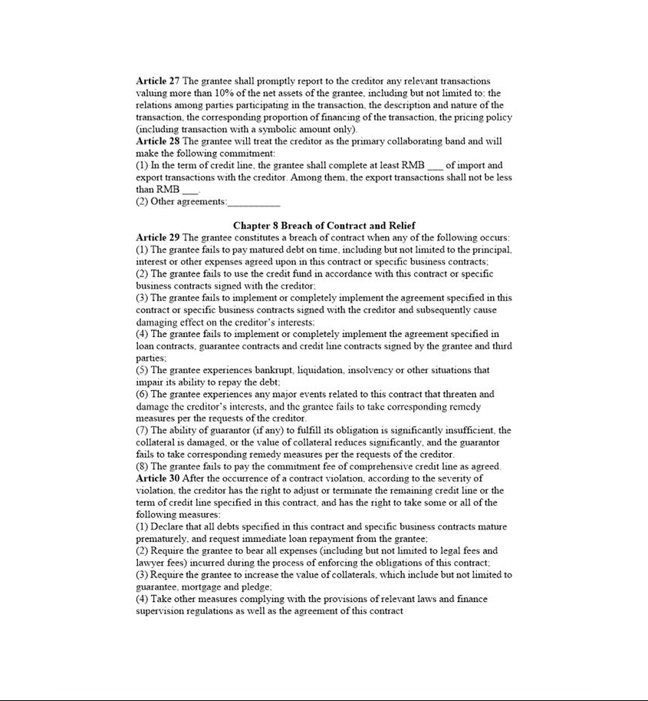

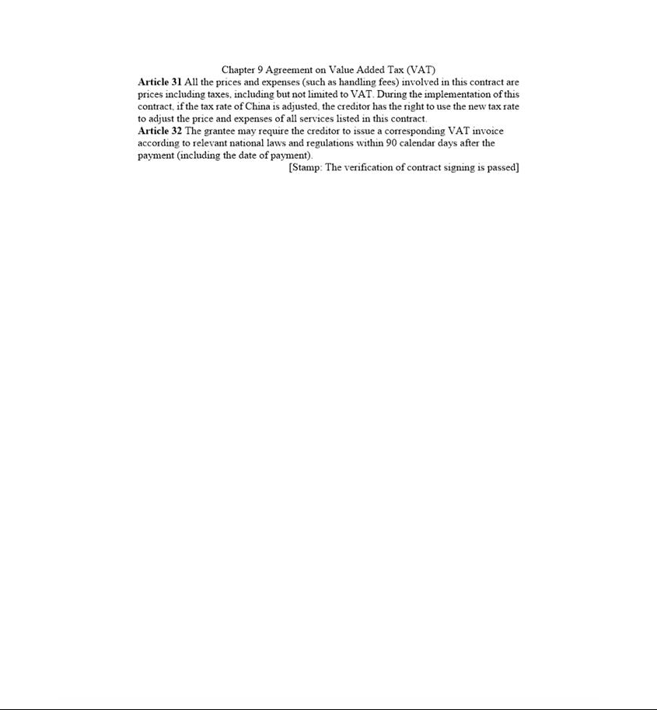

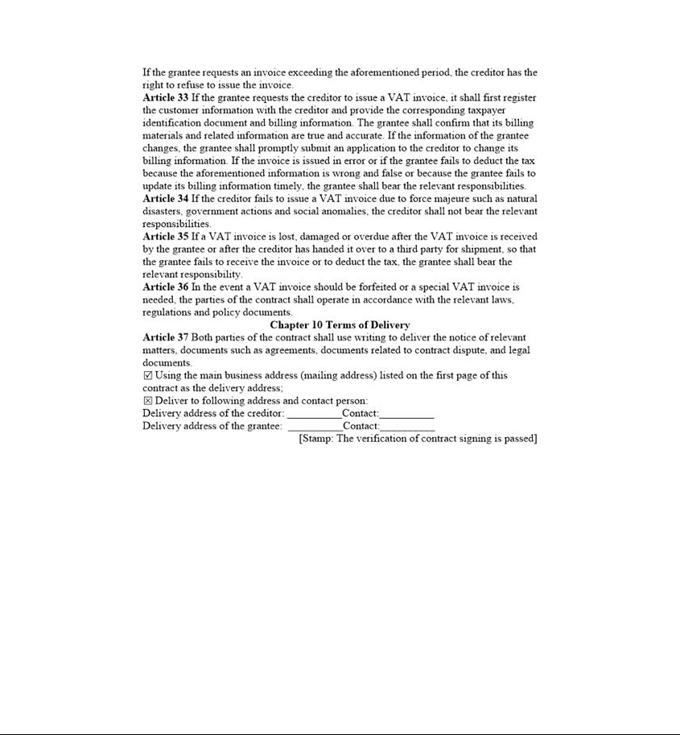

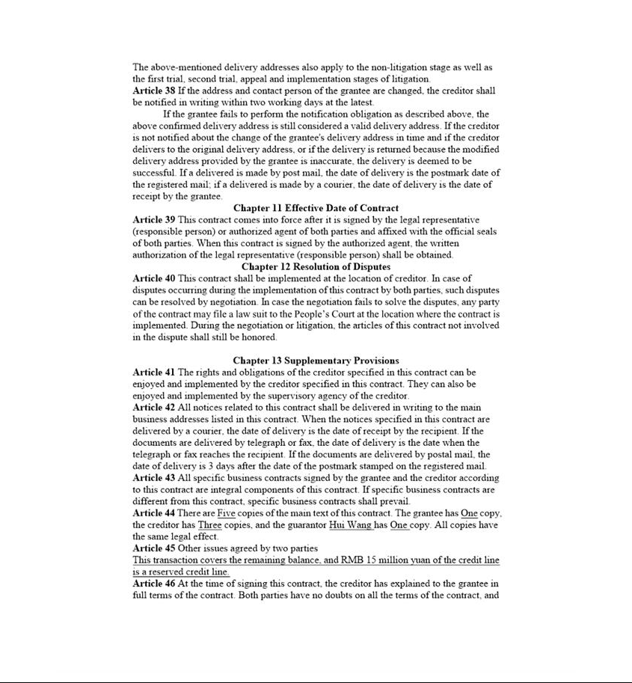



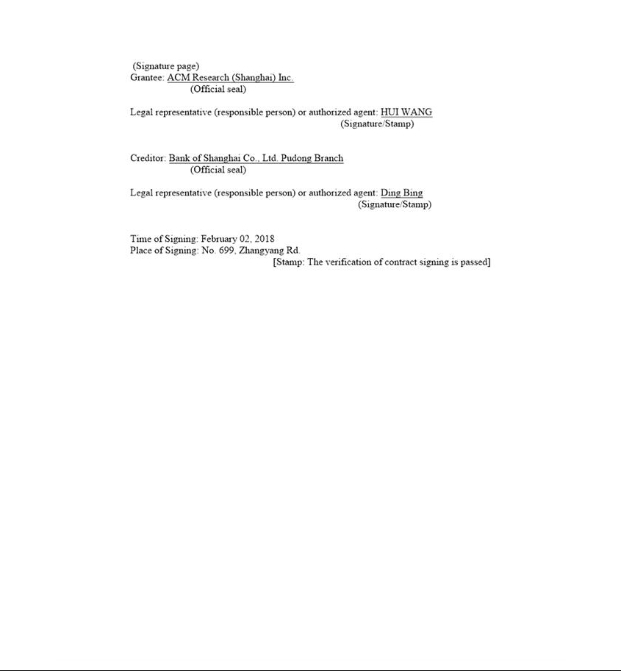

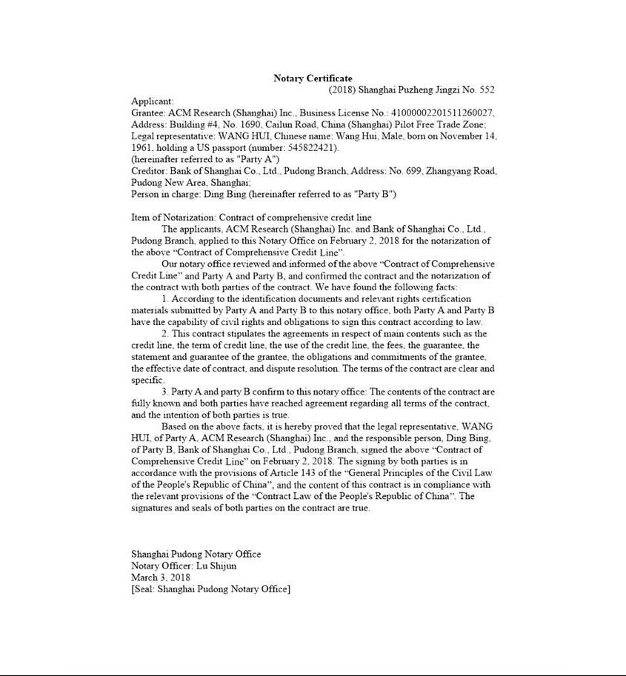

Exhibit 10.3
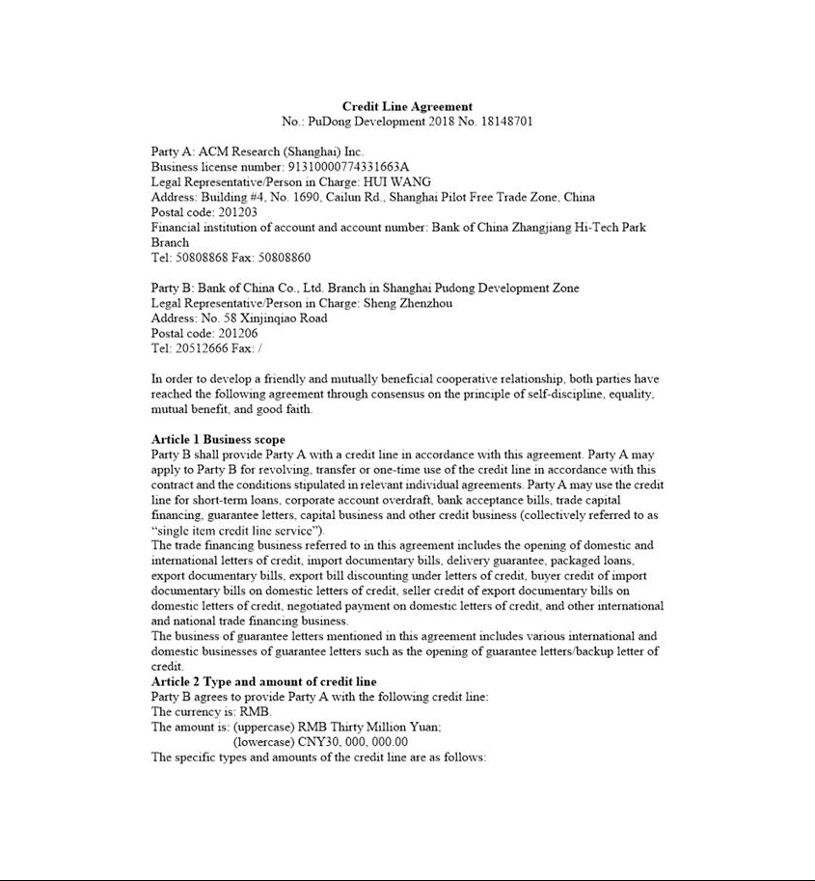

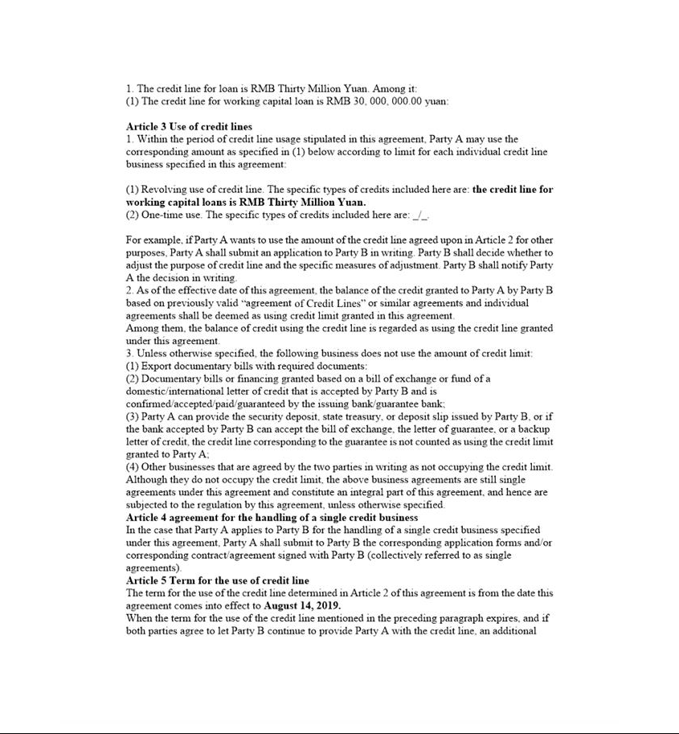

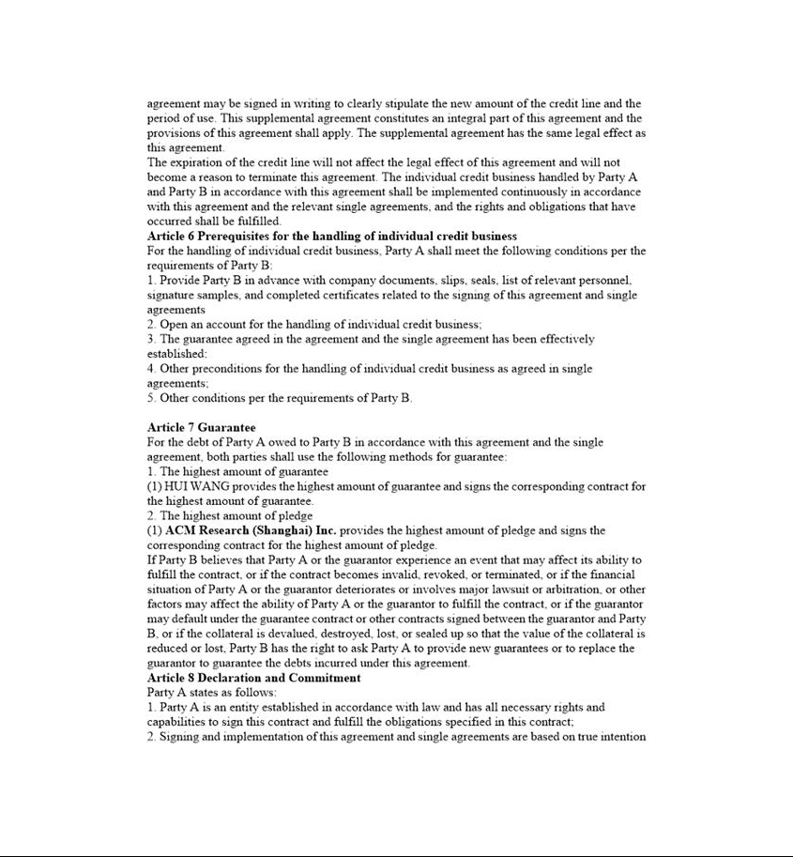

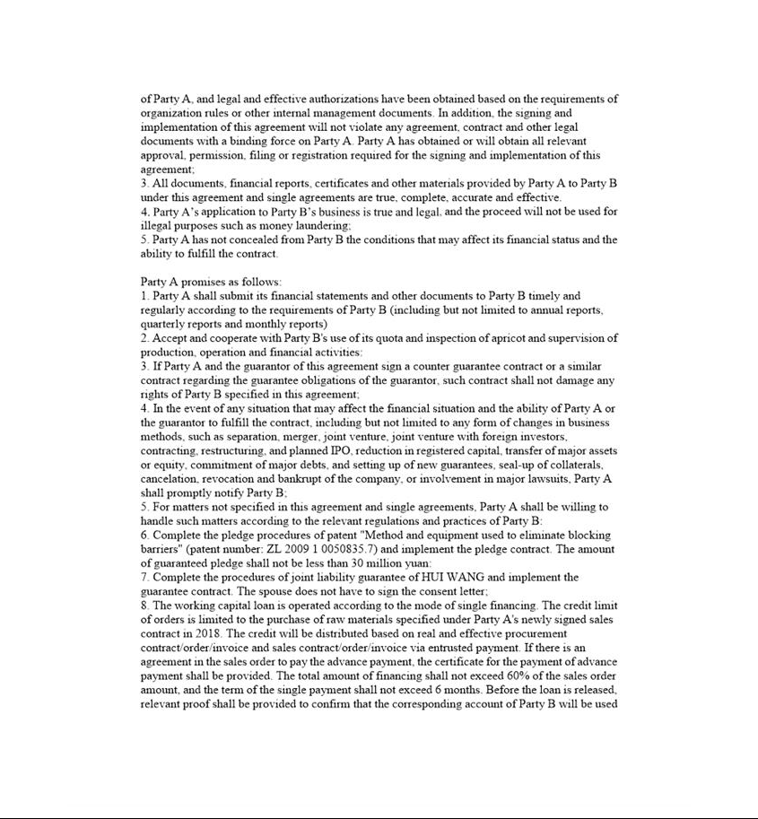

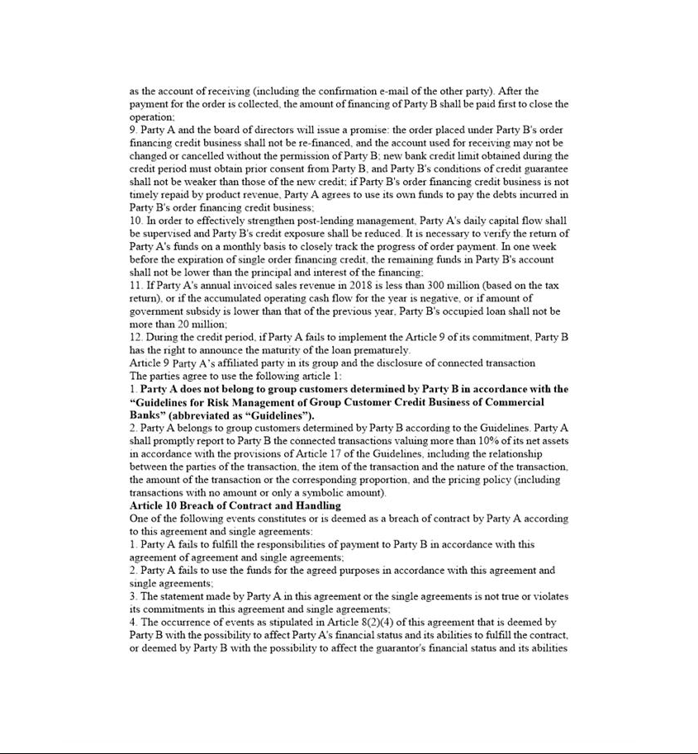

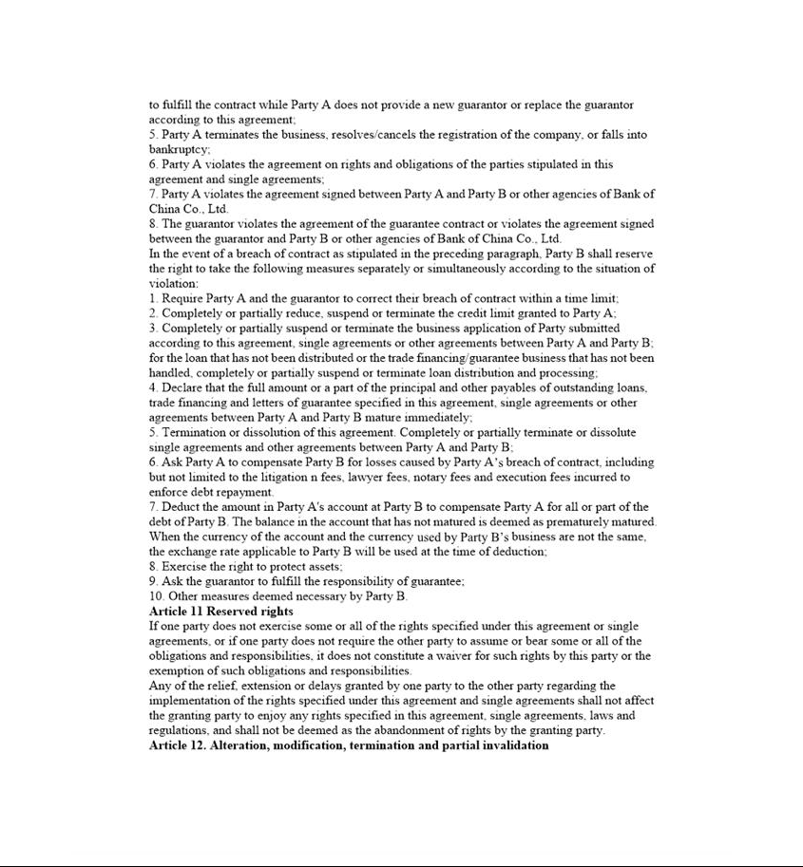

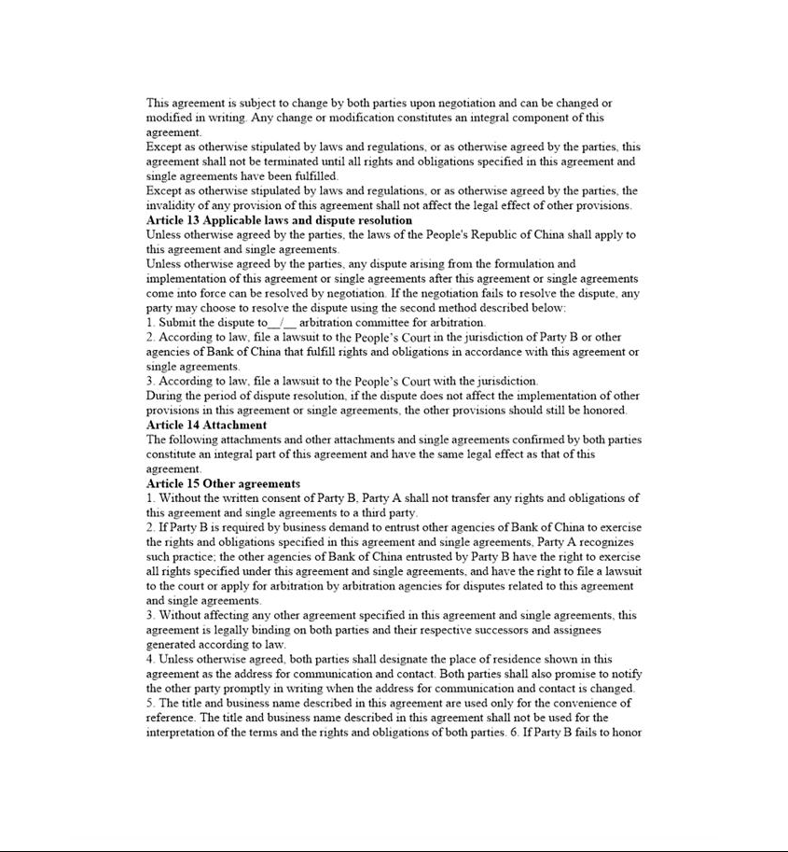

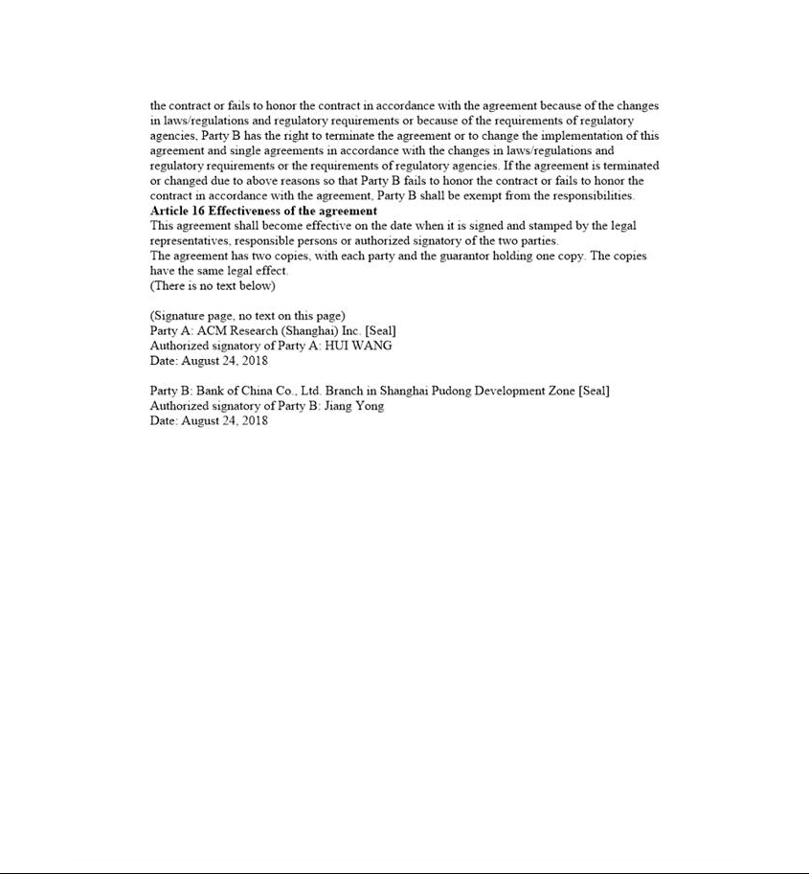

Exhibit 31.01

CERTIFICATION OF PRINCIPAL EXECUTIVE OFFICER

PURSUANT TO SECTION 302 OF THE SARBANES-OXLEY ACT OF 2002

I, David H. Wang, certify that:

- I have reviewed this quarterly report on Form 10-Q of ACM Research, Inc.

- Based on my knowledge, this report does not contain any untrue statement of a material fact or omit to state a material fact necessary to make the statements made, in light of the circumstances under which such statements were made, not misleading with respect to the period covered by this quarterly report.

- Based on my knowledge, the financial statements, and other financial information included in this report, fairly present in all material respects the financial condition, results of operations and cash flows of the registrant as of, and for, the periods presented in this report.

- The registrant’s other certifying officer and I are responsible for establishing and maintaining disclosure controls and procedures (as defined in Exchange Act Rules 13a–15(e) and 15d–15(e)) for the registrant and have:

  - designed such disclosure controls and procedures, or caused such disclosure controls and procedures to be designed under our supervision, to ensure that material information relating to the registrant, including its consolidated subsidiaries, is made known to us by others within those entities, particularly during the period in which this report is being prepared;

  - evaluated the effectiveness of the registrant’s disclosure controls and procedures and presented in this report our conclusions about the effectiveness of the disclosure controls and procedures, as of the end of the period covered by this report based on such evaluation; and

  - disclosed in this report any change in the registrant’s internal control over financial reporting that occurred during the registrant’s most recent fiscal quarter (the registrant’s fourth fiscal quarter in the case of an annual report) that has materially affected, or is reasonably likely to materially affect, the registrant’s internal control over financial reporting.

- The registrant’s other certifying officer and I have disclosed, based on our most recent evaluation of internal control over financial reporting, to the registrant’s auditors and the audit committee of the registrant’s board of directors (or persons performing the equivalent functions):

  - all significant deficiencies and material weaknesses in the design or operation of internal control over financial reporting which are reasonably likely to adversely affect the registrant’s ability to record, process, summarize and report financial information; and

  - any fraud, whether or not material, that involves management or other employees who have a significant role in the registrant’s internal control over financial reporting.

Dated: November 14, 2018 By: /s/ DAVID H. WANG

David H. Wang

Chief Executive Officer and President

(Principal Executive Officer)

Exhibit 31.02

CERTIFICATION OF PRINCIPAL FINANCIAL OFFICER

PURSUANT TO SECTION 302 OF THE SARBANES-OXLEY ACT OF 2002

I, Lisa Feng, certify that:

- I have reviewed this quarterly report on Form 10-Q of ACM Research, Inc.

- Based on my knowledge, this report does not contain any untrue statement of a material fact or omit to state a material fact necessary to make the statements made, in light of the circumstances under which such statements were made, not misleading with respect to the period covered by this quarterly report.

- Based on my knowledge, the financial statements, and other financial information included in this report, fairly present in all material respects the financial condition, results of operations and cash flows of the registrant as of, and for, the periods presented in this report.

- The registrant’s other certifying officer and I are responsible for establishing and maintaining disclosure controls and procedures (as defined in Exchange Act Rules 13a–15(e) and 15d–15(e)) for the registrant and have:

  - designed such disclosure controls and procedures, or caused such disclosure controls and procedures to be designed under our supervision, to ensure that material information relating to the registrant, including its consolidated subsidiaries, is made known to us by others within those entities, particularly during the period in which this report is being prepared;

  - evaluated the effectiveness of the registrant’s disclosure controls and procedures and presented in this report our conclusions about the effectiveness of the disclosure controls and procedures, as of the end of the period covered by this report based on such evaluation; and

  - disclosed in this report any change in the registrant’s internal control over financial reporting that occurred during the registrant’s most recent fiscal quarter (the registrant's fourth fiscal quarter in the case of an annual report) that has materially affected, or is reasonably likely to materially affect, the registrant's internal control over financial reporting.

- The registrant’s other certifying officer and I have disclosed, based on our most recent evaluation of internal control over financial reporting, to the registrant’s auditors and the audit committee of the registrant’s board of directors (or persons performing the equivalent functions):

  - all significant deficiencies and material weaknesses in the design or operation of internal control over financial reporting which are reasonably likely to adversely affect the registrant’s ability to record, process, summarize and report financial information; and

  - any fraud, whether or not material, that involves management or other employees who have a significant role in the registrant’s internal control over financial reporting.

Dated: November 14, 2018 By: /s/ LISA FENG

Lisa Feng

Interim Chief Financial Officer, Chief Accounting Officer and

Treasurer (Principal Financial Officer)

Exhibit 32.01

CERTIFICATION OF PRINCIPAL EXECUTIVE OFFICER AND PRINCIPAL FINANCIAL OFFICER PURSUANT TO SECTION 906 OF THE

SARBANES-OXLEY ACT OF 2002

In connection with the Quarterly Report on Form 10-Q of ACM Research, Inc. for the quarterly period ended September 30, 2018, as filed with the Securities and Exchange Commission on the date hereof (the “Report”), each of the undersigned certifies, pursuant to 18 U.S.C. 1350, as adopted pursuant to Section 906 of the Sarbanes-Oxley Act of 2002, that, to his or her knowledge:

- The Report fully complies with the requirements of Section 13(a) or 15(d) of the Securities Exchange Act of 1934.

- The information contained in the Report fairly presents, in all material respects, the financial condition and results of operations of ACM Research, Inc.

Dated: November 14, 2018 | By: | /s/ DAVID H. WANG
 |  | David H. Wang
 |  | Chief Executive Officer and President
 |  | (Principal Executive Officer)
Dated: November 14, 2018 | By: | /s/ LISA FENG
 |  | Lisa Feng
 |  | Interim Chief Financial Officer, Chief Accounting Officer and
 |  | Treasurer (Principal Financial Officer)

