Table of Contents
UNITED STATES SECURITIES AND EXCHANGE COMMISSION
Washington, D.C. 20549
FORM 10-Q
(Mark One)
☑ |  |  | QUARTERLY REPORT PURSUANT TO SECTION 13 OR 15(d) OF THE SECURITIES EXCHANGE ACT OF 1934
For the quarterly period ended September 30, 2024
or
o |  |  | TRANSITION REPORT PURSUANT TO SECTION 13 OR 15(d) OF THE SECURITIES EXCHANGE ACT OF 1934
For the transition period from _________ to _____________
Commission file number: 001-38273
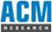
ACM Research, Inc.
(Exact Name of Registrant as Specified in Its Charter)
Delaware |  |  | 94-3290283
(State or Other Jurisdiction of Incorporation or Organization) |  |  | (I.R.S. Employer Identification No.)
42307 Osgood Road, Suite I  Fremont, California |  |  | 94539
(Address of Principal Executive Offices) |  |  | (Zip Code)
Registrant’s telephone number, including area code: (510) 445-3700
Securities registered pursuant to Section 12(b) of the Act:
Title of Each Class |  |  |  |  |  | Trading Symbol |  |  |  |  |  | Name of Each Exchange on which Registered
Class A Common Stock, $0.0001 par value |  |  |  |  |  | ACMR |  |  |  |  |  | The NASDAQ Stock Market LLC
Indicate by check mark whether the registrant (1) has filed all reports required to be filed by Section 13 or 15(d) of the Securities Exchange Act of 1934 during the preceding 12 months (or for such shorter period that the registrant was required to file such reports), and (2) has been subject to such filing requirements for the past 90 days. Yes ☑ No o
Indicate by check mark whether the registrant has submitted electronically every Interactive Data file required to be submitted pursuant to Rule 405 of Regulation S-T (§232.405 of this chapter) during the preceding 12 months (or for such shorter period that the registrant was required to submit such files). Yes ☑ No o
Indicate by check mark whether the registrant is a large accelerated filer, an accelerated filer, a non-accelerated filer, a smaller reporting company or an emerging growth company. See definitions of “large accelerated filer,” “accelerated filer,” “smaller reporting company” and “emerging growth company” in Rule 12b-2 of the Exchange Act.
 |  |  | Large accelerated filer |  |  | ☑ |  |  |  |  |  | Accelerated filer |  |  | o
 |  |  | Non-accelerated filer |  |  | o |  |  |  |  |  | Smaller reporting company |  |  | o
 |  |  |  |  |  |  |  |  |  |  |  | Emerging growth company |  |  | o
If an emerging growth company, indicate by check mark if the registrant has elected not to use the extended transition period for complying with any new or revised financial accounting standards provided pursuant to Section 13(a) of the Exchange Act. o
Indicate by check mark whether the registrant is a shell company (as defined in Rule 12b-2 of the Exchange Act). Yes o No ☑
Indicate the number of shares outstanding of each of the registrant’s classes of common stock, as of the latest practicable date.
Class |  |  |  |  |  | Number of Shares Outstanding
Class A Common Stock, $0.0001 par value |  |  |  |  |  | 57,606,036 shares outstanding as of November 4, 2024
Class B Common Stock, $0.0001 par value |  |  |  |  |  | 5,021,811 shares outstanding as of November 4, 2024

Table of Contents
TABLE OF CONTENTS
PART I. |  |  |  |  |  | FINANCIAL INFORMATION |  |  | 4
 |  |  | Item 1. |  |  | Financial Statements (unaudited) |  |  | 4
 |  |  |  |  |  | Condensed Consolidated Balance Sheets as of September 30, 2024 and December 31, 2023 |  |  | 4
 |  |  |  |  |  | Condensed Consolidated Statements of Comprehensive Income for the Three and Nine Months Ended September 30, 2024 and 2023 |  |  | 5
 |  |  |  |  |  | Condensed Consolidated Statements of Changes in Equity for the Three and Nine Months Ended September 30, 2024 and 2023 |  |  | 6
 |  |  |  |  |  | Condensed Consolidated Statements of Cash Flows for the Nine Months Ended September 30, 2024 and 2023 |  |  | 8
 |  |  |  |  |  | Notes to the Condensed Consolidated Financial Statements |  |  | 9
 |  |  | Item 2. |  |  | Management’s Discussion and Analysis of Financial Condition and Results of Operations |  |  | 37
 |  |  | Item 3. |  |  | Quantitative and Qualitative Disclosures about Market Risks |  |  | 60
 |  |  | Item 4. |  |  | Controls and Procedures |  |  | 60
PART II. |  |  |  |  |  | OTHER INFORMATION |  |  | 60
 |  |  | Item 1. |  |  | Legal Proceedings |  |  | 61
 |  |  | Item 1A. |  |  | Risk Factors |  |  | 61
 |  |  | Item 2. |  |  | Unregistered Sales of Equity Securities and Use of Proceeds |  |  | 61
 |  |  | Item 3. |  |  | Defaults Upon Senior Securities |  |  | 63
 |  |  | Item 4. |  |  | Mine Safety Disclosures |  |  | 63
 |  |  | Item 5. |  |  | Other Information |  |  | 61
 |  |  | Item 6. |  |  | Exhibits |  |  | 63
Signatures |  |  |  |  |  |  |  |  | 64
ACM Research, Inc., or ACM Research, is a Delaware corporation founded in California in 1998 to supply capital equipment developed for the global semiconductor industry. Since 2005, ACM Research has conducted its business operations principally through its subsidiary ACM Research (Shanghai), Inc., or ACM Shanghai, a limited liability corporation formed by ACM Research in the People’s Republic of China, or mainland China, in 2005. Unless the context requires otherwise, references in this report to “our company,” “our,” “us,” “we” and similar terms refer to ACM Research, Inc. and its subsidiaries, including ACM Shanghai, collectively.

We conduct a substantial majority of our product development, manufacturing, support and services in mainland China through ACM Shanghai. We are not a mainland China operating company, and we do not conduct our operations in mainland China through the use of a variable interest entity or any other structure designed for the purpose of avoiding mainland China legal restrictions on direct foreign investments in mainland China-based companies. For a description of certain matters relating to our operations in mainland China, including our corporate structure, the movement of cash throughout our organization, certain audit and regulatory matters, and risks associated therewith, please see “Item 2—Management’s Discussion and Analysis of Financial Condition and Results of Operations” in this report, the disclosure at the forefront of our Annual Report on Form 10-K for the fiscal year ended December 31, 2023, and the Risk Factors included therein, as referenced or updated by the disclosure included in “Part II. Item 1A—Risk Factors” in this report.
For purposes of this report, certain amounts in Renminbi, or RMB, have been translated into U.S. dollars solely for the convenience of the reader. The translations have been made based on the conversion rates published by the State Administration of Foreign Exchange of the People’s Republic of China.
SAPS, TEBO, ULTRA C, ULTRA Fn, Ultra ECP, Ultra ECP map, and Ultra ECP ap are trademarks of ACM Research. For convenience, these trademarks appear in this report without ™ symbols, but that practice does not mean that ACM Research will not assert, to the fullest extent under applicable law, ACM Research’s rights to the trademarks. This report also contains other companies’ trademarks, registered marks and trade names, which are the property of those companies.

2
Table of Contents
FORWARD-LOOKING STATEMENTS AND STATISTICAL DATA
This report contains forward-looking statements within the meaning of the Private Securities Litigation Reform Act of 1995. All statements, other than statements of historical facts, included in this report regarding our strategy, future operations, future financial position, future revenue, projected costs, prospects, plans and objectives of management are forward-looking statements. In some cases, you can identify forward-looking statements by terms such as “may,” “might,” “will,” “objective,” “intend,” “should,” “could,” “can,” “would,” “expect,” “believe,” “anticipate,” “project,” “target,” “design,” “estimate,” “predict,” “potential,” “plan” or the negative of these terms, and similar expressions intended to identify forward-looking statements. These statements reflect our current views with respect to future events and are based on our management’s belief and assumptions and on information currently available to our management. Although we believe that the expectations reflected in these forward-looking statements are reasonable, these statements relate to future events or our future operational or financial performance, and involve known and unknown risks, uncertainties and other factors, including those described or incorporated by reference in “Item 1A. Risk Factors” of Part II of this report, that may cause our actual results, performance or achievements to be materially different from any future results, performance or achievements expressed or implied by these forward-looking statements.
The information included under the heading “Item 2. Management’s Discussion and Analysis of Financial Condition and Results of Operations – Overview,” of Part I of this report contains statistical data and estimates, including forecasts, that are based on information provided by Gartner, Inc., or Gartner, in “Forecast: Semiconductor Wafer Fab Equipment, Worldwide, 4Q23 Update” (December 2023), or the Gartner Report. The Gartner Report represents research opinions or viewpoints that are published, as part of a syndicated subscription service, by Gartner and are not representations of fact. The Gartner Report speaks as of its original publication date (and not as of the date of this report), and the opinions expressed in the Gartner Report are subject to change without notice. While we are not aware of any misstatements regarding any of the data presented from the Gartner Report, estimates, and in particular forecasts, involve numerous assumptions and are subject to risks and uncertainties, as well as change based on various factors, that could cause results to differ materially from those expressed in the data presented below.
Any forward-looking statement made by us in this report speaks only as of the date on which it is made. Except as required by law, we assume no obligation to update these statements publicly or to update the reasons actual results could differ materially from those anticipated in these statements, even if new information becomes available in the future.
You should read this report, and the documents that we reference in this report and have filed as exhibits to this report, completely and with the understanding that our actual future results may be materially different from what we expect. We qualify all of our forward-looking statements by these cautionary statements.

3
Table of Contents
PART I. FINANCIAL INFORMATION

Item 1. Financial Statements

ACM RESEARCH, INC.
Condensed Consolidated Balance Sheets
(In thousands, except per share data)

 |  |  | September 30, |  |  |  |  |  | December 31,
 |  |  | 2024 |  |  |  |  |  | 2023
Assets |  |  | (Unaudited)
Current assets:
Cash and cash equivalents (note 2) |  |  | $ | 333,472 |  |  |  |  | $ | 182,090
Restricted cash |  |  | 1,782 |  |  |  |  |  | 1,083
Short-term time deposits (note 2) |  |  | 20,304 |  |  |  |  |  | 80,524
Short-term investments (note 15) |  |  | 20,351 |  |  |  |  |  | 21,312
Accounts receivable, net (note 4) |  |  | 370,589 |  |  |  |  |  | 283,186
Other receivables |  |  | 57,849 |  |  |  |  |  | 40,065
Inventories, net (note 5) |  |  | 628,720 |  |  |  |  |  | 545,395
Advances to related party (note 16) |  |  | 1,453 |  |  |  |  |  | 2,432
Prepaid expenses |  |  | 10,794 |  |  |  |  |  | 20,023
Total current assets |  |  | 1,445,314 |  |  |  |  |  | 1,176,110
Property, plant and equipment, net (note 6) |  |  | 250,099 |  |  |  |  |  | 201,848
Land use right, net (note 7) |  |  | 8,320 |  |  |  |  |  | 8,367
Operating lease right-of-use assets, net (note 11) |  |  | 5,680 |  |  |  |  |  | 7,026
Intangible assets, net |  |  | 2,838 |  |  |  |  |  | 2,538
Long-term time deposits (note 2) |  |  | 13,517 |  |  |  |  |  | 40,818
Deferred tax assets (note 19) |  |  | 13,400 |  |  |  |  |  | 20,271
Long-term investments (note 14) |  |  | 33,655 |  |  |  |  |  | 27,880
Other long-term assets (note 8) |  |  | 21,352 |  |  |  |  |  | 6,050
Total assets |  |  | $ | 1,794,175 |  |  |  |  | $ | 1,490,908
Liabilities and Equity
Current liabilities:
Short-term borrowings (note 9) |  |  | $ | 33,795 |  |  |  |  | $ | 31,335
Current portion of long-term borrowings (note 12) |  |  | 30,670 |  |  |  |  |  | 6,783
Related party accounts payable (note 16) |  |  | 15,392 |  |  |  |  |  | 11,407
Accounts payable |  |  | 170,810 |  |  |  |  |  | 141,814
Advances from customers (note 3) |  |  | 215,678 |  |  |  |  |  | 181,368
Deferred revenue (note 3) |  |  | 10,138 |  |  |  |  |  | 3,687
Income taxes payable (note 19) |  |  | 6,796 |  |  |  |  |  | 6,401
FIN-48 payable (note 19) |  |  | 8,991 |  |  |  |  |  | 12,149
Other payables and accrued expenses (note 10) |  |  | 115,388 |  |  |  |  |  | 102,951
Current portion of operating lease liabilities (note 11) |  |  | 2,377 |  |  |  |  |  | 2,764
Total current liabilities |  |  | 610,035 |  |  |  |  |  | 500,659
Long-term borrowings (note 12) |  |  | 106,069 |  |  |  |  |  | 53,952
Long-term operating lease liabilities (note 11) |  |  | 3,303 |  |  |  |  |  | 4,262
Other long-term liabilities (note 13) |  |  | 5,685 |  |  |  |  |  | 5,873
Total liabilities |  |  | 725,092 |  |  |  |  |  | 564,746
Commitments and contingencies (note 21)
Equity:
Stockholders’ equity:
Class A Common stock (note 17) |  |  | 6 |  |  |  |  |  | 6
Class B Common stock (note 17) |  |  | 1 |  |  |  |  |  | 1
Additional paid-in capital |  |  | 669,540 |  |  |  |  |  | 629,845
Retained earnings |  |  | 229,374 |  |  |  |  |  | 156,827
Statutory surplus reserve (note 22) |  |  | 30,060 |  |  |  |  |  | 30,060
Accumulated other comprehensive loss |  |  | (40,815) |  |  |  |  |  | (49,349)
Total ACM Research, Inc. stockholders’ equity |  |  | 888,166 |  |  |  |  |  | 767,390
Non-controlling interests |  |  | 180,917 |  |  |  |  |  | 158,772
Total equity |  |  | 1,069,083 |  |  |  |  |  | 926,162
Total liabilities and equity |  |  | $ | 1,794,175 |  |  |  |  | $ | 1,490,908

The accompanying notes are an integral part of these condensed consolidated financial statements.

4
Table of Contents
ACM RESEARCH, INC.
Condensed Consolidated Statements of Comprehensive Income
(In thousands, except share and per share data)
(Unaudited)
 |  |  | Three Months Ended September 30, |  |  |  |  |  |  |  |  |  |  |  | Nine Months Ended September 30,
 |  |  | 2024 |  |  |  |  |  | 2023 |  |  |  |  |  | 2024 |  |  |  |  |  | 2023
Revenue (note 3) |  |  | $ | 203,976 |  |  |  |  | $ | 168,569 |  |  |  |  | $ | 558,647 |  |  |  |  | $ | 387,402
Cost of revenue, including cost of revenue from related parties of $15,276 and $46,547 for the three and nine months ended September 30, 2024, respectively, and $7,952 and $37,632 for the three and nine months ended September 30, 2023, respectively (note 16) |  |  | 99,142 |  |  |  |  |  | 80,055 |  |  |  |  |  | 277,908 |  |  |  |  |  | 190,263
Gross profit |  |  | 104,834 |  |  |  |  |  | 88,514 |  |  |  |  |  | 280,739 |  |  |  |  |  | 197,139
Operating expenses:
Sales and marketing |  |  | 15,759 |  |  |  |  |  | 16,803 |  |  |  |  |  | 47,067 |  |  |  |  |  | 37,579
Research and development |  |  | 27,837 |  |  |  |  |  | 26,151 |  |  |  |  |  | 77,723 |  |  |  |  |  | 60,244
General and administrative |  |  | 17,054 |  |  |  |  |  | 12,387 |  |  |  |  |  | 48,940 |  |  |  |  |  | 26,851
Total operating expenses |  |  | 60,650 |  |  |  |  |  | 55,341 |  |  |  |  |  | 173,730 |  |  |  |  |  | 124,674
Income from operations |  |  | 44,184 |  |  |  |  |  | 33,173 |  |  |  |  |  | 107,009 |  |  |  |  |  | 72,465
Interest income |  |  | 2,967 |  |  |  |  |  | 2,152 |  |  |  |  |  | 7,122 |  |  |  |  |  | 6,283
Interest expense |  |  | (1,208) |  |  |  |  |  | (640) |  |  |  |  |  | (2,923) |  |  |  |  |  | (1,984)
Realized gain from sale of short-term investments (note 15) |  |  | 171 |  |  |  |  |  | 656 |  |  |  |  |  | 444 |  |  |  |  |  | 8,569
Unrealized gain (loss) on short-term investments (note 15) |  |  | 413 |  |  |  |  |  | (1,319) |  |  |  |  |  | (1,151) |  |  |  |  |  | (4,428)
Other income (loss), net |  |  | (5,164) |  |  |  |  |  | (2,150) |  |  |  |  |  | (727) |  |  |  |  |  | 156
Income (loss) from equity method investments (note 15) |  |  | 1,316 |  |  |  |  |  | (160) |  |  |  |  |  | 101 |  |  |  |  |  | 3,728
Income before income taxes |  |  | 42,679 |  |  |  |  |  | 31,712 |  |  |  |  |  | 109,875 |  |  |  |  |  | 84,789
Income tax expense (note 19) |  |  | (4,007) |  |  |  |  |  | (718) |  |  |  |  |  | (17,712) |  |  |  |  |  | (11,235)
Net income |  |  | 38,672 |  |  |  |  |  | 30,994 |  |  |  |  |  | 92,163 |  |  |  |  |  | 73,554
Less: Net income attributable to non-controlling interests |  |  | 7,768 |  |  |  |  |  | 5,315 |  |  |  |  |  | 19,616 |  |  |  |  |  | 13,905
Net income attributable to ACM Research, Inc. |  |  | $ | 30,904 |  |  |  |  | $ | 25,679 |  |  |  |  | $ | 72,547 |  |  |  |  | $ | 59,649
Comprehensive income:
Net income |  |  | 38,672 |  |  |  |  |  | 30,994 |  |  |  |  |  | 92,163 |  |  |  |  |  | 73,554
Foreign currency translation adjustment, net of tax |  |  | 17,089 |  |  |  |  |  | 4,015 |  |  |  |  |  | 10,376 |  |  |  |  |  | (21,831)
Comprehensive income |  |  | 55,761 |  |  |  |  |  | 35,009 |  |  |  |  |  | 102,539 |  |  |  |  |  | 51,723
Less: Comprehensive income attributable to non-controlling interests |  |  | 10,842 |  |  |  |  |  | 7,768 |  |  |  |  |  | 21,458 |  |  |  |  |  | 11,882
Comprehensive income attributable to ACM Research, Inc. |  |  | $ | 44,919 |  |  |  |  | $ | 27,241 |  |  |  |  | $ | 81,081 |  |  |  |  | $ | 39,841
Net income attributable to ACM Research, Inc. per share of common stock (note 2):
Basic |  |  | $ | 0.49 |  |  |  |  | $ | 0.43 |  |  |  |  | $ | 1.17 |  |  |  |  | $ | 0.99
Diluted |  |  | $ | 0.45 |  |  |  |  | $ | 0.39 |  |  |  |  | $ | 1.07 |  |  |  |  | $ | 0.90
Weighted average shares of common stock outstanding used in computing per share amounts (note 2):
Basic |  |  | 62,500,903 |  |  |  |  |  | 60,219,218 |  |  |  |  |  | 62,017,257 |  |  |  |  |  | 59,953,144
Diluted |  |  | 66,671,526 |  |  |  |  |  | 65,450,941 |  |  |  |  |  | 66,512,143 |  |  |  |  |  | 64,834,051

The accompanying notes are an integral part of these condensed consolidated financial statements.

5
Table of Contents
ACM RESEARCH, INC.
Condensed Consolidated Statements of Changes in Equity
For the Nine Months Ended September 30, 2024 and 2023
(In thousands, except share and per share data)
(Unaudited)
 |  |  | Common  Stock Class A |  |  |  |  |  |  |  |  |  |  |  | Common  Stock Class B
 |  |  | Shares |  |  |  |  |  | Amount |  |  |  |  |  | Shares |  |  |  |  |  | Amount |  |  |  |  |  | Additional Paid-  in Capital |  |  |  |  |  | Retained  Earnings |  |  |  |  |  | Statutory  Surplus  Reserve |  |  |  |  |  | Accumulated  Other  Comprehensive  Income (Loss) |  |  |  |  |  | Non-controlling  Interests |  |  |  |  |  | Total  Equity
Balance at December 31, 2022 |  |  | 54,655,286 |  |  |  |  |  | $ | 5 |  |  |  |  | 5,021,811 |  |  |  |  |  | $ | 1 |  |  |  |  | $ | 604,089 |  |  |  |  | $ | 94,426 |  |  |  |  | $ | 16,881 |  |  |  |  | $ | (40,546) |  |  |  |  | $ | 137,315 |  |  |  |  | $ | 812,171
Cumulative effect of change in accounting principle under ASC 326, net of tax |  |  | - |  |  |  |  |  | - |  |  |  |  |  | - |  |  |  |  |  | - |  |  |  |  |  | - |  |  |  |  |  | (1,769) |  |  |  |  |  | - |  |  |  |  |  | - |  |  |  |  |  | — |  |  |  |  |  | (1,769)
Net income |  |  | - |  |  |  |  |  | - |  |  |  |  |  | - |  |  |  |  |  | - |  |  |  |  |  | - |  |  |  |  |  | 59,649 |  |  |  |  |  | - |  |  |  |  |  | — |  |  |  |  |  | 13,905 |  |  |  |  |  | 73,554
Foreign currency translation adjustment |  |  | - |  |  |  |  |  | - |  |  |  |  |  | - |  |  |  |  |  | - |  |  |  |  |  | - |  |  |  |  |  | - |  |  |  |  |  | - |  |  |  |  |  | (19,808) |  |  |  |  |  | (2,023) |  |  |  |  |  | (21,831)
Exercise of stock options |  |  | 919,448 |  |  |  |  |  | 1 |  |  |  |  |  | - |  |  |  |  |  | - |  |  |  |  |  | 1,455 |  |  |  |  |  | - |  |  |  |  |  | - |  |  |  |  |  | - |  |  |  |  |  | 3,834 |  |  |  |  |  | 5,290
Stock-based compensation |  |  | - |  |  |  |  |  | - |  |  |  |  |  | - |  |  |  |  |  | - |  |  |  |  |  | 14,666 |  |  |  |  |  | - |  |  |  |  |  | - |  |  |  |  |  | - |  |  |  |  |  | - |  |  |  |  |  | 14,666
ACM Shanghai dividend |  |  | - |  |  |  |  |  | - |  |  |  |  |  | - |  |  |  |  |  | - |  |  |  |  |  | - |  |  |  |  |  | - |  |  |  |  |  | - |  |  |  |  |  | - |  |  |  |  |  | (3,951) |  |  |  |  |  | (3,951)
Balance at September 30, 2023 |  |  | 55,574,734 |  |  |  |  |  | $ | 6 |  |  |  |  | 5,021,811 |  |  |  |  |  | $ | 1 |  |  |  |  | $ | 620,210 |  |  |  |  | $ | 152,306 |  |  |  |  | $ | 16,881 |  |  |  |  | $ | (60,354) |  |  |  |  | $ | 149,080 |  |  |  |  | $ | 878,130

 |  |  | Common  Stock Class A |  |  |  |  |  | Common  Stock Class B
 |  |  | Shares |  |  | Amount |  |  | Shares |  |  | Amount |  |  | Additional Paid-  in Capital |  |  | Retained  Earnings |  |  | Statutory Surplus  Reserve |  |  | Accumulated  Other  Comprehensive  Loss |  |  | Non-controlling  Interests |  |  | Total  Equity
Balance at December 31, 2023 |  |  | 56,036,172 |  |  | 6 |  |  | 5,021,811 |  |  | 1 |  |  | 629,845 |  |  | 156,827 |  |  | 30,060 |  |  | (49,349) |  |  | 158,772 |  |  | 926,162
Net income |  |  | - |  |  | - |  |  | - |  |  | - |  |  | - |  |  | 72,547 |  |  | - |  |  | - |  |  | 19,616 |  |  | 92,163
Foreign currency translation adjustment |  |  | - |  |  | - |  |  | - |  |  | - |  |  | - |  |  | - |  |  | - |  |  | 8,534 |  |  | 1,842 |  |  | 10,376
Exercise of stock options |  |  | 1,488,347 |  |  | - |  |  | - |  |  | - |  |  | 5,698 |  |  | - |  |  | - |  |  | - |  |  | 792 |  |  | 6,490
Stock-based compensation |  |  | - |  |  | - |  |  | - |  |  | - |  |  | 33,997 |  |  | - |  |  | - |  |  | - |  |  | 6,795 |  |  | 40,792
ACM Shanghai dividend |  |  | - |  |  | - |  |  | - |  |  | - |  |  | - |  |  | - |  |  | - |  |  | - |  |  | (6,900) |  |  | (6,900)
Balance at September 30, 2024 |  |  | 57,524,519 |  |  | $ | 6 |  | 5,021,811 |  |  | $ | 1 |  | $ | 669,540 |  | $ | 229,374 |  | $ | 30,060 |  | $ | (40,815) |  | $ | 180,917 |  | $ | 1,069,083

6
Table of Contents
ACM RESEARCH, INC.
Condensed Consolidated Statements of Changes in Equity
For the Three Months Ended September 30, 2024 and 2023
(In thousands, except share and per share data)
(Unaudited)

 |  |  | Common  Stock Class A |  |  |  |  |  |  |  |  |  |  |  | Common  Stock Class B |  |  |  |  |  |  |  |  |  |  |  | Additional Paid-  in Capital |  |  |  |  |  | Retained  Earnings |  |  |  |  |  | Statutory  Surplus  Reserve |  |  |  |  |  | Accumulated  Other  Comprehensive  Income (loss) |  |  |  |  |  | Non-controlling  Interests |  |  |  |  |  | Total  Equity
 |  |  | Shares |  |  |  |  |  | Amount |  |  |  |  |  | Shares |  |  |  |  |  | Amount
Balance at June 30, 2023 |  |  | 54,951,490 |  |  |  |  |  | $ | 5 |  |  |  |  | 5,021,811 |  |  |  |  |  | $ | 1 |  |  |  |  | $ | 608,865 |  |  |  |  | $ | 126,627 |  |  |  |  | $ | 16,881 |  |  |  |  | $ | (61,916) |  |  |  |  | $ | 141,312 |  |  |  |  | $ | 831,775
Net income |  |  | - |  |  |  |  |  | - |  |  |  |  |  | - |  |  |  |  |  | - |  |  |  |  |  | - |  |  |  |  |  | 25,679 |  |  |  |  |  | - |  |  |  |  |  | — |  |  |  |  |  | 5,315 |  |  |  |  |  | 30,994
Foreign currency translation adjustment |  |  | - |  |  |  |  |  | - |  |  |  |  |  | - |  |  |  |  |  | - |  |  |  |  |  | - |  |  |  |  |  | - |  |  |  |  |  | - |  |  |  |  |  | 1,562 |  |  |  |  |  | 2,453 |  |  |  |  |  | 4,015
Exercise of stock options |  |  | 623,244 |  |  |  |  |  | 1 |  |  |  |  |  | - |  |  |  |  |  | - |  |  |  |  |  | 764 |  |  |  |  |  | - |  |  |  |  |  | - |  |  |  |  |  | - |  |  |  |  |  | - |  |  |  |  |  | 765
Stock-based compensation |  |  | - |  |  |  |  |  | - |  |  |  |  |  | - |  |  |  |  |  | - |  |  |  |  |  | 10,581 |  |  |  |  |  | - |  |  |  |  |  | - |  |  |  |  |  | - |  |  |  |  |  | - |  |  |  |  |  | 10,581
Balance at September 30, 2023 |  |  | 55,574,734 |  |  |  |  |  | $ | 6 |  |  |  |  | 5,021,811 |  |  |  |  |  | $ | 1 |  |  |  |  | $ | 620,210 |  |  |  |  | $ | 152,306 |  |  |  |  | $ | 16,881 |  |  |  |  | $ | (60,354) |  |  |  |  | $ | 149,080 |  |  |  |  | $ | 878,130
 |  |  | Common  Stock Class A |  |  |  |  |  |  |  |  |  |  |  | Common  Stock Class B |  |  |  |  |  |  |  |  |  |  |  | Additional Paid-  in Capital |  |  |  |  |  | Retained  earnings |  |  |  |  |  | Statutory  Surplus  Reserve |  |  |  |  |  | Accumulated  Other  Comprehensive  Loss |  |  |  |  |  | Non-controlling  interests |  |  |  |  |  | Total  Equity
 |  |  | Shares |  |  |  |  |  | Amount |  |  |  |  |  | Shares |  |  |  |  |  | Amount
Balance at June 30, 2024 |  |  | 57,402,253 |  |  |  |  |  | $ | 6 |  |  |  |  | 5,021,811 |  |  |  |  |  | $ | 1 |  |  |  |  | $ | 659,462 |  |  |  |  | $ | 198,470 |  |  |  |  | $ | 30,060 |  |  |  |  | $ | (54,830) |  |  |  |  | $ | 168,219 |  |  |  |  | $ | 1,001,388
Net income |  |  | - |  |  |  |  |  | - |  |  |  |  |  | - |  |  |  |  |  | - |  |  |  |  |  | - |  |  |  |  |  | 30,904 |  |  |  |  |  | - |  |  |  |  |  | — |  |  |  |  |  | 7,768 |  |  |  |  |  | 38,672
Foreign currency translation adjustment |  |  | - |  |  |  |  |  | - |  |  |  |  |  | - |  |  |  |  |  | - |  |  |  |  |  | - |  |  |  |  |  | - |  |  |  |  |  | - |  |  |  |  |  | 14,015 |  |  |  |  |  | 3,074 |  |  |  |  |  | 17,089
Exercise of stock options |  |  | 122,266 |  |  |  |  |  | - |  |  |  |  |  | - |  |  |  |  |  | - |  |  |  |  |  | 53 |  |  |  |  |  | - |  |  |  |  |  | - |  |  |  |  |  | - |  |  |  |  |  | - |  |  |  |  |  | 53
Stock-based compensation |  |  | - |  |  |  |  |  | - |  |  |  |  |  | - |  |  |  |  |  | - |  |  |  |  |  | 10,025 |  |  |  |  |  | - |  |  |  |  |  | - |  |  |  |  |  | - |  |  |  |  |  | 1,856 |  |  |  |  |  | 11,881
Balance at September 30, 2024 |  |  | 57,524,519 |  |  |  |  |  | $ | 6 |  |  |  |  | 5,021,811 |  |  |  |  |  | $ | 1 |  |  |  |  | $ | 669,540 |  |  |  |  | $ | 229,374 |  |  |  |  | $ | 30,060 |  |  |  |  | $ | (40,815) |  |  |  |  | $ | 180,917 |  |  |  |  | $ | 1,069,083

The accompanying notes are an integral part of these condensed consolidated financial statements.

7
Table of Contents
ACM RESEARCH, INC.
Condensed Consolidated Statements of Cash Flows
(In thousands)
(Unaudited)
 |  |  | Nine Months Ended September 30,
 |  |  | 2024 |  |  |  |  |  | 2023
Cash flows from operating activities:
Net income |  |  | $ | 92,163 |  |  |  |  | $ | 73,554
Adjustments to reconcile net income from operations to net cash generated from (used in) operating activities
Non-cash operating lease cost |  |  | 2,848 |  |  |  |  |  | 2,639
Depreciation and amortization |  |  | 7,073 |  |  |  |  |  | 6,021
Loss (gain) on disposals of property, plant and equipment |  |  | 1,063 |  |  |  |  |  | (2)
Realized gain on short-term investments |  |  | (444) |  |  |  |  |  | (8,569)
Income from equity method investments |  |  | (101) |  |  |  |  |  | (3,728)
Unrealized loss on short-term investments |  |  | 1,151 |  |  |  |  |  | 4,428
Inventory provision |  |  | 3,858 |  |  |  |  |  | 5,031
Provision for credit losses |  |  | 5,796 |  |  |  |  |  | 1,642
Deferred income taxes |  |  | 6,969 |  |  |  |  |  | (9,936)
Stock-based compensation |  |  | 40,792 |  |  |  |  |  | 14,666
Dividends from unconsolidated affiliates |  |  | 731 |  |  |  |  |  | 5,147
Net changes in operating assets and liabilities:
Accounts receivable |  |  | (89,391) |  |  |  |  |  | (76,243)
Other receivables |  |  | (16,529) |  |  |  |  |  | (1,563)
Inventories |  |  | (82,201) |  |  |  |  |  | (135,888)
Advances to related party (note 16) |  |  | 979 |  |  |  |  |  | 2,158
Prepaid expenses |  |  | 9,610 |  |  |  |  |  | (3,188)
Related party accounts payable (note 16) |  |  | 3,985 |  |  |  |  |  | (6,784)
Accounts payable |  |  | 27,062 |  |  |  |  |  | 39,081
Advances from customers |  |  | 32,778 |  |  |  |  |  | 42,340
Deferred revenue |  |  | 6,451 |  |  |  |  |  | 3,753
Income taxes payable |  |  | 365 |  |  |  |  |  | 7,739
FIN-48 payable |  |  | (3,159) |  |  |  |  |  | (199)
Other payables and accrued expenses |  |  | 15,042 |  |  |  |  |  | 6,928
Operating lease liabilities |  |  | (2,848) |  |  |  |  |  | (2,639)
Other long-term liabilities |  |  | (188) |  |  |  |  |  | (3,358)
Net cash provided by (used in) operating activities |  |  | 63,855 |  |  |  |  |  | (36,970)
Cash flows from investing activities:
Purchase of property and equipment |  |  | $ | (71,047) |  |  |  |  | (49,535)
Purchase of intangible assets |  |  | (1,984) |  |  |  |  |  | (1,611)
Purchase of short-term investments (note 15) |  |  | (1,403) |  |  |  |  |  | (18,109)
Purchase of time deposits |  |  | (68,810) |  |  |  |  |  | (22,930)
Proceeds from redemption and maturity of time deposits |  |  | 156,015 |  |  |  |  |  | 71,471
Proceeds from sale of short-term investments (note 15) |  |  | 3,167 |  |  |  |  |  | 19,914
Purchase of long-term investments (note 14) |  |  | (7,366) |  |  |  |  |  | (6,488)
Net cash provided by (used in) investing activities |  |  | 8,572 |  |  |  |  |  | (7,288)
Cash flows from financing activities:
Proceeds from short-term borrowings |  |  | 32,784 |  |  |  |  |  | 29,314
Repayments of short-term borrowings |  |  | (30,738) |  |  |  |  |  | (49,730)
Proceeds from long-term borrowings |  |  | 81,693 |  |  |  |  |  | 27,860
Repayments of long-term borrowings |  |  | (6,304) |  |  |  |  |  | (1,770)
ACM Shanghai dividends |  |  | (6,900) |  |  |  |  |  | (3,951)
Proceeds from exercise of stock options |  |  | 6,490 |  |  |  |  |  | 5,290
Net cash provided by financing activities |  |  | 77,025 |  |  |  |  |  | 7,013
Effect of exchange rate changes on cash, cash equivalents and restricted cash |  |  | $ | 2,629 |  |  |  |  | $ | (3,545)
Net increase (decrease) in cash, cash equivalents and restricted cash |  |  | 152,081 |  |  |  |  |  | $ | (40,790)
Cash, cash equivalents and restricted cash at beginning of period |  |  | 183,173 |  |  |  |  |  | 248,451
Cash, cash equivalents and restricted cash at end of period |  |  | $ | 335,254 |  |  |  |  | $ | 207,661
Supplemental disclosure of cash flow information:
Interest paid, net of capitalized interest |  |  | $ | 2,923 |  |  |  |  | $ | 1,984
Cash paid for income taxes |  |  | 9,799 |  |  |  |  |  | $ | 16,474
Reconciliation of cash, cash equivalents and restricted cash in consolidated statements of cash flows:
Cash and cash equivalents |  |  | $ | 333,472 |  |  |  |  | $ | 207,101
Restricted cash |  |  | 1,782 |  |  |  |  |  | 560
Cash, cash equivalents and restricted cash |  |  | $ | 335,254 |  |  |  |  | $ | 207,661
Non-cash financing activities:
Cashless exercise of stock options |  |  | $ | 317 |  |  |  |  | $ | 211
Non-cash investing activities:
Transfer from inventory to property, plant and equipment |  |  | $ | — |  |  |  |  | $ | 4,379
Purchase property, plant and equipment through accounts payable and other payable |  |  | $ | — |  |  |  |  | $ | 27,388
Transfer of prepayment for property to property, plant, and equipment |  |  | $ | 5,584 |  |  |  |  | $ | —
The accompanying notes are an integral part of these condensed consolidated financial statements.

8
Table of Contents
ACM RESEARCH, INC.
Notes to the Condensed Consolidated Financial Statements
(In thousands, except share, percentage and per share data)

NOTE 1 – DESCRIPTION OF BUSINESS

ACM Research, Inc. (“ACM” or “ACM Research”) and its subsidiaries (collectively with ACM, the “Company”) develop, manufacture and sell capital equipment to the global semiconductor industry.
The Company has direct or indirect interests in the following subsidiaries:
 |  |  |  |  |  |  |  |  | Effective interest held as at
Name of subsidiaries |  |  | Place and date of incorporation |  |  | Principal Activities |  |  | September 30,  2024 |  |  | December 31,  2023
ACM Research (Shanghai), Inc. ("ACM Shanghai") |  |  | Mainland China, May 2005 |  |  | Principal operating subsidiary |  |  | 82.0 |  | % | 82.1 |  | %
ACM Research (Wuxi), Inc. ("ACM Wuxi") |  |  | Mainland China, July 2011 |  |  | Sales and services |  |  | 82.0 |  | % | 82.1 |  | %
CleanChip Technologies Limited ("CleanChip") |  |  | Hong Kong, June 2017 |  |  | Trading partner between ACM Shanghai and its customers |  |  | 82.0 |  | % | 82.1 |  | %
ACM Research Korea CO., LTD. |  |  | Korea, December 2017 |  |  | Sales, marketing, R&D, production |  |  | 82.0 |  | % | 82.1 |  | %
ACM Research ( Lingang), Inc. ("ACM Lingang") (1) |  |  | Mainland China, March 2019 |  |  | Management of production activities |  |  | 82.0 |  | % | 82.1 |  | %
ACM Research (CA), Inc. ("ACM California") |  |  | USA, April 2019 |  |  | Procurement for ACM Shanghai |  |  | 82.0 |  | % | 82.1 |  | %
ACM Research (Cayman), Inc. |  |  | Cayman Islands, April 2019 |  |  | Administrative function (inactive) |  |  | 100.0 |  | % | 100.0 |  | %
ACM Research (Singapore) PTE. Ltd. ("ACM Singapore") |  |  | Singapore, August 2021 |  |  | Sales, marketing, business development |  |  | 100.0 |  | % | 100.0 |  | %
ACM Research (Beijing), Inc. ("ACM Beijing") |  |  | Mainland China, February 2022 |  |  | Sales, marketing, business development |  |  | 82.0 |  | % | 82.1 |  | %
Hanguk ACM CO., LTD |  |  | Korea, March 2022 |  |  | Sales, services, business development |  |  | 100.0 |  | % | 100.0 |  | %
Yusheng Micro Semiconductor (Shanghai) Co., Ltd. |  |  | Mainland China, June 2023 |  |  | Business development |  |  | 82.0 |  | % | 82.1 |  | %
ACM-Wooil Microelectronics (Shanghai) Co., Ltd. |  |  | Mainland China, June 2023 |  |  | Component development and production |  |  | 59.3 |  | % | 59.4 |  | %
(1) ACM Research (Lingang) Inc. is the English name referred to by its Chinese language name Shengwei Research (Shanghai), Inc., or ACM Shengwei in prior filings. ACM Research (Lingang), Inc. and Shengwei Research (Shanghai), Inc. refer to the same entity.

9
Table of Contents
ACM RESEARCH, INC.
Notes to the Condensed Consolidated Financial Statements
(In thousands, except share, percentage and per share data)
NOTE 2 – SUMMARY OF SIGNIFICANT ACCOUNTING POLICIES
Basis of Presentation and Principles of Consolidation
The Company’s condensed consolidated financial statements include the accounts of ACM and its subsidiaries. ACM’s subsidiaries are those entities in which ACM, directly or indirectly, controls a majority of the voting power. All significant intercompany transactions and balances have been eliminated upon consolidation.
The accompanying condensed consolidated financial statements of the Company have been prepared in accordance with U.S. generally accepted accounting principles (“GAAP”) for interim financial information and the rules and regulations of the Securities and Exchange Commission (the “SEC”) for reporting on Form 10-Q. Accordingly, they do not include all the information and footnotes required by GAAP for complete financial statements. The accompanying condensed consolidated financial statements should be read in conjunction with the historical consolidated financial statements of the Company for the year ended December 31, 2023 included in ACM’s Annual Report on Form 10-K for the fiscal year ended December 31, 2023.
The accompanying condensed consolidated financial statements are unaudited. In the opinion of management, these unaudited condensed consolidated financial statements of the Company reflect all adjustments that are necessary for a fair presentation of the Company’s financial position and results of operations. Such adjustments are of a normal recurring nature, unless otherwise noted. The balance sheet as of September 30, 2024 and the results of operations for the three and nine months ended September 30, 2024 are not necessarily indicative of the results to be expected for any future period.
Use of Estimates
The preparation of the condensed consolidated financial statements in conformity with GAAP requires management to make estimates and assumptions that affect the reported amounts of assets and liabilities and disclosure of contingent assets and liabilities at the balance sheet date and the reported revenues and expenses during the reported period in the condensed consolidated financial statements and accompanying notes. The Company’s significant accounting estimates and assumptions include, but are not limited to, those used for revenue recognition and deferred revenue, the valuation and recognition of fair value of certain short-term investments and long-term investments, stock-based compensation arrangements, realization of deferred tax assets, assessment for impairment of long-lived assets and long-term investments, allowance for credit losses, inventory valuation, useful lives of property, plant and equipment and useful lives of intangible assets.
Management evaluates these estimates and assumptions on a regular basis. Actual results could differ from those estimates and assumptions.
Cash and Cash Equivalents

Cash and cash equivalents consist of cash on hand, bank deposits that are unrestricted as to withdrawal and use, and highly liquid investments with an original maturity date of three months or less at the date of purchase. At times, cash deposits may exceed government-insured limits.
10
Table of Contents
ACM RESEARCH, INC.
Notes to the Condensed Consolidated Financial Statements
(In thousands, except share, percentage and per share data)
The following table presents cash and cash equivalents, according to jurisdiction as of September 30, 2024 and December 31, 2023:
 |  |  | September 30,  2024 |  |  |  |  |  | December 31,  2023
United States |  |  | $ | 59,039 |  |  |  |  | $ | 43,614
Mainland China |  |  | 80,115 |  |  |  |  |  | 70,418
China Hong Kong |  |  | 190,948 |  |  |  |  |  | 64,057
Korea |  |  | 3,303 |  |  |  |  |  | 3,934
Singapore |  |  | 67 |  |  |  |  |  | 67
Total |  |  | $ | 333,472 |  |  |  |  | $ | 182,090
The amounts in mainland China do not include short-term and long-term time deposits which in aggregate totaled $33,821 and $121,342 at September 30, 2024 and December 31, 2023, respectively.
Cash held in the U.S. exceeds the Federal Deposit Insurance Corporation insurance limits and is subject to risk of loss. No losses have been experienced to date.
Cash amounts held in mainland China are subject to a series of risk control regulatory standards from mainland China bank regulatory authorities. ACM’s subsidiaries in mainland China are required to obtain approval from the State Administration of Foreign Exchange (“SAFE”) to transfer funds into or out of mainland China. SAFE requires a valid agreement to approve the transfers, which are processed through a bank. Other than these mainland China foreign exchange restrictions, ACM’s subsidiaries in mainland China are not subject to any restrictions and limitations on its ability to transfer funds to ACM or among our other subsidiaries. However, cash held in mainland China does exceed applicable insurance limits and is subject to risk of loss, although no such losses have been experienced to date.

ACM California periodically procures goods and services on behalf of ACM Shanghai and ACM Lingang. For these transactions, ACM Shanghai and ACM Lingang make cash payments to ACM California in accordance with applicable transfer pricing arrangements. For the three months ended September 30, 2024 and 2023, cash payments from ACM Shanghai and ACM Lingang to ACM California for the procurement of goods and services was $2,335 and $10,724, respectively. For the nine months ended September 30, 2024 and 2023, cash payments from ACM Shanghai and ACM Lingang to ACM California for the procurement of goods and services was $16,734 and $36,155, respectively. ACM California periodically borrows funds for working capital advances from its direct parent, CleanChip. ACM California repays or renews these intercompany loans in accordance with their terms.

For sales through CleanChip and ACM Research, a certain amount of sales or advanced payments from customers is repatriated back to ACM Shanghai in accordance with applicable transfer pricing arrangements in the ordinary course of business. ACM Research provides services to certain customers located in the U.S., Europe and other regions outside of mainland China to support the evaluation of first tools and provide support for tools under warranty on behalf of ACM Shanghai. For these transactions, ACM Shanghai makes cash payments to ACM Research in accordance with applicable transfer pricing arrangements.

Amounts held in Korea exceed the Korea Deposit Insurance Corporation insurance limits and is subject to risk of loss. No losses have been experienced to date. There is no additional restriction for the transfer of cash from bank accounts in the U.S., Korea, Singapore and Hong Kong.

For the nine months ended September 30, 2024 and 2023, with the exception of sales and services-related transfer-pricing payments in the ordinary course of business, and dividend paid by ACM Shanghai to the stockholders of ACM Shanghai (including ACM Research), no transfers, or distributions have been made between ACM Research and its subsidiaries, including ACM Shanghai, or to holders of ACM Research Class A common stock.
11
Table of Contents
ACM RESEARCH, INC.
Notes to the Condensed Consolidated Financial Statements
(In thousands, except share, percentage and per share data)
Time Deposits
Time deposits are deposited with banks in mainland China with fixed terms and interest rates which cannot be withdrawn before maturity, and are presented as short-term deposits and long-term deposits in the condensed consolidated financial statements based on their expected time of collection. They are also subject to the risk control regulatory standards described above upon maturity.

At September 30, 2024 and December 31, 2023, time deposits consisted of the following:
 |  |  | September 30,  2024 |  |  | December 31,  2023
Deposit in China Merchant Bank which matured on January 29, 2024 with an annual interest rate of 2.85% |  |  | $ | — |  | $ | 29,797
Deposit in Bank of Ningbo which matured on February 17, 2024 with an annual interest rate of 2.85% |  |  | $ | — |  | $ | 44,630
Deposit in Shanghai Pudong Development Bank which was redeemed on June 20, 2024 with an annual interest rate of 3.10% |  |  | $ | — |  | $ | 7,322
Deposit in Shanghai Pudong Development Bank which was redeemed on May 28, 2024 with an annual interest rate of 3.10% |  |  | $ | — |  | $ | 7,307
Deposit in Shanghai Pudong Development Bank which was redeemed on March 7, 2024 with an annual interest rate of 3.10% |  |  | $ | — |  | $ | 4,376
Deposit in Shanghai Pudong Development Bank which was redeemed on March 22, 2024 with an annual interest rate of 3.10% |  |  | $ | — |  | $ | 4,373
Deposit in Shanghai Pudong Development Bank which was redeemed on January 29, 2024 with an annual interest rate of 3.10% |  |  | $ | — |  | $ | 2,912
Deposit in China Industrial Bank which matures on January 30, 2026 with an annual interest rate of 3.15% |  |  | $ | 13,517 |  | $ | 14,528
Deposit in China Everbright Bank which matured on January 5, 2024 with an annual interest rate of 5.38% |  |  | $ | — |  | $ | 3,079
Deposit in China Everbright Bank which matured on May 22, 2024 with an annual interest rate of 5.38% |  |  | $ | — |  | $ | 3,018
Deposit in China Everbright Bank which matures on January 9, 2025 with an annual interest rate of 5.29% |  |  | $ | 10,116 |  | $ | —
Deposit in China Everbright Bank which matures on November 23, 2024 with an annual interest rate of 5.28% |  |  | $ | 10,188 |  | $ | —
Total |  |  | $ | 33,821 |  | $ | 121,342
For the three months ended September 30, 2024 and 2023, interest income related to time deposits was $486 and $867, respectively. For the nine months ended September 30, 2024 and 2023, interest income related to time deposits was $1,732 and $2,779, respectively.
Financial Instruments

The Company periodically invests in equity securities, and maintains an investment portfolio of various holdings, types, and maturities. For equity investments that do not have a readily determinable fair value, the Company classified them as long-term investments, and records them using either: 1) the measurement alternative which measures the equity investments at cost minus impairment, if any, plus or minus changes resulting from qualifying observable price changes; or 2) the equity method whereby the Company recognizes its proportional share of the income or loss from the equity method investment. The equity method is utilized when the equity investments are common stock or in substance common stock, and the Company does not have the ability to control the investee but is deemed to have the ability to exercise significant influence over the investee’s operating or financial policies. For equity investments that have a readily determinable fair
12
Table of Contents
ACM RESEARCH, INC.
Notes to the Condensed Consolidated Financial Statements
(In thousands, except share, percentage and per share data)
value, the Company classified them as short-term investments, and records them at fair market value on a recurring basis based upon quoted market prices. Realized and unrealized gains and losses resulting from application of the measurement alternative, the impact of the application of the equity method to the Company’s equity investments, and recognition of changes in fair market value, as applicable, are recognized as non-operating income (expenses), net in the condensed consolidated statements of comprehensive income.

The Company defines fair value as the price that would be received from selling an asset or paid to transfer a liability in an orderly transaction between market participants at the measurement date. When determining the fair value measurements for assets and liabilities required or permitted to be recorded at fair value, the Company considers the principal or most advantageous market in which it would transact, and it considers assumptions that market participants would use when pricing the asset or liability.

A fair value hierarchy has been established that prioritizes the inputs to valuation techniques used to measure fair value. The level of an asset or liability in the hierarchy is based on the lowest level of input that is significant to the fair value measurement. Assets and liabilities carried at fair value are classified and disclosed in one of the following three categories:

Level 1: Valuations based on quoted prices in active markets for identical assets or liabilities with sufficient volume and frequency of transactions.

Level 2: Valuations based on observable inputs other than Level 1 prices such as quoted prices for similar assets or liabilities, quoted prices in markets that are not active for identical assets or liabilities, or model-derived valuations techniques for which all significant inputs are observable in the market or can be corroborated by observable market data for substantially the full term of the assets or liabilities.

Level 3: Valuations based on unobservable inputs to the valuation methodology that are significant to the measurement of fair value of assets or liabilities and based on non-binding, broker-provided price quotes and may not have been corroborated by observable market data.
The Company’s primary financial instruments include its cash, cash equivalents, short term and long term deposits, restricted cash, short-term and long-term investments, other receivables, accounts receivable, accounts payable, and short-term and long-term borrowings. The estimated fair value of cash and cash equivalents, short-term time deposits, accounts receivable, other receivables, accounts payable, and short-term borrowings approximates their carrying value due to the short period of time to their maturities.

All transfers between fair value hierarchy levels are recognized by the Company at the end of each reporting period. In certain cases, the inputs used to measure fair value may fall into different levels of the fair value hierarchy. In such cases, an investment’s level within the fair value hierarchy is based on the lowest level of input that is significant to the fair value
measurement in its entirety, requires judgment and considers factors specific to the investment. The inputs or methodology
used for valuing financial instruments are not necessarily an indication of the risks associated with investment in those instruments.

Assets and liabilities measured at fair value on a recurring basis:
13
Table of Contents
ACM RESEARCH, INC.
Notes to the Condensed Consolidated Financial Statements
(In thousands, except share, percentage and per share data)
 |  |  | Quoted Prices in Active Markets for Identical Liabilities (Level 1) |  |  | Significant Other Observable Inputs (Level 2) |  |  | Significant Unobservable Inputs (Level 3) |  |  | Total
As of September 30, 2024:
Assets
Cash and cash equivalents |  |  | $ | 32,943 |  | $ | — |  | $ | — |  | $ | 32,943
Short-term investments |  |  | 20,351 |  |  | — |  |  | — |  |  | 20,351
 |  |  | $ | 53,294 |  | $ | — |  | $ | — |  | $ | 53,294
As of December 31, 2023:
Assets
Cash and cash equivalents |  |  | $ | 37,518 |  | $ | — |  | $ | — |  | $ | 37,518
Short-term investments |  |  | 21,312 |  |  | — |  |  | — |  |  | 21,312
 |  |  | $ | 58,830 |  | $ | — |  | $ | — |  | $ | 58,830

Assets and liabilities measured at fair value on a non-recurring basis:

 |  |  | Quoted Prices in Active Markets for Identical Liabilities (Level 1) |  |  |  |  |  | Significant Other Observable Inputs (Level 2) |  |  |  |  |  | Significant Unobservable Inputs (Level 3) |  |  |  |  |  | Total
As of December 31, 2023:
Assets
Investments accounted for using measurement alternative |  |  | $ | — |  |  |  |  | $ | — |  |  |  |  | $ | 10,378 |  |  |  |  | $ | 10,378
 |  |  | $ | — |  |  |  |  | $ | — |  |  |  |  | $ | 10,378 |  |  |  |  | $ | 10,378

The Company did not have any assets and liabilities measured at fair value on a non-recurring basis as of September 30, 2024, and the Company did not recognize any unrealized gains (upward adjustments) or unrealized losses (downward adjustments) resulting from observable price changes in orderly transactions for an identical or similar investment of the same issuer for its long-term investments accounted for using measurement alternatives during the three and nine months ended September 30, 2024 and 2023.

Refer to Note 12 for fair value information related to the Company’s outstanding long-term borrowings as of September 30, 2024 and December 31, 2023.
14
Table of Contents
ACM RESEARCH, INC.
Notes to the Condensed Consolidated Financial Statements
(In thousands, except share, percentage and per share data)
Basic and Diluted Net Income per Share of Common Stock
Basic and diluted net income per share of common stock are calculated as follows:
 |  |  | Three Months Ended September 30, |  |  |  |  |  |  |  |  |  |  |  | Nine Months Ended September 30,
 |  |  | 2024 |  |  |  |  |  | 2023 |  |  |  |  |  | 2024 |  |  |  |  |  | 2023
Numerator:
Net income |  |  | $ | 38,672 |  |  |  |  | $ | 30,994 |  |  |  |  | $ | 92,163 |  |  |  |  | $ | 73,554
Less: Net income attributable to non-controlling interests |  |  | 7,768 |  |  |  |  |  | 5,315 |  |  |  |  |  | 19,616 |  |  |  |  |  | 13,905
Net income available to common stockholders, basic |  |  | $ | 30,904 |  |  |  |  | $ | 25,679 |  |  |  |  | $ | 72,547 |  |  |  |  | $ | 59,649
Less: Dilutive effect arising from stock-based awards by ACM Shanghai |  |  | 585 |  |  |  |  |  | 461 |  |  |  |  |  | 1,503 |  |  |  |  |  | 1,338
Net income available to common stockholders, diluted |  |  | $ | 30,319 |  |  |  |  | $ | 25,218 |  |  |  |  | $ | 71,044 |  |  |  |  | $ | 58,311
Weighted average shares outstanding, basic |  |  | 62,500,903 |  |  |  |  |  | 60,219,218 |  |  |  |  |  | 62,017,257 |  |  |  |  |  | 59,953,144
Effect of dilutive securities |  |  | 4,170,623 |  |  |  |  |  | 5,231,723 |  |  |  |  |  | 4,494,886 |  |  |  |  |  | 4,880,907
Weighted average shares outstanding, diluted |  |  | 66,671,526 |  |  |  |  |  | 65,450,941 |  |  |  |  |  | 66,512,143 |  |  |  |  |  | 64,834,051
Net income per share of common stock:
Basic |  |  | $ | 0.49 |  |  |  |  | $ | 0.43 |  |  |  |  | $ | 1.17 |  |  |  |  | $ | 0.99
Diluted |  |  | $ | 0.45 |  |  |  |  | $ | 0.39 |  |  |  |  | $ | 1.07 |  |  |  |  | $ | 0.90

Basic and diluted net income per share of common stock is presented using the two-class method, which allocates undistributed earnings to common stock and any participating securities according to dividend rights and participation rights on a proportionate basis. Under the two-class method, basic net income per share of common stock is computed by dividing the sum of distributed and undistributed earnings attributable to common stockholders by the weighted average number of shares of common stock outstanding during the period. ACM Research did not have any participating securities outstanding during the three and nine months ended September 30, 2024 and 2023.
ACM Research has been authorized to issue Class A and Class B common stock since redomesticating in Delaware in November 2016. The two classes of common stock are substantially identical in all material respects, except for voting rights. Since ACM Research did not declare cash dividends during the nine months ended September 30, 2024 or 2023, the net income per share of common stock attributable to each class is the same under the “two-class” method. As such, the two classes of common stock have been presented on a combined basis in the condensed consolidated statements of comprehensive income and in the above computation of net income per share of common stock.

Diluted net income per share of common stock reflects the potential dilution from securities, such as stock options that could share in ACM Research’s earnings. Certain potential dilutive securities were excluded from the net income per share calculation because the impact would be anti-dilutive. The number of potentially dilutive shares that were not included in the calculation of diluted net income per share in the periods presented where their inclusion would be anti-dilutive were 1,397,590 and 887,985 stock options for the three and nine months ended September 30, 2024, respectively, and 1,757,605 and 4,099,228 stock options for the three and nine months ended September 30, 2023, respectively.
15
Table of Contents
ACM RESEARCH, INC.
Notes to the Condensed Consolidated Financial Statements
(In thousands, except share, percentage and per share data)
Concentration of Credit Risk
Financial instruments that potentially subject the Company to credit risk consist principally of cash and cash equivalents, time deposits, and accounts receivable. The Company deposits and invests its cash and cash equivalents and time deposits with financial institutions that management believes are creditworthy.
The Company is potentially subject to concentrations of credit risks in its revenue and accounts receivable.
•Revenue concentration. For the three months ended September 30, 2024 and 2023, four customers accounted for 62.3% and two customers accounted for 53.2% of revenue, respectively. For the nine months ended September 30, 2024 and 2023, four customers accounted for 56.3% and three customer accounted for 48.8% of revenue, respectively.
•Accounts receivable concentration. As of September 30, 2024 and December 31, 2023, three customers accounted for 51.6% and four customers accounted for 59.1%, respectively, of the Company’s accounts receivables. The Company believes that the receivable balances from these largest customers do not represent a significant credit risk based on past collection experience.
Recently issued accounting pronouncements not yet adopted

In November 2023, the FASB issued ASU No. 2023-07, Improvements to Reportable Segment Disclosures. This ASU updates reportable segment disclosure requirements by requiring disclosures of significant reportable segment expenses that are regularly provided to the Chief Operating Decision Maker (“CODM”) and included within each reported measure of a segment's profit or loss. This ASU also requires disclosure of the title and position of the individual identified as the CODM and an explanation of how the CODM uses the reported measures of a segment’s profit or loss in assessing segment performance and deciding how to allocate resources. The ASU is effective for annual periods beginning after December 15, 2023, and interim periods within fiscal years beginning after December 15, 2024. Adoption of the ASU should be applied retrospectively to all prior periods presented in the financial statements. Early adoption is also permitted. The Company is currently evaluating the provisions of this ASU and expect to adopt it for the year ending December 31, 2024.

In December 2023, the FASB issued ASU No. 2023-09, Improvements to Income Tax Disclosures (Topic 740). The ASU requires disaggregated information about a reporting entity’s effective tax rate reconciliation as well as additional information on income taxes paid. The ASU is effective on a prospective basis for annual periods beginning after December 15, 2024. Retrospective application is permitted. Early adoption is also permitted for annual financial statements that have not yet been issued or made available for issuance. The Company is currently evaluating the provisions of this ASU.

16
Table of Contents
ACM RESEARCH, INC.
Notes to the Condensed Consolidated Financial Statements
(In thousands, except share, percentage and per share data)
NOTE 3 – REVENUE FROM CONTRACTS WITH CUSTOMERS

The Company assesses revenues based upon the nature or type of goods or services it provides and the geographic location of the customer facility. The following tables present disaggregated revenue information:
 |  |  | Three Months Ended September 30, |  |  |  |  |  |  |  |  |  |  |  | Nine Months Ended September 30,
 |  |  | 2024 |  |  |  |  |  | 2023 |  |  |  |  |  | 2024 |  |  |  |  |  | 2023
Single Wafer Cleaning, Tahoe and Semi-Critical Cleaning Equipment |  |  | $ | 160,985 |  |  |  |  | $ | 132,417 |  |  |  |  | $ | 423,676 |  |  |  |  | $ | 281,559
ECP (front-end and packaging), Furnace and Other Technologies |  |  | 34,600 |  |  |  |  |  | 25,508 |  |  |  |  |  | 99,362 |  |  |  |  |  | 71,223
Advanced Packaging (excluding ECP), Services & Spares |  |  | 8,391 |  |  |  |  |  | 10,644 |  |  |  |  |  | 35,609 |  |  |  |  |  | 34,620
Total Revenue by Product Category |  |  | $ | 203,976 |  |  |  |  | $ | 168,569 |  |  |  |  | $ | 558,647 |  |  |  |  | $ | 387,402
 |  |  | Three Months Ended September 30, |  |  |  |  |  |  |  |  |  |  |  | Nine Months Ended September 30,
 |  |  | 2024 |  |  |  |  |  | 2023 |  |  |  |  |  | 2024 |  |  |  |  |  | 2023
Mainland China |  |  | $ | 203,672 |  |  |  |  | $ | 168,302 |  |  |  |  | $ | 552,642 |  |  |  |  | $ | 375,528
Other regions |  |  | 304 |  |  |  |  |  | 267 |  |  |  |  |  | 6,005 |  |  |  |  |  | 11,874
 |  |  | $ | 203,976 |  |  |  |  | $ | 168,569 |  |  |  |  | $ | 558,647 |  |  |  |  | $ | 387,402
Below are the accounts receivables and contract liabilities balances as of:
 |  |  | September 30,  2024 |  |  |  |  |  | December 31,  2023
Accounts receivable |  |  | $ | 370,589 |  |  |  |  | $ | 283,186
Advances from customers |  |  | 215,678 |  |  |  |  |  | 181,368
Deferred revenue |  |  | $ | 10,138 |  |  |  |  | $ | 3,687
During the nine months ended September 30, 2024, advances from customers increased by $34.3 million, due to an increase of payments made by customers for first tools under evaluation, offset by a decrease in customer pre-payments for tools prior to delivery.
Below are revenues recognized from amounts included in contract liabilities at the beginning of the year.
 |  |  | Three Months Ended September 30, |  |  |  |  |  |  |  |  |  |  |  | Nine Months Ended September 30,
 |  |  | 2024 |  |  |  |  |  | 2023 |  |  |  |  |  | 2024 |  |  |  |  |  | 2023
Revenue recognized from amounts included in contract liabilities at the beginning of the year |  |  | $ | 28,077 |  |  |  |  | $ | 24,138 |  |  |  |  | $ | 114,260 |  |  |  |  | $ | 70,023

17
Table of Contents
ACM RESEARCH, INC.
Notes to the Condensed Consolidated Financial Statements
(In thousands, except share, percentage and per share data)
NOTE 4 – ACCOUNTS RECEIVABLE

At September 30, 2024 and December 31, 2023, accounts receivable consisted of the following:
 |  |  | September 30,  2024 |  |  |  |  |  | December 31,  2023
Accounts receivable |  |  | $ | 380,449 |  |  |  |  | $ | 288,016
Less: Allowance for credit losses |  |  | (9,860) |  |  |  |  |  | (4,830)
Total accounts receivable, net |  |  | $ | 370,589 |  |  |  |  | $ | 283,186
The $87.4 million increase in accounts receivable, net for the first nine months of 2024 corresponds to a $171.2 million increase in revenue compared to the nine months ended September 30, 2023.
The movement of the allowance for credit losses for the nine months ended September 30, 2024 is as follows:
Allowance for credit losses, before tax, as of December 31, 2023
Provision for credit losses, net
Allowance for credit losses, before tax, as of September 30, 2024
September 30,
2024
$ | (4,830)
(5,030)
$ | (9,860)

The Company assesses collectability by reviewing accounts receivable on a general basis where similar characteristics exist and on an individual basis when the Company identifies specific customers with known disputes or collectability issues. In determining the amount of the allowance for credit losses, the Company considers historical collectability based on past due status, the age of the accounts receivable balances, credit quality of the Company’s customers based on ongoing credit evaluations, current economic conditions, reasonable and supportable forecasts of future economic conditions, and other factors that may affect the Company’s ability to collect from customers.

NOTE 5 – INVENTORIES

At September 30, 2024 and December 31, 2023, inventories consisted of the following:
 |  |  | September 30,  2024 |  |  |  |  |  | December 31,  2023
Raw materials |  |  | $ | 250,326 |  |  |  |  | $ | 235,062
Work-in-process |  |  | 79,469 |  |  |  |  |  | 81,438
Finished goods |  |  | 298,925 |  |  |  |  |  | 228,895
Total inventory, net |  |  | $ | 628,720 |  |  |  |  | $ | 545,395

At September 30, 2024 and December 31, 2023, the value of finished goods inventory of which were first-tools at customer physical locations for which customers were contractually obligated to take ownership upon acceptance totaled $196,987 and $123,390, respectively.

The $15,264 increase in raw materials at September 30, 2024 compared to December 31, 2023 was due to additional purchase of supplies to support a higher level of expected total shipments for the next several quarters, and to reduce the risk of supply chain delays to meet anticipated customer demand for the Company’s products.

The $70,030 increase in finished goods inventory at September 30, 2024 compared to December 31, 2023 primarily reflects a higher value of first-tools under evaluation by existing or prospective customers, partly offset by a reduction of finished goods inventory at the Company's facilities.
18
Table of Contents
ACM RESEARCH, INC.
Notes to the Condensed Consolidated Financial Statements
(In thousands, except share, percentage and per share data)

The Company’s products each require a certain degree of customization, and the substantial majority of the work-in-process inventory and finished goods inventory is built to meet a specific customer order for a repeat shipment or a first tool shipment. At the end of each period, the Company assesses the status of each item in work-in-process and finished goods. The Company recognizes a loss or impairment if in management’s judgement the inventory cannot be sold or used for production, if it has been damaged or should be considered as obsolete, or if the net realizable value is lower than the cost.

At the end of each period, the Company also assesses the status of its raw materials. The Company recognizes a loss or impairment for any raw materials aged more than three years. The three-year aging is based on the Company’s assessment of technology change, its requirement to maintain stock for warranty coverage, and other factors.
During the three months ended September 30, 2024 and 2023, provision for inventory of $849 and $1,807 were recognized in cost of revenue, respectively. During the nine months ended September 30, 2024 and 2023, provision for inventory of $3,858 and $5,031 were recognized in cost of revenue, respectively. Write-downs were due to an internal assessment that certain inventory could not be sold or used for production due to damage or obsolescence.

NOTE 6 – PROPERTY, PLANT AND EQUIPMENT, NET
At September 30, 2024 and December 31, 2023, property, plant and equipment consisted of the following:
 |  |  | September 30,  2024 |  |  |  |  |  | December 31,  2023
Buildings and plants |  |  | $ | 89,548 |  |  |  |  | $ | 83,109
Manufacturing equipment |  |  | 19,248 |  |  |  |  |  | 16,556
Office equipment |  |  | 5,896 |  |  |  |  |  | 4,953
Transportation equipment |  |  | 409 |  |  |  |  |  | 404
Leasehold improvement |  |  | 8,404 |  |  |  |  |  | 7,889
Total cost |  |  | 123,505 |  |  |  |  |  | 112,911
Less: Total accumulated depreciation and amortization |  |  | (23,631) |  |  |  |  |  | (17,503)
Construction in progress |  |  | 150,225 |  |  |  |  |  | 106,440
Total property, plant and equipment, net |  |  | $ | 250,099 |  |  |  |  | $ | 201,848

Depreciation expense for the three months ended September 30, 2024 and 2023 was $2,389 and $2,023, respectively, and $7,073 and $5,077 for the nine months ended September 30, 2024 and 2023, respectively. Buildings and plants represent Lingang housing property owned by ACM Lingang at a value of RMB 249,746 ($35,639), and facilities for the new headquarters of ACM Shanghai ("Zhangjiang New Building") at a value of RMB 377,779 ($53,909), as of September 30, 2024. The Lingang housing property is pledged as security for loans from China Merchants Bank (Note 12).

Construction in progress primarily reflects costs incurred related to the construction of ACM Shanghai’s Lingang development and production center, which is scheduled to begin initial operations in the fourth quarter of 2024.

NOTE 7 – LAND USE RIGHT, NET
A summary of land use right is as follows:
 |  |  | September 30,  2024 |  |  |  |  |  | December 31,  2023
Land use right purchase amount |  |  | $ | 9,092 |  |  |  |  | $ | 8,996
Less: accumulated amortization |  |  | (772) |  |  |  |  |  | (629)
Land use right, net |  |  | $ | 8,320 |  |  |  |  | $ | 8,367
19
Table of Contents
ACM RESEARCH, INC.
Notes to the Condensed Consolidated Financial Statements
(In thousands, except share, percentage and per share data)
The amortization for the three months ended September 30, 2024 and 2023 was $58 and $44, respectively, and the nine months ended September 30, 2024 and 2023 was $143 and $136.
The annual amortization of land use right is as follows:
Year ending December 31,
remainder of 2024 |  |  | $ | 45
2025 |  |  | 182
2026 |  |  | 182
2027 |  |  | 182
2028 |  |  | 182
2029 and thereafter |  |  | 7,547
Total |  |  | $ | 8,320

NOTE 8 – OTHER LONG-TERM ASSETS

At September 30, 2024 and December 31, 2023, other long-term assets consisted of the following:
 |  |  | September 30,  2024 |  |  |  |  |  | December 31,  2023
Prepayments for property, plant and equipment |  |  | $ | 17,732 |  |  |  |  | $ | 3,380
Lease deposits |  |  | 920 |  |  |  |  |  | 834
Security deposit for land use right |  |  | 703 |  |  |  |  |  | 696
Others |  |  | 1,997 |  |  |  |  |  | 1,140
Total other long-term assets |  |  | $ | 21,352 |  |  |  |  | $ | 6,050

20
Table of Contents
ACM RESEARCH, INC.
Notes to the Condensed Consolidated Financial Statements
(In thousands, except share, percentage and per share data)
NOTE 9 – SHORT-TERM BORROWINGS

At September 30, 2024 and December 31, 2023, short-term borrowings consisted of the following:
 |  |  | September 30,  2024 |  |  | December 31,  2023
Line of credit up to RMB 150,000 from China Everbright Bank,
1)due on August 29, 2024 with an annual interest rate of 3.00%. |  |  | - |  |  | 2,463
Line of credit up to RMB 40,000 from Bank of China,
1)due on September 7, 2024 with an annual interest rate of 2.87%. |  |  | - |  |  | 5,648
2)due on March 20, 2025 with an annual interest rate of 2.75%. |  |  | 17,136 |  |  | -
3)due on September 22, 2025 with an annual interest rate of 2.50%. |  |  | 5,711 |  |  | -
Line of credit up to RMB 200,000 from China Merchants Bank,
1)due on August 7, 2024 with an annual interest rate of 3.00%. |  |  | - |  |  | 1,271
2)due on August 8, 2024 with an annual interest rate of 3.00%. |  |  | - |  |  | 1,271
3)due on August 9, 2024 with an annual interest rate of 3.00%. |  |  | - |  |  | 1,271
4)due on August 14, 2024 with an annual interest rate of 3.00%. |  |  | - |  |  | 1,271
5)due on August 17, 2024 with an annual interest rate of 3.00%. |  |  | - |  |  | 1,271
6)due on August 20, 2024 with an annual interest rate of 3.00%. |  |  | - |  |  | 1,271
7)due on August 21, 2024 with an annual interest rate of 3.00%. |  |  | - |  |  | 1,271
8)due on August 22, 2024 with an annual interest rate of 3.00%. |  |  | - |  |  | 1,271
9)due on August 24, 2024 with an annual interest rate of 3.00%. |  |  | - |  |  | 1,271
10)due on August 27, 2024 with an annual interest rate of 3.00%. |  |  | - |  |  | 1,271
11)due on August 29, 2024 with an annual interest rate of 3.00%. |  |  | - |  |  | 1,271
12)due on August 30, 2024 with an annual interest rate of 3.00%. |  |  | - |  |  | 1,271
13)due on September 3, 2024 with an annual interest rate of 3.00%. |  |  | - |  |  | 1,271
14)due on September 5, 2024 with an annual interest rate of 3.00%. |  |  | - |  |  | 1,270
15)due on September 6, 2024 with an annual interest rate of 3.00%. |  |  | - |  |  | 1,270
16)due on September 10, 2024 with an annual interest rate of 3.00%. |  |  | - |  |  | 1,270
17)due on September 12, 2024 with an annual interest rate of 3.00%. |  |  | - |  |  | 1,270
18)due on February 27, 2025 with an annual interest rate of 2.60%. |  |  | 1,356 |  |  | -
19)due on February 28, 2025 with an annual interest rate of 2.60%. |  |  | 1,356 |  |  | -
20)due on March 1, 2025 with an annual interest rate of 2.60%. |  |  | 1,356 |  |  | -
21)due on March 5, 2025 with an annual interest rate of 2.60%. |  |  | 1,357 |  |  | -
22)due on March 8, 2025 with an annual interest rate of 2.60%. |  |  | 1,285 |  |  | -
23)due on August 27, 2025 with an annual interest rate of 2.60%. |  |  | 1,357 |  |  | -
24)due on September 11, 2025 with an annual interest rate of 2.60%. |  |  | 1,357 |  |  | -
Line of credit up to KRW 500,000 from Industrial Bank of Korea,
1)due on July 12, 2024 with an annual interest rate of 6.03%. |  |  | - |  |  | 77
Line of credit up to KRW 2,000,000 from Industrial Bank of Korea,
1)due on December 15, 2024 with an annual interest rate of 4.27%. |  |  | 1,524 |  |  | 1,544
Total |  |  | $ | 33,795 |  | $ | 31,335
For the three months ended September 30, 2024 and 2023, interest expense related to short-term borrowings amounted to $373 and $364, respectively, and for the nine months ended September 30, 2024 and 2023, interest expense related to short-term borrowings amounted to $1,011 and $1,338, respectively.

21
Table of Contents
ACM RESEARCH, INC.
Notes to the Condensed Consolidated Financial Statements
(In thousands, except share, percentage and per share data)
NOTE 10 – OTHER PAYABLES AND ACCRUED EXPENSES

At September 30, 2024 and December 31, 2023, other payables and accrued expenses consisted of the following:
 |  |  | September 30,  2024 |  |  | December 31,  2023
Accrued commissions |  |  | $ | 20,968 |  | $ | 15,572
Accrued warranty |  |  | 11,877 |  |  | 9,834
Accrued payroll |  |  | 18,632 |  |  | 14,840
Accrued professional fees |  |  | 412 |  |  | 696
Accrued machine testing fees |  |  | 1,710 |  |  | 1,762
Accrued machine sales fees |  |  | 8,431 |  |  | 6,010
Accrued Lingang construction fees |  |  | 28,413 |  |  | 33,729
Others |  |  | 24,945 |  |  | 20,508
Total |  |  | $ | 115,388 |  | $ | 102,951
Warranties
The Company provides standard warranties on its products. The liability amount is based on actual historical warranty spending activity by type of product, customer, and geographic region, modified for any known differences such as the impact of product reliability improvements.
Changes in the Company’s accrued warranty were as follows:
 |  |  | Three Months Ended September 30, |  |  |  |  |  |  |  |  | Nine Months Ended September 30,
 |  |  | 2024 |  |  | 2023 |  |  |  |  |  | 2024 |  |  | 2023
Balance at beginning of period |  |  | $ | 11,273 |  | $ | 9,179 |  |  |  |  | $ | 9,834 |  | $ | 8,780
Warranties accrued during the period |  |  | 3,193 |  |  | 2,386 |  |  |  |  |  | 8,291 |  |  | 5,381
Settlements made during the period |  |  | (2,589) |  |  | (1,117) |  |  |  |  |  | (6,248) |  |  | (3,713)
Balance at end of period |  |  | $ | 11,877 |  | $ | 10,448 |  |  |  |  | $ | 11,877 |  | $ | 10,448

NOTE 11 – LEASES

The Company leases space under non-cancelable operating leases for several offices and manufacturing locations. These leases do not have significant rent escalation holidays, concessions, leasehold improvement incentives, or other build-out clauses. Further, the leases do not contain contingent rent provisions.
Most leases include one or more options to renew. The Company regularly evaluates the renewal options, and when they are reasonably certain of exercise, the Company includes the renewal period in its lease term.
22
Table of Contents
ACM RESEARCH, INC.
Notes to the Condensed Consolidated Financial Statements
(In thousands, except share, percentage and per share data)
The components of lease expense were as follows:
 |  |  | Three Months Ended September 30, |  |  |  |  |  |  |  |  | Nine Months Ended September 30,
 |  |  | 2024 |  |  | 2023 |  |  |  |  |  | 2024 |  |  | 2023
Operating lease cost |  |  | $ | 844 |  | $ | 899 |  |  |  |  | $ | 2,848 |  | $ | 2,639
Short-term lease cost |  |  | 313 |  |  | 267 |  |  |  |  |  | 986 |  |  | 859
Total lease cost |  |  | $ | 1,157 |  | $ | 1,166 |  |  |  |  | $ | 3,834 |  | $ | 3,498
Supplemental cash flow information related to operating leases was as follows:
 |  |  | Three Months Ended September 30, |  |  |  |  |  |  |  |  | Nine Months Ended September 30,
 |  |  | 2024 |  |  | 2023 |  |  |  |  |  | 2024 |  |  | 2023
Operating cash outflow from operating leases |  |  | $ | 844 |  | $ | 899 |  |  |  |  | $ | 2,848 |  | $ | 2,639
Operating lease right-of-use assets obtained (removed) in exchange for new (cancelled) operating lease liabilities |  |  | $ | (17) |  | $ | (714) |  |  |  |  | $ | 604 |  | $ | 5,878
As of September 30, 2024, maturities of outstanding lease liabilities for all operating leases were as follows:
 |  |  | December 31,
remainder of 2024 |  |  | $ | 916
2025 |  |  | 2,139
2026 |  |  | 1,355
2027 |  |  | 1,206
2028 and thereafter |  |  | 638
Total lease payments |  |  | $ | 6,254
Less: Interest |  |  | (574)
Present value of lease liabilities |  |  | $ | 5,680
The weighted average remaining lease terms and discount rates for all operating leases were as follows:
 |  |  | September 30,  2024 |  |  | December 31,  2023
Remaining lease term and discount rate:
Weighted average remaining lease term (years) |  |  | 3.17 |  |  | 3.44
Weighted average discount rate |  |  | 3.85 |  | % | 3.91 |  | %

23
Table of Contents
ACM RESEARCH, INC.
Notes to the Condensed Consolidated Financial Statements
(In thousands, except share, percentage and per share data)
NOTE 12 – LONG-TERM BORROWINGS

At September 30, 2024 and December 31, 2023, long-term borrowings consisted of the following:
 |  |  | September 30,  2024 |  |  | December 31,  2023
Loan from China Merchants Bank |  |  | $ | 12,221 |  | $ | 13,362
Loans from Agricultural Bank of China |  |  | 2,771 |  |  | —
Loans from Bank of China |  |  | 29,129 |  |  | 5,013
Loan from Bank of Shanghai |  |  | 14,280 |  |  | 14,120
Loans from China CITIC Bank |  |  | 28,509 |  |  | 28,240
Loan from China Everbright Bank |  |  | 49,829 |  |  | —
Less: Current portion |  |  | (30,670) |  |  | (6,783)
Total |  |  | $ | 106,069 |  | $ | 53,952
The loan from China Merchants Bank is for the purpose of purchasing housing property in Lingang, Shanghai. The loan is repayable in 120 total installments with the last installment due in November 2030, with an annual interest rate of 3.95%. The loan is pledged by the property of ACM Lingang and guaranteed by ACM Shanghai.

The loan from Agricultural Bank of China is for the purpose of purchasing housing property in Lingang, Shanghai. The loan is repayable in 120 total installments with the last installment due in July 2034, with an annual interest rate of 2.78%. The loan is pledged by the property of ACM Lingang and guaranteed by ACM Shanghai.

The second from Agricultural Bank of China is for the purpose of purchasing housing property in Lingang, Shanghai. The loan is repayable in 120 total installments with the last installment due in September 2034, with an annual interest rate of 2.78%. The loan is pledged by the property of ACM Lingang and guaranteed by ACM Shanghai.

Two loans from Bank of China are for the purpose of funding ACM Shanghai project expenditures. The first loan bore interest at an annual rate of 2.60% and was repayable in 6 installments with the last installment paid in September 2024. The second loan from Bank of China is for the purpose of funding ACM Shanghai's general corporate expenses and working capital. The loan bears interest at an annual rate of 2.62% and is payable in 6 installments, with the last installment due in June 2027.
The loan from Bank of Shanghai is for the purpose of funding ACM Shanghai project expenditures. The loan bears interest at an annual rate of 2.85%, and will be fully repaid in April 2025.
The first loan from China CITIC Bank is for the purpose of funding ACM Shanghai project expenditures. The loan bears interest at an annual rate of 3.1% and is repayable in 4 installments, with the last installment due in August 2025.
The second loan from China CITIC bank is for the purpose of funding ACM's general corporate expenses and working
capital. The loan bears interest at an annual rate of 4.50% payable quarterly, and the principal amount is repayable in 4
installments, with the last installment due in November 2025.

The loan from the China Everbright Bank is for the purpose of funding ACM's general corporate expenses and working
capital. The loan bears interest at an annual floating rate of 2.60% and is payable in 6 installments, with the last installment due in June 2027.

As of September 30, 2024 and December 31, 2023, the total carrying amount of long-term loans was $136,739 and $60,735, compared with an estimated fair value of $129,024 and $56,462, respectively. The fair value of the long-term loans is estimated by discounting cash flows using interest rates currently available for debts with similar terms and maturities (Level 2 fair value measurement).
24
Table of Contents
ACM RESEARCH, INC.
Notes to the Condensed Consolidated Financial Statements
(In thousands, except share, percentage and per share data)
Scheduled principal payments for the outstanding long-term loan, including the current portion, as of September 30, 2024 are as follows:
Year ending December 31
remainder of 2024 |  |  | $ | 674
2025 |  |  | 44,867
2026 |  |  | 26,073
2027 |  |  | 56,236
2028 |  |  | 2,025
Thereafter |  |  | 6,864
 |  |  | $ | 136,739

For the three months ended September 30, 2024 and 2023, interest expense related to long-term borrowings was $835 and $276, respectively.
For the nine months ended September 30, 2024 and 2023, interest expense related to long-term borrowings was $1,912 and $646, respectively.

NOTE 13 – OTHER LONG-TERM LIABILITIES

Other long-term liabilities represent government subsidies received from mainland China governmental authorities for development and commercialization of certain technology but not yet recognized. At September 30, 2024 and December 31, 2023, other long-term liabilities consisted of the following unearned government subsidies:
 |  |  | September 30, 2024 |  |  | December 31, 2023
Subsidies commenced in 2020 and prior |  |  | $ | 789 |  | $ | 1,107
Subsidies to SW Lingang R&D development commenced in 2021 |  |  | 3,486 |  |  | 3,467
Other |  |  | 1,410 |  |  | 1,299
Total |  |  | $ | 5,685 |  | $ | 5,873

NOTE 14 – LONG-TERM INVESTMENTS
On January 12, 2024, ACM Shanghai entered into an investment agreement with Company C to invest RMB 12,500 ($1,760), which represented 5.0% of the Company C's total equity interest. Since there is no readily determinable fair value, the Company measures the investments at measurement alternative.
On January 19, 2024, ACM Shanghai entered into a limited partnership agreement with Company D to invest RMB 30,000 ($4,230), which represented 16.7% of the partnership's total equity interest. The investment in the limited partnership with Company D is accounted for under the equity method in accordance with ASC323-30-S99-1.
On January 22, 2024, ACM Shanghai entered into an investment agreement with Company E to invest RMB 10,000 ($1,403) which represented 0.6% of the Company E's total equity interest. The transaction was closed in April 2024. Since there is no readily determinable fair value, the Company measures the investments at measurement alternative.
25
Table of Contents
ACM RESEARCH, INC.
Notes to the Condensed Consolidated Financial Statements
(In thousands, except share, percentage and per share data)
Equity investee: |  |  | Initial investment dates |  |  | Investment entity |  |  | Percent ownership by ACM and subsidiaries |  |  | Investment purchase price
Ninebell Co., Ltd. ("Ninebell") |  |  | September 2017 |  |  | ACM |  |  | 20.0% |  |  | $ | 1,200
Wooil Flucon Co. ("Wooil") |  |  | August 2022 |  |  | ACM Singapore |  |  | 20.0% |  |  | $ | 1,000
Hefei Shixi Chanheng Integrated Circuit Industry Venture Capital FundPartnership (LP) (“Hefei Shixi”) |  |  | September 2019 |  |  | ACM Shanghai |  |  | 10.0% |  |  | RMB 30,000 ($4,200)
Shengyi Semiconductor Technology Co., Ltd. ("Shengyi") |  |  | June 2019 |  |  | ACM Shanghai |  |  | 14.0% |  |  | $ | 109
Company D |  |  | February 2024 |  |  | ACM Shanghai |  |  | 16.7% |  |  | RMB 30,000 ($4,230)
Investments accounted for using measurement alternative:
Waferworks (Shanghai) Co., Ltd. (“Waferworks”) |  |  | October 2021 |  |  | ACM Shanghai |  |  | 0.3% |  |  | $ | 1,568
Shengyi |  |  | September 2023 |  |  | ACM Shanghai |  |  | 1.0% |  |  | RMB 6,100 ($860)
Company A |  |  | September 2023 |  |  | ACM Shanghai |  |  | 4.4% |  |  | RMB 30,000 ($4,200)
Company B |  |  | November 2023 |  |  | ACM Shanghai |  |  | 1.4% |  |  | RMB 6,600 ($930)
Company C |  |  | February 2024 |  |  | ACM Shanghai |  |  | 5.0% |  |  | RMB 12,500 ($1,760)
Company E |  |  | April 2024 |  |  | ACM Shanghai |  |  | 0.6% |  |  | RMB 10,000 ($1,403)
Equity investee: |  |  | September 30,  2024 |  |  | December 31,  2023
Ninebell |  |  | $ | 6,516 |  | $ | 5,632
Wooil |  |  | 944 |  |  | 1,003
Shengyi |  |  | 2,594 |  |  | 1,693
Hefei Shixi |  |  | 7,047 |  |  | 9,174
Company D |  |  | 4,281 |  |  | —
Subtotal |  |  | 21,382 |  |  | 17,502
Investments accounted for using measurement alternative:
Waferworks |  |  | — |  |  | 1,412
Shengyi |  |  | 867 |  |  | 857
Company A |  |  | 4,281 |  |  | 4,236
Company B |  |  | 942 |  |  | 932
Company C |  |  | 1,784 |  |  | —
Company E |  |  | 1,427 |  |  | —
Other |  |  | 2,972 |  |  | 2,941
Subtotal measurement alternative |  |  | 12,273 |  |  | 10,378
Total |  |  | 33,655 |  |  | 27,880
26
Table of Contents
ACM RESEARCH, INC.
Notes to the Condensed Consolidated Financial Statements
(In thousands, except share, percentage and per share data)

For the three months ended September 30, 2024 and 2023, the Company’s share of equity investees’ net income (loss) was $1,316 and $(160), respectively, and $101 and $3,728 for the nine months ended September 30, 2024 and 2023, respectively, which amounts were included in income (loss) from equity method investments in the accompanying condensed consolidated statements of comprehensive income. For the three months ended September 30, 2024 and 2023, the Company received $131 and $52 dividends from equity investee. For the nine months ended September 30, 2024 and 2023, the Company received $731 and $5,147 dividends from equity investee.

NOTE 15 – SHORT-TERM INVESTMENTS
Pursuant to an Agreement entered into on September 19, 2022 (the ‘‘Agreement’’), ACM Shanghai became a limited partner of the Nuode Asset Fund Pujiang No. 783 Single Asset Management Plan (‘‘Nuode Asset Fund’’), a Chinese limited partnership formed by Nuode Asset Management Co., Ltd, a financial services firm based in Shanghai, China. The limited partners of the Nuode Asset Fund contributed a total RMB 160 million ($22,160) to the fund, of which ACM Shanghai contributed RMB 30 million ($4,196), or 18.75% of the contribution on September 27, 2022. In December 2022, the Nuode Asset Fund purchased shares in the secondary stock offering of a publicly traded mainland China-stock listing, and was apportioned to the limited partners in proportion to their respective capital contributions. The investments were fully-disposed by Nuode Asset Fund during the three months ended June 30, 2024. The Company received net proceeds of RMB 22,478 ($3,167) during the three months ended September 30, 2024.
Pursuant to a Share Purchase Agreement dated June 2023, ACM Shanghai acquired shares of Huahong Semiconductor Limited (“Huahong”) in July 2023 with amount of RMB 100 million ($13,930). The shares held by ACM Shanghai are restricted for sale for a minimum period of twelve months. Huahong completed its STAR IPO in August 2023.

Pursuant to a Share Purchase Agreement dated August 2023, ACM Shanghai acquired shares of Zhongjuxin Limited Company (“Zhongjuxin”) in September 2023 with amount of RMB 30 million ($4,179). The shares held by ACM Shanghai are restricted for sale for a minimum period of twelve months. Zhongjuxin completed its STAR IPO in September 2023.

Pursuant to a Share Purchase Agreement dated January 2024, ACM Shanghai acquired shares of Shanghai Syncrystalline Silicon Materials Co., Ltd. (“Syncrystalline”) in February 2024 with amount of RMB 10 million ($1,409). The shares held by ACM Shanghai are restricted for sale for a minimum period of twelve months. Syncrystalline completed its STAR IPO in February 2024. As of September 30, 2024, the Company's total investment costs in Syncrystalline were RMB 20,000 ($2,818), including RMB 10 million ($1,409) invested by ACM Shanghai in 2021 and RMB 10 million ($1,409) invested by ACM Shanghai in February 2024.

At September 30, 2024 and December 31, 2023, the components of short-term investments were as follows:
 |  |  | September 30,  2024 |  |  | December 31,  2023
Short-term investments listed in Shanghai Stock Exchange
Cost |  |  | $ | 21,045 |  | $ | 20,155
Market value |  |  | 20,351 |  |  | 21,312
For the three and nine months ended September 30, 2024 and 2023, the net gains (losses) recognized on equity securities were as follows:
27
Table of Contents
ACM RESEARCH, INC.
Notes to the Condensed Consolidated Financial Statements
(In thousands, except share, percentage and per share data)
 |  |  | Three Months Ended September 30, |  |  |  |  |  |  |  |  | Nine Months Ended September 30,
 |  |  | 2024 |  |  | 2023 |  |  |  |  |  | 2024 |  |  | 2023
Unrealized gains (losses) recognized during the reporting period on short-term investment still held at September 30 |  |  | $ | 413 |  | $ | (1,319) |  |  |  |  | $ | (1,151) |  | $ | (4,428)
Net gains recognized during the period on short-term sold during the period |  |  | $ | 171 |  | $ | 656 |  |  |  |  | $ | 444 |  | $ | 8,569
Total net gains (losses) recognized at September 30 on short-term investment |  |  | $ | 584 |  | $ | (663) |  |  |  |  | $ | (707) |  | $ | 4,141
For the three and nine months ended September 30, 2024, the Company received proceeds of $3,167 and $3,167 from the sale of short-term investments, respectively, including realized gains of $171 and $444, respectively.
For the three and nine months ended September 30, 2023, the Company received $2,205 and $19,914 in proceeds from the sale of short-term investments, respectively, including realized gains of $656 and $8,569, respectively.

NOTE 16 – RELATED PARTY BALANCES AND TRANSACTIONS
Ninebell
Ninebell is an equity investee of ACM (note 14) and is the Company’s principal supplier of robotic delivery system subassemblies used in our single-wafer cleaning equipment. The Company purchases equipment from Ninebell for production in the ordinary course of business. The Company pays for a portion of the equipment in advance and is obligated for the remaining amounts upon receipt of the product.
Shengyi
Shengyi is an equity investee of ACM Shanghai (note 14) and is one of the Company’s component suppliers in mainland China. The Company purchases components from Shengyi for production in the ordinary course of business. The Company incurs a service fee related to installation and hook-up fees which is recorded within cost of revenue on the Company’s condensed consolidated statements of comprehensive income. The Company pays for a portion of the raw materials in advance and is obligated for the remaining amounts upon receipt of the product.
All related party outstanding balances are short-term in nature and are expected to be settled in cash.
The following tables reflect related party transactions in our condensed consolidated financial statements:
Advances to related party |  |  | September 30,  2024 |  |  | December 31,  2023
Ninebell |  |  | $ | 1,453 |  | $ | 2,432
Accounts payable |  |  | September 30,  2024 |  |  | December 31,  2023
Ninebell |  |  | $ | 10,042 |  | $ | 7,624
Shengyi |  |  | 5,350 |  |  | 3,783
Total |  |  | $ | 15,392 |  | $ | 11,407
28
Table of Contents
ACM RESEARCH, INC.
Notes to the Condensed Consolidated Financial Statements
(In thousands, except share, percentage and per share data)
 |  |  | Three Months Ended September 30, |  |  |  |  |  |  |  |  | Nine Months Ended September 30,
Purchase of materials |  |  | 2024 |  |  | 2023 |  |  |  |  |  | 2024 |  |  | 2023
Ninebell |  |  | $ | 13,791 |  | $ | 6,830 |  |  |  |  | $ | 41,721 |  | $ | 33,831
Shengyi |  |  | 1,485 |  |  | 1,122 |  |  |  |  |  | 4,826 |  |  | 3,801
Total |  |  | $ | 15,276 |  | $ | 7,952 |  |  |  |  | $ | 46,547 |  | $ | 37,632
 |  |  | Three Months Ended September 30, |  |  |  |  |  |  |  |  |  |  |  | Nine Months Ended September 30,
Service fee charged by |  |  | 2024 |  |  |  |  |  | 2023 |  |  |  |  |  | 2024 |  |  |  |  |  | 2023
Shengyi |  |  | $ | 125 |  |  |  |  | $ | 79 |  |  |  |  | $ | 352 |  |  |  |  | $ | 809

NOTE 17 – COMMON STOCK
ACM is authorized to issue 150,000,000 shares of Class A common stock and 5,307,816 shares of Class B common stock, each with a par value of $0.0001. Each share of Class A common stock is entitled to one vote, and each share of Class B common stock is entitled to twenty votes and is convertible at any time into one share of Class A common stock. Shares of Class A common stock and Class B common stock are treated equally, identically and ratably with respect to any dividends declared by the Board of Directors of ACM unless such Board of Directors declares different dividends to the Class A common stock and Class B common stock, which is subject to approval from a majority of common stockholders.
During the three months ended September 30, 2024, ACM issued 122,266 shares of Class A common stock upon option exercises by employees and non-employees. During the nine months ended September 30, 2024, ACM issued 1,488,347 shares of Class A common stock upon option exercises by employees and non-employees.
During the three months ended September 30, 2023, ACM issued 623,244 shares of Class A common stock upon option exercises by employees and non-employees. During the nine months ended September 30, 2023, ACM issued 919,448 shares of Class A common stock upon option exercises by employees and non-employees
At September 30, 2024 and December 31, 2023, the number of shares of Class A common stock issued and outstanding was 57,524,519 and 56,036,172, respectively.
At September 30, 2024 and December 31, 2023, the number of shares of Class B common stock issued and outstanding was 5,021,811 and 5,021,811, respectively.

NOTE 18 – STOCK-BASED COMPENSATION

ACM’s stock-based compensation consists of employee and non-employee awards issued under its 1998 Stock Option Plan and its 2016 Omnibus Incentive Plan. The vesting condition may consist of a service period condition and certain performance conditions determined by the Board of Directors. The fair value of the stock options granted with a service period based condition and/or performance condition is estimated at the date of grant using the Black-Scholes option pricing model. The fair value of the stock options granted with a market based condition is estimated at the date of grant using the Monte Carlo simulation model.
29
Table of Contents
ACM RESEARCH, INC.
Notes to the Condensed Consolidated Financial Statements
(In thousands, except share, percentage and per share data)
Employee Awards
The following table summarizes the Company’s employee share option activities during the nine months ended September 30, 2024:
 |  |  | Number of  Option Shares |  |  | Weighted  Average Grant  Date Fair Value |  |  | Weighted  Average Exercise Price |  |  | Weighted Average  Remaining  Contractual Term
Outstanding at December 31, 2023 |  |  | 9,998,637 |  |  | $ | 5.15 |  | $ | 9.47 |  | 6.17 years
Granted |  |  | 460,500 |  |  | 15.31 |  |  | 20.69
Exercised |  |  | (1,220,340) |  |  | 2.25 |  |  | 4.81
Forfeited/cancelled |  |  | (64,288) |  |  | 12.04 |  |  | 25.43
Outstanding at September 30, 2024 |  |  | 9,174,509 |  |  | $ | 6.00 |  | $ | 10.54 |  | 5.90 years
Vested and exercisable at September 30, 2024 |  |  | 5,656,683
As of September 30, 2024, $25,929 of total unrecognized employee stock-based compensation expense, net of estimated forfeitures, related to employee stock-based awards for ACM were expected to be recognized over a weighted-average period of 3.5 years, after September 30, 2024. Total recognized compensation cost may be adjusted for future changes in estimated forfeitures.
The aggregate intrinsic value of options exercised in the three and nine months ended September 30, 2024 was $234 and $29,311. The aggregate intrinsic value of options outstanding and exercisable as of September 30, 2024 were $96,975 and $72,321, respectively.
The fair value of options granted to employees is estimated on the grant date using the Black-Scholes valuation with following assumptions:
Nine Months Ended
September 30, 2024
Fair value of share of common stock(1) |  |  | $23.02-$31.92
Expected term in years(2) |  |  | 5.81-6.25
Volatility(3) |  |  | 84.87%-85.48%
Risk-free interest rate(4) |  |  | 4.23%-4.49%
Expected dividend(5) |  |  | —%
(1)Fair value of Class A common stock value was closing market price of the Class A common stock on the grant date.
(2)Expected term of share options is based on the average of the vesting period and the contractual term for each grant.
(3)Volatility is calculated based on the historical volatility of ACM in the period equal to the expected term of each grant.
(4)Risk-free interest rate is based on the yields of U.S. Treasury securities with maturities similar to the expected term of the share options in effect at the time of grant.
(5)Expected dividend is assumed to be 0% as ACM has no history or expectation of paying a dividend on its common stock.
30
Table of Contents
ACM RESEARCH, INC.
Notes to the Condensed Consolidated Financial Statements
(In thousands, except share, percentage and per share data)
Non-employee Awards
The following table summarizes the Company’s non-employee share option activities during the nine months ended September 30, 2024:
 |  |  | Number of  Option Shares |  |  | Weighted  Average Grant  Date Fair Value |  |  | Weighted  Average  Exercise Price |  |  | Weighted  Average  Remaining  Contractual Term
Outstanding at December 31, 2023 |  |  | 1,170,795 |  |  | $ | 0.42 |  | $ | 1.31 |  | 2.66 years
Exercised |  |  | (268,007) |  |  | 0.22 |  |  | 0.50
Forfeited/cancelled |  |  | (5,878) |  |  | 0.22 |  |  | 0.50
Outstanding at September 30, 2024 |  |  | 896,910 |  |  | $ | 0.48 |  | $ | 1.56 |  | 2.51 years
Vested and exercisable at September 30, 2024 |  |  | 896,910
As of September 30, 2024 there is no unrecognized non-employee stock-based compensation expense, net of estimated forfeitures, related to stock-based awards expected to be recognized. Total recognized compensation cost may be adjusted for future changes in estimated forfeitures.
The aggregate intrinsic value of options exercised in the three and nine months ended September 30, 2024 was $2,247 and $6,514, respectively. The aggregate intrinsic value of options outstanding and exercisable as of September 30, 2024 was $16,809.
ACM Shanghai 2019 Option Grants
In January 2020, ACM Shanghai adopted a 2019 Stock Option Incentive Plan (the “2019 Subsidiary Stock Option Plan”) that provides for, among other incentives, the granting to officers, directors, and employees of options to purchase shares of ACM Shanghai’s common stock.
The following table summarizes the stock option activities of the ACM Shanghai 2019 Subsidiary Stock Option Plan during the nine months ended September 30, 2024:
 |  |  | Number of  Option Shares in  ACM Shanghai |  |  | Weighted  Average Grant  Date Fair Value |  |  | Weighted  Average  Exercise Price |  |  | Weighted  Average  Remaining  Contractual Term
Outstanding at December 31, 2023 |  |  | 3,134,883 |  |  | $ | 0.24 |  | $ | 1.85 |  | 0.85 years
Exercised |  |  | (446,154) |  |  | $ | 0.20 |  | $ | 1.85
Forfeited/cancelled |  |  | (92,308) |  |  | 0.22 |  |  | $ | 1.85
Outstanding at September 30, 2024 |  |  | 2,596,421 |  |  | $ | 0.20 |  | $ | 1.85 |  | 0.51 years
Vested and exercisable at September 30, 2024 |  |  | 2,596,421

The aggregate intrinsic value of options exercised in the three and nine months ended September 30, 2024 was $$0 and $5,198 . The aggregate intrinsic value of options outstanding and exercisable as of September 30, 2024 was $33,788.

ACM Shanghai 2023 Option Grants

In June 2023, ACM Shanghai adopted a 2023 Stock Option Incentive Plan (the "2023 Subsidiary Stock Option Plan”) that provides for, among other incentives, the granting to officers, directors, and employees of options to purchase shares of
31
Table of Contents
ACM RESEARCH, INC.
Notes to the Condensed Consolidated Financial Statements
(In thousands, except share, percentage and per share data)
ACM Shanghai’s common stock. The vesting conditions consist of service periods conditions and performance conditions related to certain sales and research and development progress targets determined by the Board of Directors of ACM Shanghai.

The following table summarizes the ACM Shanghai 2023 Subsidiary Stock Option Plan’s stock option activities during the three months ended September 30, 2024:

 |  |  | Number of Option Shares in ACM Shanghai |  |  |  |  |  | Weighted  Average Grant  Date Fair Value |  |  |  |  |  | Weighted  Average  Exercise Price |  |  |  |  |  | Weighted  Average  Remaining  Contractual Term
Outstanding at December 31, 2023 |  |  | 10,575,500 |  |  |  |  |  | $ | 9.49 |  |  |  |  | $ | 7.06 |  |  |  |  | 3.09 years
Granted |  |  | 1,391,000 |  |  |  |  |  | $ | 6.04 |  |  |  |  | $ | 7.00
Forfeited/cancelled |  |  | (293,065) |  |  |  |  |  | $ | 9.09 |  |  |  |  | $ | 7.06
Outstanding at September 30, 2024 |  |  | 11,673,435 |  |  |  |  |  | $ | 9.01 |  |  |  |  | $ | 7.00 |  |  |  |  | 2.45 years
Vested and exercisable at September 30, 2024 |  |  | -

The fair value of options granted to employees is estimated on the grant date using the Black-Scholes valuation with following assumptions:
 |  |  | Nine Months Ended September 30, 2024
Fair value of share of common stock (1) |  |  | $4.93-$6.89
Expected term in years (2) |  |  | 1.50-4.50
Volatility (3) |  |  | 45.92%-56.18%
Risk-free interest rate (4) |  |  | 1.50%-2.75%
Expected dividend (5) |  |  | —%

(1) Equal to closing value on the grant date.
(2) Expected term of share options is based on the average of the vesting period and the contractual term for each grant.
(3) Volatility is calculated based on the historical volatility of ACM Shanghai in the period equal to the expected term of each grant.
(4) Risk-free interest rate is based on the yields of RMB deposit in mainland China with maturities similar to the expected term of the share options in effect at the time of grant.
(5) Expected dividend is assumed to be 0% as the impact is adjusted on the value of share of common stock.

As of September 30, 2024, there is $50,887 unrecognized non-employee stock-based compensation expense, net of estimated forfeitures, related to ACM Shanghai stock-based awards expected to be recognized over a weighted-average period of 1.5 years. Total recognized compensation cost may be adjusted for future changes in estimated forfeitures.

The aggregate intrinsic value of options exercised in the three and nine months ended September 30, 2024 was $0 as there were no options exercised during the periods. As there were no options exercisable during the periods, the aggregate intrinsic value of options outstanding and exercisable as of September 30, 2024 were $91,501 and $0, respectively.

The following table summarizes the components of stock-based compensation expense included in the condensed consolidated statements of comprehensive income:

32
Table of Contents
ACM RESEARCH, INC.
Notes to the Condensed Consolidated Financial Statements
(In thousands, except share, percentage and per share data)
 |  |  | Three Months Ended September 30, |  |  |  |  |  |  |  |  | Nine Months Ended September 30,
 |  |  | 2024 |  |  | 2023 |  |  |  |  |  | 2024 |  |  | 2023
Stock-Based Compensation Expense:
Cost of revenue |  |  | $ | 447 |  | $ | 588 |  |  |  |  | $ | 2,020 |  | $ | 838
Sales and marketing expense |  |  | 2,594 |  |  | 2,543 |  |  |  |  |  | 8,645 |  |  | 3,405
Research and development expense |  |  | 3,373 |  |  | 3,421 |  |  |  |  |  | 12,082 |  |  | 4,831
General and administrative expense |  |  | 5,467 |  |  | 4,029 |  |  |  |  |  | 18,045 |  |  | 5,592
 |  |  | $ | 11,881 |  | $ | 10,581 |  |  |  |  | $ | 40,792 |  | $ | 14,666
 |  |  | Three Months Ended September 30, |  |  |  |  |  |  |  |  | Nine Months Ended September 30,
 |  |  | 2024 |  |  | 2023 |  |  |  |  |  | 2024 |  |  | 2023
Stock-based compensation expense by type:
Employee stock purchase plan |  |  | $ | 2,860 |  | $ | 2,352 |  |  |  |  | $ | 7,602 |  | $ | 6,345
Non-employee stock purchase plan |  |  | 21 |  |  | 12 |  |  |  |  |  | 30 |  |  | 35
2019 and 2023 Subsidiary option grants |  |  | 9,000 |  |  | 8,217 |  |  |  |  |  | 33,160 |  |  | 8,286
 |  |  | $ | 11,881 |  | $ | 10,581 |  |  |  |  | $ | 40,792 |  | $ | 14,666

NOTE 19 – INCOME TAXES
Income taxes are accounted for under the asset and liability method. Deferred tax assets and liabilities are recognized for the future tax consequences attributable to differences between the financial statement carrying amounts of existing assets and liabilities and their respective tax bases and operating loss and tax credit carry-forwards. Deferred tax assets and liabilities are measured using enacted tax rates expected to apply to taxable income in the years in which those temporary differences are expected to be recovered or settled. The effect of a change in tax rates on deferred tax assets and liabilities is recognized in income in the period during which such rates are enacted.
The Company considers all available evidence to determine whether it is more likely than not that some portion or all of the deferred tax assets will be realized. The ultimate realization of deferred tax assets is dependent upon the generation of future taxable income during the periods in which those temporary differences become realizable. Management considers the scheduled reversal of deferred tax liabilities (including the impact of available carryback and carry-forward periods) and projected taxable income in assessing the realizability of deferred tax assets. In making such judgments, significant weight is given to evidence that can be objectively verified.

As of each reporting date, management considers new evidence, both positive and negative, that could affect its view of the future realization of deferred tax assets. Prior to September 30, 2019, the Company had recorded a valuation allowance for the full amount of net deferred tax assets in the United States, as the realization of deferred tax assets was uncertain. Since September 30, 2019, the Company has not maintained a valuation allowance except for a partial valuation allowance on certain U.S. and foreign deferred tax assets. In order to recognize the remaining U.S. deferred tax assets that continue to be subject to a valuation allowance, the Company will need to generate sufficient U.S. taxable income in future periods before the expiration of the deferred tax assets governed by the tax code.

ACM Shanghai has shown a three-year historical cumulative profit and has projections of future income. As a result, the Company does not maintain a valuation allowance. The Company accounts for uncertain tax positions in accordance with the authoritative guidance on income taxes under which the Company may only recognize or continue to recognize tax positions that meet a more likely than not threshold. The Company recognizes accrued interest and penalties related to unrecognized tax benefits as a component of the provision for income taxes.

The Company’s effective tax rate differs from statutory rates of 21% for U.S. federal income tax purposes and 15% to 25% for Chinese income tax purposes due to the effects of the valuation allowance and certain permanent differences from book-tax differences, including stock based compensation, deemed dividend income under Subchapter F of the U.S. Internal Revenue Code of 1986, as amended (Subpart F), and global intangible low-taxed income (GILTI) inclusions, and
33
Table of Contents
ACM RESEARCH, INC.
Notes to the Condensed Consolidated Financial Statements
(In thousands, except share, percentage and per share data)
R&D super deduction. As a result, the Company recorded income tax expense of $17,712 and $11,235 during the nine months ended September 30, 2024 and 2023, respectively. The increase in the Company's effective income tax rate for the nine months ended September 30, 2024 compared to the same period of the prior year was primarily due to a decrease in certain discrete tax benefits.

Under the change in Section 174 made by the Tax Cuts and Jobs Act of 2017 which became effective on January 1, 2022, the Company is required to capitalize, and subsequently amortize R&D expenses over fifteen years for research activities conducted outside of the U.S. The capitalization of overseas R&D expenses results in a significant increase in the Company’s global intangible low-taxed income inclusion.

The Company had total unrecognized tax benefits of $7,600 and $13,026 as of September 30, 2024 and December 31, 2023. If recognized, the net impact to effective rate would be $7,518. The Company did not expect any reversal of unrecognized tax benefits in the next 12 months. The Company will recognize interest and penalties, when they occur, related to uncertain tax provisions as a component of tax expense. For the nine months ended September 30, 2024 and 2023, $995 and $569 of interest and penalties was recognized, respectively.

The Company is subject to taxation in the United States, state, and foreign jurisdictions. All tax returns will remain open for examination by the federal and state authorities for three and four years, respectively, from the date of utilization of any net operating loss or credits. Certain tax years are subject to foreign income tax examinations by tax authorities until the statute of limitations expire.

The Company’s four principal mainland China subsidiaries, ACM Shanghai, ACM Wuxi, ACM Beijing and ACM Lingang, are liable for mainland China corporate income taxes at the rates of 15%, 25%, 25% and 15%, respectively. Pursuant to the Corporate Income Tax Law of mainland China, ACM’s mainland China subsidiaries generally would be liable for mainland China corporate income taxes as a rate of 25%. According to Guoshuihan 2009 No. 203, an entity certified as an “advanced and new technology enterprise” is entitled to a preferential income tax rate of 15%. ACM Shanghai was certified as an “advanced and new technology enterprise” in 2012 and again in 2016, 2018, and 2021, with an effective period of three years and is expected to be re-certified for future years in 2024. In 2021, ACM Shanghai was certified as an eligible integrated circuit production enterprise and was entitled to a preferential income tax rate of 12.5% from January 1, 2020 to December 31, 2022. Certain entities which meet requirements according to the Policy of the Lingang New area in China (Shanghai) Pilot Free Trade Zone are entitled to a preferential income tax rate of 15%. ACM Lingang was certified for this in 2021, and this preferential income tax rate is valid from January 1, 2020 until December 31, 2024.
Income tax expense was as follows:
 |  |  | Three Months Ended September 30, |  |  |  |  |  |  |  |  | Nine Months Ended September 30,
 |  |  | 2024 |  |  | 2023 |  |  |  |  |  | 2024 |  |  | 2023
Total income tax expense |  |  | $ | (4,007) |  | $ | (718) |  |  |  |  | $ | (17,712) |  | $ | (11,235)

NOTE 20 – Commitments and Contingencies
The Company leases offices under non-cancelable operating lease agreements. See Note 11 for future minimum lease payments under non-cancelable operating lease agreements with initial terms of one year or more.
As of September 30, 2024, the Company had $11,023 of open capital commitments to construction contracts and had additional $16,737 of capital investment commitments to Ninebell in April 2024. As of December 31, 2023, the Company had $30,936 of open commitments to construction contracts and had additional $7,413 of capital investment commitments.
Covenants in ACM Lingang’s Grant Contract for State-owned Construction Land Use Right in Shanghai City (Category of R&D Headquarters and Industrial Projects) with the China (Shanghai) Pilot Free Trade Zone Lingang Special Area Administration require, among other things, that ACM Lingang pay liquidated damages in the event that within 7 years after the land use right is obtained, or prior to July 9, 2027, the Company does not (i) generate a minimum specified amount of annual sales of products manufactured on the granted land or (ii) pay to mainland China at least RMB 157.6
34
Table of Contents
ACM RESEARCH, INC.
Notes to the Condensed Consolidated Financial Statements
(In thousands, except share, percentage and per share data)
million ($22,000) in annual total taxes (including value-added taxes, corporate income tax, personal income taxes, urban maintenance and construction taxes, education surcharges, stamp taxes, and vehicle and shipping taxes) as a result of operations in connection with the granted land.
The Construction Completion Milestone was required to be met by January 9, 2024 but was not achieved. However, ACM Lingang believes it will receive the refund without penalty based on its explanation to the respective regulatory authorities and expects that it will meet the milestone in 2024. The Company cannot guarantee that ACM Lingang will achieve the milestone in 2024, or even if it does achieve the milestone in 2024, that it will be refunded some or all of the 20% portion of the performance deposit of RMB 2.5 million ($0.4 million).
In the normal course of business, the Company is subject to contingencies, including legal proceedings and environmental claims arising out of the normal course of businesses that relate to a wide range of matters, including among others, contracts breach liability. The Company records accruals for such contingencies based upon the assessment of the probability of occurrence and, where determinable, an estimate of the liability. Management may consider many factors in making these assessments including past history, scientific evidence and the specifics of each matter. Some of these contingencies involve claims that are subject to substantial uncertainties and un-estimable damages.
The Company’s management has evaluated all such proceedings and claims that existed as of September 30, 2024 and December 31, 2023. In the opinion of management, no provision for liability nor disclosure was required as of September 30, 2024 related to any claim against the Company because: (a) there is not a reasonable possibility that a loss exceeding amounts already recognized (if any) may be incurred with respect to such claim; (b) a reasonably possible loss or range of loss cannot be estimated; or (c) such estimate is immaterial.
As of September 30, 2024, the Company had no outstanding legal proceedings.

NOTE 21 – SEGMENT INFORMATION

The Company identifies operating segments according to how the business activities are managed and evaluated. The Company’s chief operating decision maker (“CODM”) has been identified as ACM’s Chief Executive Officer. The Company's operating segments include ACM Research and ACM Shanghai. As the Company is engaged in the developing, manufacture and sale of capital equipment to global semiconductor manufacturers, and each of the operating segments share similar economic and other qualitative characteristics, the results of the Company’s operating segments are aggregated into one reportable segment.

For geographical reporting, revenue by geographic location is determined by the location of customers’ facilities to which products were shipped. Long-lived assets consist primarily of property, plant and equipment, land use right, and right-of-use assets and are attributed to the geographic location in which they are located.

Long-lived assets by geographic region as of the periods ended were as follows:
 |  |  | September 30,  2024 |  |  | December 31,  2023
Long-lived assets by geography:
Mainland China |  |  | $ | 263,930 |  | $ | 209,725
Korea |  |  | 12,497 |  |  | 12,190
United States |  |  | 9,024 |  |  | 1,276
Total |  |  | $ | 285,451 |  | $ | 223,191

NOTE 22 – STATUTORY SURPLUS RESERVE
In accordance with mainland China’s Foreign Enterprise Law, ACM Shanghai, ACM Lingang, and ACM Wuxi are required to make appropriation to reserve funds, comprising the statutory surplus reserve and discretionary surplus reserve,
35
Table of Contents
ACM RESEARCH, INC.
Notes to the Condensed Consolidated Financial Statements
(In thousands, except share, percentage and per share data)
based on after-tax net income in accordance with generally accepted accounting principles of mainland China (“mainland China GAAP”).
Appropriations to the statutory surplus reserve are required to be at least 10% of the after-tax net income determined in accordance with mainland China GAAP until the reserve is equal to 50% of the entities’ registered capital. The amount is calculated annually at the end of each calendar year. The balances of statutory reserve funds was $30,060 as of both September 30, 2024 and December 31, 2023, and is presented as statutory surplus reserve on the Company’s condensed consolidated balance sheets.

NOTE 23 - SUBSEQUENT EVENTS

On October 1, 2024, the Company acquired a commercial facility, comprised of 39,500 square foot total floor space and which includes a 5,200 square foot functional clean room, for a price of $7.75 million. This facility is located in the City of Hillsboro in Oregon, and is intended to further expand ACM’s R&D and demonstration capability in the U.S. market.
ACM Shanghai completed the purchase of additional equity interest of Ninebell (note 16) on October 21, 2024 for the purchase of $16,737. After the purchase, the Company owned 36.4% of Ninebell.

36
Table of Contents
Item 2. Management’s Discussion and Analysis of Financial Condition and Results of Operations

You should read the following discussion of our financial condition and results of operations together with our condensed consolidated financial statements and the related notes and other financial information included elsewhere in this report and our Annual Report on Form 10-K for the fiscal year ended December 31, 2023, or our Annual Report. The following discussion contains forward-looking statements that reflect our plans, estimates, and beliefs. Our actual results could differ materially from those discussed in the forward-looking statements. Factors that could cause or contribute to these differences include those discussed in Part I, Item 1A. “Risk Factors” in our Annual Report, as well as those discussed below and elsewhere in this report, particularly in the section titled “Item 1A – Risk Factors” in Part II below.

ACM Research, Inc., or ACM Research, is a Delaware corporation founded in California in 1998 to supply capital equipment developed for the global semiconductor industry. Since 2005, ACM Research has conducted its business operations principally through its subsidiary ACM Research (Shanghai), Inc., or ACM Shanghai, a limited liability corporation formed by ACM Research in the People’s Republic of China, or mainland China, in 2005. Unless the context requires otherwise, references in this report to “our company,” “our,” “us,” “we” and similar terms refer to ACM Research, Inc. and its subsidiaries, including ACM Shanghai, collectively.

Our principal corporate office is located in Fremont, California. We conduct a substantial majority of our product development, manufacturing, support and services in mainland China through ACM Shanghai. We perform, through a subsidiary of ACM Shanghai, additional product development and subsystem production in Korea, and we conduct, through ACM Research, sales and marketing activities focused on sales of ACM Shanghai products in North America, Europe and certain regions in Asia outside mainland China.

ACM Research is not a mainland China operating company, and we do not conduct our operations in mainland China through the use of a variable interest entity, or VIE, or any other structure designed for the purpose of avoiding mainland China legal restrictions on direct foreign investments in mainland China-based companies. ACM Research has a direct ownership interest in ACM Shanghai as the result of its holding 82.0% of the outstanding shares of ACM Shanghai. Stockholders of ACM Research may never directly own equity interests in ACM Shanghai. We do not believe that our corporate structure or any other matters relating to our business operations require that we obtain any permissions or approvals from the China Securities Regulatory Commission, the Cyberspace Administration of China, or any other mainland China central government authority in order to continue to list shares of Class A common stock of ACM Research on the Nasdaq Global Select Market. This determination was based on the facts aforementioned and mainland China Company Law, mainland China Securities Law, cybersecurity regulations and other relevant laws, regulations and regulatory requirements in mainland China currently in effect. However, if this determination proves to be incorrect, then it could have a material adverse effect on ACM Research. See “Item IA. Risk Factors—Risks Related to International Aspects of Our Business—If any mainland China central government authority were to determine that existing mainland China laws or regulations require that ACM Shanghai obtain the authority’s permission or approval to continue the listing of ACM Research’s Class A common stock in the United States or if those existing mainland China laws and regulations, or interpretations thereof, were to change to require such permission or approval, or if we inadvertently conclude that permissions or approvals are not required, ACM Shanghai may be unable to obtain the required permission or approval or may only be able to obtain such permission or approval on terms and conditions that impose material new restrictions and limitations on operation of ACM Shanghai, either of which could have a material adverse effect on our business, financial condition, results of operations, reputation and prospects and on the trading price of ACM Research Class A common stock, which could decline in value or become worthless” in our Annual Report.

The business of ACM Shanghai is subject to complex laws and regulations in mainland China that can change quickly with little or no advance notice. To date, beyond the COVID-19-related restrictions in 2022, we have not experienced such intervention or influence by mainland China central government authorities or a change in those authorities’ rules and regulations that have had a material impact on ACM Shanghai or ACM Research.

In addition, in the ordinary course of business, ACM Shanghai is required to obtain certain operating permits and licenses necessary for it to operate in mainland China, including business licenses, certifications relating to quality management standards, import and export-related qualifications from customs, as well as environmental and construction permits, licenses and approvals relating to construction projects. We believe ACM Shanghai has all such required permits and licenses. However, from time to time mainland China government issues new regulations, which may require additional actions on the part of ACM Shanghai to comply. If ACM Shanghai does not, or is unable to, obtain any such additional permits or licenses, ACM Shanghai may be subjected to restrictions and penalties imposed by the relevant mainland China
37
Table of Contents
regulatory authorities, and it could have a material adverse effect on our business, financial condition, results of operations, reputation and prospects and on the trading price of ACM Research Class A common stock, which could decline in value or become worthless.
The following chart depicts our corporate organization as of September 30, 2024:
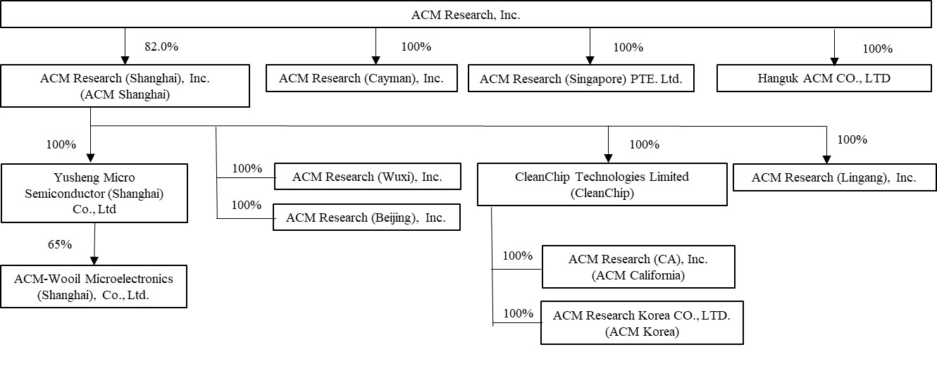
A detailed description of how cash is transferred through our organization is set forth under “Note 2 – Summary of Significant Accounting Policies – Cash and Cash Equivalents” to the Condensed Consolidated Financial Statements of this report.

The U.S. Holding Foreign Companies Accountable Act, or the HFCA Act, requires that the Public Company Accounting Oversight Board, or the PCAOB, determine whether it is unable to inspect or investigate completely registered public accounting firms located in a non-U.S. jurisdiction because of a position taken by one or more authorities in any non-U.S. jurisdiction. Under current regulations, if ACM Research were to be included on the SEC's "Conclusive list of issuers identified under the HFCA Act" for two consecutive years due to our independent auditor being located in a jurisdiction that does not allow for PCAOB inspections, the SEC would prohibit trading in our securities and this ultimately could cause our securities to be delisted in the U.S., and their value may significantly decline or become worthless. See “Item 1A. Risk Factors—Risks Related to International Aspects of Our Business—We could be adversely affected if we are unable to comply with legislation and regulations regarding improved access to audit and other information and audit inspections of accounting firms, including registered public accounting firms, such as our prior and current audit firms, operating in mainland China” in our Annual Report for more information.

In addition to the matters discussed above, we are also subject to a number of legal and operational risks associated with our corporate structure, including as the result of a substantial portion of our operations being conducted in mainland China. Consequences of any of those risks could result in a material adverse change in our operations or cause the value of ACM Research Class A common stock to significantly decline in value or become worthless. Please carefully read the information included in “Item 1A. Risk Factors” in our Annual Report, in particular the risk factors addressing the following issues:
•If any mainland China central government authority were to determine that existing mainland China laws or regulations require that ACM Shanghai obtain the authority’s permission or approval to continue the listing of ACM Research’s Class A common stock in the United States or if those existing mainland China laws and regulations, or interpretations thereof, were to change to require such permission or approval, or if we inadvertently conclude that permissions or approvals are not required, ACM Shanghai may be unable to obtain the required permission or approval or may only be able to obtain such permission or approval on terms and conditions that impose material new restrictions and limitations on operation of ACM Shanghai, either of which could have a material adverse effect on our business, financial condition, results of operations, reputation and prospects and on the trading price of ACM Research Class A common stock, which could decline in value or become worthless.
38
Table of Contents
•Mainland China central government authorities may intervene in, or influence, ACM Shanghai’s mainland China-based operations at any time, and those authorities’ rules and regulations in mainland China can change quickly with little or no advance notice.
•The mainland China central government may determine to exert additional control over offerings conducted overseas or foreign investment in mainland China-based issuers, which could result in a material change in operations of ACM Shanghai and cause significant declines in the value of ACM Research Class A common stock, or make them worthless.

Past statements and regulatory actions by mainland China central government authorities with respect to the use of VIEs and to data security and anti-monopoly concerns have not affected our ability to conduct our business operations in mainland China. For further information, see “Item 1A. Risk Factors —Risks Related to International Aspects of Our Business” in our Annual Report for more information.

Overview

We supply advanced, innovative capital equipment developed for the global semiconductor industry. Fabricators of advanced integrated circuits, or chips, can use our wet-cleaning and other front-end processing tools in numerous steps to improve product yield, even at increasingly advanced process nodes. We have designed these tools for use in fabricating foundry, logic and memory chips, including dynamic random-access memory, or DRAM, and 3D NAND-flash memory chips. We also develop, manufacture and sell a range of advanced packaging tools to wafer assembly and packaging customers.

Since 2009 we have delivered more than 1,025 tools to our customers, more than 840 of which were repeat orders or acceptances upon contractual performance obligations having been met and thereby generated revenue to us. The balance of the delivered tools is subject to the customer's acceptance of the tool upon the tool's satisfaction of applicable contractual requirements or subject to the customer's subsequent discretionary commitment to purchase the tool. To date, substantially all of our sales of equipment for semiconductor-manufacturing have been to customers located in Asia, and we anticipate that a substantial majority of our revenue from these products will continue to come from customers located in this region for the foreseeable future. We have begun to add to our efforts to further address customers in North America, Western Europe and Southeast Asia, by expanding our direct sales teams and increasing our global marketing activities.

Recent Developments
ACM Shanghai Dividend

During the three months ended September 30, 2024, ACM Research's principal operating subsidiary, ACM Shanghai (SSEC: 688082.SS), paid a cash dividend for an aggregate total of approximately RMB 273.2 million ($38.4 million) to the stockholders of ACM Shanghai, including ACM Research, which owns 82.0% of the outstanding shares of ACM Shanghai. ACM Research intends to use the net proceeds for working capital and general corporate purposes.
ACM Shanghai Proposed Private Offering

In January 2024, ACM Research announced ACM Shanghai's intended plan to offer up to 43.6 million of its ordinary shares, subject to market conditions, the approval of ACM Shanghai’s stockholders, completion of the review process by the Shanghai Stock Exchange, completion of the registration process by the China Securities Regulatory Commission, and other factors, in a private offering to qualified buyers, in compliance with the requirements of the China Securities Regulatory Commission, which would constitute up to 10% of ACM Shanghai’s share capital prior to the transaction (the “Private Offering”).

ACM Research estimates that if consummated in full, the proposed Private Offering would generate gross proceeds of up to RMB 4.5 billion ($642.2 million) to ACM Shanghai, whose management would have broad discretion over the use of such proceeds. It is unlikely that any of such proceeds would be distributed to ACM Research. ACM Research's equity interest in ACM Shanghai, if the proposed Private Offering is consummated in full, would decline from 82.0% to approximately 74.6%. As of September 30, 2024 and the date of this report, the proposed Private Offering has not been completed.
39
Table of Contents

Oregon Clean Room Purchase

On July 30, 2024, ACM Research entered into an agreement to acquire a commercial facility, comprised of 39,500 square foot total floor space and which includes a 5,200 square foot functional clean room, for a price of $7.75 million. This facility is located in the City of Hillsboro in Oregon, and is intended to further expand ACM’s R&D and demonstration capability in the U.S. market. The purchase was completed on October 1, 2024.

Mainland China Government Research and Development Funding

Since 2008, ACM Shanghai has received various government grants for the development and commercialization of certain technologies, and the development of the R&D and production center in the Lingang Special Area of Shanghai (note 13). The governmental grants contain certain operating conditions, in some cases require us to also invest certain amounts, and are subject to a government due-diligence review process upon completion of the project. The grants are recorded as long-term liabilities upon receipt, although we are not required to return any funds. Other subsidies are the subsidies received from government without further performance obligation.
Grant amounts are recognized in our statements of comprehensive income as follows:
•Government subsidies are recorded as reductions of current expenses in the periods in which the qualified expenses are incurred. For the nine months ended September 30, 2024 and 2023, government subsidies recognized as reductions of relevant expenses in the condensed consolidated statements of comprehensive income were $0.7 million and $1.5 million, respectively.
•Other subsidies are recorded as other income in the periods as incurred. For the nine months ended September 30, 2024 and 2023, related government subsidies recognized as other income in the condensed consolidated statements of comprehensive income were $1.9 million and $0.4 million, respectively.

Net Income Attributable to Non-Controlling Interests
In 2019 ACM Shanghai sold a total number of shares representing 8.3% of its outstanding ACM Shanghai shares, after which ACM Research held the remaining 91.7% of ACM Shanghai’s outstanding shares. In 2021 ACM Shanghai sold a total number of shares representing an additional 10% of its outstanding ACM Shanghai shares in its STAR IPO, after which ACM Research held the remaining 82.5% of ACM Shanghai’s outstanding shares. However, in May 2023, ACM Research's ownership declined to 82.1% due to the exercise of 2,150,309 stock options related to ACM Shanghai shares. In June 2024, ACM Research's ownership further declined to 82.0% due to the exercise of 446,154 stock options related to ACM Shanghai shares. As a result, we reflect the portion of our net income allocable to the minority holders of ACM Shanghai shares as net income attributable to non-controlling interests.

Critical Accounting Policies and Estimates

In preparing our condensed consolidated financial statements in conformity with GAAP, we make assumptions, judgments and estimates in applying our accounting policies that can have a significant impact on our revenue, operating income and net income, as well as on the value of certain assets and liabilities on our condensed consolidated balance sheets. We base our assumptions, judgments and estimates on historical experience and various other factors that we believe to be reasonable under the circumstances. At least quarterly, we evaluate our assumptions, judgments and estimates and make changes as deemed necessary. Actual results could differ materially from these estimates under different assumptions or conditions.

We believe that the assumptions, judgments and estimates involved in the accounting for the following accounting policies have the greatest potential impact on our condensed consolidated financial statements, and we therefore consider these to be our critical accounting estimates. For information on our significant accounting policies, see Note 2 in the notes to condensed consolidated financial statements in Part I, Item 1 of this report and in the Notes to Condensed Consolidated Financial Statements in Part II, Item 8 of our Annual Report, describe the significant accounting policies and methods used in the preparation of the Company’s condensed consolidated financial statements. There have been no material changes to the Company’s critical accounting estimates included in our Annual Report.

40
Table of Contents
Recent Accounting Pronouncements
A discussion of recent accounting pronouncements is included in our Annual Report and is updated in Note 2 to the condensed consolidated financial statements included in this report.

Results of Operations
The following table sets forth our results of operations for the periods presented, as percentages of revenue.
 |  |  | Three Months Ended September 30, |  |  |  |  |  |  |  |  |  |  |  | Nine Months Ended September 30,
 |  |  | 2024 |  |  |  |  |  | 2023 |  |  |  |  |  | 2024 |  |  |  |  |  | 2023
Revenue |  |  | 100.0 |  | % |  |  |  | 100.0 |  | % |  |  |  | 100.0 |  | % |  |  |  | 100.0 |  | %
Cost of revenue |  |  | 48.6 |  |  |  |  |  | 47.5 |  |  |  |  |  | 49.7 |  |  |  |  |  | 49.1
Gross margin |  |  | 51.4 |  |  |  |  |  | 52.5 |  |  |  |  |  | 50.3 |  |  |  |  |  | 50.9
Operating expenses:
Sales and marketing |  |  | 7.7 |  |  |  |  |  | 10.0 |  |  |  |  |  | 8.4 |  |  |  |  |  | 9.7
Research and development |  |  | 13.6 |  |  |  |  |  | 15.5 |  |  |  |  |  | 13.9 |  |  |  |  |  | 15.6
General and administrative |  |  | 8.4 |  |  |  |  |  | 7.3 |  |  |  |  |  | 8.8 |  |  |  |  |  | 6.9
Total operating expenses |  |  | 29.7 |  |  |  |  |  | 32.8 |  |  |  |  |  | 31.1 |  |  |  |  |  | 32.2
Income from operations |  |  | 21.7 |  |  |  |  |  | 19.7 |  |  |  |  |  | 19.2 |  |  |  |  |  | 18.7
Interest income, net |  |  | 0.9 |  |  |  |  |  | 0.9 |  |  |  |  |  | 0.8 |  |  |  |  |  | 1.1
Realized gain from sale of short-term investments |  |  | 0.1 |  |  |  |  |  | 0.4 |  |  |  |  |  | 0.1 |  |  |  |  |  | 2.2
Unrealized gain (loss) on short-term investments |  |  | 0.2 |  |  |  |  |  | -0.8 |  |  |  |  |  | -0.2 |  |  |  |  |  | -1.1
Other income, net |  |  | -2.5 |  |  |  |  |  | -1.3 |  |  |  |  |  | -0.1 |  |  |  |  |  | 0.0
Income (loss) from equity method investments |  |  | 0.6 |  |  |  |  |  | -0.1 |  |  |  |  |  | 0.0 |  |  |  |  |  | 1.0
Income before income taxes |  |  | 21.0 |  |  |  |  |  | 18.8 |  |  |  |  |  | 19.8 |  |  |  |  |  | 21.9
Income tax expense |  |  | -2.0 |  |  |  |  |  | -0.4 |  |  |  |  |  | -3.2 |  |  |  |  |  | -2.9
Net income |  |  | 19.0 |  |  |  |  |  | 18.4 |  |  |  |  |  | 16.6 |  |  |  |  |  | 19.0
Less: Net income attributable to non-controlling interests |  |  | 3.8 |  |  |  |  |  | 3.2 |  |  |  |  |  | 3.5 |  |  |  |  |  | 3.6
Net income attributable to ACM Research, Inc. |  |  | 15.2 |  | % |  |  |  | 15.2 |  | % |  |  |  | 13.1 |  | % |  |  |  | 15.4 |  | %
41
Table of Contents
Comparison of Three Months Ended September 30, 2024 and 2023
Revenue
 |  |  | Three Months Ended September 30,
 |  |  | 2024 |  |  |  |  |  | 2023 |  |  |  |  |  | % Change  2024 v 2023 |  |  |  |  |  | Absolute Change  2024 v 2023
 |  |  | (in thousands)
Single wafer cleaning, Tahoe and semi-critical cleaning equipment |  |  | $ | 160,985 |  |  |  |  | $ | 132,417 |  |  |  |  | 21.6 |  | % |  |  |  | $ | 28,568
ECP (front-end and packaging), furnace and other technologies |  |  | 34,600 |  |  |  |  |  | 25,508 |  |  |  |  |  | 35.6 |  | % |  |  |  | 9,092
Advanced packaging (excluding ECP), services & spares |  |  | 8,391 |  |  |  |  |  | 10,644 |  |  |  |  |  | (21.2) |  | % |  |  |  | (2,253)
Total Revenue by Product Category |  |  | $ | 203,976 |  |  |  |  | $ | 168,569 |  |  |  |  | 21.0 |  | % |  |  |  | $ | 35,407
The increase in revenue for three months ended September 30, 2024 as compared to the same period in 2023 reflects higher sales of single wafer cleaning, Tahoe and semi-critical cleaning equipment, and ECP (front-end and packaging), furnace and other technologies, partly offset by lower Advanced packaging (excluding ECP), services and spares. The increased demand is due in part to a longer term commitment by our mainland China-based customers to increase production capacity to achieve a greater share of the global semiconductor market.
Cost of Revenue and Gross Margin
 |  |  | Three Months Ended September 30,
 |  |  | 2024 |  |  |  |  |  | 2023 |  |  |  |  |  | % Change  2024 v 2023 |  |  |  |  |  | Absolute Change  2024 v 2023
Cost of revenue |  |  | $ | 99,142 |  |  |  |  | $ | 80,055 |  |  |  |  | 23.8 |  | % |  |  |  | $ | 19,087
Gross profit |  |  | 104,834 |  |  |  |  |  | 88,514 |  |  |  |  |  | 18.4 |  | % |  |  |  | 16,320
Gross margin |  |  | 51.4 |  | % |  |  |  | 52.5 |  | % |  |  |  | (1.1) |  | % |  |  |  | (111)bps
Cost of revenue and gross profit increased in the three months ended September 30, 2024 as compared to the corresponding period in 2023 due to the increased sales volume, partly offset by a slight decrease in gross margin. The decrease in gross margin versus the prior-year period was primarily due to revenue mix between product categories, net of a favorable impact from fluctuations in the RMB to U.S. dollar exchange rate. Gross margin may vary from period to period, primarily related to the level of utilization and the timing and mix of revenue. We expect gross margin to be between 40.0% and 45.0% for the foreseeable future, with direct manufacturing costs approximating 50.0% to 55.0% of revenue and overhead costs totaling 5.0% of revenue.
42
Table of Contents
Operating Expenses
 |  |  | Three Months Ended September 30,
 |  |  | 2024 |  |  |  |  |  | 2023 |  |  |  |  |  | % Change  2024 v 2023 |  |  |  |  |  | Absolute Change  2024 v 2023
 |  |  | (in thousands)
Sales and marketing expense |  |  | $ | 15,759 |  |  |  |  | $ | 16,803 |  |  |  |  | (6.2) |  | % |  |  |  | $ | (1,044)
Research and development expense |  |  | 27,837 |  |  |  |  |  | 26,151 |  |  |  |  |  | 6.4 |  | % |  |  |  | 1,686
General and administrative expense |  |  | 17,054 |  |  |  |  |  | 12,387 |  |  |  |  |  | 37.7 |  | % |  |  |  | 4,667
Total operating expenses |  |  | $ | 60,650 |  |  |  |  | $ | 55,341 |  |  |  |  | 9.6 |  | % |  |  |  | $ | 5,309

Sales and marketing expense decreased in the three months ended September 30, 2024 as compared to the corresponding period in 2023, reflecting a net decrease of $1.1 million due to costs for personnel, commissions, travel & entertainment, outside service, professional services, and other expenses, offset by a $0.1 million increase in stock-based compensation.

Sales and marketing expense consists primarily of:
•compensation of personnel associated with pre-sale and after-sale services and support and other sales and marketing activities, including stock-based compensation;
•sales commissions paid to independent sales representatives;
•fees paid to sales consultants;
•cost of trade shows;
•costs of tools built for promotional purposes for potential new customers;
•travel and entertainment; and
•allocated overhead for rent and utilities.
We expect that, for the foreseeable future, sales and marketing expenses will increase in dollars, as we incur additional costs associated with growing our customer base in mainland China and regions outside of mainland China.
Research and development expense increased in the three months ended September 30, 2024 as compared to the corresponding period in 2023, reflecting an increase of $2.7 million R&D-related personnel and other costs, and $0.1 million in depreciation, outside services and other R&D-related costs, offset by a $1.1 million decrease in costs of components for tools built for product development purposes.
Research and development expense represented 13.6% and 15.5% of our revenue in the three months ended September 30, 2024 and 2023, respectively. Without reduction by grant amounts received from mainland China governmental authorities (see ‘–Mainland China Government Research and Development Funding’’), gross research and development expense totaled $27.9 million, or 13.7% of total revenue, in the three months ended September 30, 2024 as compared to $26.4 million, or 15.7% of revenue, in the corresponding period in 2023.
Research and development expense consists primarily of:
•compensation of personnel associated with our research and development activities, including stock based compensation;
•costs of components and other research and development supplies;
•costs of tools built for product development purposes;
•travel expense associated with the research of technical requirements for product development purposes and testing of concepts under consideration;
•amortization of costs of software used for research and development purposes; and
•allocated overhead for rent and utilities.

We expect that, for the foreseeable future, research and development expenses will increase in dollars, as we incur additional costs to expand our product portfolio to address additional production steps and expand our research and development team to new regions.
43
Table of Contents

General and administrative expense increased in the three months ended September 30, 2024 as compared to the corresponding period in 2023, primarily reflecting a $1.4 million increase in stock based compensation, and a $2.7 million increase in allowance for credit losses, and a $0.6 million increase in personnel and other costs related to general and administrative costs.

General and administrative expense consists primarily of:
•compensation of executive, accounting and finance, human resources, information technology, and other administrative personnel, including stock-based compensation;
•professional fees, including accounting and corporate legal and defense fees;
•other corporate expenses including insurance;
•allowance for credit losses; and
•allocated overhead for rent and utilities.
We expect that, for the foreseeable future, general and administrative expenses will increase in dollars, as we incur additional costs associated with growing our business, operating ACM Research, as a public company in the United States and operating ACM Shanghai as a public company in mainland China.
Interest income, net, Other expense, net
 |  |  | Three Months Ended September 30,
 |  |  | 2024 |  |  |  |  |  | 2023 |  |  |  |  |  | % Change  2024 v 2023 |  |  |  |  |  | Absolute Change  2024 v 2023
 |  |  | (in thousands)
Interest income |  |  | $ | 2,967 |  |  |  |  | $ | 2,152 |  |  |  |  | 37.9 |  | % |  |  |  | $ | 815
Interest expense |  |  | (1,208) |  |  |  |  |  | (640) |  |  |  |  |  | 88.8 |  | % |  |  |  | (568)
Interest income, net |  |  | $ | 1,759 |  |  |  |  | $ | 1,512 |  |  |  |  | 16.3 |  | % |  |  |  | $ | 247
Other expense, net |  |  | $ | (5,164) |  |  |  |  | $ | (2,150) |  |  |  |  | 140.2 |  | % |  |  |  | $ | (3,014)

Interest income (expense), net consists of interest earned on our cash and cash equivalents, restricted cash accounts, and short-term and long-term time deposits, offset by interest expense incurred from outstanding short-term and long-term borrowings. Interest income (expense), net increased in the three months ended September 30, 2024 as compared to the corresponding period in 2023, as a result of changes in balances of cash, cash equivalents, time deposits, and debt, together with changes in interest rates earned or expensed on the respective balances.
Other expense, net primarily reflects (a) loss recognized from the impact of exchange rates on our working-capital which was $(5.4) million for the three months ended September 30, 2024 compared to $(1.7) million loss recognized from the impact of exchange rates on our working capital for the three months ended September 30, 2023, (b) government subsidies, as described under “—Mainland China Government Research and Development Funding” above, and other factors.
44
Table of Contents
Realized gain and unrealized loss from short-term investment, and income (loss) from equity investments.
 |  |  | Three Months Ended September 30,
 |  |  | 2024 |  |  |  |  |  | 2023 |  |  |  |  |  | % Change  2024 v 2023 |  |  |  |  |  | Absolute Change  2024 v 2023
 |  |  | (in thousands)
Realized gain from sale of short term investments |  |  | $ | 171 |  |  |  |  | $ | 656 |  |  |  |  | (73.9) |  | % |  |  |  | $ | (485)
Unrealized gain (loss) on short term investments |  |  | 413 |  |  |  |  |  | (1,319) |  |  |  |  |  | (131.3) |  | % |  |  |  | $ | 1,732
Income (loss) from equity method investments |  |  | $ | 1,316 |  |  |  |  | $ | (160) |  |  |  |  | (922.5) |  | % |  |  |  | $ | 1,476
We recorded a realized gain from sale of short term investments of $0.2 million for the three months ended September 30, 2024 as compared to $0.7 million in the prior-year period due to a sale of short-term investments (note 15).
We recorded an unrealized gain on short term investments of $0.4 million for the three months ended September 30, 2024 as compared to an unrealized loss of $1.3 million for the same period in 2023, based on a change in market value of ACM Shanghai’s short-term investments (note 15).
Income from equity investments was $1.3 million for the three months ended September 30, 2024 as compared to loss from equity method investments of $0.2 million in the same period in 2023 due to an increase of net income from investments in affiliates (note 14).
Income Tax Expense
The following presents components of income tax expense for the indicated periods:
 |  |  | Three Months Ended September 30,
 |  |  | 2024 |  |  |  |  |  | 2023
 |  |  | (in thousands)
Total income tax expense |  |  | $ | (4,007) |  |  |  |  | $ | (718)

We recognized a tax expense of $4.0 million for the three months ended September 30, 2024 as compared to a tax expense of $0.7 million for the prior year period. The tax expense for the three months ended September 30, 2024 primarily resulted from the tax effect of an increase in our effective income tax rate applied to an increase in operating profit for the period. The increase in our effective income tax rate for the three months ended September 30, 2023 compared to the same period of the prior year was primarily due to an increase in capitalized R&D expenses in certain foreign jurisdictions.

Our effective tax rate differs from statutory rates of 21% for U.S. federal income tax purposes and 12.5% to 25% for mainland China income tax purposes due to the effects of the valuation allowance and certain permanent differences as it pertains to book-tax differences in the treatment of stock-based compensation and non-U.S. research expenses. Our four mainland China subsidiaries, ACM Shanghai, ACM Wuxi, ACM Beijing, and ACM Lingang, are liable for mainland China corporate income taxes at the rates of 15%, 25%, 25%, and 15%, respectively. Pursuant to the Corporate Income Tax Law of mainland China, our mainland China subsidiaries generally would be liable for mainland China corporate income taxes at a rate of 25%. According to Guoshuihan 2009 No. 203, an entity certified as an “advanced and new technology enterprise” is entitled to a preferential income tax rate of 15%. ACM Shanghai was certified as an “advanced and new technology enterprise” in 2012 and again in 2016, 2018, and 2021, with an effective period of three years, and is expected to be re-certified for future years in 2024. In 2021, ACM Shanghai was certified as an eligible integrated circuit production enterprise and was entitled to a preferential income tax rate of 12.5% from January 1, 2020 to December 31, 2022. Certain entities which meet requirements according to the Policy of the Lingang New area in China (Shanghai) Pilot Free Trade Zone are entitled to a preferential income tax rate of 15%. ACM Lingang was certified for this in 2021, and this
45
Table of Contents
preferential income tax rate is valid from January 1, 2020 until December 31, 2024. We file income tax returns in the United States and state and foreign jurisdictions.

All tax returns will remain open for examination by the federal and state authorities for three and four years, respectively, from the date of utilization of any net operating loss or credits. Certain tax years are subject to foreign income tax examinations by tax authorities until the statute of limitations expire.
Net Income Attributable to Non-Controlling Interests
 |  |  | Three Months Ended September 30,
 |  |  | 2024 |  |  |  |  |  | 2023 |  |  |  |  |  | % Change  2024 v 2023 |  |  |  |  |  | Absolute Change  2024 v 2023
 |  |  | (in thousands)
Net income attributable to non-controlling interests |  |  | $ | 7,768 |  |  |  |  | $ | 5,315 |  |  |  |  | 46.2 |  | % |  |  |  | $ | 2,453
ACM Research owns 82.0% of ACM Shanghai’s (note 1) outstanding shares which is reflected in our condensed consolidated financial statements. We reflect the portion of net income allocable to the minority holders of ACM Shanghai shares as net income attributable to non-controlling interests.
Foreign currency translation adjustment
 |  |  | Three Months Ended September 30,
 |  |  | 2024 |  |  |  |  |  | 2023 |  |  |  |  |  | % Change  2024 v 2023 |  |  |  |  |  | Absolute Change  2024 v 2023
 |  |  | (in thousands)
Foreign currency translation adjustment |  |  | $ | 17,089 |  |  |  |  | $ | 4,015 |  |  |  |  | 325.6 |  | % |  |  |  | $ | 13,074
We recorded a gain of foreign currency translation adjustment of $17.1 million for the three months ended September 30, 2024, as compared to a gain of $4.0 million for the same period in 2023, primarily based on the net effect of RMB to dollar exchange rate fluctuations for the period on the converted value of ACM Shanghai’s RMB-denominated balances to U.S. dollar equivalents.

Comprehensive income attributable to non-controlling interests

 |  |  | Three Months Ended September 30,
 |  |  | 2024 |  |  |  |  |  | 2023 |  |  |  |  |  | % Change  2024 v 2023 |  |  |  |  |  | Absolute Change  2024 v 2023
 |  |  | (in thousands)
Comprehensive income attributable to non-controlling interests |  |  | $ | 10,842 |  |  |  |  | $ | 7,768 |  |  |  |  | 39.6 |  | % |  |  |  | $ | 3,074

Comprehensive income attributable to non-controlling interests for the three months ended September 30, 2024 increased by $3.1 million as compared to the same period in 2023, reflecting a change in net income attributable to the non-
46
Table of Contents
controlling interests for the period together with the impact of foreign exchange rate fluctuations on the cumulative balance.
Comparison of Nine Months Ended September 30, 2024 and 2023
Revenue
 |  |  | Nine Months Ended September 30,
 |  |  | 2024 |  |  |  |  |  | 2023 |  |  |  |  |  | % Change  2024 v 2023 |  |  |  |  |  | Absolute Change  2024 v 2023
 |  |  | (in thousands)
Single wafer cleaning, Tahoe and semi-critical cleaning equipment |  |  | $ | 423,676 |  |  |  |  | $ | 281,559 |  |  |  |  | 50.5 |  | % |  |  |  | $ | 142,117
ECP (front-end and packaging), furnace and other technologies |  |  | 99,362 |  |  |  |  |  | 71,223 |  |  |  |  |  | 39.5 |  | % |  |  |  | 28,139
Advanced packaging (excluding ECP), services & spares |  |  | 35,609 |  |  |  |  |  | 34,620 |  |  |  |  |  | 2.9 |  | % |  |  |  | 989
Total Revenue by Product Category |  |  | $ | 558,647 |  |  |  |  | $ | 387,402 |  |  |  |  | 44.2 |  | % |  |  |  | $ | 171,245
The increase in revenue for nine months ended September 30, 2024 as compared to the same period in 2023 reflects higher sales of single wafer cleaning, Tahoe and semi-critical cleaning equipment, ECP (front-end and packaging), furnace and other technologies, and Advanced packaging (excluding ECP), services and spares. The increased demand from is due in part to a longer term commitment by our mainland China-based customers to increase production capacity to achieve a greater share of the global semiconductor market.
Cost of Revenue and Gross Margin
 |  |  | Nine Months Ended September 30,
 |  |  | 2024 |  |  |  |  |  | 2023 |  |  |  |  |  | % Change  2024 v 2023 |  |  |  |  |  | Absolute Change  2024 v 2023
 |  |  | (in thousands)
Cost of revenue |  |  | $ | 277,908 |  |  |  |  | $ | 190,263 |  |  |  |  | 46.1 |  | % |  |  |  | $ | 87,645
Gross profit |  |  | 280,739 |  |  |  |  |  | 197,139 |  |  |  |  |  | 42.4 |  | % |  |  |  | 83,600
Gross margin |  |  | 50.3 |  | % |  |  |  | 50.9 |  | % |  |  |  | (0.6) |  | % |  |  |  | (63)bps
Cost of revenue and gross profit increased in the nine months ended September 30, 2024 as compared to the corresponding period in 2023 due to the increased sales volume, offset by a slight decrease in gross margin. The decrease in gross margin
47
Table of Contents
versus the prior-year period was primarily due to revenue mix between product categories, net of a favorable impact from fluctuations in the RMB to U.S. dollar exchange rate.
Gross margin may vary from period to period, primarily related to the level of utilization and the timing and mix of revenue. We expect gross margin to be between 40.0% and 45.0% for the foreseeable future, with direct manufacturing costs approximating 50.0% to 55.0% of revenue and overhead costs totaling 5.0% of revenue.
Operating Expenses
 |  |  | Nine Months Ended September 30,
 |  |  | 2024 |  |  |  |  |  | 2023 |  |  |  |  |  | % Change  2024 v 2023 |  |  |  |  |  | Absolute Change  2024 v 2023
 |  |  | (in thousands)
Sales and marketing expense |  |  | $ | 47,067 |  |  |  |  | $ | 37,579 |  |  |  |  | 25.2 |  | % |  |  |  | $ | 9,488
Research and development expense |  |  | 77,723 |  |  |  |  |  | 60,244 |  |  |  |  |  | 29.0 |  | % |  |  |  | 17,479
General and administrative expense |  |  | 48,940 |  |  |  |  |  | 26,851 |  |  |  |  |  | 82.3 |  | % |  |  |  | 22,089
Total operating expenses |  |  | $ | 173,730 |  |  |  |  | $ | 124,674 |  |  |  |  | 39.3 |  | % |  |  |  | $ | 49,056
Sales and marketing expense increased in the nine months ended September 30, 2024 as compared to the corresponding period in 2023, reflecting an increase of $5.3 million in stock-based compensation, and a net increase of $4.2 million due to increased costs for personnel, commissions, travel & entertainment, professional services, office, outside service, and other expenses
We expect that, for the foreseeable future, sales and marketing expenses will increase in dollars, as we incur additional costs associated with growing our customer base in mainland China and regions outside of mainland China.
Research and development expense increased in the nine months ended September 30, 2024 as compared to the corresponding period in 2023, reflecting an increase of $7.3 million in stock-based compensation, $6.9 million in R&D-related personnel costs, $1.4 million in costs of components for tools built for product development purposes, and a $2.5 million increase in other R&D-related costs, depreciation and other expenses, offset by a $0.6 million decrease in outside services.
Research and development expense represented 13.9% and 15.6% of our revenue in the nine months ended September 30, 2024 and 2023, respectively. Without reduction by grant amounts received from mainland China governmental authorities (see ‘–Mainland China Government Research and Development Funding’’), gross research and development expense totaled $78.4 million, or 14.0% of total revenue, in the nine months ended September 30, 2024 as compared to $61.7 million, or 15.9% of revenue, in the corresponding period in 2023.
General and administrative expense increased in the nine months ended September 30, 2024 as compared to the corresponding period in 2023, primarily reflecting a $12.5 million increase in stock based compensation, a $4.1 million
48
Table of Contents
increase in allowance for credit losses, a $4.4 million increase other costs related to general and administrative activities, and a $1.1 million increase in personnel and professional services.
We expect that, for the foreseeable future, general and administrative expenses will increase in dollars, as we incur additional costs associated with growing our business, ACM Research operating a public company in the United States and ACM Shanghai operating as a public company in China.
Interest income, net, Other income (expense), net
 |  |  | Nine Months Ended September 30,
 |  |  | 2024 |  |  |  |  |  | 2023 |  |  |  |  |  | % Change  2024 v 2023 |  |  |  |  |  | Absolute Change  2024 v 2023
 |  |  | (in thousands)
Interest income |  |  | $ | 7,122 |  |  |  |  | $ | 6,283 |  |  |  |  | 13.4 |  | % |  |  |  | $ | 839
Interest expense |  |  | (2,923) |  |  |  |  |  | (1,984) |  |  |  |  |  | 47.3 |  | % |  |  |  | (939)
Interest income, net |  |  | $ | 4,199 |  |  |  |  | $ | 4,299 |  |  |  |  | -2.3 |  | % |  |  |  | $ | (100)
Other income (expense), net |  |  | $ | (727) |  |  |  |  | $ | 156 |  |  |  |  | -566.0 |  | % |  |  |  | $ | (883)
Interest income (expense), net consists of interest earned on our cash and cash equivalents, restricted cash accounts, and short-term and long-term time deposits, offset by interest expense incurred from outstanding short-term and long-term borrowings. Interest income (expense), net decreased in the nine months ended September 30, 2024 as compared to the corresponding period in 2023, as a result of changes in balances of cash, cash equivalents, time deposits, and debt, together with changes in interest rates earned or expensed on the respective balances.
Other income (expense), net primarily reflects (a) loss recognized from the impact of exchange rates on our working-capital which was $2.6 million for the nine months ended September 30, 2024 compared to less than $0.1 million recognized from the impact of exchange rates on our working capital for the nine months ended September 30, 2023, (b) government subsidies, as described under “—Mainland China Government Research and Development Funding” above, and other factors.
Realized gain and unrealized loss from short-term investment, and income (loss) from equity investments.
 |  |  | Nine Months Ended September 30,
 |  |  | 2024 |  |  |  |  |  | 2023 |  |  |  |  |  | % Change  2024 v 2023 |  |  |  |  |  | Absolute Change  2024 v 2023
 |  |  | (in thousands)
Realized gain from sale of short-term investments |  |  | $ | 444 |  |  |  |  | $ | 8,569 |  |  |  |  | (94.8) |  | % |  |  |  | $ | (8,125)
Unrealized loss on short-term investments |  |  | $ | (1,151) |  |  |  |  | $ | (4,428) |  |  |  |  | (74.0) |  | % |  |  |  | $ | 3,277
Gain from equity method investments |  |  | $ | 101 |  |  |  |  | $ | 3,728 |  |  |  |  | (97.3) |  | % |  |  |  | $ | (3,627)
We recorded a realized gain from sale of equity investment of $0.4 million for the nine months ended September 30, 2024 as compared to $8.6 million in the prior-year period due to a sale of short-term investments (note 15).
We recorded an unrealized loss on short-term investments of $1.2 million for the nine months ended September 30, 2024 as compared to an unrealized loss of $4.4 million for the same period in 2023, based on a change in market value of ACM Shanghai’s short-term investments (note 15).
49
Table of Contents
Gain from equity investments was $0.1 million for the nine months ended September 30, 2024 as compared to income from equity method investments of $3.7 million in the same period in 2023 due to a decrease of net income from investments in affiliates (note 14).
Income Tax Expense
The following presents components of income tax expense for the indicated periods:
 |  |  | Nine Months Ended September 30,
 |  |  | 2024 |  |  |  |  |  | 2023 |  |  |  |  |  | % Change  2024 v 2023 |  |  |  |  |  | Absolute Change  2024 v 2023
 |  |  | (in thousands)
Total income tax expense |  |  | $ | (17,712) |  |  |  |  | $ | (11,235) |  |  |  |  | 57.7 |  | % |  |  |  | $ | (6,477)

We recognized a tax expense of $17.7 million for the nine months ended September 30, 2024 as compared to a tax expense of $11.2 million for the prior year period. The tax expense for the nine months ended September 30, 2024 primarily resulted from the tax effect of an increase in our effective income tax rate applied to an increase in operating profit for the period. The increase in our effective income tax rate for the nine months ended September 30, 2024, compared to the same period of the prior year, was primarily due to a decrease in certain permanent deductions in certain foreign jurisdictions.
Net Income Attributable to Non-Controlling Interests
 |  |  | Nine Months Ended September 30,
 |  |  | 2024 |  |  |  |  |  | 2023 |  |  |  |  |  | % Change  2024 v 2023 |  |  |  |  |  | Absolute Change  2024 v 2023
 |  |  | (in thousands)
Net income attributable to non-controlling interests |  |  | $ | 19,616 |  |  |  |  | $ | 13,905 |  |  |  |  | 41.1 |  | % |  |  |  | $ | 5,711
ACM Research owns 82.0% of ACM Shanghai’s (note 1) outstanding shares which is reflected in our condensed consolidated financial statements. We reflect the portion of net income allocatable to the minority holders of ACM Shanghai shares as net income attributable to non-controlling interests.
Foreign currency translation adjustment
 |  |  | Nine Months Ended September 30,
 |  |  | 2024 |  |  |  |  |  | 2023 |  |  |  |  |  | % Change  2024 v 2023 |  |  |  |  |  | Absolute Change  2024 v 2023
 |  |  | (in thousands)
Foreign currency translation adjustment |  |  | $ | 10,376 |  |  |  |  | $ | (21,831) |  |  |  |  | (147.5) |  | % |  |  |  | $ | 32,207
We recorded a gain of foreign currency translation adjustment of $10.4 million for the nine months ended September 30, 2024, as compared to a loss of foreign currency translation adjustment of $(21.8 million) for the same period in 2023,
50
Table of Contents
primarily based on the net effect of RMB to dollar exchange rate fluctuations for the period on the converted value of ACM Shanghai’s RMB-denominated balances to U.S. dollar equivalents.

Comprehensive income attributable to non-controlling interests
 |  |  | Nine Months Ended September 30,
 |  |  | 2024 |  |  |  |  |  | 2023 |  |  |  |  |  | % Change  2024 v 2023 |  |  |  |  |  | Absolute Change  2024 v 2023
 |  |  | (in thousands)
Comprehensive income attributable to non-controlling interests |  |  | $ | 21,458 |  |  |  |  | $ | 11,882 |  |  |  |  | 80.6 |  | % |  |  |  | $ | 9,576
Comprehensive income attributable to non-controlling interests for the nine months ended September 30, 2024 increased as compared to the prior-year period, reflecting a change in net income attributable to the non-controlling interests for the period together with the impact of foreign exchange rate fluctuations on the cumulative balance.

Liquidity and Capital Resources

During the first nine months of 2024, we funded our technology development and operations principally through our beginning global cash balances, including the cash balances at ACM Shanghai, borrowings by ACM Shanghai from local financial institutions, and our loan from China CITIC Bank, and cash flow from operations.

Cash and cash equivalents, restricted cash, short-term time deposits and long-term time deposits were $369.1 million at September 30, 2024, compared to $304.5 million at December 31, 2023. The $64.6 million increase was primarily driven by $63.9 million of cash provided by operations, ($78.6 million), excluding the change in net cash related to time deposits, used in investing activities, $77.0 million net cash provided by financing activities, and a $2.3 million increase from the effect of exchange rate on cash, cash equivalents, restricted cash and non-cash items.
 |  |  | September 30,  2024 |  |  |  |  |  | December 31,  2023
 |  |  | (In thousands)
Cash and cash equivalents, restricted cash, and time deposits:
Cash and cash equivalents and restricted cash |  |  | $ | 335,254 |  |  |  |  | $ | 183,173
Short-term time deposits |  |  | 20,304 |  |  |  |  |  | 80,524
Long-term time deposits |  |  | 13,517 |  |  |  |  |  | 40,818
Total |  |  | $ | 369,075 |  |  |  |  | $ | 304,515
Our future working capital needs beyond the next twelve months will depend on many factors, including the rate of our business and revenue growth, the payment schedules of our customers, the timing and magnitude of our capital expenditures, and the timing of investment in our research and development as well as sales and marketing. We believe our existing cash and cash equivalents and short-term and long-term time deposits, our cash flow from operating activities, and bank borrowings by us and ACM Shanghai will be sufficient to meet our anticipated cash needs within our longer term planning horizon.
ACM Shanghai has historically participated in certain mainland China government-sponsored grant and subsidy programs, as described under “—Mainland China Government Research and Development Funding” and “—Contractual Obligations” and we expect that ACM Shanghai will continue to take advantage of these programs when they are available and fit with our business strategy. ACM Shanghai generally applies for these grants and subsidies through the applicable mainland China government agency’s defined processes. Periodically, the public relations department researches the availability of these grants and subsidies through mainland China government agencies with whom ACM Shanghai files business surveys and taxes. Management of ACM Shanghai then assesses which grants and subsidies for which ACM Shanghai may be eligible and submits the relevant application. The decision to award the grant to ACM Shanghai is made
51
Table of Contents
by the relevant mainland China government agencies based on suitability and the merits of the application. Neither ACM Research, nor ACM Shanghai or any of our other subsidiaries, has any direct relationship with any mainland China government agency, and our anticipated cash needs for the next twelve months neither anticipate, nor require, receipt of any mainland China government grants or subsidies.
To the extent our cash and cash equivalents, cash flow from operating activities and short-term bank borrowings are insufficient to fund our future activities in accordance with our strategic plan, we may determine to raise additional funds through public or private debt or equity financings or additional bank credit arrangements. We also may need to raise additional funds in the event we determine in the future to effect one or more acquisitions of businesses, technologies and products. If additional funding is necessary or desirable, we may not be able to obtain bank credit arrangements or to obtain an equity or debt financing on terms acceptable to us or at all.
Restrictions under mainland China laws and regulations as well as restrictions under ACM Shanghai’s bank loan agreements, may significantly restrict ACM Shanghai’s ability to transfer a portion of ACM Shanghai’s net assets to ACM Research, other subsidiaries of ACM Research and to holders of ACM Research Class A common stock. See “Item 1A. Risk Factors – Regulatory Risks – Mainland China's currency exchange control and government restrictions on investment repatriation may impact our ability to transfer funds outside of mainland China, which could materially and adversely affect our ability to grow, make investments or acquisitions that could benefit our business, otherwise fund and conduct our business, or pay dividends on our common stock” in our Annual Report.

For the nine months ended September 30, 2024 and 2023, with the exception of sales and services-related transfer-pricing payments in the ordinary course of business, and the dividend paid by ACM Shanghai to the stockholders of ACM Shanghai (including ACM Research), no transfers or distributions have been made between ACM Research, and its subsidiaries, including ACM Shanghai, or to holders of ACM Research Class A common stock.
Our cash and cash equivalents at September 30, 2024 were held for working capital purposes and other potential investments. ACM Shanghai, our only direct mainland China subsidiary, is, however, subject to mainland China restrictions on distributions to equity holders. The use of proceeds raised by the STAR Market IPO, without further approvals, are limited to specific usage. Our accounts receivable balance fluctuates from period to period, which affects our cash flow from operating activities. Fluctuations vary depending on cash collections, client mix, and the timing of shipment and acceptance of our tools.
ACM Research has never declared or paid cash dividends on our capital stock. AMC Research intends to retain all available funds and any future earnings to support the operation of and to finance the growth and development of our business and do not anticipate paying any cash dividends in the foreseeable future.
52
Table of Contents
Cash Flow Provided by Operating Activities. Net cash provided by operating activities of $63.8 million during the nine months ended September 30, 2024 consisted of:
 |  |  | Nine Months Ended September 30,
 |  |  | 2024 |  |  |  |  |  | 2023
 |  |  | (In thousands)
Net Income |  |  | $ | 92,163 |  |  |  |  | $ | 73,554
Non-cash operating lease cost |  |  | 2,848 |  |  |  |  |  | 2,639
Provision for inventory |  |  | 3,858 |  |  |  |  |  | 5,031
Provision for credit losses |  |  | 5,796 |  |  |  |  |  | 1,642
Depreciation and amortization |  |  | 7,073 |  |  |  |  |  | 6,021
Loss (gain) on disposals of property, plant and equipment |  |  | 1,063 |  |  |  |  |  | (2)
Realized gain on short-term investment |  |  | (444) |  |  |  |  |  | (8,569)
Income from equity method investments |  |  | (101) |  |  |  |  |  | (3,728)
Unrealized loss on short-term investments |  |  | 1,151 |  |  |  |  |  | 4,428
Deferred income taxes |  |  | 6,969 |  |  |  |  |  | (9,936)
Stock-based compensation |  |  | 40,792 |  |  |  |  |  | 14,666
Dividends from unconsolidated affiliates |  |  | 731 |  |  |  |  |  | 5,147
Net changes in operating assets and liabilities |  |  | (98,044) |  |  |  |  |  | (127,863)
Net cash flow provided by (used in) operating activities |  |  | 63,855 |  |  |  |  |  | (36,970)
Significant net changes in operating asset and liability accounts primarily include the following:
• uses of cash: an increase of accounts receivable of ($89.4 million) (note 4), an increase of inventories, net ($82.2 million) (note 5), and an increase in other receivables ($16.5 million), and a $6.0 million decrease in FIN-48 and operating lease liabilities, and
• sources of cash: a $32.8 million increase in customer advances, a $27.1 million increase in accounts payables, a $15.0 million increase in other payables and accrued expenses, a $9.6 million decrease in prepaid expenses, and a $6.5 million increase in deferred revenue.
Cash Flow Used in Investing Activities. Net cash used in investing activities, excluding the change in net cash related to time deposits, for the nine months ended September 30, 2024 was ($78.6 million), primarily consisting of ($73.0 million) for purchase of property, plant and equipment, and intangible assets, ($8.8 million) for purchase of short-term and long-term investments, offset by $3.2 million proceeds from sale of short-term investments.
Cash Flow Provided by Financing Activities. Net cash provided by financing activities for the nine months ended September 30, 2024 was $77.0 million, primarily consisting of $81.7 million proceeds from long-term borrowing (note 12), $32.8 million proceeds from short-term borrowing, and $6.5 million proceeds from exercise of stock options, offset by ($37.0 million) repayment of short-term and long-term borrowings and ($6.9 million) payment of ACM Shanghai dividend.
We and ACM Shanghai, together with the subsidiaries of ACM Shanghai, have short-term and long-term borrowings with the following banks:
53
Table of Contents
Lender |  |  |  |  |  | Agreement Date |  |  |  |  |  | Maturity Date |  |  |  |  |  | Annual  Interest Rate |  |  |  |  |  | Maximum Borrowing  Amount(1) |  |  |  |  |  | Amount Outstanding  at September 30, 2024
 |  |  |  |  |  |  |  |  |  |  |  |  |  |  |  |  |  |  |  |  |  |  |  | (in thousands)
China CITIC Bank (2) |  |  |  |  |  | July 2023 |  |  |  |  |  | Repayable by installments and the last installments repayable in December 2025 |  |  |  |  |  | 4.50% |  |  |  |  |  | RMB200,000 |  |  |  |  |  | RMB99,900
 |  |  |  |  |  |  |  |  |  |  |  |  |  |  |  |  |  |  |  |  |  |  |  | $ | 28,540 |  |  |  |  | $ | 14,256
China Everbright Bank |  |  |  |  |  | August 2024 |  |  |  |  |  | August 2027 |  |  |  |  |  | 2.60% |  |  |  |  |  | RMB400,000 |  |  |  |  |  | RMB349,189
 |  |  |  |  |  |  |  |  |  |  |  |  |  |  |  |  |  |  |  |  |  |  |  | $ | 57,080 |  |  |  |  | $ | 49,829
China Merchants Bank |  |  |  |  |  | August 2024 |  |  |  |  |  | August 2025 |  |  |  |  |  | 2.60% |  |  |  |  |  | RMB200,000 |  |  |  |  |  | RMB66,043
 |  |  |  |  |  |  |  |  |  |  |  |  |  |  |  |  |  |  |  |  |  |  |  | $ | 28,540 |  |  |  |  | $ | 9,424
Bank of China |  |  |  |  |  | September 2024 |  |  |  |  |  | September 2025 |  |  |  |  |  | 2.50%-2.75% |  |  |  |  |  | RMB400,000 |  |  |  |  |  | RMB364,233
 |  |  |  |  |  |  |  |  |  |  |  |  |  |  |  |  |  |  |  |  |  |  |  | $ | 57,080 |  |  |  |  | $ | 51,976
China Merchants Bank |  |  |  |  |  | August 2024 |  |  |  |  |  | August 2035 |  |  |  |  |  | NA |  |  |  |  |  | RMB1,000,000 |  |  |  |  |  | NIL
 |  |  |  |  |  |  |  |  |  |  |  |  |  |  |  |  |  |  |  |  |  |  |  | RMB142,700 |  |  |  |  |  | RMB—
China Merchants Bank |  |  |  |  |  | November 2020 |  |  |  |  |  | Repayable by installments and the last installments repayable in November 2030 |  |  |  |  |  | 3.65% |  |  |  |  |  | RMB128,500 |  |  |  |  |  | RMB85,641
 |  |  |  |  |  |  |  |  |  |  |  |  |  |  |  |  |  |  |  |  |  |  |  | $ | 18,337 |  |  |  |  | $ | 12,221
Agricultural Bank of China |  |  |  |  |  | June, 2024 |  |  |  |  |  | Repayable by installments and the last installments repayable in November 2034 |  |  |  |  |  | 2.78% |  |  |  |  |  | RMB300,000 |  |  |  |  |  | RMB19,418
 |  |  |  |  |  |  |  |  |  |  |  |  |  |  |  |  |  |  |  |  |  |  |  | $ | 42,810 |  |  |  |  | $ | 2,771
Bank of Shanghai |  |  |  |  |  | December 2022 |  |  |  |  |  | October 2024 |  |  |  |  |  | 2.85% |  |  |  |  |  | RMB100,000 |  |  |  |  |  | RMB100,071
 |  |  |  |  |  |  |  |  |  |  |  |  |  |  |  |  |  |  |  |  |  |  |  | $ | 14,270 |  |  |  |  | $ | 14,280
China CITIC Bank |  |  |  |  |  | August 2023 |  |  |  |  |  | Repayable by installments and the last installments repayable in August,2025 |  |  |  |  |  | 3.10% |  |  |  |  |  | RMB100,000 |  |  |  |  |  | RMB99,878
 |  |  |  |  |  |  |  |  |  |  |  |  |  |  |  |  |  |  |  |  |  |  |  | $ | 14,270 |  |  |  |  | $ | 14,253
Industrial Bank of Korea |  |  |  |  |  | December 2023 |  |  |  |  |  | December 2024 |  |  |  |  |  | 4.27% |  |  |  |  |  | KRW2,000,000 |  |  |  |  |  | KRW2,000,000
 |  |  |  |  |  |  |  |  |  |  |  |  |  |  |  |  |  |  |  |  |  |  |  | $ | 1,524 |  |  |  |  | $ | 1,524
 |  |  |  |  |  |  |  |  |  |  |  |  |  |  |  |  |  | Total |  |  |  |  |  | $ | 405,151 |  |  |  |  | $ | 170,534
(1)Converted from RMB to dollars as of September 30, 2024. The loan from China Merchants Bank is secured by a pledge of the property of ACM Lingang and guaranteed by ACM Shanghai, as described above under “—Contractual Obligations.”
54
Table of Contents
(2)This China CITIC bank facility agreement is with ACM Research, Inc.
Effect of exchange rate changes on cash, cash equivalents and restricted cash. The effect of exchange rate cash, and cash equivalents was $2.3 million during the first nine months ended September 30, 2024. The impact of fluctuations of the RMB to U.S. dollar currency exchange rate on a significant balance of these items held in RMB-denominated accounts (note 2) contributed to the change.

Contractual Obligations
Grant Contract for State-owned Construction Land Use Right in Shanghai City
In 2020 ACM Shanghai, through its wholly-owned subsidiary ACM Lingang, entered into a Grant Contract for State-owned Construction Land Use Right in Shanghai City (Category of R&D Headquarters and Industrial Projects), or the Grant Agreement, with the China (Shanghai) Pilot Free Trade Zone Lin-gang Special Area Administration, or the Grantor. ACM Lingang obtained rights to use approximately 43,000 square meters (10.6 acres) of land in the Lingang Heavy Equipment Industrial Zone of Lin-gang Special Area of China (Shanghai) Pilot Free Trade Zone, or the Land Use Right, for a period of fifty years, commencing on the date of delivery of the land in July 2020, which we refer to as the Delivery Date.
In exchange for its land use rights, ACM Lingang paid aggregate grant fees of RMB 61.7 million ($9.5 million), or the Grant Fees, and a performance deposit of RMB 12.3 million ($1.9 million), which is equal to 20% of the aggregate grant fees, to secure its achievement of the following performance milestones:
•the start of construction within 6 months after the Delivery Date (60% of the performance deposit), or Construction Start Milestone;
•the completion of construction within 30 months after the Delivery Date (20% of the performance deposit), or Construction Completion Milestone; and
•the start of production within 42 months after the Delivery Date (20% of the performance deposit), or Production Start Milestone.
Upon satisfaction of a milestone, the portion of the performance deposit attributable to that milestone will be repayable to ACM Lingang within ten business days. If the achievement of any of the above milestones is delayed or abandoned, ACM Lingang may be subject to additional penalties and may lose its rights to both the use of the granted land and any partially completed facilities on that land.
The status of the performance milestones for the period ended September 30, 2024 is as follows:
•ACM Lingang achieved the Construction Start Milestone and 60% of the performance deposit was refunded to ACM Shanghai in 2020.
•The Construction Completion Milestone was required to be met by January 9, 2024 but was not achieved. However, ACM Lingang believes it will receive the refund without penalty based on its explanation to the respective regulatory authorities of logistics-related delays and expectations that it will meet the milestone in 2024. We cannot guarantee that ACM Lingang will achieve the missed milestone in 2024, or even if it does achieve the milestone in 2024, that it will be refunded some or all of the 20% portion of the performance deposit of RMB 2.5 million ($0.4 million).
Contractual penalties in the case of a delay of Construction Completion Milestone:
◦If ACM Lingang fails to complete the construction pursuant to the date agreed under the Grant Agreement or any extended completion date approved by the Grantor, ACM Lingang shall pay 50% of the deposit for timely completion of construction as liquidated damages.
◦If ACM Lingang delays the completion for more than nine months beyond the date agreed under the Grant Agreement, or beyond any extended completion date approved by the Grantor, it shall pay the total deposit for timely completion of construction as liquidated damages.
◦If the delay is more than one year, the Grantor is entitled to terminate the Grant Agreement and take back the Land Use Right. In such case, the Grantor shall refund the Grant Fees for the remaining land use term after deducting the deposit agreed under the Grant Agreement and refund the deposit for timely commencement of production and relevant bank interests in full to ACM Lingang.
55
Table of Contents

•The Production Start Milestone is now required to be met by January 9, 2025. The Production Start Milestone was originally required to be met prior to January 9, 2024, but due to COVID-related delays, ACM filed multiple requests for extensions, the latest of which was granted on July 7, 2023. We cannot guarantee that ACM Lingang will meet any extended deadline or be refunded this 20% portion of the performance deposit.
Contractual penalties in the case of a delay of Production Start Milestone:
◦If ACM Lingang fails to commence production pursuant to the date agreed under the Grant Agreement or any extended commencement date approved by the Grantor, ACM Lingang shall pay the total deposit for timely commencement of production as liquidated damages;
◦If ACM Lingang fails to commence production pursuant to the extended commencement of production date (more than nine months beyond the extended production start milestone), the Grantor is entitled to terminate the Grant Agreement and take back the Land Use Right. In such case, the Grantor shall refund the Grant Fees for the remaining land use term after deducting the deposit agreed under the Grant Agreement to ACM Lingang.
In addition to the milestones, covenants in the Grant Agreement require that, among other things, ACM Lingang will be required to pay liquidated damages in the event that within seven years after the Delivery Date, or prior to July 9, 2027, it does not (i) generate a minimum specified amount of annual sales of products manufactured on the granted land or (ii) pay at least RMB 157.6 million ($22.2 million) in annual total taxes (including value-added taxes, corporate income tax, personal income taxes, urban maintenance and construction taxes, education surcharges, stamp taxes, and vehicle and shipping taxes) as a result of operations in connection with the granted land.
If the total tax revenue of the project fails to reach but is no less than 80% of the standard agreed under the Grant Agreement, ACM Lingang shall pay 20% of the actual shortfall amount of the tax revenue as liquidated damages. If the total tax revenue of the project fails to reach 80% of the standard agreed under the Grant Agreement within 1 month after the agreed date of reaching target production, the Grantor is entitled to terminate the Grant Agreement, take back the Land Use Right, and shall refund the Grant Fees for the remaining land use term to ACM Lingang.
If the Grant Agreement is terminated because of breach of any terms above, the Grantor shall take back the buildings, fixtures and auxiliary facilities on the land area and provide ACM Lingang with corresponding compensation according to the residual value of the buildings, fixtures and auxiliary facilities when they are taken back. The total cumulative investment of land, buildings and construction in progress related to ACM Lingang amounted to $153.5 million and $116.9 million at September 30, 2024 and December 31, 2023, respectively.

How We Evaluate Our Operations
We present information below with respect to four measures of financial performance:
•We define shipments of tools to include (a) a repeat shipment to a customer of a type of tool that the customer has previously accepted, for which we recognize revenue upon shipment or delivery, and (b) a first-time shipment of a first tool to a customer on an approval basis, for which we may recognize revenue in the future if contractual conditions are met, or if a purchase order is received.
•We define “adjusted EBITDA” as net income excluding interest expense (net), income tax benefit (expense), depreciation and amortization, unrealized (gain) loss on short-term investments, and stock-based compensation. We define adjusted EBITDA to also exclude restructuring costs, although we have not incurred any such costs to date.
•We define “free cash flow” as net cash provided by operating activities less purchases of property and equipment (net of proceeds from disposals) and purchase of short-term and long-term investments.
•We define “adjusted operating income (loss)” as our income (loss) from operations excluding stock-based compensation.
These financial measures are not based on any standardized methodologies prescribed by accounting principles generally accepted in the United States, or GAAP, and are not necessarily comparable to similarly titled measures presented by other companies.
56
Table of Contents
We have presented shipments, adjusted EBITDA, free cash flow and adjusted operating income (loss) because they are key measures used by our management and board of directors to understand and evaluate our operating performance, to establish budgets and to develop operational goals for managing our business. We believe that these financial measures help identify underlying trends in our business that could otherwise be masked by the effect of the expenses that we exclude. In particular, we believe that the exclusion of the expenses eliminated in calculating adjusted EBITDA and adjusted operating income (loss) can provide useful measures for period-to-period comparisons of our core operating performance and that the exclusion of property and equipment purchases from operating cash flow can provide a usual means to gauge our capability to generate cash. Accordingly, we believe that these financial measures provide useful information to investors and others in understanding and evaluating our operating results, enhancing the overall understanding of our past performance and future prospects, and allowing for greater transparency with respect to key financial metrics used by our management in its financial and operational decision-making.
Shipments, adjusted EBITDA, free cash flow and adjusted operating income (loss) are not prepared in accordance with GAAP, and should not be considered in isolation of, or as an alternative to, measures prepared in accordance with GAAP.
Shipments
We consider shipments a key operating metric as it reflects the total value of products delivered to customers and prospective customers by our productive assets.
Shipments consist of two components:
•a shipment to a customer of a type of tool that the customer has previously accepted, for which we recognize revenue when the tool is delivered; and
•a shipment to a customer of a type of tool that the customer is receiving and evaluating for the first time, in each case a first tool, for which we may recognize revenue at a later date, subject to the customer’s acceptance of the tool upon the tool’s satisfaction of applicable contractual requirements or subject to the customer’s subsequent discretionary commitment to purchase the tool.
First tool shipments can be made to either an existing customer that has not previously accepted that specific type of tool in the past ─ for example, a delivery of a SAPS V tool to a customer that previously had received only SAPS II tools ─ or to a new customer that has never purchased any tool from us.
Shipments in the nine months ended September 30, 2024 totaled $709.7 million, as compared to $456.1 million for the same periods in 2023. Repeat tool shipments in the nine months ended September 30, 2024 totaled $353.5 million, as compared to $232.1 million for same periods in 2023. First tool shipments in the nine months ended September 30, 2024 totaled $356.2 million, as compared to $224.0 million for the same periods in 2023.
The dollar amount attributed to a first tool shipment is equal to the consideration we expect to receive if any and all contractual requirements are satisfied and the customer accepts the tool, or if the customer subsequently determines in its discretion to purchase the tool. There are a number of limitations related to the use of shipments in evaluating our business, including that customers have significant, or in some cases total, discretion in determining whether to accept or purchase our tools after evaluation and their decision not to accept or purchase delivered tools is likely to result in our inability to recognize revenue from the delivered tools. “First tool” shipments reflect the value of incremental new products under evaluation delivered to our customers or prospective customers for a given period and is used as an internal key metric to reflect future potential revenue opportunity. The cumulative cost of “first tool” shipments under evaluation at customers which have not been accepted by the customer is carried at cost and reflected in finished goods inventory (see Note 5 to the condensed consolidated financial statements included in this report). “First tool” shipments exclude deliveries to customers for which ACM Research does not have a basis to expect future revenue.
Adjusted EBITDA
There are a number of limitations related to the use of adjusted EBITDA rather than net income (loss), which is the nearest GAAP equivalent. Some of these limitations are:
•adjusted EBITDA excludes depreciation and amortization and, although these are non-cash expenses, the assets being depreciated or amortized may have to be replaced in the future;
57
Table of Contents
•we exclude stock-based compensation expense from adjusted EBITDA and adjusted operating income (loss), although (a) it has been, and will continue to be for the foreseeable future, a significant recurring expense for our business and an important part of our compensation strategy and (b) if we did not pay out a portion of our compensation in the form of stock-based compensation, the cash salary expense included in operating expenses would be higher, which would affect our cash position;
•the expenses and other items that we exclude in our calculation of adjusted EBITDA may differ from the expenses and other items, if any, that other companies may exclude from adjusted EBITDA when they report their operating results;
•adjusted EBITDA does not reflect changes in, or cash requirements for, working capital needs;
•adjusted EBITDA does not reflect interest expense, or the requirements necessary to service interest or principal payments on debt;
•adjusted EBITDA does not reflect income tax expense (benefit) or the cash requirements to pay taxes;
•adjusted EBITDA does not reflect historical cash expenditures or future requirements for capital expenditures or contractual commitments; and
•adjusted EBITDA includes expense reductions and non-operating other income attributable to mainland China governmental grants, which may mask the effect of underlying developments in net income, including trends in current expenses and interest expense, and free cash flow includes mainland China governmental grants, the amount and timing of which can be difficult to predict and are outside our control.
The following table reconciles net income, the most directly comparable GAAP financial measure, to adjusted EBITDA:
 |  |  | Nine Months Ended September 30,
 |  |  | 2024 |  |  |  |  |  | 2023 |  |  |  |  |  | % Change  2024 v 2023 |  |  |  |  |  | Absolute Change  2024 v 2023
 |  |  | (in thousands)
Adjusted EBITDA Data:
Net Income |  |  | $ | 92,163 |  |  |  |  | $ | 73,554 |  |  |  |  | 25.3 |  | % |  |  |  | $ | 18,609
Interest expense (income), net |  |  | (4,199) |  |  |  |  |  | (4,299) |  |  |  |  |  | -2.3 |  | % |  |  |  | 100
Income tax expense |  |  | 17,712 |  |  |  |  |  | 11,235 |  |  |  |  |  | 57.7 |  | % |  |  |  | 6,477
Depreciation and amortization |  |  | 7,073 |  |  |  |  |  | 6,021 |  |  |  |  |  | 17.5 |  | % |  |  |  | 1,052
Stock based compensation |  |  | 40,792 |  |  |  |  |  | 14,666 |  |  |  |  |  | 178.1 |  | % |  |  |  | 26,126
Unrealized loss on short-term investments |  |  | 1,151 |  |  |  |  |  | 4,428 |  |  |  |  |  | -74.0 |  | % |  |  |  | (3,277)
Adjusted EBITDA |  |  | $ | 154,692 |  |  |  |  | $ | 105,605 |  |  |  |  | 46.5 |  | % |  |  |  | $ | 49,087

The increase in adjusted EBITDA for the nine months ended September 30, 2024 as compared to the same period in 2023 reflects a $18.6 million increase in net income, a $26.1 million increase in stock based compensation, a $1.1 million increase in depreciation and amortization, a $6.5 million impact from a change in income tax expense, offset by a $3.3 million decrease in unrealized loss on short-term investment, and other items.

We do not exclude from adjusted EBITDA expense reductions and non-operating other income attributable to mainland China governmental grants because we consider and incorporate the expected amounts and timing of those grants in incurring expenses and capital expenditures. If we did not receive the grants, our cash expenses therefore would be lower, and our cash position would not be affected, to the extent we have accurately anticipated the amounts of the grants. For additional information regarding our mainland China grants, please see “—Mainland China Government Research and Development Funding.”
58
Table of Contents
Free Cash Flow
The following table reconciles net cash provided by (used in) operating activities, the most directly comparable GAAP financial measure, to free cash flow:
 |  |  | Nine Months Ended September 30,
 |  |  | 2024 |  |  |  |  |  | 2023 |  |  |  |  |  | % Change  2024 v 2023 |  |  |  |  |  | Absolute Change  2024 v 2023
 |  |  | (in thousands)
Free Cash Flow Data:
Net cash provided by (used in) operating activities |  |  | $ | 63,855 |  |  |  |  | $ | (36,970) |  |  |  |  | (272.7 |  | %) |  |  |  | $ | 100,825
Purchase of property and equipment |  |  | (71,047) |  |  |  |  |  | (49,535) |  |  |  |  |  | 43.4 |  | % |  |  |  | (21,512)
Purchase of short-term and long-term investments |  |  | (8,769) |  |  |  |  |  | (6,488) |  |  |  |  |  | 35.2 |  | % |  |  |  | (2,281)
Free cash flow |  |  | $ | (15,961) |  |  |  |  | $ | (92,993) |  |  |  |  | (82.8 |  | %) |  |  |  | $ | 77,032
The improvement in free cash flow for the nine months ended September 30, 2024 as compared to the same period in 2023 reflected the factors driving net cash used in operating activities, an increase of purchases of property and equipment, and long-term investment. Consistent with our methodology for calculating adjusted EBITDA, we do not adjust free cash flow for the effects of mainland China government subsidies, because we take those subsidies into account in incurring expenses and capital expenditures. We do not adjust free cash flow for the effects of time-deposits, which for our internal purposes are considered as largely similar to cash.
Adjusted Operating Income
Adjusted operating income excludes stock-based compensation from income from operations. Although stock-based compensation is an important aspect of the compensation of our employees and executives, determining the fair value of certain of the stock-based instruments we utilize involves judgment and estimation and the expense recorded may bear little resemblance to the actual value realized upon the vesting or future exercise of the related stock-based awards. Furthermore, unlike cash compensation, the value of stock options, which is an element of our ongoing stock-based compensation expense, is determined using a complex formula that incorporates factors. Management believes it is useful to exclude stock-based compensation in order to better understand the long-term performance of our core business and to facilitate comparison of our results to those of peer companies. The use of non-GAAP financial measures excluding stock-based compensation has limitations, however. If we did not pay out a portion of our compensation in the form of stock-based compensation, the cash salary expense included in operating expenses would be higher and our cash holdings would be
59
Table of Contents
less. The following tables reflect the exclusion of stock-based compensation, or SBC, from line items comprising income from operations:
 |  |  | Nine Months Ended September 30,
 |  |  | 2024 |  |  |  |  |  |  |  |  |  |  |  |  |  |  |  |  |  | 2023
 |  |  | Actual  (GAAP) |  |  |  |  |  | SBC |  |  |  |  |  | Adjusted  (Non-  GAAP) |  |  |  |  |  | Actual  (GAAP) |  |  |  |  |  | SBC |  |  |  |  |  | Adjusted  (Non-GAAP)
 |  |  | (in thousands)
Revenue |  |  | $ | 558,647 |  |  |  |  | $ | - |  |  |  |  | $ | 558,647 |  |  |  |  | $ | 387,402 |  |  |  |  | $ | - |  |  |  |  | $ | 387,402
Cost of revenue |  |  | (277,908) |  |  |  |  |  | (2,020) |  |  |  |  |  | (275,888) |  |  |  |  |  | (190,263) |  |  |  |  |  | (838) |  |  |  |  |  | (189,425)
Gross profit |  |  | 280,739 |  |  |  |  |  | (2,020) |  |  |  |  |  | 282,759 |  |  |  |  |  | 197,139 |  |  |  |  |  | (838) |  |  |  |  |  | 197,977
Operating expenses:
Sales and marketing |  |  | (47,067) |  |  |  |  |  | (8,645) |  |  |  |  |  | (38,422) |  |  |  |  |  | (37,579) |  |  |  |  |  | (3,405) |  |  |  |  |  | (34,174)
Research and development |  |  | (77,723) |  |  |  |  |  | (12,082) |  |  |  |  |  | (65,641) |  |  |  |  |  | (60,244) |  |  |  |  |  | (4,831) |  |  |  |  |  | (55,413)
General and administrative |  |  | (48,940) |  |  |  |  |  | (18,045) |  |  |  |  |  | (30,895) |  |  |  |  |  | (26,851) |  |  |  |  |  | (5,592) |  |  |  |  |  | (21,259)
Income (loss) from operations |  |  | $ | 107,009 |  |  |  |  | $ | (40,792) |  |  |  |  | $ | 147,801 |  |  |  |  | $ | 72,465 |  |  |  |  | $ | (14,666) |  |  |  |  | $ | 87,131
Adjusted operating income for the nine months ended September 30, 2024 increased by $60.7 million, as compared with the same period in 2023, due to a $34.5 million increase in income from operations and a $26.1 million increase in stock-based compensation expense.

Item 3. Quantitative and Qualitative Disclosures About Market Risks
Our market risks and the ways we manage them are summarized in the section captioned “Part II, Item 7A. Quantitative and Qualitative Disclosures About Market Risk” in our Annual Report. There have been no material changes in the first nine months of 2024 to our market risks or to our management of such risks.

Item 4. Controls and Procedures

Evaluation of Disclosure Controls and Procedures

Our management, with the participation of our Chief Executive Officer and Chief Financial Officer, evaluated the effectiveness of our disclosure controls and procedures pursuant to Rule 13a-15 under the Securities Exchange Act of 1934, or the Exchange Act, as of September 30, 2024. In designing and evaluating the disclosure controls and procedures, our management recognizes that any controls and procedures, no matter how well designed and operated, can provide only reasonable assurance of achieving the desired control objectives. In addition, the design of disclosure controls and procedures must reflect the fact that there are resource constraints and that our management is required to apply its judgment in evaluating the benefits of possible controls and procedures relative to their costs.

Based on such evaluation, our Chief Executive Officer and Chief Financial Officer concluded that, as of September 30, 2024, our disclosure controls and procedures were effective to provide reasonable assurance that information we are required to disclose in reports that we file or submit under the Exchange Act is recorded, processed, summarized and reported within the time periods specified in the Securities and Exchange Commission rules and forms, and that such information is accumulated and communicated to our management, including our Chief Executive Officer and Chief Financial Officer, as appropriate, to allow timely decisions regarding required disclosure.

Changes in Internal Control Over Financial Reporting

There were no changes in our internal control over financial reporting that occurred during the quarter ended September 30, 2024, that have materially affected, or are reasonably likely to materially affect, our internal control over financial reporting.

PART II. OTHER INFORMATION

60
Table of Contents
Item 1. Legal Proceedings
From time to time, we may become involved in legal proceedings or may be subject to claims arising in the ordinary course of our business. Although the results of these proceedings and claims cannot be predicted with certainty, we currently believe that the final outcome of these ordinary course matters will not have a material adverse effect on our business, operating results, financial condition or cash flows. Regardless of the outcome, litigation can have an adverse impact on us because of defense and settlement costs, diversion of management resources and other factors.

Item 1A. Risk Factors
Except as set forth below, there were no material changes to the risk factors discussed in Item 1A. “Risk Factors” of Part I in our Annual Report. In addition to the other information set forth in this report, you should carefully consider those risk factors, which could materially affect our business, financial condition and future operating results. Those risk factors are not the only risks facing our company. Additional risks and uncertainties not currently known to us or that we currently deem to be immaterial also may have a material adverse effect on our business, financial condition and operating results.

Regulatory Risks

The U.S. Government will implement an outbound investment review mechanism in early 2025, which may prevent us from taking advantage of investment opportunities outside the United States that could otherwise be advantageous to our stockholders

On October 28, 2024, the Office of Investment Security of the U.S. Department of the Treasury issued a final rule to implement President Biden’s August 2023 Executive Order on Addressing United States Investments in Certain National Security Technologies and Products in Countries of Concern (the EO). The EO provided for the establishment of a new and targeted national security regulatory framework directed at controlling outbound investment from the United States in certain sensitive industry sectors in the People’s Republic of China (PRC) and the Special Administrative Regions of Hong Kong and Macau (collectively, China). This rule is scheduled to be effective January 2, 2025.

As implemented by the final rule, the new framework would impose notification requirements and prohibitions on specified investments by U.S. persons in the semiconductor and microelectronics sector, quantum information technologies, and artificial intelligence (AI) systems.

Within the semiconductor and microelectronics sector, prohibited investments will include certain covered investments in electronic design automation software; certain fabrication and advanced packaging tools; the design, fabrication, or packaging of certain advanced integrated circuits, and supercomputers. Notifiable investments will include any covered investments related to the design, fabrication, or packaging of integrated circuits not otherwise covered by the prohibition.

Given the breadth of the notification requirement as applicable within the semiconductor industry, we will likely be subject to increased regulatory burden to engage in certain investments in the PRC. Such a mechanism could negatively impact our ability to realize value from certain existing and future investments, including by limiting exit opportunities or causing us to favor buyers that may avoid complex notification requirements, even in circumstances where other buyers may offer better terms or more consideration. There can be no assurances that we will be able to maintain or proceed with investments on terms acceptable to us. It is possible that the outbound investment reporting requirements and prohibitions could adversely affect our business, financial condition, and operating results.

Item 2. Unregistered Sales of Equity Securities and Use of Proceeds

During the nine months ended September 30, 2024, ACM Research issued, pursuant to the exercise of stock options at a per share exercise price of $0.50 per share, an aggregate of 621,186 shares of Class A common stock that were not registered under the Securities Act of 1933, as amended. We believe the offer and sale of those shares were exempt from registration under the Securities Act of 1933, as amended, by virtue of Section 4(a)(2) thereof (or Regulation D promulgated thereunder) because they did not involve a public offering. The recipients of the shares acquired the securities for investment only and not with a view to or for sale in connection with any distribution thereof, and appropriate legends
61
Table of Contents
were recorded with respect to the shares. The recipients of the shares were accredited investors under Rule 501 of Regulation D.

Sale Date |  |  |  |  |  | Exercised Shares (Net)
January 3, 2024 |  |  |  |  |  |  |  |  | 27,033
March 1, 2024 |  |  |  |  |  |  |  |  | 34,434
March 1, 2024 |  |  |  |  |  |  |  |  | 177,089
March 5, 2024 |  |  |  |  |  |  |  |  | 9,843
March 5, 2024 |  |  |  |  |  |  |  |  | 27,341
May 3, 2024 |  |  |  |  |  |  |  |  | 27,253
May 14, 2024 |  |  |  |  |  |  |  |  | 176,090
May 14, 2024 |  |  |  |  |  |  |  |  | 34,239
July 2, 2024 |  |  |  |  |  |  |  |  | 27,178
July 8, 2024 |  |  |  |  |  |  |  |  | 19,582
August 14, 2024 |  |  |  |  |  |  |  |  | 34,097
September 3, 2024 |  |  |  |  |  |  |  |  | 27,007
Total |  |  |  |  |  |  |  |  | 621,186

Item 3. Defaults Upon Senior Securities

None

Item 4. Mine Safety Disclosures

None

Item 5. Other Information

On August 13, 2024, Sotheara Cheav, Senior Vice President, Manufacturing of ACM Shanghai, adopted a Rule 10b5-1 trading arrangement (the “Cheav Plan”) that is intended to satisfy the affirmative defense of Rule 10b5-1(c) of the Exchange Act. The Cheav Plan allows for the contemporaneous exercise of options and sale of up to 22,598 shares of Class A Common Stock, at specific market prices, commencing on November 13, 2024, and continuing until (i) all such options are exercised and the underlying shares are sold, (ii) March 31, 2025, or (iii) such date that the Cheav Plan is otherwise terminated according to its terms, whichever comes first.

On August 13, 2024, David Wang, President, Chief Executive Officer and a member of the Board of Directors of ACM Research, amended a prior Rule 10b5-1 trading arrangement which was entered into on May 14, 2024, and is considered to have terminated such prior Rule 10b5-1 trading arrangement and established a new Rule 10b5-1 trading arrangement (the “Wang Plan”). The Wang Plan allows for the contemporaneous exercise of options and sale of up to 300,000 shares of Class A Common Stock, at specific market prices, commencing on November 22, 2024, and continuing until (i) all such options are exercised and the underlying shares are sold, (ii) April 30, 2025, or (iii) such date that the Wang Plan is otherwise terminated according to its terms, whichever comes first.

62
Table of Contents
Item 6. Exhibits
The following exhibits are filed as part of this report:
Exhibit  No. |  |  |  |  |  | Description
10.01 |  |  |  |  |  | Signed Purchase and Sale Agreement and Receipt for Earnest Money, dated July 30, 2024, by and among ACM Research, Inc. and William R. O’Neill, Lynda E. O’Neill and Gordon A. Harris (incorporated herein by reference to Exhibit 10.01 to the Quarterly Report on Form 10-Q filed on August 7, 2024)
31.01 |  |  |  |  |  | Certification of Principal Executive Officer Pursuant to Rules 13a-14(a) and 15d-14(a) under the Securities Exchange Act of 1934, as Adopted Pursuant to Section 302 of the Sarbanes-Oxley Act of 2002
31.02 |  |  |  |  |  | Certification of Principal Financial Officer Pursuant to Rules 13a-14(a) and 15d-14(a) under the Securities Exchange Act of 1934, as Adopted Pursuant to Section 302 of the Sarbanes-Oxley Act of 2002
32.01 |  |  |  |  |  | Certification of Principal Executive Officer and Principal Financial Officer Pursuant to 18 U.S.C. Section 1350, as Adopted Pursuant to Section 906 of the Sarbanes-Oxley Act of 2002
101.INS |  |  |  |  |  | Inline XBRL Instance Document (the instance document does not appear in the Interactive Data File because its XBRL tags are embedded within the Inline XBRL document)
101.SCH |  |  |  |  |  | Inline XBRL Taxonomy Extension Schema Document
101.CAL |  |  |  |  |  | Inline XBRL Taxonomy Extension Calculation Linkbase Document
101.DEF |  |  |  |  |  | Inline XBRL Taxonomy Extension Definition Linkbase Document
101.LAB |  |  |  |  |  | Inline XBRL Taxonomy Extension Label Linkbase Document
101.PRE |  |  |  |  |  | Inline XBRL Taxonomy Extension Presentation Linkbase Document
104 |  |  |  |  |  | Cover Page Interactive Data File (formatted as inline XBRL and contained in exhibit 101)

63
Table of Contents
SIGNATURES
Pursuant to the requirements of the Securities Exchange Act of 1934, the registrant has duly caused this report to be signed on its behalf by the undersigned, thereunto duly authorized.
 |  |  | ACM RESEARCH, INC.
Date: November 7, 2024 |  |  | By: |  |  | /s/ Mark McKechnie
 |  |  |  |  |  | Mark McKechnie
Chief Financial Officer, Executive Vice President and
Treasurer
(Principal Financial Officer)
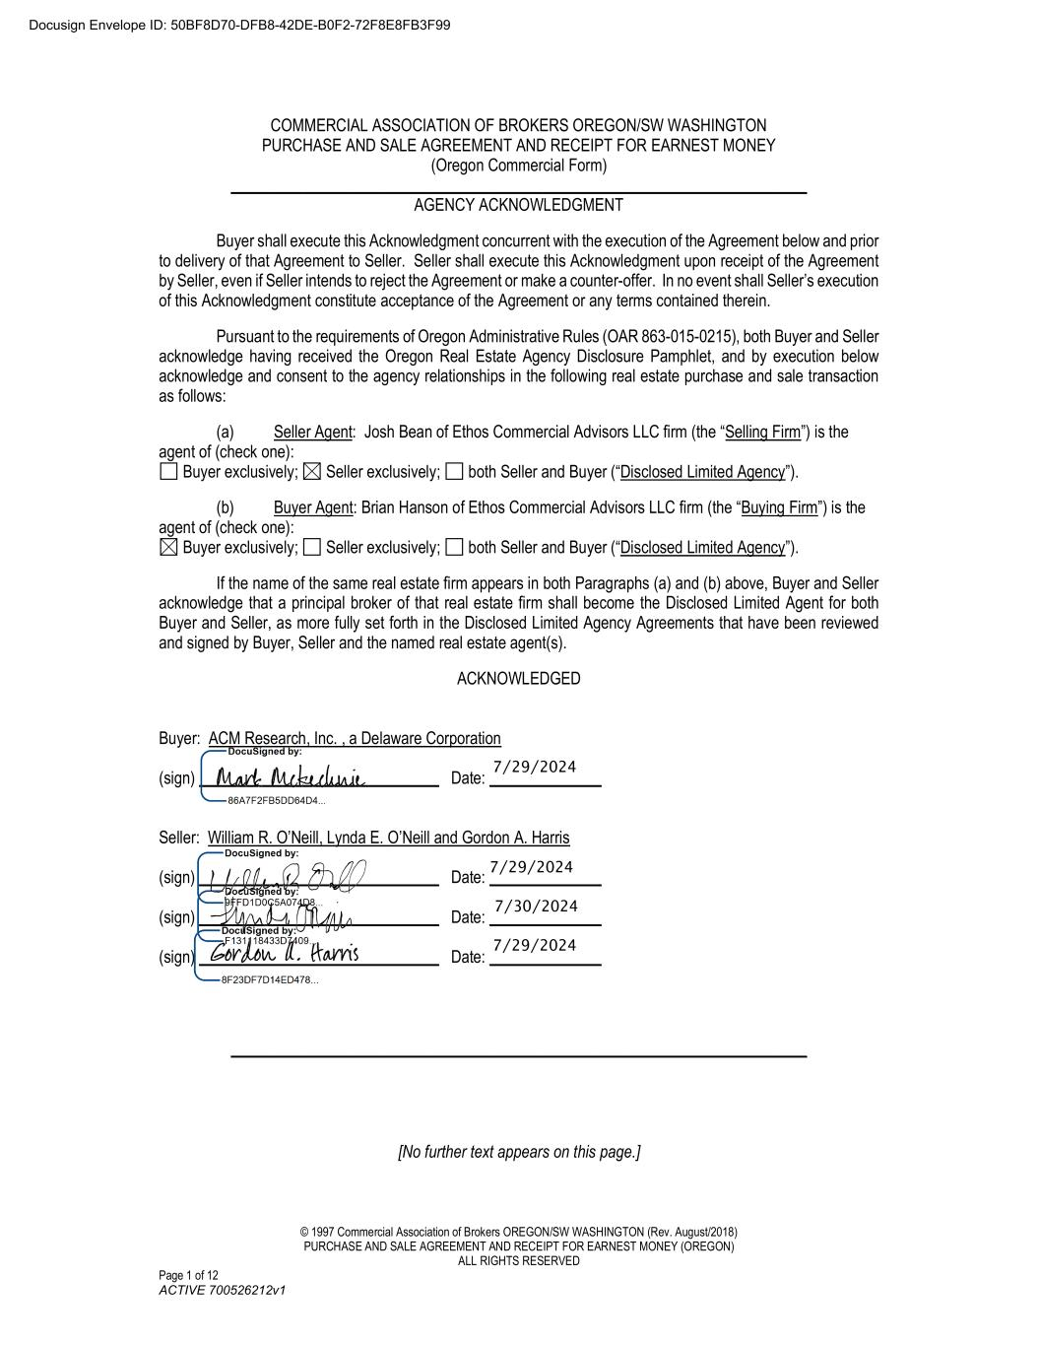
64
© 1997 Commercial Association of Brokers OREGON/SW WASHINGTON (Rev. August/2018) PURCHASE AND SALE AGREEMENT AND RECEIPT FOR EARNEST MONEY (OREGON) ALL RIGHTS RESERVED Page 1 of 12 ACTIVE 700526212v1 COMMERCIAL ASSOCIATION OF BROKERS OREGON/SW WASHINGTON PURCHASE AND SALE AGREEMENT AND RECEIPT FOR EARNEST MONEY (Oregon Commercial Form) ________________________________________________________________________ AGENCY ACKNOWLEDGMENT Buyer shall execute this Acknowledgment concurrent with the execution of the Agreement below and prior to delivery of that Agreement to Seller. Seller shall execute this Acknowledgment upon receipt of the Agreement by Seller, even if Seller intends to reject the Agreement or make a counter-offer. In no event shall Seller’s execution of this Acknowledgment constitute acceptance of the Agreement or any terms contained therein. Pursuant to the requirements of Oregon Administrative Rules (OAR 863-015-0215), both Buyer and Seller acknowledge having received the Oregon Real Estate Agency Disclosure Pamphlet, and by execution below acknowledge and consent to the agency relationships in the following real estate purchase and sale transaction as follows: (a) Seller Agent: Josh Bean of Ethos Commercial Advisors LLC firm (the “Selling Firm”) is the agent of (check one): Buyer exclusively; Seller exclusively; both Seller and Buyer (“Disclosed Limited Agency”). (b) Buyer Agent: Brian Hanson of Ethos Commercial Advisors LLC firm (the “Buying Firm”) is the agent of (check one): Buyer exclusively; Seller exclusively; both Seller and Buyer (“Disclosed Limited Agency”). If the name of the same real estate firm appears in both Paragraphs (a) and (b) above, Buyer and Seller acknowledge that a principal broker of that real estate firm shall become the Disclosed Limited Agent for both Buyer and Seller, as more fully set forth in the Disclosed Limited Agency Agreements that have been reviewed and signed by Buyer, Seller and the named real estate agent(s). ACKNOWLEDGED Buyer: ACM Research, Inc. , a Delaware Corporation (sign) ______________________________ Date: ______________ Seller: William R. O’Neill, Lynda E. O’Neill and Gordon A. Harris (sign) ______________________________ Date: ______________ (sign) ______________________________ Date: ______________ (sign) ______________________________ Date: ______________ ________________________________________________________________________ [No further text appears on this page.] Docusign Envelope ID: 50BF8D70-DFB8-42DE-B0F2-72F8E8FB3F99 7/29/2024 7/30/2024 7/29/2024 7/29/2024

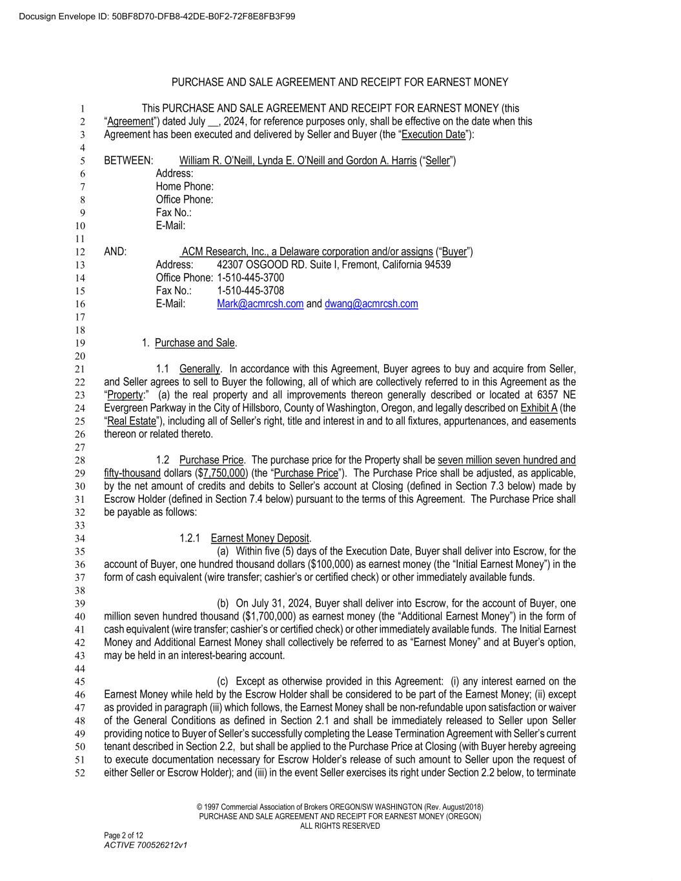
© 1997 Commercial Association of Brokers OREGON/SW WASHINGTON (Rev. August/2018) PURCHASE AND SALE AGREEMENT AND RECEIPT FOR EARNEST MONEY (OREGON) ALL RIGHTS RESERVED Page 2 of 12 ACTIVE 700526212v1 PURCHASE AND SALE AGREEMENT AND RECEIPT FOR EARNEST MONEY This PURCHASE AND SALE AGREEMENT AND RECEIPT FOR EARNEST MONEY (this 1 “Agreement”) dated July __, 2024, for reference purposes only, shall be effective on the date when this 2 Agreement has been executed and delivered by Seller and Buyer (the “Execution Date”): 3 4 BETWEEN: William R. O’Neill, Lynda E. O’Neill and Gordon A. Harris (“Seller”) 5 Address: 6 Home Phone: 7 Office Phone: 8 Fax No.: 9 E-Mail: 10 11 AND: ACM Research, Inc., a Delaware corporation and/or assigns (“Buyer”) 12 Address: 42307 OSGOOD RD. Suite I, Fremont, California 94539 13 Office Phone: 1-510-445-3700 14 Fax No.: 1-510-445-3708 15 E-Mail: Mark@acmrcsh.com and dwang@acmrcsh.com 16 17 18 1. Purchase and Sale. 19 20 1.1 Generally. In accordance with this Agreement, Buyer agrees to buy and acquire from Seller, 21 and Seller agrees to sell to Buyer the following, all of which are collectively referred to in this Agreement as the 22 “Property:” (a) the real property and all improvements thereon generally described or located at 6357 NE 23 Evergreen Parkway in the City of Hillsboro, County of Washington, Oregon, and legally described on Exhibit A (the 24 “Real Estate”), including all of Seller’s right, title and interest in and to all fixtures, appurtenances, and easements 25 thereon or related thereto. 26 27 1.2 Purchase Price. The purchase price for the Property shall be seven million seven hundred and 28 fifty-thousand dollars ($7,750,000) (the “Purchase Price”). The Purchase Price shall be adjusted, as applicable, 29 by the net amount of credits and debits to Seller’s account at Closing (defined in Section 7.3 below) made by 30 Escrow Holder (defined in Section 7.4 below) pursuant to the terms of this Agreement. The Purchase Price shall 31 be payable as follows: 32 33 1.2.1 Earnest Money Deposit. 34 (a) Within five (5) days of the Execution Date, Buyer shall deliver into Escrow, for the 35 account of Buyer, one hundred thousand dollars ($100,000) as earnest money (the “Initial Earnest Money”) in the 36 form of cash equivalent (wire transfer; cashier’s or certified check) or other immediately available funds. 37 38 (b) On July 31, 2024, Buyer shall deliver into Escrow, for the account of Buyer, one 39 million seven hundred thousand ($1,700,000) as earnest money (the “Additional Earnest Money”) in the form of 40 cash equivalent (wire transfer; cashier’s or certified check) or other immediately available funds. The Initial Earnest 41 Money and Additional Earnest Money shall collectively be referred to as “Earnest Money” and at Buyer’s option, 42 may be held in an interest-bearing account. 43 44 (c) Except as otherwise provided in this Agreement: (i) any interest earned on the 45 Earnest Money while held by the Escrow Holder shall be considered to be part of the Earnest Money; (ii) except 46 as provided in paragraph (iii) which follows, the Earnest Money shall be non-refundable upon satisfaction or waiver 47 of the General Conditions as defined in Section 2.1 and shall be immediately released to Seller upon Seller 48 providing notice to Buyer of Seller’s successfully completing the Lease Termination Agreement with Seller’s current 49 tenant described in Section 2.2, but shall be applied to the Purchase Price at Closing (with Buyer hereby agreeing 50 to execute documentation necessary for Escrow Holder’s release of such amount to Seller upon the request of 51 either Seller or Escrow Holder); and (iii) in the event Seller exercises its right under Section 2.2 below, to terminate 52 Docusign Envelope ID: 50BF8D70-DFB8-42DE-B0F2-72F8E8FB3F99

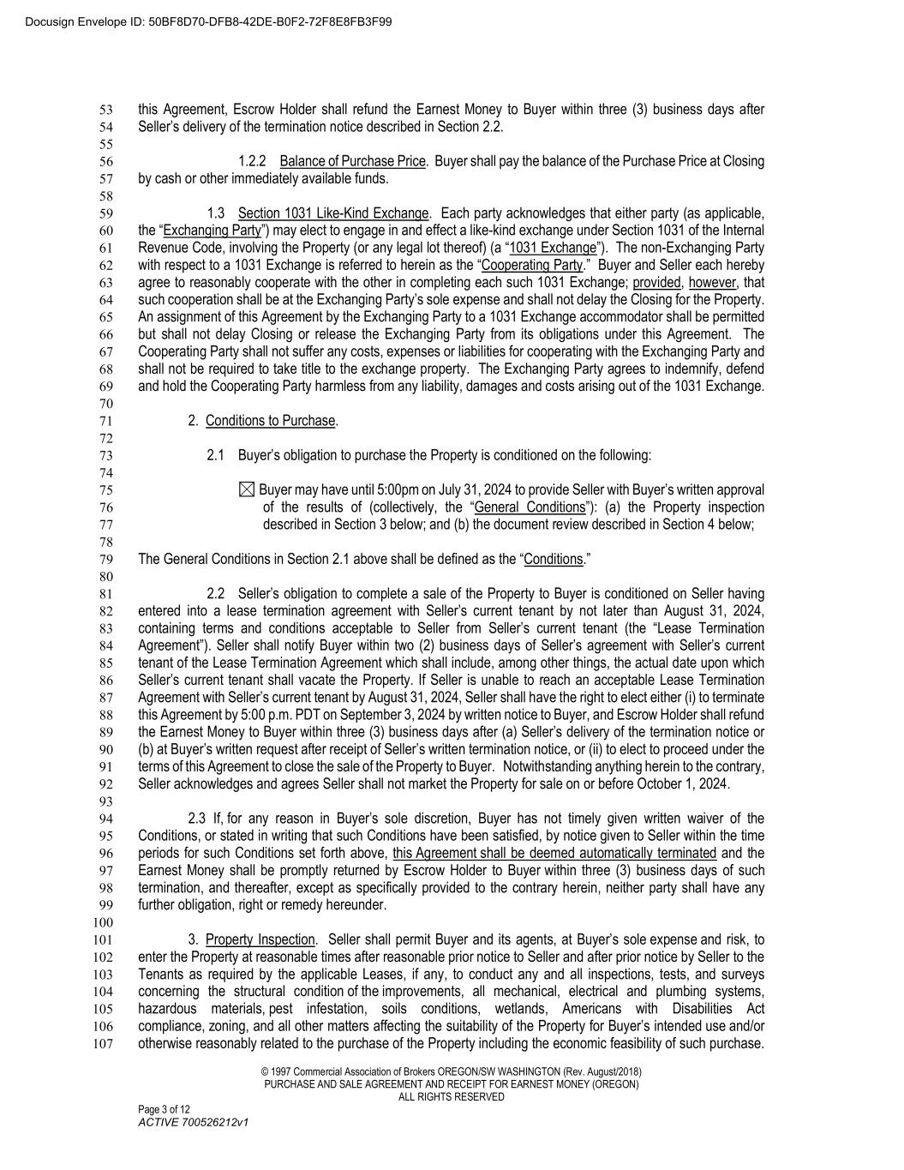
© 1997 Commercial Association of Brokers OREGON/SW WASHINGTON (Rev. August/2018) PURCHASE AND SALE AGREEMENT AND RECEIPT FOR EARNEST MONEY (OREGON) ALL RIGHTS RESERVED Page 3 of 12 ACTIVE 700526212v1 this Agreement, Escrow Holder shall refund the Earnest Money to Buyer within three (3) business days after 53 Seller’s delivery of the termination notice described in Section 2.2. 54 55 1.2.2 Balance of Purchase Price. Buyer shall pay the balance of the Purchase Price at Closing 56 by cash or other immediately available funds. 57 58 1.3 Section 1031 Like-Kind Exchange. Each party acknowledges that either party (as applicable, 59 the “Exchanging Party”) may elect to engage in and effect a like-kind exchange under Section 1031 of the Internal 60 Revenue Code, involving the Property (or any legal lot thereof) (a “1031 Exchange”). The non-Exchanging Party 61 with respect to a 1031 Exchange is referred to herein as the “Cooperating Party.” Buyer and Seller each hereby 62 agree to reasonably cooperate with the other in completing each such 1031 Exchange; provided, however, that 63 such cooperation shall be at the Exchanging Party’s sole expense and shall not delay the Closing for the Property. 64 An assignment of this Agreement by the Exchanging Party to a 1031 Exchange accommodator shall be permitted 65 but shall not delay Closing or release the Exchanging Party from its obligations under this Agreement. The 66 Cooperating Party shall not suffer any costs, expenses or liabilities for cooperating with the Exchanging Party and 67 shall not be required to take title to the exchange property. The Exchanging Party agrees to indemnify, defend 68 and hold the Cooperating Party harmless from any liability, damages and costs arising out of the 1031 Exchange. 69 70 2. Conditions to Purchase. 71 72 2.1 Buyer’s obligation to purchase the Property is conditioned on the following: 73 74 Buyer may have until 5:00pm on July 31, 2024 to provide Seller with Buyer’s written approval 75 of the results of (collectively, the “General Conditions”): (a) the Property inspection 76 described in Section 3 below; and (b) the document review described in Section 4 below; 77 78 The General Conditions in Section 2.1 above shall be defined as the “Conditions.” 79 80 2.2 Seller’s obligation to complete a sale of the Property to Buyer is conditioned on Seller having 81 entered into a lease termination agreement with Seller’s current tenant by not later than August 31, 2024, 82 containing terms and conditions acceptable to Seller from Seller’s current tenant (the “Lease Termination 83 Agreement”). Seller shall notify Buyer within two (2) business days of Seller’s agreement with Seller’s current 84 tenant of the Lease Termination Agreement which shall include, among other things, the actual date upon which 85 Seller’s current tenant shall vacate the Property. If Seller is unable to reach an acceptable Lease Termination 86 Agreement with Seller’s current tenant by August 31, 2024, Seller shall have the right to elect either (i) to terminate 87 this Agreement by 5:00 p.m. PDT on September 3, 2024 by written notice to Buyer, and Escrow Holder shall refund 88 the Earnest Money to Buyer within three (3) business days after (a) Seller’s delivery of the termination notice or 89 (b) at Buyer’s written request after receipt of Seller’s written termination notice, or (ii) to elect to proceed under the 90 terms of this Agreement to close the sale of the Property to Buyer. Notwithstanding anything herein to the contrary, 91 Seller acknowledges and agrees Seller shall not market the Property for sale on or before October 1, 2024. 92 93 2.3 If, for any reason in Buyer’s sole discretion, Buyer has not timely given written waiver of the 94 Conditions, or stated in writing that such Conditions have been satisfied, by notice given to Seller within the time 95 periods for such Conditions set forth above, this Agreement shall be deemed automatically terminated and the 96 Earnest Money shall be promptly returned by Escrow Holder to Buyer within three (3) business days of such 97 termination, and thereafter, except as specifically provided to the contrary herein, neither party shall have any 98 further obligation, right or remedy hereunder. 99 100 3. Property Inspection. Seller shall permit Buyer and its agents, at Buyer’s sole expense and risk, to 101 enter the Property at reasonable times after reasonable prior notice to Seller and after prior notice by Seller to the 102 Tenants as required by the applicable Leases, if any, to conduct any and all inspections, tests, and surveys 103 concerning the structural condition of the improvements, all mechanical, electrical and plumbing systems, 104 hazardous materials, pest infestation, soils conditions, wetlands, Americans with Disabilities Act 105 compliance, zoning, and all other matters affecting the suitability of the Property for Buyer’s intended use and/or 106 otherwise reasonably related to the purchase of the Property including the economic feasibility of such purchase. 107 Docusign Envelope ID: 50BF8D70-DFB8-42DE-B0F2-72F8E8FB3F99

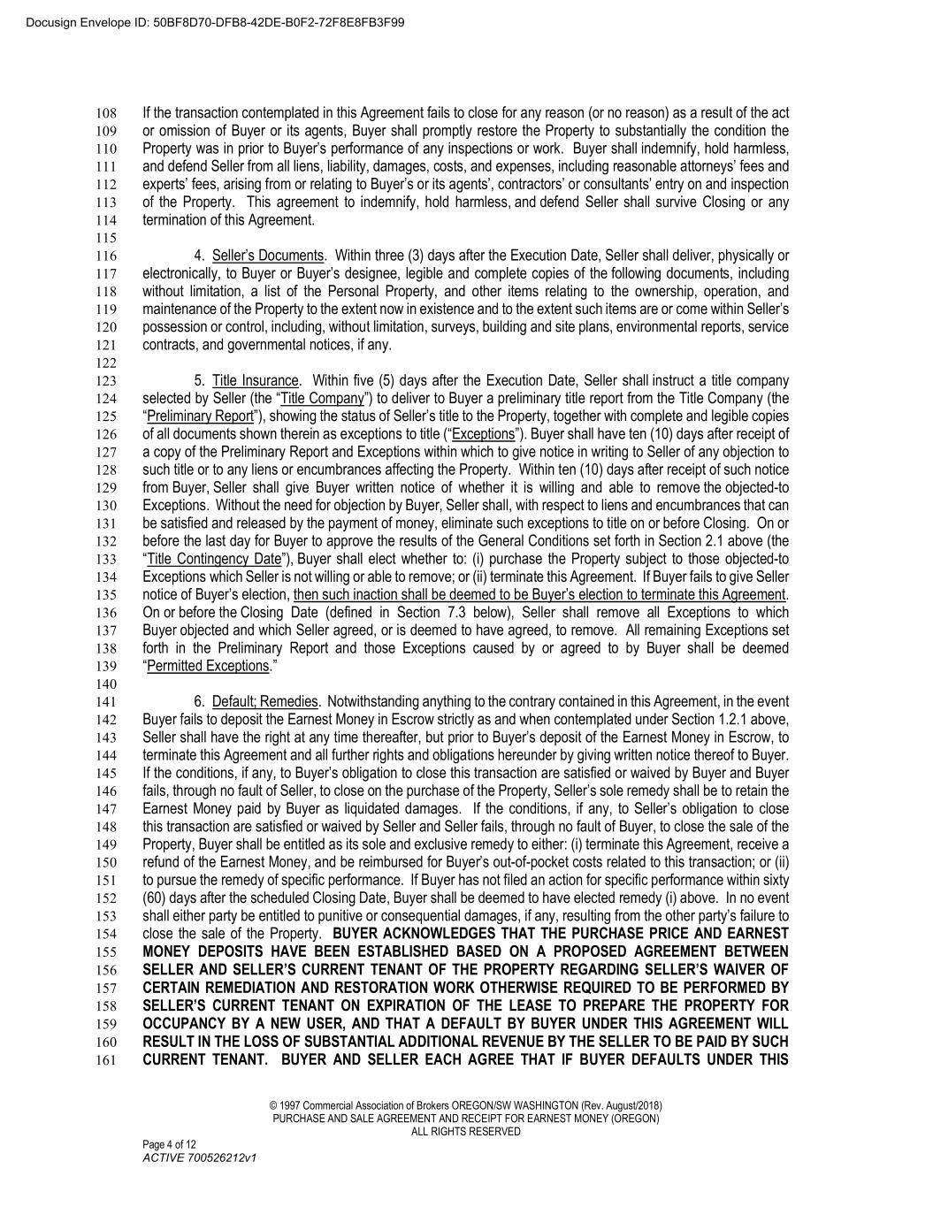
© 1997 Commercial Association of Brokers OREGON/SW WASHINGTON (Rev. August/2018) PURCHASE AND SALE AGREEMENT AND RECEIPT FOR EARNEST MONEY (OREGON) ALL RIGHTS RESERVED Page 4 of 12 ACTIVE 700526212v1 If the transaction contemplated in this Agreement fails to close for any reason (or no reason) as a result of the act 108 or omission of Buyer or its agents, Buyer shall promptly restore the Property to substantially the condition the 109 Property was in prior to Buyer’s performance of any inspections or work. Buyer shall indemnify, hold harmless, 110 and defend Seller from all liens, liability, damages, costs, and expenses, including reasonable attorneys’ fees and 111 experts’ fees, arising from or relating to Buyer’s or its agents’, contractors’ or consultants’ entry on and inspection 112 of the Property. This agreement to indemnify, hold harmless, and defend Seller shall survive Closing or any 113 termination of this Agreement. 114 115 4. Seller’s Documents. Within three (3) days after the Execution Date, Seller shall deliver, physically or 116 electronically, to Buyer or Buyer’s designee, legible and complete copies of the following documents, including 117 without limitation, a list of the Personal Property, and other items relating to the ownership, operation, and 118 maintenance of the Property to the extent now in existence and to the extent such items are or come within Seller’s 119 possession or control, including, without limitation, surveys, building and site plans, environmental reports, service 120 contracts, and governmental notices, if any. 121 122 5. Title Insurance. Within five (5) days after the Execution Date, Seller shall instruct a title company 123 selected by Seller (the “Title Company”) to deliver to Buyer a preliminary title report from the Title Company (the 124 “Preliminary Report”), showing the status of Seller’s title to the Property, together with complete and legible copies 125 of all documents shown therein as exceptions to title (“Exceptions”). Buyer shall have ten (10) days after receipt of 126 a copy of the Preliminary Report and Exceptions within which to give notice in writing to Seller of any objection to 127 such title or to any liens or encumbrances affecting the Property. Within ten (10) days after receipt of such notice 128 from Buyer, Seller shall give Buyer written notice of whether it is willing and able to remove the objected-to 129 Exceptions. Without the need for objection by Buyer, Seller shall, with respect to liens and encumbrances that can 130 be satisfied and released by the payment of money, eliminate such exceptions to title on or before Closing. On or 131 before the last day for Buyer to approve the results of the General Conditions set forth in Section 2.1 above (the 132 “Title Contingency Date”), Buyer shall elect whether to: (i) purchase the Property subject to those objected-to 133 Exceptions which Seller is not willing or able to remove; or (ii) terminate this Agreement. If Buyer fails to give Seller 134 notice of Buyer’s election, then such inaction shall be deemed to be Buyer’s election to terminate this Agreement. 135 On or before the Closing Date (defined in Section 7.3 below), Seller shall remove all Exceptions to which 136 Buyer objected and which Seller agreed, or is deemed to have agreed, to remove. All remaining Exceptions set 137 forth in the Preliminary Report and those Exceptions caused by or agreed to by Buyer shall be deemed 138 “Permitted Exceptions.” 139 140 6. Default; Remedies. Notwithstanding anything to the contrary contained in this Agreement, in the event 141 Buyer fails to deposit the Earnest Money in Escrow strictly as and when contemplated under Section 1.2.1 above, 142 Seller shall have the right at any time thereafter, but prior to Buyer’s deposit of the Earnest Money in Escrow, to 143 terminate this Agreement and all further rights and obligations hereunder by giving written notice thereof to Buyer. 144 If the conditions, if any, to Buyer’s obligation to close this transaction are satisfied or waived by Buyer and Buyer 145 fails, through no fault of Seller, to close on the purchase of the Property, Seller’s sole remedy shall be to retain the 146 Earnest Money paid by Buyer as liquidated damages. If the conditions, if any, to Seller’s obligation to close 147 this transaction are satisfied or waived by Seller and Seller fails, through no fault of Buyer, to close the sale of the 148 Property, Buyer shall be entitled as its sole and exclusive remedy to either: (i) terminate this Agreement, receive a 149 refund of the Earnest Money, and be reimbursed for Buyer’s out-of-pocket costs related to this transaction; or (ii) 150 to pursue the remedy of specific performance. If Buyer has not filed an action for specific performance within sixty 151 (60) days after the scheduled Closing Date, Buyer shall be deemed to have elected remedy (i) above. In no event 152 shall either party be entitled to punitive or consequential damages, if any, resulting from the other party’s failure to 153 close the sale of the Property. BUYER ACKNOWLEDGES THAT THE PURCHASE PRICE AND EARNEST 154 MONEY DEPOSITS HAVE BEEN ESTABLISHED BASED ON A PROPOSED AGREEMENT BETWEEN 155 SELLER AND SELLER’S CURRENT TENANT OF THE PROPERTY REGARDING SELLER’S WAIVER OF 156 CERTAIN REMEDIATION AND RESTORATION WORK OTHERWISE REQUIRED TO BE PERFORMED BY 157 SELLER’S CURRENT TENANT ON EXPIRATION OF THE LEASE TO PREPARE THE PROPERTY FOR 158 OCCUPANCY BY A NEW USER, AND THAT A DEFAULT BY BUYER UNDER THIS AGREEMENT WILL 159 RESULT IN THE LOSS OF SUBSTANTIAL ADDITIONAL REVENUE BY THE SELLER TO BE PAID BY SUCH 160 CURRENT TENANT. BUYER AND SELLER EACH AGREE THAT IF BUYER DEFAULTS UNDER THIS 161 Docusign Envelope ID: 50BF8D70-DFB8-42DE-B0F2-72F8E8FB3F99

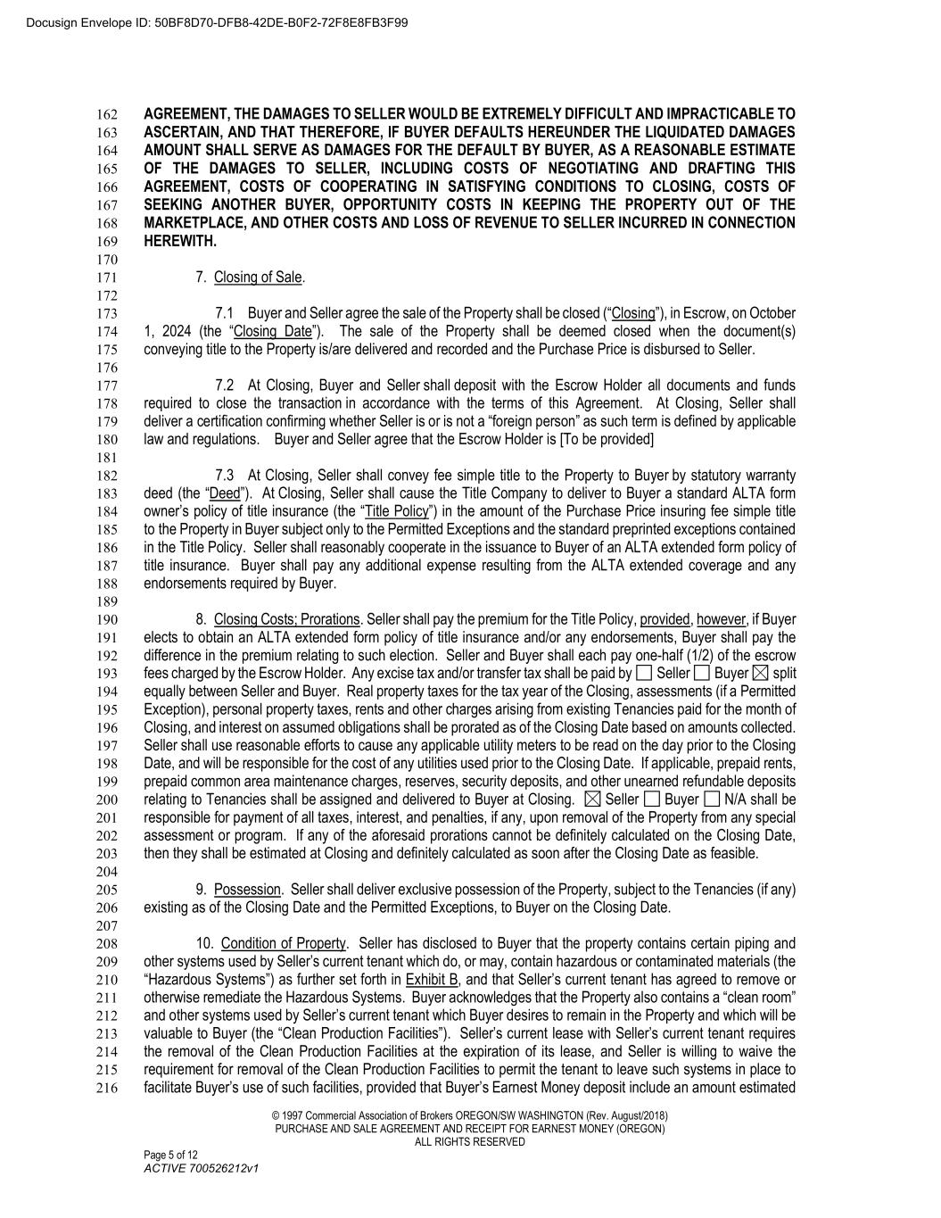
© 1997 Commercial Association of Brokers OREGON/SW WASHINGTON (Rev. August/2018) PURCHASE AND SALE AGREEMENT AND RECEIPT FOR EARNEST MONEY (OREGON) ALL RIGHTS RESERVED Page 5 of 12 ACTIVE 700526212v1 AGREEMENT, THE DAMAGES TO SELLER WOULD BE EXTREMELY DIFFICULT AND IMPRACTICABLE TO 162 ASCERTAIN, AND THAT THEREFORE, IF BUYER DEFAULTS HEREUNDER THE LIQUIDATED DAMAGES 163 AMOUNT SHALL SERVE AS DAMAGES FOR THE DEFAULT BY BUYER, AS A REASONABLE ESTIMATE 164 OF THE DAMAGES TO SELLER, INCLUDING COSTS OF NEGOTIATING AND DRAFTING THIS 165 AGREEMENT, COSTS OF COOPERATING IN SATISFYING CONDITIONS TO CLOSING, COSTS OF 166 SEEKING ANOTHER BUYER, OPPORTUNITY COSTS IN KEEPING THE PROPERTY OUT OF THE 167 MARKETPLACE, AND OTHER COSTS AND LOSS OF REVENUE TO SELLER INCURRED IN CONNECTION 168 HEREWITH. 169 170 7. Closing of Sale. 171 172 7.1 Buyer and Seller agree the sale of the Property shall be closed (“Closing”), in Escrow, on October 173 1, 2024 (the “Closing Date”). The sale of the Property shall be deemed closed when the document(s) 174 conveying title to the Property is/are delivered and recorded and the Purchase Price is disbursed to Seller. 175 176 7.2 At Closing, Buyer and Seller shall deposit with the Escrow Holder all documents and funds 177 required to close the transaction in accordance with the terms of this Agreement. At Closing, Seller shall 178 deliver a certification confirming whether Seller is or is not a “foreign person” as such term is defined by applicable 179 law and regulations. Buyer and Seller agree that the Escrow Holder is [To be provided] 180 181 7.3 At Closing, Seller shall convey fee simple title to the Property to Buyer by statutory warranty 182 deed (the “Deed”). At Closing, Seller shall cause the Title Company to deliver to Buyer a standard ALTA form 183 owner’s policy of title insurance (the “Title Policy”) in the amount of the Purchase Price insuring fee simple title 184 to the Property in Buyer subject only to the Permitted Exceptions and the standard preprinted exceptions contained 185 in the Title Policy. Seller shall reasonably cooperate in the issuance to Buyer of an ALTA extended form policy of 186 title insurance. Buyer shall pay any additional expense resulting from the ALTA extended coverage and any 187 endorsements required by Buyer. 188 189 8. Closing Costs; Prorations. Seller shall pay the premium for the Title Policy, provided, however, if Buyer 190 elects to obtain an ALTA extended form policy of title insurance and/or any endorsements, Buyer shall pay the 191 difference in the premium relating to such election. Seller and Buyer shall each pay one-half (1/2) of the escrow 192 fees charged by the Escrow Holder. Any excise tax and/or transfer tax shall be paid by Seller Buyer split 193 equally between Seller and Buyer. Real property taxes for the tax year of the Closing, assessments (if a Permitted 194 Exception), personal property taxes, rents and other charges arising from existing Tenancies paid for the month of 195 Closing, and interest on assumed obligations shall be prorated as of the Closing Date based on amounts collected. 196 Seller shall use reasonable efforts to cause any applicable utility meters to be read on the day prior to the Closing 197 Date, and will be responsible for the cost of any utilities used prior to the Closing Date. If applicable, prepaid rents, 198 prepaid common area maintenance charges, reserves, security deposits, and other unearned refundable deposits 199 relating to Tenancies shall be assigned and delivered to Buyer at Closing. Seller Buyer N/A shall be 200 responsible for payment of all taxes, interest, and penalties, if any, upon removal of the Property from any special 201 assessment or program. If any of the aforesaid prorations cannot be definitely calculated on the Closing Date, 202 then they shall be estimated at Closing and definitely calculated as soon after the Closing Date as feasible. 203 204 9. Possession. Seller shall deliver exclusive possession of the Property, subject to the Tenancies (if any) 205 existing as of the Closing Date and the Permitted Exceptions, to Buyer on the Closing Date. 206 207 10. Condition of Property. Seller has disclosed to Buyer that the property contains certain piping and 208 other systems used by Seller’s current tenant which do, or may, contain hazardous or contaminated materials (the 209 “Hazardous Systems”) as further set forth in Exhibit B, and that Seller’s current tenant has agreed to remove or 210 otherwise remediate the Hazardous Systems. Buyer acknowledges that the Property also contains a “clean room” 211 and other systems used by Seller’s current tenant which Buyer desires to remain in the Property and which will be 212 valuable to Buyer (the “Clean Production Facilities”). Seller’s current lease with Seller’s current tenant requires 213 the removal of the Clean Production Facilities at the expiration of its lease, and Seller is willing to waive the 214 requirement for removal of the Clean Production Facilities to permit the tenant to leave such systems in place to 215 facilitate Buyer’s use of such facilities, provided that Buyer’s Earnest Money deposit include an amount estimated 216 Docusign Envelope ID: 50BF8D70-DFB8-42DE-B0F2-72F8E8FB3F99

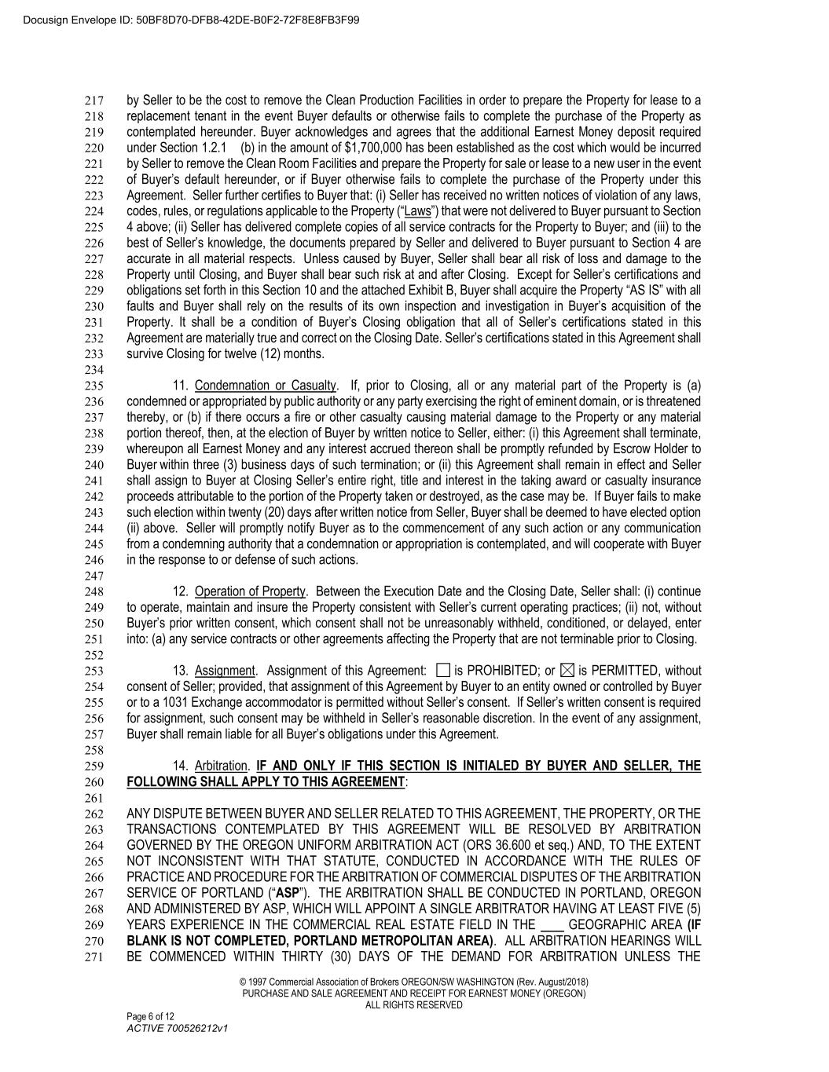
© 1997 Commercial Association of Brokers OREGON/SW WASHINGTON (Rev. August/2018) PURCHASE AND SALE AGREEMENT AND RECEIPT FOR EARNEST MONEY (OREGON) ALL RIGHTS RESERVED Page 6 of 12 ACTIVE 700526212v1 by Seller to be the cost to remove the Clean Production Facilities in order to prepare the Property for lease to a 217 replacement tenant in the event Buyer defaults or otherwise fails to complete the purchase of the Property as 218 contemplated hereunder. Buyer acknowledges and agrees that the additional Earnest Money deposit required 219 under Section 1.2.1 (b) in the amount of $1,700,000 has been established as the cost which would be incurred 220 by Seller to remove the Clean Room Facilities and prepare the Property for sale or lease to a new user in the event 221 of Buyer’s default hereunder, or if Buyer otherwise fails to complete the purchase of the Property under this 222 Agreement. Seller further certifies to Buyer that: (i) Seller has received no written notices of violation of any laws, 223 codes, rules, or regulations applicable to the Property (“Laws”) that were not delivered to Buyer pursuant to Section 224 4 above; (ii) Seller has delivered complete copies of all service contracts for the Property to Buyer; and (iii) to the 225 best of Seller’s knowledge, the documents prepared by Seller and delivered to Buyer pursuant to Section 4 are 226 accurate in all material respects. Unless caused by Buyer, Seller shall bear all risk of loss and damage to the 227 Property until Closing, and Buyer shall bear such risk at and after Closing. Except for Seller’s certifications and 228 obligations set forth in this Section 10 and the attached Exhibit B, Buyer shall acquire the Property “AS IS” with all 229 faults and Buyer shall rely on the results of its own inspection and investigation in Buyer’s acquisition of the 230 Property. It shall be a condition of Buyer’s Closing obligation that all of Seller’s certifications stated in this 231 Agreement are materially true and correct on the Closing Date. Seller’s certifications stated in this Agreement shall 232 survive Closing for twelve (12) months. 233 234 11. Condemnation or Casualty. If, prior to Closing, all or any material part of the Property is (a) 235 condemned or appropriated by public authority or any party exercising the right of eminent domain, or is threatened 236 thereby, or (b) if there occurs a fire or other casualty causing material damage to the Property or any material 237 portion thereof, then, at the election of Buyer by written notice to Seller, either: (i) this Agreement shall terminate, 238 whereupon all Earnest Money and any interest accrued thereon shall be promptly refunded by Escrow Holder to 239 Buyer within three (3) business days of such termination; or (ii) this Agreement shall remain in effect and Seller 240 shall assign to Buyer at Closing Seller’s entire right, title and interest in the taking award or casualty insurance 241 proceeds attributable to the portion of the Property taken or destroyed, as the case may be. If Buyer fails to make 242 such election within twenty (20) days after written notice from Seller, Buyer shall be deemed to have elected option 243 (ii) above. Seller will promptly notify Buyer as to the commencement of any such action or any communication 244 from a condemning authority that a condemnation or appropriation is contemplated, and will cooperate with Buyer 245 in the response to or defense of such actions. 246 247 12. Operation of Property. Between the Execution Date and the Closing Date, Seller shall: (i) continue 248 to operate, maintain and insure the Property consistent with Seller’s current operating practices; (ii) not, without 249 Buyer’s prior written consent, which consent shall not be unreasonably withheld, conditioned, or delayed, enter 250 into: (a) any service contracts or other agreements affecting the Property that are not terminable prior to Closing. 251 252 13. Assignment. Assignment of this Agreement: is PROHIBITED; or is PERMITTED, without 253 consent of Seller; provided, that assignment of this Agreement by Buyer to an entity owned or controlled by Buyer 254 or to a 1031 Exchange accommodator is permitted without Seller’s consent. If Seller’s written consent is required 255 for assignment, such consent may be withheld in Seller’s reasonable discretion. In the event of any assignment, 256 Buyer shall remain liable for all Buyer’s obligations under this Agreement. 257 258 14. Arbitration. IF AND ONLY IF THIS SECTION IS INITIALED BY BUYER AND SELLER, THE 259 FOLLOWING SHALL APPLY TO THIS AGREEMENT: 260 261 ANY DISPUTE BETWEEN BUYER AND SELLER RELATED TO THIS AGREEMENT, THE PROPERTY, OR THE 262 TRANSACTIONS CONTEMPLATED BY THIS AGREEMENT WILL BE RESOLVED BY ARBITRATION 263 GOVERNED BY THE OREGON UNIFORM ARBITRATION ACT (ORS 36.600 et seq.) AND, TO THE EXTENT 264 NOT INCONSISTENT WITH THAT STATUTE, CONDUCTED IN ACCORDANCE WITH THE RULES OF 265 PRACTICE AND PROCEDURE FOR THE ARBITRATION OF COMMERCIAL DISPUTES OF THE ARBITRATION 266 SERVICE OF PORTLAND (“ASP”). THE ARBITRATION SHALL BE CONDUCTED IN PORTLAND, OREGON 267 AND ADMINISTERED BY ASP, WHICH WILL APPOINT A SINGLE ARBITRATOR HAVING AT LEAST FIVE (5) 268 YEARS EXPERIENCE IN THE COMMERCIAL REAL ESTATE FIELD IN THE GEOGRAPHIC AREA (IF 269 BLANK IS NOT COMPLETED, PORTLAND METROPOLITAN AREA). ALL ARBITRATION HEARINGS WILL 270 BE COMMENCED WITHIN THIRTY (30) DAYS OF THE DEMAND FOR ARBITRATION UNLESS THE 271 Docusign Envelope ID: 50BF8D70-DFB8-42DE-B0F2-72F8E8FB3F99

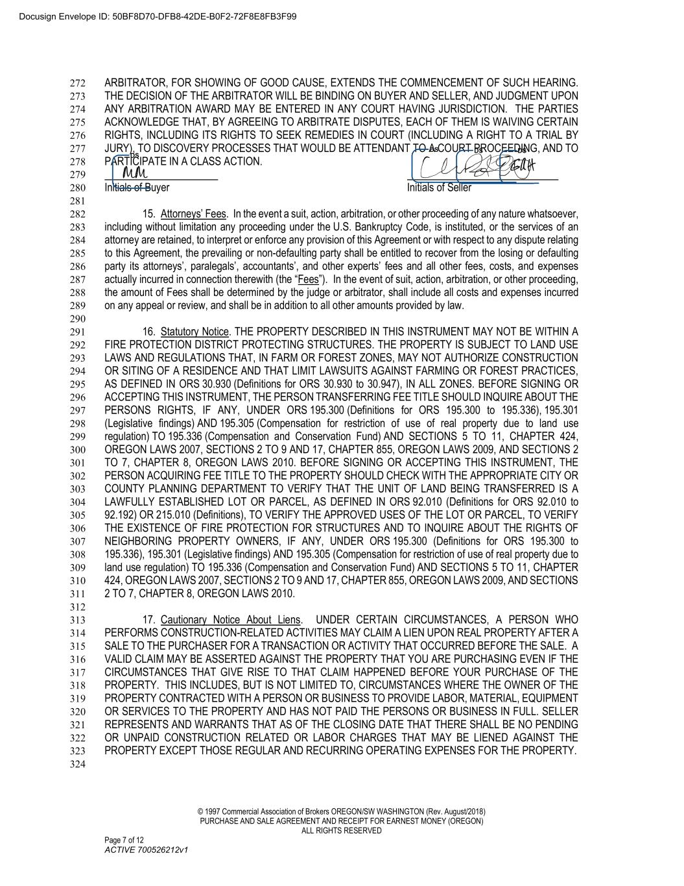
© 1997 Commercial Association of Brokers OREGON/SW WASHINGTON (Rev. August/2018) PURCHASE AND SALE AGREEMENT AND RECEIPT FOR EARNEST MONEY (OREGON) ALL RIGHTS RESERVED Page 7 of 12 ACTIVE 700526212v1 ARBITRATOR, FOR SHOWING OF GOOD CAUSE, EXTENDS THE COMMENCEMENT OF SUCH HEARING. 272 THE DECISION OF THE ARBITRATOR WILL BE BINDING ON BUYER AND SELLER, AND JUDGMENT UPON 273 ANY ARBITRATION AWARD MAY BE ENTERED IN ANY COURT HAVING JURISDICTION. THE PARTIES 274 ACKNOWLEDGE THAT, BY AGREEING TO ARBITRATE DISPUTES, EACH OF THEM IS WAIVING CERTAIN 275 RIGHTS, INCLUDING ITS RIGHTS TO SEEK REMEDIES IN COURT (INCLUDING A RIGHT TO A TRIAL BY 276 JURY), TO DISCOVERY PROCESSES THAT WOULD BE ATTENDANT TO A COURT PROCEEDING, AND TO 277 PARTICIPATE IN A CLASS ACTION. 278 279 Initials of Buyer Initials of Seller 280 281 15. Attorneys’ Fees. In the event a suit, action, arbitration, or other proceeding of any nature whatsoever, 282 including without limitation any proceeding under the U.S. Bankruptcy Code, is instituted, or the services of an 283 attorney are retained, to interpret or enforce any provision of this Agreement or with respect to any dispute relating 284 to this Agreement, the prevailing or non-defaulting party shall be entitled to recover from the losing or defaulting 285 party its attorneys’, paralegals’, accountants’, and other experts’ fees and all other fees, costs, and expenses 286 actually incurred in connection therewith (the “Fees”). In the event of suit, action, arbitration, or other proceeding, 287 the amount of Fees shall be determined by the judge or arbitrator, shall include all costs and expenses incurred 288 on any appeal or review, and shall be in addition to all other amounts provided by law. 289 290 16. Statutory Notice. THE PROPERTY DESCRIBED IN THIS INSTRUMENT MAY NOT BE WITHIN A 291 FIRE PROTECTION DISTRICT PROTECTING STRUCTURES. THE PROPERTY IS SUBJECT TO LAND USE 292 LAWS AND REGULATIONS THAT, IN FARM OR FOREST ZONES, MAY NOT AUTHORIZE CONSTRUCTION 293 OR SITING OF A RESIDENCE AND THAT LIMIT LAWSUITS AGAINST FARMING OR FOREST PRACTICES, 294 AS DEFINED IN ORS 30.930 (Definitions for ORS 30.930 to 30.947), IN ALL ZONES. BEFORE SIGNING OR 295 ACCEPTING THIS INSTRUMENT, THE PERSON TRANSFERRING FEE TITLE SHOULD INQUIRE ABOUT THE 296 PERSONS RIGHTS, IF ANY, UNDER ORS 195.300 (Definitions for ORS 195.300 to 195.336), 195.301 297 (Legislative findings) AND 195.305 (Compensation for restriction of use of real property due to land use 298 regulation) TO 195.336 (Compensation and Conservation Fund) AND SECTIONS 5 TO 11, CHAPTER 424, 299 OREGON LAWS 2007, SECTIONS 2 TO 9 AND 17, CHAPTER 855, OREGON LAWS 2009, AND SECTIONS 2 300 TO 7, CHAPTER 8, OREGON LAWS 2010. BEFORE SIGNING OR ACCEPTING THIS INSTRUMENT, THE 301 PERSON ACQUIRING FEE TITLE TO THE PROPERTY SHOULD CHECK WITH THE APPROPRIATE CITY OR 302 COUNTY PLANNING DEPARTMENT TO VERIFY THAT THE UNIT OF LAND BEING TRANSFERRED IS A 303 LAWFULLY ESTABLISHED LOT OR PARCEL, AS DEFINED IN ORS 92.010 (Definitions for ORS 92.010 to 304 92.192) OR 215.010 (Definitions), TO VERIFY THE APPROVED USES OF THE LOT OR PARCEL, TO VERIFY 305 THE EXISTENCE OF FIRE PROTECTION FOR STRUCTURES AND TO INQUIRE ABOUT THE RIGHTS OF 306 NEIGHBORING PROPERTY OWNERS, IF ANY, UNDER ORS 195.300 (Definitions for ORS 195.300 to 307 195.336), 195.301 (Legislative findings) AND 195.305 (Compensation for restriction of use of real property due to 308 land use regulation) TO 195.336 (Compensation and Conservation Fund) AND SECTIONS 5 TO 11, CHAPTER 309 424, OREGON LAWS 2007, SECTIONS 2 TO 9 AND 17, CHAPTER 855, OREGON LAWS 2009, AND SECTIONS 310 2 TO 7, CHAPTER 8, OREGON LAWS 2010. 311 312 17. Cautionary Notice About Liens. UNDER CERTAIN CIRCUMSTANCES, A PERSON WHO 313 PERFORMS CONSTRUCTION-RELATED ACTIVITIES MAY CLAIM A LIEN UPON REAL PROPERTY AFTER A 314 SALE TO THE PURCHASER FOR A TRANSACTION OR ACTIVITY THAT OCCURRED BEFORE THE SALE. A 315 VALID CLAIM MAY BE ASSERTED AGAINST THE PROPERTY THAT YOU ARE PURCHASING EVEN IF THE 316 CIRCUMSTANCES THAT GIVE RISE TO THAT CLAIM HAPPENED BEFORE YOUR PURCHASE OF THE 317 PROPERTY. THIS INCLUDES, BUT IS NOT LIMITED TO, CIRCUMSTANCES WHERE THE OWNER OF THE 318 PROPERTY CONTRACTED WITH A PERSON OR BUSINESS TO PROVIDE LABOR, MATERIAL, EQUIPMENT 319 OR SERVICES TO THE PROPERTY AND HAS NOT PAID THE PERSONS OR BUSINESS IN FULL. SELLER 320 REPRESENTS AND WARRANTS THAT AS OF THE CLOSING DATE THAT THERE SHALL BE NO PENDING 321 OR UNPAID CONSTRUCTION RELATED OR LABOR CHARGES THAT MAY BE LIENED AGAINST THE 322 PROPERTY EXCEPT THOSE REGULAR AND RECURRING OPERATING EXPENSES FOR THE PROPERTY. 323 324 Docusign Envelope ID: 50BF8D70-DFB8-42DE-B0F2-72F8E8FB3F99

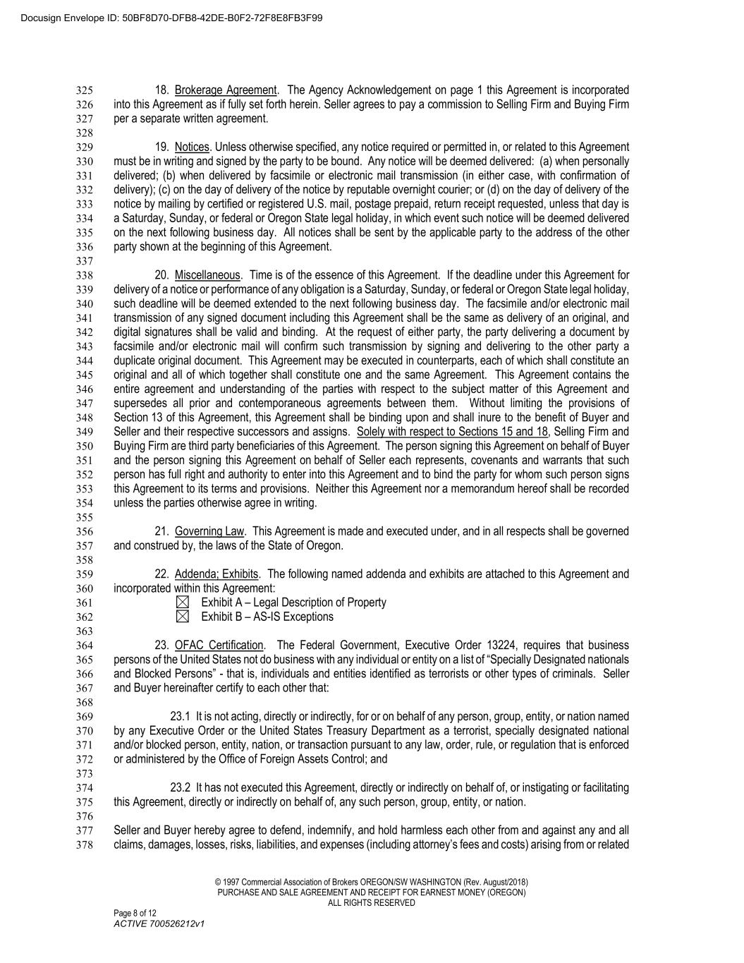
© 1997 Commercial Association of Brokers OREGON/SW WASHINGTON (Rev. August/2018) PURCHASE AND SALE AGREEMENT AND RECEIPT FOR EARNEST MONEY (OREGON) ALL RIGHTS RESERVED Page 8 of 12 ACTIVE 700526212v1 18. Brokerage Agreement. The Agency Acknowledgement on page 1 this Agreement is incorporated 325 into this Agreement as if fully set forth herein. Seller agrees to pay a commission to Selling Firm and Buying Firm 326 per a separate written agreement. 327 328 19. Notices. Unless otherwise specified, any notice required or permitted in, or related to this Agreement 329 must be in writing and signed by the party to be bound. Any notice will be deemed delivered: (a) when personally 330 delivered; (b) when delivered by facsimile or electronic mail transmission (in either case, with confirmation of 331 delivery); (c) on the day of delivery of the notice by reputable overnight courier; or (d) on the day of delivery of the 332 notice by mailing by certified or registered U.S. mail, postage prepaid, return receipt requested, unless that day is 333 a Saturday, Sunday, or federal or Oregon State legal holiday, in which event such notice will be deemed delivered 334 on the next following business day. All notices shall be sent by the applicable party to the address of the other 335 party shown at the beginning of this Agreement. 336 337 20. Miscellaneous. Time is of the essence of this Agreement. If the deadline under this Agreement for 338 delivery of a notice or performance of any obligation is a Saturday, Sunday, or federal or Oregon State legal holiday, 339 such deadline will be deemed extended to the next following business day. The facsimile and/or electronic mail 340 transmission of any signed document including this Agreement shall be the same as delivery of an original, and 341 digital signatures shall be valid and binding. At the request of either party, the party delivering a document by 342 facsimile and/or electronic mail will confirm such transmission by signing and delivering to the other party a 343 duplicate original document. This Agreement may be executed in counterparts, each of which shall constitute an 344 original and all of which together shall constitute one and the same Agreement. This Agreement contains the 345 entire agreement and understanding of the parties with respect to the subject matter of this Agreement and 346 supersedes all prior and contemporaneous agreements between them. Without limiting the provisions of 347 Section 13 of this Agreement, this Agreement shall be binding upon and shall inure to the benefit of Buyer and 348 Seller and their respective successors and assigns. Solely with respect to Sections 15 and 18, Selling Firm and 349 Buying Firm are third party beneficiaries of this Agreement. The person signing this Agreement on behalf of Buyer 350 and the person signing this Agreement on behalf of Seller each represents, covenants and warrants that such 351 person has full right and authority to enter into this Agreement and to bind the party for whom such person signs 352 this Agreement to its terms and provisions. Neither this Agreement nor a memorandum hereof shall be recorded 353 unless the parties otherwise agree in writing. 354 355 21. Governing Law. This Agreement is made and executed under, and in all respects shall be governed 356 and construed by, the laws of the State of Oregon. 357 358 22. Addenda; Exhibits. The following named addenda and exhibits are attached to this Agreement and 359 incorporated within this Agreement: 360 Exhibit A – Legal Description of Property 361 Exhibit B – AS-IS Exceptions 362 363 23. OFAC Certification. The Federal Government, Executive Order 13224, requires that business 364 persons of the United States not do business with any individual or entity on a list of “Specially Designated nationals 365 and Blocked Persons” - that is, individuals and entities identified as terrorists or other types of criminals. Seller 366 and Buyer hereinafter certify to each other that: 367 368 23.1 It is not acting, directly or indirectly, for or on behalf of any person, group, entity, or nation named 369 by any Executive Order or the United States Treasury Department as a terrorist, specially designated national 370 and/or blocked person, entity, nation, or transaction pursuant to any law, order, rule, or regulation that is enforced 371 or administered by the Office of Foreign Assets Control; and 372 373 23.2 It has not executed this Agreement, directly or indirectly on behalf of, or instigating or facilitating 374 this Agreement, directly or indirectly on behalf of, any such person, group, entity, or nation. 375 376 Seller and Buyer hereby agree to defend, indemnify, and hold harmless each other from and against any and all 377 claims, damages, losses, risks, liabilities, and expenses (including attorney’s fees and costs) arising from or related 378 Docusign Envelope ID: 50BF8D70-DFB8-42DE-B0F2-72F8E8FB3F99

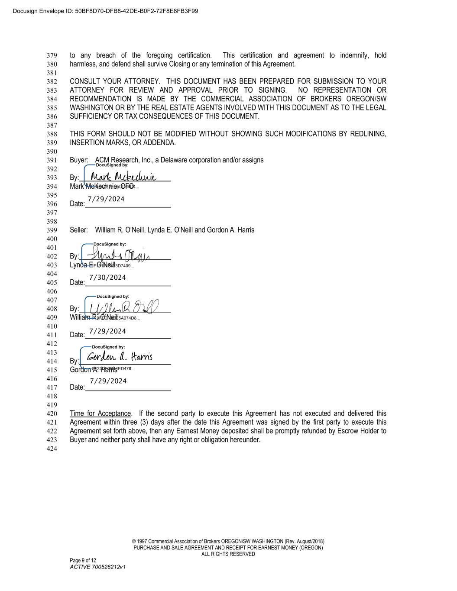
© 1997 Commercial Association of Brokers OREGON/SW WASHINGTON (Rev. August/2018) PURCHASE AND SALE AGREEMENT AND RECEIPT FOR EARNEST MONEY (OREGON) ALL RIGHTS RESERVED Page 9 of 12 ACTIVE 700526212v1 to any breach of the foregoing certification. This certification and agreement to indemnify, hold 379 harmless, and defend shall survive Closing or any termination of this Agreement. 380 381 CONSULT YOUR ATTORNEY. THIS DOCUMENT HAS BEEN PREPARED FOR SUBMISSION TO YOUR 382 ATTORNEY FOR REVIEW AND APPROVAL PRIOR TO SIGNING. NO REPRESENTATION OR 383 RECOMMENDATION IS MADE BY THE COMMERCIAL ASSOCIATION OF BROKERS OREGON/SW 384 WASHINGTON OR BY THE REAL ESTATE AGENTS INVOLVED WITH THIS DOCUMENT AS TO THE LEGAL 385 SUFFICIENCY OR TAX CONSEQUENCES OF THIS DOCUMENT. 386 387 THIS FORM SHOULD NOT BE MODIFIED WITHOUT SHOWING SUCH MODIFICATIONS BY REDLINING, 388 INSERTION MARKS, OR ADDENDA. 389 390 Buyer: ACM Research, Inc., a Delaware corporation and/or assigns 391 392 By: 393 Mark McKechnie, CFO 394 395 Date: 396 397 398 Seller: William R. O’Neill, Lynda E. O’Neill and Gordon A. Harris 399 400 401 By: 402 Lynda E. O’Neill 403 404 Date: 405 406 407 By: 408 William R. O’Neill 409 410 Date: 411 412 413 By: 414 Gordon A. Harris 415 416 Date: 417 418 419 Time for Acceptance. If the second party to execute this Agreement has not executed and delivered this 420 Agreement within three (3) days after the date this Agreement was signed by the first party to execute this 421 Agreement set forth above, then any Earnest Money deposited shall be promptly refunded by Escrow Holder to 422 Buyer and neither party shall have any right or obligation hereunder. 423 424 Docusign Envelope ID: 50BF8D70-DFB8-42DE-B0F2-72F8E8FB3F99 7/29/2024 7/30/2024 7/29/2024 7/29/2024

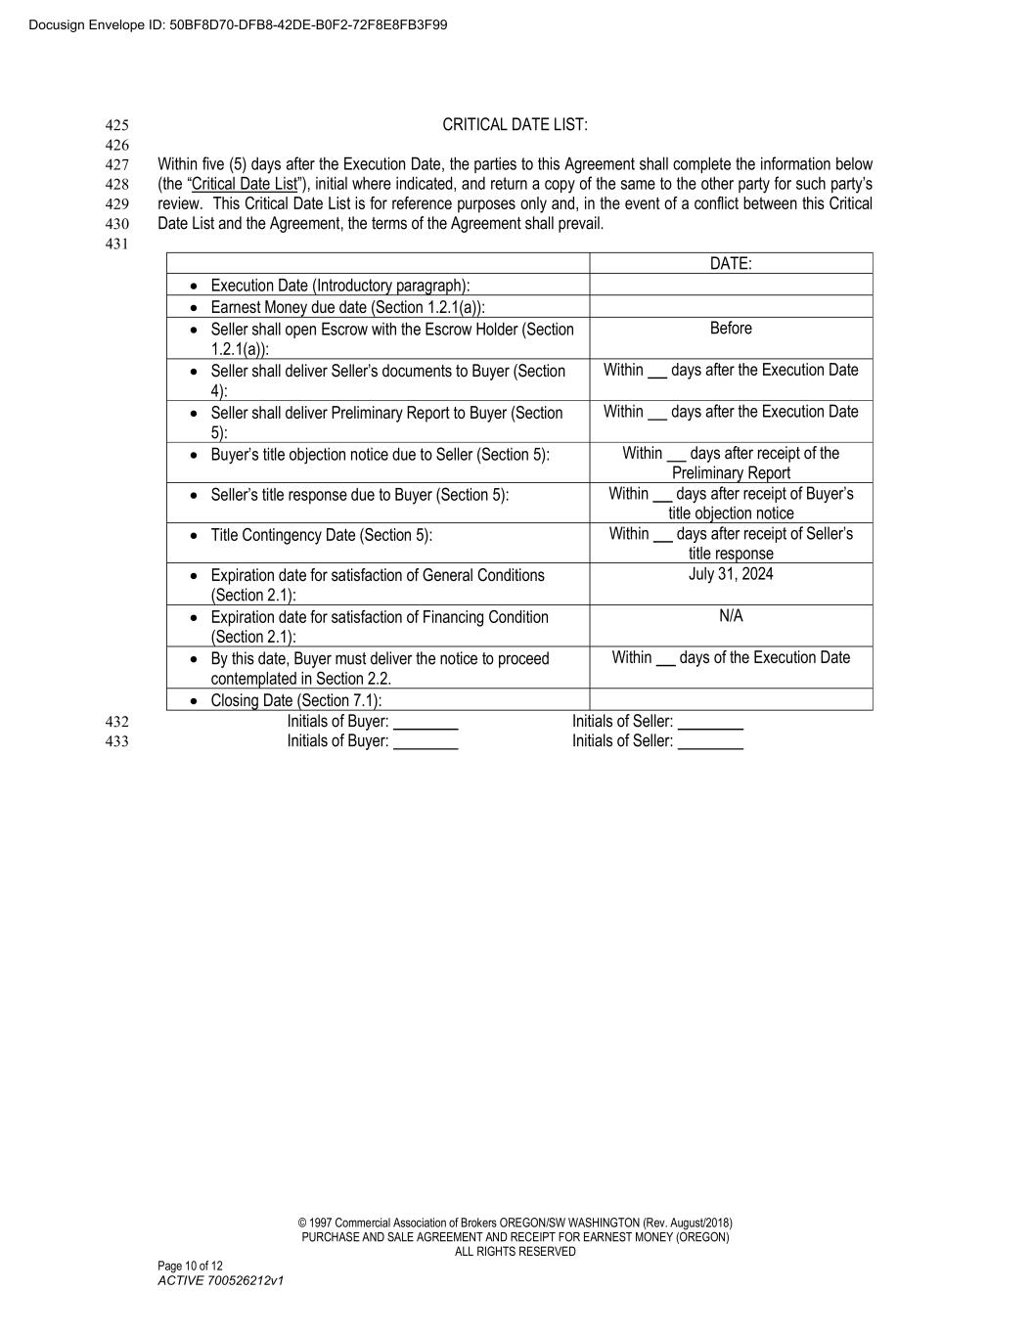
© 1997 Commercial Association of Brokers OREGON/SW WASHINGTON (Rev. August/2018) PURCHASE AND SALE AGREEMENT AND RECEIPT FOR EARNEST MONEY (OREGON) ALL RIGHTS RESERVED Page 10 of 12 ACTIVE 700526212v1 CRITICAL DATE LIST: 425 426 Within five (5) days after the Execution Date, the parties to this Agreement shall complete the information below 427 (the “Critical Date List”), initial where indicated, and return a copy of the same to the other party for such party’s 428 review. This Critical Date List is for reference purposes only and, in the event of a conflict between this Critical 429 Date List and the Agreement, the terms of the Agreement shall prevail. 430 431 DATE: • Execution Date (Introductory paragraph): • Earnest Money due date (Section 1.2.1(a)): • Seller shall open Escrow with the Escrow Holder (Section 1.2.1(a)): Before • Seller shall deliver Seller’s documents to Buyer (Section 4): Within days after the Execution Date • Seller shall deliver Preliminary Report to Buyer (Section 5): Within days after the Execution Date • Buyer’s title objection notice due to Seller (Section 5): Within days after receipt of the Preliminary Report • Seller’s title response due to Buyer (Section 5): Within days after receipt of Buyer’s title objection notice • Title Contingency Date (Section 5): Within days after receipt of Seller’s title response • Expiration date for satisfaction of General Conditions (Section 2.1): July 31, 2024 • Expiration date for satisfaction of Financing Condition (Section 2.1): N/A • By this date, Buyer must deliver the notice to proceed contemplated in Section 2.2. Within days of the Execution Date • Closing Date (Section 7.1): Initials of Buyer: Initials of Seller: 432 Initials of Buyer: Initials of Seller: 433 Docusign Envelope ID: 50BF8D70-DFB8-42DE-B0F2-72F8E8FB3F99

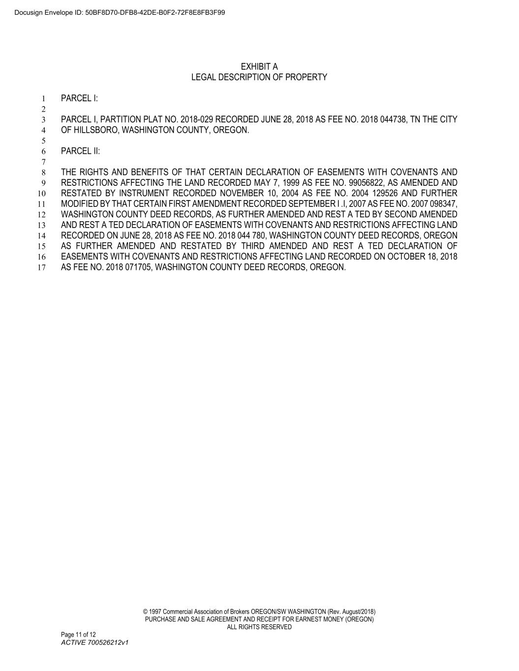
© 1997 Commercial Association of Brokers OREGON/SW WASHINGTON (Rev. August/2018) PURCHASE AND SALE AGREEMENT AND RECEIPT FOR EARNEST MONEY (OREGON) ALL RIGHTS RESERVED Page 11 of 12 ACTIVE 700526212v1 EXHIBIT A LEGAL DESCRIPTION OF PROPERTY PARCEL I: 1 2 PARCEL I, PARTITION PLAT NO. 2018-029 RECORDED JUNE 28, 2018 AS FEE NO. 2018 044738, TN THE CITY 3 OF HILLSBORO, WASHINGTON COUNTY, OREGON. 4 5 PARCEL II: 6 7 THE RIGHTS AND BENEFITS OF THAT CERTAIN DECLARATION OF EASEMENTS WITH COVENANTS AND 8 RESTRICTIONS AFFECTING THE LAND RECORDED MAY 7, 1999 AS FEE NO. 99056822, AS AMENDED AND 9 RESTATED BY INSTRUMENT RECORDED NOVEMBER 10, 2004 AS FEE NO. 2004 129526 AND FURTHER 10 MODIFIED BY THAT CERTAIN FIRST AMENDMENT RECORDED SEPTEMBER I .I, 2007 AS FEE NO. 2007 098347, 11 WASHINGTON COUNTY DEED RECORDS, AS FURTHER AMENDED AND REST A TED BY SECOND AMENDED 12 AND REST A TED DECLARATION OF EASEMENTS WITH COVENANTS AND RESTRICTIONS AFFECTING LAND 13 RECORDED ON JUNE 28, 2018 AS FEE NO. 2018 044 780, WASHINGTON COUNTY DEED RECORDS, OREGON 14 AS FURTHER AMENDED AND RESTATED BY THIRD AMENDED AND REST A TED DECLARATION OF 15 EASEMENTS WITH COVENANTS AND RESTRICTIONS AFFECTING LAND RECORDED ON OCTOBER 18, 2018 16 AS FEE NO. 2018 071705, WASHINGTON COUNTY DEED RECORDS, OREGON. 17 Docusign Envelope ID: 50BF8D70-DFB8-42DE-B0F2-72F8E8FB3F99

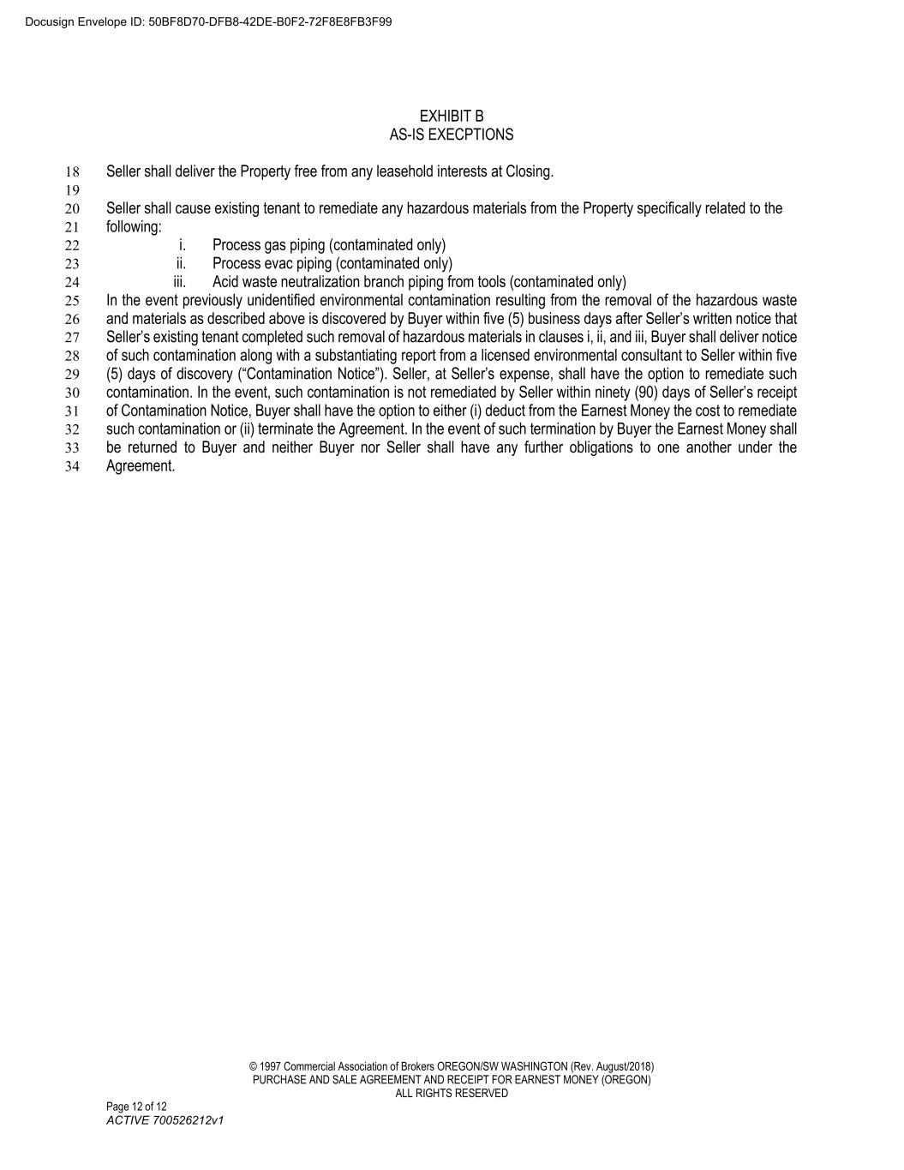
© 1997 Commercial Association of Brokers OREGON/SW WASHINGTON (Rev. August/2018) PURCHASE AND SALE AGREEMENT AND RECEIPT FOR EARNEST MONEY (OREGON) ALL RIGHTS RESERVED Page 12 of 12 ACTIVE 700526212v1 EXHIBIT B AS-IS EXECPTIONS Seller shall deliver the Property free from any leasehold interests at Closing. 18 19 Seller shall cause existing tenant to remediate any hazardous materials from the Property specifically related to the 20 following: 21 i. Process gas piping (contaminated only) 22 ii. Process evac piping (contaminated only) 23 iii. Acid waste neutralization branch piping from tools (contaminated only) 24 In the event previously unidentified environmental contamination resulting from the removal of the hazardous waste 25 and materials as described above is discovered by Buyer within five (5) business days after Seller’s written notice that 26 Seller’s existing tenant completed such removal of hazardous materials in clauses i, ii, and iii, Buyer shall deliver notice 27 of such contamination along with a substantiating report from a licensed environmental consultant to Seller within five 28 (5) days of discovery (“Contamination Notice”). Seller, at Seller’s expense, shall have the option to remediate such 29 contamination. In the event, such contamination is not remediated by Seller within ninety (90) days of Seller’s receipt 30 of Contamination Notice, Buyer shall have the option to either (i) deduct from the Earnest Money the cost to remediate 31 such contamination or (ii) terminate the Agreement. In the event of such termination by Buyer the Earnest Money shall 32 be returned to Buyer and neither Buyer nor Seller shall have any further obligations to one another under the 33 Agreement. 34 Docusign Envelope ID: 50BF8D70-DFB8-42DE-B0F2-72F8E8FB3F99

Exhibit 31.01
CERTIFICATION OF PRINCIPAL EXECUTIVE OFFICER
PURSUANT TO SECTION 302 OF THE SARBANES-OXLEY ACT OF 2002
I, David H. Wang, certify that:
1.I have reviewed this Quarterly Report on Form 10-Q of ACM Research, Inc.
2.Based on my knowledge, this report does not contain any untrue statement of a material fact or omit to state a material fact necessary to make the statements made, in light of the circumstances under which such statements were made, not misleading with respect to the period covered by this quarterly report.
3.Based on my knowledge, the financial statements, and other financial information included in this report, fairly present in all material respects the financial condition, results of operations and cash flows of the registrant as of, and for, the periods presented in this report.
4.The registrant’s other certifying officer and I are responsible for establishing and maintaining disclosure controls and procedures (as defined in Exchange Act Rules 13a-15(e) and 15d-15(e)) and internal control over financial reporting (as defined in Exchange Act Rules 13a-15(f) and 15d-15(f)), for the registrant and have:
(a)designed such disclosure controls and procedures, or caused such disclosure controls and procedures to be designed under our supervision, to ensure that material information relating to the registrant, including its consolidated subsidiaries, is made known to us by others within those entities, particularly during the period in which this report is being prepared;
(b)designed such internal control over financial reporting, or caused such internal control over financial reporting to be designed under our supervision, to provide reasonable assurance regarding the reliability of financial reporting and the preparation of financial statements for external purposes in accordance with generally accepted accounting principles;
(c)evaluated the effectiveness of the registrant’s disclosure controls and procedures and presented in this report our conclusions about the effectiveness of the disclosure controls and procedures, as of the end of the period covered by this report based on such evaluation; and
(d)disclosed in this report any change in the registrant’s internal control over financial reporting that occurred during the registrant’s most recent fiscal quarter (the registrant’s fourth fiscal quarter in the case of an annual report) that has materially affected, or is reasonably likely to materially affect, the registrant’s internal control over financial reporting.
5.The registrant’s other certifying officer and I have disclosed, based on our most recent evaluation of internal control over financial reporting, to the registrant’s auditors and the audit committee of the registrant’s board of directors (or persons performing the equivalent functions):
(a)all significant deficiencies and material weaknesses in the design or operation of internal control over financial reporting which are reasonably likely to adversely affect the registrant’s ability to record, process, summarize and report financial information; and
(b)any fraud, whether or not material, that involves management or other employees who have a significant role in the registrant’s internal control over financial reporting.
Date: November 7, 2024 |  |  | /s/ David H. Wang
 |  |  | David H. Wang
 |  |  | Chief Executive Officer and President
 |  |  | (Principal Executive Officer)

Exhibit 31.02
CERTIFICATION OF PRINCIPAL FINANCIAL OFFICER
PURSUANT TO SECTION 302 OF THE SARBANES-OXLEY ACT OF 2002
I, Mark McKechnie, certify that:
1.I have reviewed this Quarterly Report on Form 10-Q of ACM Research, Inc.
2.Based on my knowledge, this report does not contain any untrue statement of a material fact or omit to state a material fact necessary to make the statements made, in light of the circumstances under which such statements were made, not misleading with respect to the period covered by this quarterly report.
3.Based on my knowledge, the financial statements, and other financial information included in this report, fairly present in all material respects the financial condition, results of operations and cash flows of the registrant as of, and for, the periods presented in this report.
4.The registrant’s other certifying officer and I are responsible for establishing and maintaining disclosure controls and procedures (as defined in Exchange Act Rules 13a-15(e) and 15d-15(e)) and internal control over financial reporting (as defined in Exchange Act Rules 13a-15(f) and 15d-15(f)), for the registrant and have:
(a)designed such disclosure controls and procedures, or caused such disclosure controls and procedures to be designed under our supervision, to ensure that material information relating to the registrant, including its consolidated subsidiaries, is made known to us by others within those entities, particularly during the period in which this report is being prepared;
(b)designed such internal control over financial reporting, or caused such internal control over financial reporting to be designed under our supervision, to provide reasonable assurance regarding the reliability of financial reporting and the preparation of financial statements for external purposes in accordance with generally accepted accounting principles;
(c)evaluated the effectiveness of the registrant’s disclosure controls and procedures and presented in this report our conclusions about the effectiveness of the disclosure controls and procedures, as of the end of the period covered by this report based on such evaluation; and
(d)disclosed in this report any change in the registrant’s internal control over financial reporting that occurred during the registrant’s most recent fiscal quarter (the registrant’s fourth fiscal quarter in the case of an annual report) that has materially affected, or is reasonably likely to materially affect, the registrant’s internal control over financial reporting.
5.The registrant’s other certifying officer and I have disclosed, based on our most recent evaluation of internal control over financial reporting, to the registrant’s auditors and the audit committee of registrant’s board of directors (or persons performing the equivalent functions):
(a)all significant deficiencies and material weaknesses in the design or operation of internal control over financial reporting which are reasonably likely to adversely affect the registrant’s ability to record, process, summarize and report financial information; and
(b)any fraud, whether or not material, that involves management or other employees who have a significant role in the registrant’s internal control over financial reporting.
Date: November 7, 2024 |  |  | /s/ Mark McKechnie
 |  |  | Mark McKechnie
 |  |  | Chief Financial Officer, Executive Vice President and Treasurer
 |  |  | (Principal Financial Officer)

Exhibit 32.01
CERTIFICATION PURSUANT TO 18 U.S.C. 1350,
AS ADOPTED PURSUANT TO SECTION 906 OF THE SARBANES-OXLEY ACT OF 2002
In connection with the Quarterly Report on Form 10-Q of ACM Research, Inc. for the quarterly period ended September 30, 2024, as filed with the Securities and Exchange Commission on the date hereof (the “Report”), each of the undersigned certifies, pursuant to 18 U.S.C. Section 1350, as adopted pursuant to Section 906 of the Sarbanes-Oxley Act of 2002, that, to his or her knowledge on the date hereof:
1.The Report fully complies with the requirements of Section 13(a) or 15(d) of the Securities Exchange Act of 1934; and
2.The information contained in the Report fairly presents, in all material respects, the financial condition and results of operations of ACM Research, Inc. for the period presented therein.
Date: November 7, 2024 |  |  | /s/ David H. Wang
 |  |  | David H. Wang
 |  |  | Chief Executive Officer and President
 |  |  | (Principal Executive Officer)
Date: November 7, 2024 |  |  | /s/ Mark McKechnie
 |  |  | Mark McKechnie
 |  |  | Chief Financial Officer, Executive Vice President and Treasurer
 |  |  | (Principal Financial Officer)
The foregoing certification is being furnished solely pursuant to 18 U.S.C. § 1350 and is not being filed as part of the Report or as a separate disclosure document.

