Table of Contents

UNITED STATES SECURITIES AND EXCHANGE COMMISSION
Washington, D.C. 20549
FORM 10-Q
(Mark One)
☑ |  |  | QUARTERLY REPORT PURSUANT TO SECTION 13 OR 15(d) OF THE SECURITIES EXCHANGE ACT OF 1934
For the quarterly period ended March 31, 2025
or
o |  |  | TRANSITION REPORT PURSUANT TO SECTION 13 OR 15(d) OF THE SECURITIES EXCHANGE ACT OF 1934
For the transition period from _________ to _____________
Commission file number: 001-38273

ACM Research, Inc.
(Exact Name of Registrant as Specified in Its Charter)
Delaware |  |  | 94-3290283
(State or Other Jurisdiction of Incorporation or Organization) |  |  | (I.R.S. Employer Identification No.)
42307 Osgood Road, Suite I  Fremont, California |  |  | 94539
(Address of Principal Executive Offices) |  |  | (Zip Code)
Registrant’s telephone number, including area code: (510) 445-3700
Securities registered pursuant to Section 12(b) of the Act:
Title of Each Class |  |  |  |  |  | Trading Symbol |  |  |  |  |  | Name of Each Exchange on which Registered
Class A Common Stock, $0.0001 par value |  |  |  |  |  | ACMR |  |  |  |  |  | The NASDAQ Stock Market LLC
Indicate by check mark whether the registrant (1) has filed all reports required to be filed by Section 13 or 15(d) of the Securities Exchange Act of 1934 during the preceding 12 months (or for such shorter period that the registrant was required to file such reports), and (2) has been subject to such filing requirements for the past 90 days. Yes ☑ No o
Indicate by check mark whether the registrant has submitted electronically every Interactive Data file required to be submitted pursuant to Rule 405 of Regulation S-T (§232.405 of this chapter) during the preceding 12 months (or for such shorter period that the registrant was required to submit such files). Yes ☑ No o
Indicate by check mark whether the registrant is a large accelerated filer, an accelerated filer, a non-accelerated filer, a smaller reporting company or an emerging growth company. See definitions of “large accelerated filer,” “accelerated filer,” “smaller reporting company” and “emerging growth company” in Rule 12b-2 of the Exchange Act.
 |  |  | Large accelerated filer |  |  | ☑ |  |  |  |  |  | Accelerated filer |  |  | o
 |  |  | Non-accelerated filer |  |  | o |  |  |  |  |  | Smaller reporting company |  |  | o
 |  |  |  |  |  |  |  |  |  |  |  | Emerging growth company |  |  | o
If an emerging growth company, indicate by check mark if the registrant has elected not to use the extended transition period for complying with any new or revised financial accounting standards provided pursuant to Section 13(a) of the Exchange Act. o
Indicate by check mark whether the registrant is a shell company (as defined in Rule 12b-2 of the Exchange Act). Yes o No ☑
Indicate the number of shares outstanding of each of the registrant’s classes of common stock, as of the latest practicable date.
Class |  |  |  |  |  | Number of Shares Outstanding
Class A Common Stock, $0.0001 par value |  |  |  |  |  | 58,842,693 shares outstanding as of May 5, 2025
Class B Common Stock, $0.0001 par value |  |  |  |  |  | 5,021,811 shares outstanding as of May 5, 2025

Table of Contents
TABLE OF CONTENTS
PART I. |  |  |  |  |  | FINANCIAL INFORMATION |  |  | 4
 |  |  | Item 1. |  |  | Financial Statements (unaudited) |  |  | 4
 |  |  |  |  |  | Condensed Consolidated Balance Sheets as of March 31, 2025 and December 31, 2024 |  |  | 4
 |  |  |  |  |  | Condensed Consolidated Statements of Comprehensive Income for the Three Months Ended March 31, 2025 |  |  | 5
 |  |  |  |  |  | Condensed Consolidated Statements of Changes in Equity for the Three Months Ended March 31, 2025 |  |  | 6
 |  |  |  |  |  | Condensed Consolidated Statements of Cash Flows for the Three Months Ended March 31, 2025 |  |  | 7
 |  |  |  |  |  | Notes to the Condensed Consolidated Financial Statements |  |  | 8
 |  |  | Item 2. |  |  | Management’s Discussion and Analysis of Financial Condition and Results of Operations |  |  | 30
 |  |  | Item 3. |  |  | Quantitative and Qualitative Disclosures about Market Risks |  |  | 48
 |  |  | Item 4. |  |  | Controls and Procedures |  |  | 48
PART II. |  |  |  |  |  | OTHER INFORMATION |  |  | 48
 |  |  | Item 1. |  |  | Legal Proceedings |  |  | 49
 |  |  | Item 1A. |  |  | Risk Factors |  |  | 49
 |  |  | Item 2. |  |  | Unregistered Sales of Equity Securities and Use of Proceeds |  |  | 49
 |  |  | Item 3. |  |  | Defaults Upon Senior Securities |  |  | 52
 |  |  | Item 4. |  |  | Mine Safety Disclosures |  |  | 52
 |  |  | Item 5. |  |  | Other Information |  |  | 50
 |  |  | Item 6. |  |  | Exhibits |  |  | 51
Signatures |  |  |  |  |  |  |  |  | 52
ACM Research, Inc., or ACM Research, is a Delaware corporation founded in California in 1998 to supply capital equipment developed for the global semiconductor industry. Since 2005, ACM Research has conducted its business operations principally through its subsidiary ACM Research (Shanghai), Inc., or ACM Shanghai, a limited liability corporation formed by ACM Research in the People’s Republic of China, or mainland China, in 2005. Unless the context requires otherwise, references in this report to “our company,” “our,” “us,” “we” and similar terms refer to ACM Research, Inc. and its subsidiaries, including ACM Shanghai, collectively.

We conduct a substantial majority of our product development, manufacturing, support and services in mainland China through ACM Shanghai. We are not a mainland China operating company, and we do not conduct our operations in mainland China through the use of a variable interest entity or any other structure designed for the purpose of avoiding mainland China legal restrictions on direct foreign investments in mainland China-based companies. For a description of certain matters relating to our operations in mainland China, including our corporate structure, the movement of cash throughout our organization, certain audit and regulatory matters, and risks associated therewith, please see “Item 2—Management’s Discussion and Analysis of Financial Condition and Results of Operations” in this report, the disclosure at the forefront of our Annual Report on Form 10-K for the fiscal year ended December 31, 2024, and the Risk Factors included therein, as referenced or updated by the disclosure included in “Part II. Item 1A—Risk Factors” in this report.
For purposes of this report, certain amounts in Renminbi, or RMB, have been translated into U.S. dollars solely for the convenience of the reader. The translations have been made based on the conversion rates published by the State Administration of Foreign Exchange of the People’s Republic of China.
SAPS, TEBO, ULTRA C, ULTRA Fn, Ultra ECP, Ultra ECP map, and Ultra ECP ap are trademarks of ACM Research. For convenience, these trademarks appear in this report without ™ symbols, but that practice does not mean that ACM Research will not assert, to the fullest extent under applicable law, ACM Research’s rights to the trademarks. This report also contains other companies’ trademarks, registered marks and trade names, which are the property of those companies.

2
Table of Contents
FORWARD-LOOKING STATEMENTS AND STATISTICAL DATA
This report contains forward-looking statements within the meaning of the Private Securities Litigation Reform Act of 1995. All statements, other than statements of historical facts, included in this report regarding our strategy, future operations, future financial position, future revenue, projected costs, prospects, plans and objectives of management are forward-looking statements. In some cases, you can identify forward-looking statements by terms such as “may,” “might,” “will,” “objective,” “intend,” “should,” “could,” “can,” “would,” “expect,” “believe,” “anticipate,” “project,” “target,” “design,” “estimate,” “predict,” “potential,” “plan” or the negative of these terms, and similar expressions intended to identify forward-looking statements. These statements reflect our current views with respect to future events and are based on our management’s belief and assumptions and on information currently available to our management. Although we believe that the expectations reflected in these forward-looking statements are reasonable, these statements relate to future events or our future operational or financial performance, and involve known and unknown risks, uncertainties and other factors, including those described or incorporated by reference in “Item 1A. Risk Factors” of Part II of this report, that may cause our actual results, performance or achievements to be materially different from any future results, performance or achievements expressed or implied by these forward-looking statements.
The information included under the heading “Item 2. Management’s Discussion and Analysis of Financial Condition and Results of Operations – Overview,” of Part I of this report contains statistical data and estimates, including forecasts, that are based on information provided by Gartner, Inc. ("Gartner") in "Forecast: Semiconductor Capital Spending, Wafer Fab Equipment and Capacity, Worldwide, 4Q24 Update, Bob Johnson et al., 26 December 2024." GARTNER is a registered trademark and service mark of Gartner, and/or its affiliates in the U.S. and internationally and is used herein with permission.The Gartner Content described herein ("Gartner Content"), represents research opinions or viewpoints published, as part of a syndicated subscription service, by Gartner, and are not representations of fact. Gartner Content speaks as of its original publication date (not as of the date of this report) and the opinions expressed in the Gartner Content are subject to change without notice. While we are not aware of any misstatements in the Gartner Content, estimates, and in particular forecasts, involve numerous assumptions and are subject to risks and uncertainties, as well as change based on various factors, that could cause results to differ materially from those expressed in the data presented below.
Any forward-looking statement made by us in this report speaks only as of the date on which it is made. Except as required by law, we assume no obligation to update these statements publicly or to update the reasons actual results could differ materially from those anticipated in these statements, even if new information becomes available in the future.
You should read this report, and the documents that we reference in this report and have filed as exhibits to this report, completely and with the understanding that our actual future results may be materially different from what we expect. We qualify all of our forward-looking statements by these cautionary statements.

3
Table of Contents
PART I. FINANCIAL INFORMATION

Item 1. Financial Statements

ACM RESEARCH, INC.
Condensed Consolidated Balance Sheets
(In thousands, except per share data)

 |  |  | March 31 |  |  |  |  |  | December 31,
 |  |  | 2025 |  |  |  |  |  | 2024
Assets |  |  | (Unaudited)
Current assets:
Cash and cash equivalents (note 2) |  |  | $ | 457,240 |  |  |  |  | $ | 407,445
Restricted cash |  |  | 10,586 |  |  |  |  |  | 3,865
Short-term time deposits (note 2) |  |  | 17,202 |  |  |  |  |  | 17,277
Short-term investments (note 14) |  |  | 18,319 |  |  |  |  |  | 19,373
Accounts receivable, net (note 4) |  |  | 387,849 |  |  |  |  |  | 387,045
Other receivables |  |  | 35,050 |  |  |  |  |  | 41,859
Inventories, net (note 5) |  |  | 609,567 |  |  |  |  |  | 597,984
Advances to related party (note 15) |  |  | 1,384 |  |  |  |  |  | 1,024
Prepaid expenses and other current assets |  |  | 10,677 |  |  |  |  |  | 7,507
Total current assets |  |  | 1,547,874 |  |  |  |  |  | 1,483,379
Property, plant and equipment, net (note 6) |  |  | 277,065 |  |  |  |  |  | 269,272
Operating lease right-of-use assets, net (note 10) |  |  | 17,747 |  |  |  |  |  | 14,038
Intangible assets, net |  |  | 2,997 |  |  |  |  |  | 3,461
Long-term time deposits (note 2) |  |  | 13,393 |  |  |  |  |  | 13,275
Deferred tax assets (note 18) |  |  | 16,457 |  |  |  |  |  | 14,781
Long-term investments (note 13) |  |  | 54,814 |  |  |  |  |  | 37,063
Other long-term assets (note 7) |  |  | 3,421 |  |  |  |  |  | 20,452
Total assets |  |  | $ | 1,933,768 |  |  |  |  | $ | 1,855,721
Liabilities and Equity
Current liabilities:
Short-term borrowings (note 8) |  |  | 24,951 |  |  |  |  |  | 32,814
Current portion of long-term borrowings (note 11) |  |  | 67,935 |  |  |  |  |  | 44,472
Related party accounts payable (note 15) |  |  | 19,285 |  |  |  |  |  | 16,133
Accounts payable |  |  | 116,441 |  |  |  |  |  | 139,294
Advances from customers |  |  | 241,456 |  |  |  |  |  | 243,949
Deferred revenue |  |  | 10,781 |  |  |  |  |  | 8,537
Income taxes payable (note 18) |  |  | 6,168 |  |  |  |  |  | 12,779
FIN-48 payable (note 18) |  |  | 19,483 |  |  |  |  |  | 19,466
Other payables and accrued expenses (note 9) |  |  | 118,814 |  |  |  |  |  | 121,657
Current portion of operating lease liabilities (note 10) |  |  | 3,564 |  |  |  |  |  | 2,132
Total current liabilities |  |  | 628,878 |  |  |  |  |  | 641,233
Long-term borrowings (note 11) |  |  | 134,540 |  |  |  |  |  | 105,525
Long-term operating lease liabilities (note 10) |  |  | 6,149 |  |  |  |  |  | 3,840
Other long-term liabilities (note 12) |  |  | 8,848 |  |  |  |  |  | 9,217
Total liabilities |  |  | 778,415 |  |  |  |  |  | 759,815
Commitments and contingencies (note 19)
Equity:
Stockholders’ equity:
Class A Common stock (note 16) |  |  | 6 |  |  |  |  |  | 6
Class B Common stock (note 16) |  |  | 1 |  |  |  |  |  | 1
Additional paid-in capital |  |  | 700,191 |  |  |  |  |  | 677,476
Retained earnings |  |  | 280,380 |  |  |  |  |  | 260,000
Statutory surplus reserve (note 21) |  |  | 30,514 |  |  |  |  |  | 30,514
Accumulated other comprehensive loss |  |  | (61,946) |  |  |  |  |  | (63,372)
Total ACM Research, Inc. stockholders’ equity |  |  | 949,146 |  |  |  |  |  | 904,625
Non-controlling interests |  |  | 206,207 |  |  |  |  |  | 191,281
Total equity |  |  | 1,155,353 |  |  |  |  |  | 1,095,906
Total liabilities and equity |  |  | $ | 1,933,768 |  |  |  |  | $ | 1,855,721

The accompanying notes are an integral part of these condensed consolidated financial statements.

4
Table of Contents
ACM RESEARCH, INC.
Condensed Consolidated Statements of Comprehensive Income
(In thousands, except share and per share data)
(Unaudited)
 |  |  | Three Months Ended March 31,
 |  |  | 2025 |  |  |  |  |  | 2024
Revenue (note 3) |  |  | $ | 172,347 |  |  |  |  | $ | 152,191
Cost of revenue, including cost of revenue from related parties of $9,399 for the three ended March 31, 2025 and $7,230 for the three months ended March 31, 2024 respectively (note 15) |  |  | 89,797 |  |  |  |  |  | 73,070
Gross profit |  |  | 82,550 |  |  |  |  |  | 79,121
Operating expenses:
Sales and marketing |  |  | 16,343 |  |  |  |  |  | 14,173
Research and development |  |  | 27,503 |  |  |  |  |  | 23,918
General and administrative |  |  | 12,927 |  |  |  |  |  | 15,798
Total operating expenses |  |  | 56,773 |  |  |  |  |  | 53,889
Income from operations |  |  | 25,777 |  |  |  |  |  | 25,232
Interest income |  |  | 3,339 |  |  |  |  |  | 1,774
Interest expense |  |  | (1,558) |  |  |  |  |  | (783)
Realized gain from sale of short-term investments (note 14) |  |  | — |  |  |  |  |  | 273
Unrealized loss on short-term investments (note 14) |  |  | (1,082) |  |  |  |  |  | (2,595)
Other (expense) income, net |  |  | (262) |  |  |  |  |  | 3,080
Income (loss) from equity method investments |  |  | 952 |  |  |  |  |  | (520)
Income before income taxes |  |  | 27,166 |  |  |  |  |  | 26,461
Income tax expense (note 18) |  |  | (2,153) |  |  |  |  |  | (4,369)
Net income |  |  | 25,013 |  |  |  |  |  | 22,092
Less: Net income attributable to non-controlling interests |  |  | 4,633 |  |  |  |  |  | 4,659
Net income attributable to ACM Research, Inc. |  |  | $ | 20,380 |  |  |  |  | $ | 17,433
Comprehensive income:
Net income |  |  | 25,013 |  |  |  |  |  | 22,092
Foreign currency translation adjustment, net of tax of nil |  |  | 1,750 |  |  |  |  |  | (6,829)
Comprehensive income |  |  | 26,763 |  |  |  |  |  | 15,263
Less: Comprehensive income attributable to non-controlling interests |  |  | 4,957 |  |  |  |  |  | 3,406
Comprehensive income attributable to ACM Research, Inc. |  |  | $ | 21,806 |  |  |  |  | $ | 11,857
Net income attributable to ACM Research, Inc. per share of common stock (note 2):
Basic |  |  | $ | 0.32 |  |  |  |  | $ | 0.28
Diluted |  |  | $ | 0.30 |  |  |  |  | $ | 0.26
Weighted average shares of common stock outstanding used in computing per share amounts (note 2):
Basic |  |  | 63,267,834 |  |  |  |  |  | 61,367,184
Diluted |  |  | 66,952,774 |  |  |  |  |  | 66,242,321

The accompanying notes are an integral part of these condensed consolidated financial statements.

5
Table of Contents
ACM RESEARCH, INC.
Condensed Consolidated Statements of Changes in Equity
For the Three Months Ended March 31, 2025 and 2024
(In thousands, except share and per share data)
(Unaudited)
 |  |  | Common  Stock Class A |  |  |  |  |  |  |  |  |  |  |  | Common  Stock Class B
 |  |  | Shares |  |  |  |  |  | Amount |  |  |  |  |  | Shares |  |  |  |  |  | Amount |  |  |  |  |  | Additional Paid-  in Capital |  |  |  |  |  | Retained  Earnings |  |  |  |  |  | Statutory  Surplus  Reserve |  |  |  |  |  | Accumulated  Other  Comprehensive  Loss |  |  |  |  |  | Non-controlling  Interests |  |  |  |  |  | Total  Equity
Balance at December 31, 2023 |  |  | 56,036,172 |  |  |  |  |  | $ | 6 |  |  |  |  | 5,021,811 |  |  |  |  |  | $ | 1 |  |  |  |  | $ | 629,845 |  |  |  |  | $ | 156,827 |  |  |  |  | $ | 30,060 |  |  |  |  | $ | (49,349) |  |  |  |  | $ | 158,772 |  |  |  |  | $ | 926,162
Net income |  |  | - |  |  |  |  |  | - |  |  |  |  |  | - |  |  |  |  |  | - |  |  |  |  |  | - |  |  |  |  |  | 17,433 |  |  |  |  |  | - |  |  |  |  |  | - |  |  |  |  |  | 4,659 |  |  |  |  |  | 22,092
Foreign currency translation adjustment |  |  | - |  |  |  |  |  | - |  |  |  |  |  | - |  |  |  |  |  | - |  |  |  |  |  | - |  |  |  |  |  | - |  |  |  |  |  | - |  |  |  |  |  | (5,576) |  |  |  |  |  | (1,253) |  |  |  |  |  | (6,829)
Exercise of stock options |  |  | 950,605 |  |  |  |  |  | - |  |  |  |  |  | - |  |  |  |  |  | - |  |  |  |  |  | 4,799 |  |  |  |  |  | - |  |  |  |  |  | - |  |  |  |  |  | - |  |  |  |  |  | - |  |  |  |  |  | 4,799
Stock-based compensation |  |  | - |  |  |  |  |  | - |  |  |  |  |  | - |  |  |  |  |  | - |  |  |  |  |  | 12,156 |  |  |  |  |  | - |  |  |  |  |  | - |  |  |  |  |  | - |  |  |  |  |  | 2,413 |  |  |  |  |  | 14,569
Balance at March 31, 2024 |  |  | 56,986,777 |  |  |  |  |  | $ | 6 |  |  |  |  | 5,021,811 |  |  |  |  |  | $ | 1 |  |  |  |  | $ | 646,800 |  |  |  |  | $ | 174,260 |  |  |  |  | $ | 30,060 |  |  |  |  | $ | (54,925) |  |  |  |  | $ | 164,591 |  |  |  |  | $ | 960,793

 |  |  | Common  Stock Class A |  |  |  |  |  |  |  |  | Common  Stock Class B
 |  |  | Shares |  |  | Amount |  |  |  |  |  | Shares |  |  | Amount |  |  | Additional Paid-  in Capital |  |  | Retained  Earnings |  |  | Statutory Surplus  Reserve |  |  | Accumulated  Other  Comprehensive  Loss |  |  | Non-controlling  Interests |  |  | Total  Equity
Balance at December 31, 2024 |  |  | 57,938,885 |  |  | 6 |  |  |  |  |  | 5,021,811 |  |  | 1 |  |  | 677,476 |  |  | 260,000 |  |  | 30,514 |  |  | (63,372) |  |  | 191,281 |  |  | 1,095,906
Net income |  |  | - |  |  | - |  |  |  |  |  | - |  |  | - |  |  | - |  |  | 20,380 |  |  | - |  |  | - |  |  | 4,633 |  |  | 25,013
Foreign currency translation adjustment |  |  | - |  |  | - |  |  |  |  |  | - |  |  | - |  |  | - |  |  | - |  |  | - |  |  | 1,426 |  |  | 324 |  |  | 1,750
Exercise of stock options |  |  | 894,040 |  |  | - |  |  |  |  |  | - |  |  | - |  |  | 14,413 |  |  | - |  |  | - |  |  | - |  |  | 8,316 |  |  | 22,729
Stock-based compensation |  |  | - |  |  | - |  |  |  |  |  | - |  |  | - |  |  | 8,302 |  |  | - |  |  | - |  |  | - |  |  | 1,515 |  |  | 9,817
Capital contribution by non-controlling shareholder |  |  | - |  |  | - |  |  |  |  |  | - |  |  | - |  |  | - |  |  | - |  |  | - |  |  | - |  |  | 138 |  |  | 138
Balance at March 31, 2025 |  |  | 58,832,925 |  |  | $ | 6 |  |  |  |  | 5,021,811 |  |  | $ | 1 |  | $ | 700,191 |  | $ | 280,380 |  | $ | 30,514 |  | $ | (61,946) |  | $ | 206,207 |  | $ | 1,155,353

The accompanying notes are an integral part of these condensed consolidated financial statements.

6
Table of Contents
ACM RESEARCH, INC.
Condensed Consolidated Statements of Cash Flows
(In thousands)
(Unaudited)
 |  |  | Three Months Ended March 31,
 |  |  | 2025 |  |  |  |  |  | 2024
Cash flows from operating activities:
Net income |  |  | $ | 25,013 |  |  |  |  | $ | 22,092
Adjustments to reconcile net income from operations to net cash used in operating activities
Non-cash operating lease cost |  |  | 1,086 |  |  |  |  |  | 973
Depreciation and amortization |  |  | 3,017 |  |  |  |  |  | 2,518
Realized gain on short-term investments |  |  | — |  |  |  |  |  | (273)
(Income) loss from equity method investments |  |  | (952) |  |  |  |  |  | 520
Unrealized loss on short-term investments |  |  | 1,082 |  |  |  |  |  | 2,595
Inventory provision |  |  | 4,523 |  |  |  |  |  | 1,025
(Reversal) provision for credit losses |  |  | (9) |  |  |  |  |  | 1,171
Deferred income taxes |  |  | (1,661) |  |  |  |  |  | (1,129)
Stock-based compensation |  |  | 9,817 |  |  |  |  |  | 14,569
Others |  |  | 1,039 |  |  |  |  |  | —
Net changes in operating assets and liabilities:
Accounts receivable |  |  | 190 |  |  |  |  |  | (15,286)
Other receivables |  |  | 7,126 |  |  |  |  |  | (11,580)
Inventories |  |  | (15,108) |  |  |  |  |  | (38,574)
Advances to related party (note 15) |  |  | (360) |  |  |  |  |  | 1,094
Prepaid expenses and other current assets |  |  | (3,136) |  |  |  |  |  | (141)
Related party accounts payable (note 15) |  |  | 3,152 |  |  |  |  |  | 4,836
Accounts payable |  |  | (23,372) |  |  |  |  |  | (5,553)
Advances from customers |  |  | (2,804) |  |  |  |  |  | 2,182
Deferred revenue |  |  | 2,243 |  |  |  |  |  | 4,892
Income taxes payable |  |  | (6,630) |  |  |  |  |  | 5,009
FIN-48 payable |  |  | 17 |  |  |  |  |  | (19)
Other payables and accrued expenses |  |  | 2,431 |  |  |  |  |  | 807
Operating lease liabilities |  |  | (1,053) |  |  |  |  |  | (973)
Other long-term liabilities |  |  | (369) |  |  |  |  |  | (404)
Net cash provided by (used in) operating activities |  |  | 5,282 |  |  |  |  |  | (9,649)
Cash flows from investing activities:
Purchase of property and equipment |  |  | $ | (16,726) |  |  |  |  | (25,419)
Purchase of intangible assets |  |  | (375) |  |  |  |  |  | (668)
Purchase of short-term investments (note 14) |  |  | — |  |  |  |  |  | (1,409)
Purchase of time deposits |  |  | (10,000) |  |  |  |  |  | (45,270)
Proceeds from redemption and maturity of time deposits |  |  | 10,261 |  |  |  |  |  | 90,445
Dividends from unconsolidated affiliates |  |  | — |  |  |  |  |  | 600
Purchase of long-term investments (note 13) |  |  | — |  |  |  |  |  | (5,988)
Net cash (used in) provided by investing activities |  |  | (16,840) |  |  |  |  |  | 12,291
Cash flows from financing activities:
Proceeds from short-term borrowings |  |  | 17,056 |  |  |  |  |  | 23,530
Repayments of short-term borrowings |  |  | (24,961) |  |  |  |  |  | (287)
Proceeds from long-term borrowings |  |  | 52,701 |  |  |  |  |  | —
Repayments of long-term borrowings |  |  | (455) |  |  |  |  |  | (1,193)
Capital contribution by non-controlling shareholder |  |  | 138 |  |  |  |  |  | —
Proceeds from exercise of stock options |  |  | 22,729 |  |  |  |  |  | 4,799
Net cash provided by financing activities |  |  | 67,208 |  |  |  |  |  | 26,849
Effect of exchange rate changes on cash, cash equivalents and restricted cash |  |  | $ | 866 |  |  |  |  | $ | (551)
Net increase in cash, cash equivalents and restricted cash |  |  | 56,516 |  |  |  |  |  | $ | 28,940
Cash, cash equivalents and restricted cash at beginning of period |  |  | 411,310 |  |  |  |  |  | 183,173
Cash, cash equivalents and restricted cash at end of period |  |  | $ | 467,826 |  |  |  |  | $ | 212,113
Supplemental disclosure of cash flow information:
Interest paid, net of capitalized interest |  |  | $ | 1,558 |  |  |  |  | $ | 783
Cash paid for income taxes |  |  | 10,801 |  |  |  |  |  | —
Reconciliation of cash, cash equivalents and restricted cash in consolidated statements of cash flows:
Cash and cash equivalents |  |  | $ | 457,240 |  |  |  |  | $ | 211,305
Restricted cash |  |  | 10,586 |  |  |  |  |  | 808
Cash, cash equivalents and restricted cash |  |  | $ | 467,826 |  |  |  |  | $ | 212,113
Non-cash financing activities:
Cashless exercise of stock options |  |  | $ | 160 |  |  |  |  | $ | 140
Non-cash investing activities:
Transfer of prepayment for property to property, plant and equipment |  |  | $ | 9 |  |  |  |  | $ | 5,320
Proceeds from sale of short-term investments included in other receivables |  |  | $ | — |  |  |  |  | $ | 3,167
Transfer from other non-current assets to long-term investment |  |  | $ | 16,737 |  |  |  |  | $ | —
Purchase property, plant and equipment through other payable |  |  | $ | 23,430 |  |  |  |  | $ | 33,591

The accompanying notes are an integral part of these condensed consolidated financial statements.

7
Table of Contents
ACM RESEARCH, INC.
Notes to the Condensed Consolidated Financial Statements
(In thousands, except share, percentage and per share data)

NOTE 1 – DESCRIPTION OF BUSINESS

ACM Research, Inc. (“ACM” or “ACM Research”) and its subsidiaries (collectively with ACM, the “Company”) develop, manufacture and sell capital equipment to the global semiconductor industry.
The Company has direct or indirect interests in the following subsidiaries:
 |  |  |  |  |  |  |  |  | Effective interest held as at
Name of subsidiaries |  |  | Place and date of incorporation |  |  | Principal Activities |  |  | March 31,  2025 |  |  | December 31,  2024
ACM Research (Shanghai), Inc. ("ACM Shanghai") |  |  | Mainland China, May 2005 |  |  | Principal operating subsidiary |  |  | 81.1 |  | % | 81.5 |  | %
ACM Research (Wuxi), Inc. ("ACM Wuxi") |  |  | Mainland China, July 2011 |  |  | Sales and services |  |  | 81.1 |  | % | 81.5 |  | %
CleanChip Technologies Limited ("CleanChip") |  |  | Hong Kong, June 2017 |  |  | Trading partner between ACM Shanghai and its customers |  |  | 81.1 |  | % | 81.5 |  | %
ACM Research Korea CO., LTD. |  |  | Korea, December 2017 |  |  | Sales, marketing, R&D, production |  |  | 81.1 |  | % | 81.5 |  | %
ACM Research ( Lingang), Inc. ("ACM Lingang") (1) |  |  | Mainland China, March 2019 |  |  | Management of production activities |  |  | 81.1 |  | % | 81.5 |  | %
ACM Research (CA), Inc. ("ACM California") |  |  | USA, April 2019 |  |  | Procurement for ACM Shanghai |  |  | 81.1 |  | % | 81.5 |  | %
ACM Research (Cayman), Inc. |  |  | Cayman Islands, April 2019 |  |  | Administrative function (inactive) |  |  | 100.0 |  | % | 100.0 |  | %
ACM Research (Singapore) PTE. Ltd. ("ACM Singapore") |  |  | Singapore, August 2021 |  |  | Sales, marketing, business development |  |  | 100.0 |  | % | 100.0 |  | %
ACM Research (Beijing), Inc. ("ACM Beijing") |  |  | Mainland China, February 2022 |  |  | Sales, marketing, business development |  |  | 81.1 |  | % | 81.5 |  | %
Hanguk ACM CO., LTD |  |  | Korea, March 2022 |  |  | Sales, services, business development |  |  | 81.1 |  | % | 81.5 |  | %
ACM Research (Chengdu), Inc. ("ACM Chengdu") |  |  | Mainland China, December 2024 |  |  | Sales and services |  |  | 81.1 |  | % | 81.5 |  | %
Shengyi Micro Semiconductor (Shanghai) Co., Ltd. |  |  | Mainland China, December 2024 |  |  | Business development |  |  | 68.9 |  | % | 69.3 |  | %
Yusheng Micro Semiconductor (Shanghai) Co., Ltd. |  |  | Mainland China, June 2023 |  |  | Business development |  |  | 81.1 |  | % | 81.5 |  | %
ACM-Wooil Microelectronics (Shanghai) Co., Ltd. |  |  | Mainland China, June 2023 |  |  | Component development and production |  |  | 58.7 |  | % | 59.0 |  | %

8
Table of Contents
ACM RESEARCH, INC.
Notes to the Condensed Consolidated Financial Statements
(In thousands, except share, percentage and per share data)
NOTE 2 – SUMMARY OF SIGNIFICANT ACCOUNTING POLICIES
Basis of Presentation and Principles of Consolidation
The Company’s condensed consolidated financial statements include the accounts of ACM and its subsidiaries. ACM’s subsidiaries are those entities in which ACM, directly or indirectly, controls a majority of the voting power. All significant intercompany transactions and balances have been eliminated upon consolidation.
The accompanying condensed consolidated financial statements of the Company have been prepared in accordance with U.S. generally accepted accounting principles (“GAAP”) for interim financial information and the rules and regulations of the Securities and Exchange Commission (the “SEC”) for reporting on Form 10-Q. Accordingly, they do not include all the information and footnotes required by GAAP for complete financial statements. The accompanying condensed consolidated financial statements should be read in conjunction with the historical consolidated financial statements of the Company for the year ended December 31, 2024 included in ACM’s Annual Report on Form 10-K.
The accompanying condensed consolidated financial statements are unaudited. In the opinion of management, these unaudited condensed consolidated financial statements of the Company reflect all adjustments that are necessary for a fair presentation of the Company’s financial position and results of operations. Such adjustments are of a normal recurring nature, unless otherwise noted. The balance sheet as of March 31, 2025 and the results of operations for the three months ended March 31, 2025 are not necessarily indicative of the results to be expected for any future period.
Use of Estimates
The preparation of the condensed consolidated financial statements in conformity with GAAP requires management to make estimates and assumptions that affect the reported amounts of assets and liabilities and disclosure of contingent assets and liabilities at the balance sheet date and the reported revenues and expenses during the reported period in the condensed consolidated financial statements and accompanying notes. The Company’s significant accounting estimates and assumptions include, but are not limited to, those used for revenue recognition and deferred revenue, the valuation and recognition of fair value of certain long-term investments, stock-based compensation arrangements, realization of deferred tax assets, uncertain tax position, assessment for impairment of long-lived assets and long-term investments, allowance for credit losses, inventory valuation, useful lives of property, plant and equipment, and useful lives of intangible assets.
Management evaluates these estimates and assumptions on a regular basis. Actual results could differ from those estimates and assumptions.
Cash and Cash Equivalents

Cash and cash equivalents consist of cash on hand, bank deposits that are unrestricted as to withdrawal and use, and highly liquid investments with an original maturity date of three months or less at the date of purchase. At times, cash deposits may exceed government-insured limits.
The following table presents cash and cash equivalents, according to jurisdiction as of March 31, 2025 and December 31, 2024:
 |  |  | March 31,  2025 |  |  |  |  |  | December 31,  2024
United States |  |  | $ | 84,723 |  |  |  |  | $ | 56,308
Mainland China |  |  | 65,356 |  |  |  |  |  | 94,701
China Hong Kong |  |  | 305,582 |  |  |  |  |  | 255,853
Korea |  |  | 1,512 |  |  |  |  |  | 516
Singapore |  |  | 67 |  |  |  |  |  | 67
Total |  |  | $ | 457,240 |  |  |  |  | $ | 407,445
9
Table of Contents
ACM RESEARCH, INC.
Notes to the Condensed Consolidated Financial Statements
(In thousands, except share, percentage and per share data)
The amounts in mainland China do not include short-term and long-term time deposits which in aggregate totaled $30,595 and $30,552 at March 31, 2025 and December 31, 2024, respectively.
Cash held in the U.S. exceeds the Federal Deposit Insurance Corporation insurance limits and is subject to risk of loss. No losses have been experienced to date.
Cash amounts held in mainland China are subject to a series of risk control regulatory standards from mainland China bank regulatory authorities. ACM’s subsidiaries in mainland China are required to obtain approval from the State Administration of Foreign Exchange (“SAFE”) to transfer funds into or out of mainland China. SAFE requires a valid agreement to approve the transfers, which are processed through a bank. Other than these mainland China foreign exchange restrictions, ACM’s subsidiaries in mainland China are not subject to any restrictions and limitations on its ability to transfer funds to ACM or among our other subsidiaries. However, cash held in mainland China does exceed applicable insurance limits and is subject to risk of loss, although no such losses have been experienced to date.

ACM California periodically procures goods and services on behalf of ACM Shanghai and ACM Lingang. For these transactions, ACM Shanghai and ACM Lingang make cash payments to ACM California in accordance with applicable transfer pricing arrangements. For the three months ended March 31, 2025 and 2024, cash payments from ACM Shanghai and ACM Lingang to ACM California for the procurement of goods and services was $2,674 and $4,648, respectively. ACM California periodically borrows funds for working capital advances from its direct parent, CleanChip. ACM California repays or renews these intercompany loans in accordance with their terms.

For sales through CleanChip and ACM Research, a certain amount of sales or advanced payments from customers is repatriated back to ACM Shanghai in accordance with applicable transfer pricing arrangements in the ordinary course of business. ACM Research provides services to certain customers located in the U.S., Europe and other regions outside of mainland China to support the evaluation of first tools and provide support for tools under warranty on behalf of ACM Shanghai. For these transactions, ACM Shanghai makes cash payments to ACM Research in accordance with applicable transfer pricing arrangements.

Amounts held in Korea exceed the Korea Deposit Insurance Corporation insurance limits and is subject to risk of loss. No losses have been experienced to date. There is no additional restriction for the transfer of cash from bank accounts in the U.S., Korea, Singapore and Hong Kong.

For the three months ended March 31, 2025 and 2024, with the exception of sales and services-related transfer-pricing payments in the ordinary course of business, no transfers, or distributions have been made between ACM Research and its subsidiaries, including ACM Shanghai, or to holders of ACM Research Class A common stock.
Time Deposits
Time deposits are deposited with banks in mainland China with fixed terms and interest rates which cannot be withdrawn before maturity, and are presented as short-term deposits and long-term deposits in the condensed consolidated financial statements based on their expected time of collection. They are also subject to the risk control regulatory standards described above upon maturity.
For the three months ended March 31, 2025 and 2024, interest income related to time deposits was $284 and $624, respectively.
Restricted Cash
As of March 31, 2025, all of the Group’s restricted cash was held by financial institutions located in mainland China, Hong Kong and Korea, and mainly represents cash secured to guarantee delivery of tools.
Fair Value Measurement

The Company defines fair value as the price that would be received from selling an asset or paid to transfer a liability in an orderly transaction between market participants at the measurement date. When determining the fair value measurements
10
Table of Contents
ACM RESEARCH, INC.
Notes to the Condensed Consolidated Financial Statements
(In thousands, except share, percentage and per share data)
for assets and liabilities required or permitted to be recorded at fair value, the Company considers the principal or most advantageous market in which it would transact, and it considers assumptions that market participants would use when pricing the asset or liability.

A fair value hierarchy has been established that prioritizes the inputs to valuation techniques used to measure fair value. The level of an asset or liability in the hierarchy is based on the lowest level of input that is significant to the fair value measurement. Assets and liabilities carried at fair value are classified and disclosed in one of the following three categories:

Level 1: Valuations based on quoted prices in active markets for identical assets or liabilities with sufficient volume and frequency of transactions.

Level 2: Valuations based on observable inputs other than Level 1 prices such as quoted prices for similar assets or liabilities, quoted prices in markets that are not active for identical assets or liabilities, or model-derived valuations techniques for which all significant inputs are observable in the market or can be corroborated by observable market data for substantially the full term of the assets or liabilities.

Level 3: Valuations based on unobservable inputs to the valuation methodology that are significant to the measurement of fair value of assets or liabilities and based on non-binding, broker-provided price quotes and may not have been corroborated by observable market data.
The Company’s primary financial instruments include its cash, cash equivalents, short term and long term deposits, restricted cash, short-term and long-term investments, other receivables, accounts receivable, accounts payable, and short-term and long-term borrowings. The estimated fair value of cash and cash equivalents, short-term time deposits, accounts receivable, other receivables, accounts payable, and short-term borrowings approximates their carrying value due to the short period of time to their maturities.

All transfers between fair value hierarchy levels are recognized by the Company at the end of each reporting period. In certain cases, the inputs used to measure fair value may fall into different levels of the fair value hierarchy. In such cases, an investment’s level within the fair value hierarchy is based on the lowest level of input that is significant to the fair value
measurement in its entirety, requires judgment and considers factors specific to the investment. The inputs or methodology
used for valuing financial instruments are not necessarily an indication of the risks associated with investment in those instruments.

Assets and liabilities measured at fair value on a recurring basis:
11
Table of Contents
ACM RESEARCH, INC.
Notes to the Condensed Consolidated Financial Statements
(In thousands, except share, percentage and per share data)
 |  |  | Quoted Prices in Active Markets for Identical Assets (Level 1) |  |  | Significant Other Observable Inputs (Level 2) |  |  | Significant Unobservable Inputs (Level 3) |  |  | Total
As of March 31, 2025:
Assets
Cash and cash equivalents |  |  | $ | 76,510 |  | $ | — |  | $ | — |  | $ | 76,510
Short-term investments |  |  | 18,319 |  |  | — |  |  | — |  |  | 18,319
Available-for-sale debt securities |  |  | — |  |  | — |  |  | 5,375 |  |  | 5,375
 |  |  | $ | 94,829 |  | $ | — |  | $ | 5,375 |  | $ | 100,204
As of December 31, 2024:
Assets
Cash and cash equivalents |  |  | $ | 50,967 |  | $ | — |  | $ | — |  | $ | 50,967
Short-term investments |  |  | 19,373 |  |  | — |  |  | — |  |  | 19,373
Available-for-sale debt securities |  |  | — |  |  | — |  |  | 5,366 |  |  | 5,366
 |  |  | $ | 70,340 |  | $ | — |  | $ | 5,366 |  | $ | 75,706

The Company did not have any assets and liabilities measured at fair value on a non-recurring basis as of March 31, 2025, and the Company did not recognize any unrealized gains (upward adjustments) or unrealized losses (downward adjustments) resulting from observable price changes in orderly transactions for an identical or similar investment of the same issuer for its long-term investments accounted for using measurement alternatives during the three and three months ended March 31, 2025 and 2024.

Refer to Note 11 for fair value information related to the Company’s outstanding long-term borrowings as of March 31, 2025 and December 31, 2024.
12
Table of Contents
ACM RESEARCH, INC.
Notes to the Condensed Consolidated Financial Statements
(In thousands, except share, percentage and per share data)
Basic and Diluted Net Income per Share of Common Stock
Basic and diluted net income per share of common stock are calculated as follows:
 |  |  | Three Months Ended March 31,
 |  |  | 2025 |  |  |  |  |  | 2024
Numerator:
Net income |  |  | $ | 25,013 |  |  |  |  | $ | 22,092
Less: Net income attributable to non-controlling interests |  |  | 4,633 |  |  |  |  |  | 4,659
Net income available to common stockholders, basic |  |  | $ | 20,380 |  |  |  |  | $ | 17,433
Less: Dilutive effect arising from stock-based awards by ACM Shanghai |  |  | 312 |  |  |  |  |  | 354
Net income available to common stockholders, diluted |  |  | $ | 20,068 |  |  |  |  | $ | 17,079
Weighted average shares outstanding, basic |  |  | 63,267,834 |  |  |  |  |  | 61,367,184
Effect of dilutive securities |  |  | 3,684,940 |  |  |  |  |  | 4,875,137
Weighted average shares outstanding, diluted |  |  | 66,952,774 |  |  |  |  |  | 66,242,321
Net income per share of common stock:
Basic |  |  | $ | 0.32 |  |  |  |  | $ | 0.28
Diluted |  |  | $ | 0.30 |  |  |  |  | $ | 0.26

Basic and diluted net income per share of common stock is presented using the two-class method, which allocates undistributed earnings to common stock and any participating securities according to dividend rights and participation rights on a proportionate basis. Under the two-class method, basic net income per share of common stock is computed by dividing the sum of distributed and undistributed earnings attributable to common stockholders by the weighted average number of shares of common stock outstanding during the period. ACM Research did not have any participating securities outstanding during the three months ended March 31, 2025 and 2024.
ACM Research has been authorized to issue Class A and Class B common stock since redomesticating in Delaware in November 2016. The two classes of common stock are substantially identical in all material respects, except for voting rights. Since ACM Research did not declare cash dividends during the three months ended March 31, 2025 or 2024, the net income per share of common stock attributable to each class is the same under the “two-class” method. As such, the two classes of common stock have been presented on a combined basis in the condensed consolidated statements of comprehensive income and in the above computation of net income per share of common stock.

Diluted net income per share of common stock reflects the potential dilution from securities, such as stock options that could share in ACM Research’s earnings. Certain potential dilutive securities were excluded from the net income per share calculation because the impact would be anti-dilutive. The number of potentially dilutive shares that were not included in the calculation of diluted net income per share in the periods presented where their inclusion would be anti-dilutive were 1,298,408 and 728,575 stock options for the three months ended March 31, 2025 and 2024, respectively.
Concentration of Credit Risk
Financial instruments that potentially subject the Company to credit risk consist principally of cash and cash equivalents, time deposits, and accounts receivable. The Company deposits and invests its cash and cash equivalents and time deposits with financial institutions that management believes are creditworthy.
The Company is potentially subject to concentrations of credit risks in its revenue and accounts receivable.
13
Table of Contents
ACM RESEARCH, INC.
Notes to the Condensed Consolidated Financial Statements
(In thousands, except share, percentage and per share data)
•Revenue concentration. For the three months ended March 31, 2025 and 2024, four customers accounted for 53.6% and two customers accounted for 55.9% of revenue, respectively.
•Accounts receivable concentration. As of March 31, 2025 and December 31, 2024, four customers accounted for 52.4% and four customers accounted for 57.1%, respectively, of the Company’s accounts receivables. The Company believes that the receivable balances from these largest customers do not represent a significant credit risk based on past collection experience.
Recently issued accounting pronouncements not yet adopted
In December 2023, the FASB issued ASU No. 2023-09, Improvements to Income Tax Disclosures (Topic 740). The ASU requires disaggregated information about a reporting entity’s effective tax rate reconciliation as well as additional information on income taxes paid. The ASU is effective on a prospective basis for annual periods beginning after December 15, 2024. Retrospective application is permitted. Early adoption is also permitted for annual financial statements that have not yet been issued or made available for issuance. The Company is currently evaluating the provisions of this ASU.

In December 2024, the FASB issued ASU 2024-03: Income Statement--Reporting Comprehensive Income--Expense Disaggregation Disclosures (Subtopic 220-40), which requires additional disclosures about specific types of expenses included in the expense captions presented on the face of the income statement as well as disclosures about selling expenses. In January 2025, the FASB issued ASU 2025-01, which clarifies the effective date of ASU 2024-03. ASU 2024-03 is effective for fiscal years beginning after December 15, 2026, and interim periods within fiscal years beginning after December 15, 2027. This ASU should be applied prospectively with the option to apply the standard retrospectively. The Company is currently evaluating the provisions of this ASU.

NOTE 3 – REVENUE FROM CONTRACTS WITH CUSTOMERS

The Company assesses revenues based upon the nature or type of goods or services it provides and the geographic location of the customer facility. The following tables present disaggregated revenue information:
 |  |  | Three Months Ended March 31,
 |  |  | 2025 |  |  |  |  |  | 2024
Single Wafer Cleaning, Tahoe and Semi-Critical Cleaning Equipment |  |  | $ | 129,569 |  |  |  |  | $ | 109,470
ECP (front-end and packaging), Furnace and Other Technologies |  |  | 27,630 |  |  |  |  |  | 25,800
Advanced Packaging (excluding ECP), Services & Spares |  |  | 15,148 |  |  |  |  |  | 16,921
 |  |  | $ | 172,347 |  |  |  |  | $ | 152,191
 |  |  | Three Months Ended March 31,
 |  |  | 2025 |  |  |  |  |  | 2024
Mainland China |  |  | $ | 169,053 |  |  |  |  | $ | 152,135
Other regions |  |  | 3,294 |  |  |  |  |  | 56
 |  |  | $ | 172,347 |  |  |  |  | $ | 152,191
Below are the accounts receivable and contract liabilities balances as of:
 |  |  | March 31,  2025 |  |  |  |  |  | December 31,  2024
Accounts receivable |  |  | $ | 387,849 |  |  |  |  | $ | 387,045
Advances from customers |  |  | 241,456 |  |  |  |  |  | 243,949
Deferred revenue |  |  | $ | 10,781 |  |  |  |  | $ | 8,537
14
Table of Contents
ACM RESEARCH, INC.
Notes to the Condensed Consolidated Financial Statements
(In thousands, except share, percentage and per share data)
Below are revenues recognized from amounts included in contract liabilities at the beginning of the year.
 |  |  | Three Months Ended March 31,
 |  |  | 2025 |  |  |  |  |  | 2024
Revenue recognized from amounts included in contract liabilities at the beginning of the periods |  |  | $ | 62,119 |  |  |  |  | $ | 29,188

NOTE 4 – ACCOUNTS RECEIVABLE, NET

At March 31, 2025 and December 31, 2024, accounts receivable consisted of the following:
 |  |  | March 31,  2025 |  |  |  |  |  | December 31,  2024
Accounts receivable |  |  | $ | 406,187 |  |  |  |  | $ | 405,392
Less: Allowance for credit losses |  |  | (18,338) |  |  |  |  |  | (18,347)
Total accounts receivable, net |  |  | $ | 387,849 |  |  |  |  | $ | 387,045
The movement of the allowance for credit losses for the three months ended March 31, 2025 is as follows:
March 31,
2025
Allowance for credit losses, before tax, at beginning of the year |  |  | $ | (18,347)
Reversal of credit losses |  |  | 9
Allowance for credit losses, before tax, at the end of the period |  |  | $ | (18,338)

The Company assesses collectability by reviewing accounts receivable on a general basis where similar characteristics exist and on an individual basis when the Company identifies specific customers with known disputes or collectability issues. In determining the amount of the allowance for credit losses, the Company considers historical collectability based on past due status, the age of the accounts receivable balances, credit quality of the Company’s customers based on ongoing credit evaluations, current economic conditions, reasonable and supportable forecasts of future economic conditions, and other factors that may affect the Company’s ability to collect from customers.

NOTE 5 – INVENTORIES, NET

At March 31, 2025 and December 31, 2024, inventories consisted of the following:
 |  |  | March 31,  2025 |  |  |  |  |  | December 31,  2024
Raw materials |  |  | $ | 239,900 |  |  |  |  | $ | 224,086
Work-in-process |  |  | 70,885 |  |  |  |  |  | 80,767
Finished goods |  |  | 298,782 |  |  |  |  |  | 293,131
Total inventories, net |  |  | $ | 609,567 |  |  |  |  | $ | 597,984

At March 31, 2025 and December 31, 2024, the value of finished goods inventory of which were first-tools at customer physical locations for which customers were contractually obligated to take ownership upon acceptance totaled $195,107 and $206,018, respectively.
15
Table of Contents
ACM RESEARCH, INC.
Notes to the Condensed Consolidated Financial Statements
(In thousands, except share, percentage and per share data)
During the three months ended March 31, 2025 and 2024, provision for inventory of $4,523 and $1,025 were recognized in cost of revenue, respectively.

NOTE 6 – PROPERTY, PLANT AND EQUIPMENT, NET
At March 31, 2025 and December 31, 2024, property, plant and equipment consisted of the following:
 |  |  | March 31,  2025 |  |  |  |  |  | December 31,  2024
Buildings and plants |  |  | $ | 139,504 |  |  |  |  | $ | 139,311
Land |  |  | 2,099 |  |  |  |  |  | 2,099
Manufacturing equipment |  |  | 37,017 |  |  |  |  |  | 37,038
Office equipment |  |  | 6,131 |  |  |  |  |  | 5,815
Transportation equipment |  |  | 402 |  |  |  |  |  | 396
Leasehold improvement |  |  | 11,844 |  |  |  |  |  | 11,579
Total cost |  |  | 196,997 |  |  |  |  |  | 196,238
Less: Total accumulated depreciation and amortization |  |  | (27,402) |  |  |  |  |  | (24,882)
Construction in progress |  |  | 107,470 |  |  |  |  |  | 97,916
Total property, plant and equipment, net |  |  | $ | 277,065 |  |  |  |  | $ | 269,272

Depreciation expense for the three months ended March 31, 2025 and 2024 was $2,385 and $2,475, respectively.

At March 31, 2025, land, buildings and plants comprised of $34,790 for the Lingang housing property, $49,764 for the Lingang development and production center, $49,292 for ACM Shanghai's corporate headquarters, and $7,757 for ACM's Oregon facilities, as compared to $34,740, $49,693, $49,221, and $7,757, respectively, at December 31, 2024. The Lingang housing property is pledged as security for loans from China Merchants Bank (Note 11).

Construction in progress primarily reflects costs incurred for certain facilities related to the construction of ACM Shanghai’s Lingang development and production center.

NOTE 7 – OTHER LONG-TERM ASSETS

At March 31, 2025 and December 31, 2024, other long-term assets consisted of the following:
 |  |  | March 31,  2025 |  |  |  |  |  | December 31,  2024
Prepayments for property, plant and equipment |  |  | $ | 218 |  |  |  |  | $ | 32
Lease deposits |  |  | 994 |  |  |  |  |  | 950
Security deposit for land use right |  |  | — |  |  |  |  |  | 686
Prepayment for investment in Ninebell (Note 13) |  |  | — |  |  |  |  |  | 16,737
Others |  |  | 2,209 |  |  |  |  |  | 2,047
Total other long-term assets |  |  | $ | 3,421 |  |  |  |  | $ | 20,452

16
Table of Contents
ACM RESEARCH, INC.
Notes to the Condensed Consolidated Financial Statements
(In thousands, except share, percentage and per share data)
NOTE 8 – SHORT-TERM BORROWINGS

At March 31, 2025 and December 31, 2024, short-term borrowings consisted of the following:
 |  |  | March 31,  2025 |  |  | December 31,  2024
Line of credit up to RMB 200,000 from China Merchants Bank,
1) due on March 12, 2026 with an annual interest rate of 2.28%. |  |  | 13,939 |  |  | -
2) due on August 27, 2025 with an annual interest rate of 2.60%. |  |  | 1,324 |  |  | 1,322
3) due on September 12, 2025 with an annual interest rate of 2.60%. |  |  | 1,324 |  |  | 1,322
4) due on March 12, 2026 with an annual interest rate of 2.28%.. |  |  | 1,394 |  |  | -
5) due on March 12, 2026 with an annual interest rate of 2.28%. |  |  | 1,394 |  |  | -
6) due on February 27, 2025 with an annual interest rate of 2.60%. |  |  | - |  |  | 1,322
7 due on February 28, 2025 with an annual interest rate of 2.60%. |  |  | - |  |  | 1,322
8) due on March 1, 2025 with an annual interest rate of 2.60%. |  |  | - |  |  | 1,322
9) due on March 5, 2025 with an annual interest rate of 2.60%. |  |  | - |  |  | 1,322
10) due on March 8, 2025 with an annual interest rate of 2.60%. |  |  | - |  |  | 1,253
Line of credit up to RMB 40,000 from Bank of China,
1) due on March 20, 2025 with an annual interest rate of 2.75%. |  |  | - |  |  | 16,706
2) due on September 23, 2025 with an annual interest rate of 2.50%. |  |  | 5,576 |  |  | 5,569
Line of credit up to KRW 2,000,000 from Industrial Bank of Korea,
1) due on December 16, 2025 with an annual interest rate of 4.43%. |  |  | - |  |  | 1,354
Total |  |  | $ | 24,951 |  | $ | 32,814
For the three months ended March 31, 2025 and 2024, interest expense related to short-term borrowings amounted to $193 and $213, respectively.

NOTE 9 – OTHER PAYABLES AND ACCRUED EXPENSES

At March 31, 2025 and December 31, 2024, other payables and accrued expenses consisted of the following:
 |  |  | March 31,  2025 |  |  | December 31,  2024
Accrued commissions |  |  | $ | 21,594 |  | $ | 20,180
Accrued warranty |  |  | 13,242 |  |  | 12,710
Accrued payroll |  |  | 25,378 |  |  | 21,677
Accrued professional fees |  |  | 784 |  |  | 896
Accrued machine testing fees |  |  | 1,113 |  |  | 1,082
Accrued machine sales fees |  |  | 9,402 |  |  | 8,840
Accrued Lingang construction fees |  |  | 22,922 |  |  | 28,103
Individual income tax payable |  |  | 11,993 |  |  | 11,975
Payments for investments |  |  | 4,736 |  |  | 4,729
Others |  |  | 7,650 |  |  | 11,465
Total |  |  | $ | 118,814 |  | $ | 121,657
Warranties
17
Table of Contents
ACM RESEARCH, INC.
Notes to the Condensed Consolidated Financial Statements
(In thousands, except share, percentage and per share data)
The Company provides standard warranties on its products. The liability amount is based on actual historical warranty spending activity by type of product, customer, and geographic region, modified for any known differences such as the impact of product reliability improvements.
Changes in the Company’s accrued warranty were as follows:
 |  |  | March 31, |  |  |  |  |  | March 31,
 |  |  | 2025 |  |  |  |  |  | 2024
Balance at beginning of period |  |  | 12,710 |  |  |  |  |  | 9,834
Additions |  |  | 2,534 |  |  |  |  |  | 2,306
Utilized |  |  | (2,002) |  |  |  |  |  | (801)
Balance at end of period |  |  | $ | 13,242 |  |  |  |  | $ | 11,339

NOTE 10 – LEASES

The Company leases space under non-cancelable operating leases for several offices and manufacturing locations. These leases do not have significant rent escalation holidays, concessions, leasehold improvement incentives, or other build-out clauses. Further, the leases do not contain contingent rent provisions.
Most leases include one or more options to renew. The Company regularly evaluates the renewal options, and when they are reasonably certain of exercise, the Company includes the renewal period in its lease term.
The Company’s leases also include a right to use state-owned land in mainland China with lease terms of 50 years expiring in 2070, for which an upfront lump-sum payment was made during the year ended December 31, 2022.
The components of lease expense were as follows:
 |  |  | Three Months Ended March 31,
 |  |  | 2025 |  |  | 2024
Operating lease cost |  |  | $ | 1,086 |  | $ | 973
Short-term lease cost |  |  | 546 |  |  | 321
Total lease cost |  |  | $ | 1,632 |  | $ | 1,294
Supplemental cash flow information related to operating leases was as follows:
 |  |  | Three Months Ended March 31,
 |  |  | 2025 |  |  | 2024
Operating cash outflow from operating leases |  |  | $ | 1,086 |  | $ | 973
Operating lease right-of-use assets obtained in exchange for new operating lease liabilities |  |  | $ | 4,376 |  | $ | 80
18
Table of Contents
ACM RESEARCH, INC.
Notes to the Condensed Consolidated Financial Statements
(In thousands, except share, percentage and per share data)
As of March 31, 2025, maturities of outstanding lease liabilities for all operating leases were as follows:
Year ending December 31
Remainder of 2025 |  |  | 3,045
2026 |  |  | 3,311
2027 |  |  | 3,184
2028 |  |  | 525
2029 and thereafter |  |  | 594
Total lease payments |  |  | $ | 10,659
Less: Interest |  |  | (946)
Present value of lease liabilities |  |  | $ | 9,713
The weighted average remaining lease terms and discount rates for all operating leases, excluding land-use rights, were as follows:
 |  |  | March 31,  2025 |  |  | December 31,  2024
Remaining lease term and discount rate:
Weighted average remaining lease term (years) |  |  | 3.11 |  |  | 3.57
Weighted average discount rate |  |  | 3.16 |  | % | 3.58 |  | %

NOTE 11 – LONG-TERM BORROWINGS

At March 31, 2025 and December 31, 2024, long-term borrowings consisted of the following:

` |  |  | March 31, |  |  |  |  |  | December 31,
 |  |  | 2025 |  |  |  |  |  | 2024
Loan from China Merchants Bank |  |  | $ | 14,052 |  |  |  |  | $ | 11,475
Loan from Agricultural Bank of China |  |  | 13,040 |  |  |  |  |  | 13,020
Loans from Bank of China |  |  | 29,249 |  |  |  |  |  | 28,258
Loan from Bank of Shanghai |  |  | 13,941 |  |  |  |  |  | 13,920
Loans from China CITIC Bank |  |  | 55,662 |  |  |  |  |  | 27,775
Loan from China Everbright Bank |  |  | 55,622 |  |  |  |  |  | 55,549
Loan from Industrial and Commercial Bank of China |  |  | 20,909 |  |  |  |  |  | —
Less: Current portion |  |  | (67,935) |  |  |  |  |  | (44,472)
Total |  |  | $ | 134,540 |  |  |  |  | $ | 105,525

In January 2025, the Company entered into a long-term loan facility, amounted $27,860 from China CITIC Bank, of which we drew down the full amount. The loan carries interest at 50 basis points above the one-year People’s Bank of China ("PBOC") benchmark rate, resulting in an effective rate of 3.6% for the three months ended March 31, 2025. Principal repayment shall be made in 6 installments, with final maturity in January 2028.

19
Table of Contents
ACM RESEARCH, INC.
Notes to the Condensed Consolidated Financial Statements
(In thousands, except share, percentage and per share data)
In August 2024, ACM Shanghai entered into a long-term loan facility, amounted $139,300, from China Merchants Bank for project expenditures. In January 2025, ACM Shanghai drew down $2,996 under this facility. The loan carries interest at 65 basis points below the five-year PBOC benchmark rate, resulting in an effective rate of 3.0%, for the three months ended March 31, 2025, and will be fully repaid in August 2034. Certain covenants for the facility require ACM Shanghai to either repay 50% of the outstanding principal within two months, or repay the loan in accordance with revised payment schedule, if ACM Shanghai does not complete, within three years after then initial drawdown, or before January 2028, a Private Offering with more than RMB 900,000 of proceeds.

In November 2024, the Company entered into a long-term loan facility, amounted $41,790 from Industrial and Commercial Bank of China for the purpose of funding ACM Shanghai's working capital. In February 2025, the Company drew down $20,909 under this facility. The loan carries interest at 75 basis points below the one-year PBOC benchmark rate, resulting in an effective rate of 2.4% for the three months ended March 31, 2025. Principal repayment shall be made in 6 installments, with final maturity in November 2027.

In November 2024, the Company entered into a long-term loan facility, amounted $139,300 from Bank of China for ACM Shanghai project expenditures. In February 2025, the Company drew down $950 under this facility. The loan carries interest at 90 basis points below the five-year PBOC benchmark rate, resulting in an effective rate of 2.7% for the three months ended March 31, 2025. Principal repayment shall be made in 12 installments, with final maturity in June 2034. Certain covenants for the facility require ACM Shanghai’s year-end outstanding interest-bearing not to exceed five times of its annual EBITDA, and to comply with other non-financial covenants, or Bank of China has the right to suspend the facility, or request ACM Shanghai to accelerate repayment or provide credit enhancement.

As of March 31, 2025 and December 31, 2024, the total carrying amount of long-term loans was $202,475 and $149,997, compared with an estimated fair value of $189,779 and $141,264, respectively. The fair value of the long-term loans is estimated by discounting cash flows using interest rates currently available for debts with similar terms and maturities (Level 2 fair value measurement).
Scheduled principal payments for the outstanding long-term loan, including the current portion, as of March 31, 2025 are as follows:
Year ending December 31
Remainder of 2025 |  |  | 44,211
2026 |  |  | 33,806
2027 |  |  | 79,275
2028 |  |  | 35,352
2029 and thereafter |  |  | 9,831
 |  |  | $ | 202,475

For the three months ended March 31, 2025 and 2024, interest expense related to long-term borrowings was $1,365 and $570, respectively.

20
Table of Contents
ACM RESEARCH, INC.
Notes to the Condensed Consolidated Financial Statements
(In thousands, except share, percentage and per share data)
NOTE 12 – OTHER LONG-TERM LIABILITIES

Other long-term liabilities represent government subsidies received from mainland China governmental authorities for development and commercialization of certain technology but not yet recognized. At March 31, 2025 and December 31, 2024, other long-term liabilities consisted of the following unearned government subsidies:
 |  |  | March 31, 2025 |  |  | December 31, 2024
Subsidies commenced in 2020 and prior |  |  | $ | 641 |  | $ | 699
Subsidies to Lingang R&D development, commenced in 2021 |  |  | 7,114 |  |  | 7,350
Other |  |  | 1,093 |  |  | 1,168
Total |  |  | $ | 8,848 |  | $ | 9,217

NOTE 13 – LONG-TERM INVESTMENTS
On April 22, 2024, ACM Shanghai entered into an investment agreement with Ninebell Co., Ltd. (“Ninebell”) to invest $16,737 which represented 20% of Ninebell’s total equity interest. In the three months ended December 31, 2024, ACM Shanghai paid the consideration of $16,737 to Ninebell, which was recorded in other long-term assets in the consolidated
21
Table of Contents
ACM RESEARCH, INC.
Notes to the Condensed Consolidated Financial Statements
(In thousands, except share, percentage and per share data)
balance sheet as of December 31, 2024. The share certificate was issued on January 1, 2025. After the share purchase transaction closed on January 1, 2025, the Company owned 36.2% of Ninebell.
 |  |  | Initial investment dates |  |  | Investment entity |  |  | Percent ownership by ACM and subsidiaries |  |  | Investment purchase price
Equity investee
Ninebell Co., Ltd. ("Ninebell") |  |  | September 2017 |  |  | ACM |  |  | 20.0% |  |  | $ | 1,200
Ninebell Co., Ltd. ("Ninebell") |  |  | January 2025 |  |  | ACM Shanghai |  |  | 20.0% |  |  | $16,737
Wooil Flucon Co. ("Wooil") |  |  | August 2022 |  |  | ACM Singapore |  |  | 20.0% |  |  | $ | 1,000
Hefei Shixi Chanheng Integrated Circuit Industry Venture Capital FundPartnership (LP) (“Hefei Shixi”) |  |  | September 2019 |  |  | ACM Shanghai |  |  | 10.0% |  |  | RMB 30,000 ($4,200)
Shengyi Semiconductor Technology Co., Ltd. ("Shengyi") |  |  | June 2019 |  |  | ACM Shanghai |  |  | 14.0% |  |  | $ | 109
Company D |  |  | February 2024 |  |  | ACM Shanghai |  |  | 14.3% |  |  | RMB 30,000 ($4,230)
Investments accounted for using measurement alternative:
Shengyi |  |  | September 2023 |  |  | ACM Shanghai |  |  | 1.0% |  |  | RMB 6,100 ($900)
Company A |  |  | September 2023 |  |  | ACM Shanghai |  |  | 4.4% |  |  | RMB 30,000 ($4,230)
Company B |  |  | November 2023 |  |  | ACM Shanghai |  |  | 1.2% |  |  | RMB 6,600 ($930)
Company C |  |  | February 2024 |  |  | ACM Shanghai |  |  | 5.0% |  |  | RMB 12,500 ($1,760)
Company E |  |  | April 2024 |  |  | ACM Shanghai |  |  | 0.6% |  |  | RMB 10,000 ($1,430)
Company F |  |  | December 2024 |  |  | ACM Shanghai |  |  | 16.7% |  |  | RMB 10,000 ($1,391)
Available for sale debt securities:
Company G |  |  | December 2024 |  |  | ACM Shanghai |  |  | 2.9% |  |  | RMB 30,000 ($4,173)
22
Table of Contents
ACM RESEARCH, INC.
Notes to the Condensed Consolidated Financial Statements
(In thousands, except share, percentage and per share data)
Equity investee: |  |  | March 31,  2025 |  |  | December 31,  2024
Ninebell |  |  | $ | 25,137 |  | $ | 7,862
Wooil |  |  | 936 |  |  | 936
Shengyi |  |  | 3,210 |  |  | 2,775
Hefei Shixi |  |  | 4,809 |  |  | 4,798
Company D |  |  | 4,179 |  |  | 4,173
Subtotal |  |  | 38,271 |  |  | 20,544
Investments accounted for using measurement alternative:
Shengyi |  |  | 846 |  |  | 845
Company A |  |  | 4,179 |  |  | 4,173
Company B |  |  | 919 |  |  | 918
Company C |  |  | 1,741 |  |  | 1,739
Company E |  |  | 1,393 |  |  | 1,391
Company F |  |  | 1,393 |  |  | 1,391
Other |  |  | 697 |  |  | 696
Subtotal measurement alternative |  |  | 11,168 |  |  | 11,153
Available for sale debt securities
Company G |  |  | 4,179 |  |  | 4,173
Other |  |  | 1,196 |  |  | 1,193
Total |  |  | $ | 54,814 |  | $ | 37,063

For the three months ended March 31, 2025 and 2024, the Company’s share of equity investees’ net income (loss) was $952 and $(520), respectively. For the three months ended March 31, 2025 and 2024, the Company received $0 and $600 dividends from equity investee.

NOTE 14 – SHORT-TERM INVESTMENTS
At March 31, 2025 and December 31, 2024, the components of short-term investments were as follows:
 |  |  | March 31,  2025 |  |  | December 31,  2024
Short-term investments listed in Shanghai Stock Exchange
Cost |  |  | $ | 17,756 |  | $ | 17,731
Market value |  |  | 18,319 |  |  | 19,373
For the three months ended March 31, 2025 and 2024, the net gains (losses) recognized on equity securities were as follows:
23
Table of Contents
ACM RESEARCH, INC.
Notes to the Condensed Consolidated Financial Statements
(In thousands, except share, percentage and per share data)
 |  |  | Three Months Ended March 31,
 |  |  | 2025 |  |  | 2024
Unrealized losses recognized during the reporting period on short-term investments still held at March 31 |  |  | $ | (1,082) |  | $ | (2,595)
Net gains realized on short-term investments sold during the period |  |  | $ | — |  | $ | 273
Total losses recognized at March 31 on short-term investments |  |  | $ | (1,082) |  | $ | (2,322)
For the three months ended March 31, 2025 and 2024 the Company received $0 proceeds from the sale of short-term investments.

NOTE 15 – RELATED PARTY BALANCES AND TRANSACTIONS
Ninebell
Ninebell is an equity investee of ACM and ACM Shanghai (note 13) and is the Company’s principal supplier of robotic delivery system subassemblies used in single-wafer cleaning equipment. The Company purchases equipment from Ninebell for production in the ordinary course of business. The Company pays for a portion of the equipment in advance and is obligated for the remaining amounts upon receipt of the product.
Shengyi
Shengyi is an equity investee of ACM Shanghai (note 13) and is one of the Company’s component suppliers in mainland China. The Company purchases components from Shengyi for production in the ordinary course of business. The Company incurs a service fee related to installation and hook-up fees which is recorded within cost of revenue on the Company’s condensed consolidated statements of comprehensive income. The Company pays for a portion of the raw materials in advance and is obligated for the remaining amounts upon receipt of the product.
All related party outstanding balances are short-term in nature and are expected to be settled in cash.
The following tables reflect related party transactions in our condensed consolidated financial statements:
Advances to related party |  |  | March 31,  2025 |  |  | December 31,  2024
Ninebell |  |  | $ | 277 |  | $ | 1,024
Shengyi |  |  | 1,107 |  |  | —
Total |  |  | $ | 1,384 |  | $ | 1,024
Accounts payable |  |  | March 31,  2025 |  |  | December 31,  2024
Ninebell |  |  | $ | 12,782 |  | $ | 10,830
Shengyi |  |  | 6,503 |  |  | 5,303
Total |  |  | $ | 19,285 |  | $ | 16,133
24
Table of Contents
ACM RESEARCH, INC.
Notes to the Condensed Consolidated Financial Statements
(In thousands, except share, percentage and per share data)
 |  |  | Three Months Ended March 31,
Purchase of materials |  |  | 2025 |  |  | 2024
Ninebell |  |  | $ | 8,812 |  | $ | 14,152
Shengyi |  |  | 1,904 |  |  | 992
Total |  |  | $ | 10,716 |  | $ | 15,144
 |  |  | Three Months Ended March 31,
Service fee charged by |  |  | 2025 |  |  |  |  |  | 2024
Shengyi |  |  | $ | 273 |  |  |  |  | $ | 73

NOTE 16 – COMMON STOCK
ACM is authorized to issue 150,000,000 shares of Class A common stock and 5,307,816 shares of Class B common stock, each with a par value of $0.0001. Each share of Class A common stock is entitled to one vote, and each share of Class B common stock is entitled to twenty votes and is convertible at any time into one share of Class A common stock. Shares of Class A common stock and Class B common stock are treated equally, identically and ratably with respect to any dividends declared by the Board of Directors of ACM unless such Board of Directors declares different dividends to the Class A common stock and Class B common stock, which is subject to approval from a majority of common stockholders.
During the three months ended March 31, 2025, ACM issued 894,040 shares of Class A common stock upon option exercises by employees. During the three months ended March 31, 2024, ACM issued 950,605 shares of Class A common stock upon option exercises by employees and non-employees.
At March 31, 2025 and December 31, 2024, the number of shares of Class A common stock issued and outstanding was 58,832,925 and 57,938,885, respectively.
At March 31, 2025 and December 31, 2024, the number of shares of Class B common stock issued and outstanding was 5,021,811 and 5,021,811, respectively.

NOTE 17 – STOCK-BASED COMPENSATION

During the three months ended March 31, 2025, the Company issued option grants for 32,000 shares to employees and board members under 2016 Omnibus Incentive Plan. The share-based awards are accounted for as equity awards, are only subject to service vesting conditions, and vest over a period of 4 years for employees and 0.25 year for board members. The Company did not grant any non-employee stock options during the three months ended March 31, 2025.

25
Table of Contents
ACM RESEARCH, INC.
Notes to the Condensed Consolidated Financial Statements
(In thousands, except share, percentage and per share data)
The fair value of options granted to employees is estimated on the grant date using the Black-Scholes valuation with following assumptions:
 |  |  | Three Months Ended  March 31, 2025 |  |  | Three Months Ended  March 31, 2024
Fair value of share of common stock(1) |  |  | $26.46-$29.18 |  |  | $31.92
Expected term in years(2) |  |  | 5.50-6.25 |  |  | 6.25
Volatility(3) |  |  | 83.14%-83.28% |  |  | 85.48%
Risk-free interest rate(4) |  |  | 4.18%-4.20% |  |  | 4.23%
Expected dividend(5) |  |  | —% |  |  | —%
(1)Fair value of Class A common stock value was closing market price of the Class A common stock on the grant date.
(2)Expected term of share options is based on the average of the vesting period and the contractual term for each grant.
(3)Volatility is calculated based on the historical volatility of ACM in the period equal to the expected term of each grant.
(4)Risk-free interest rate is based on the yields of U.S. Treasury securities with maturities similar to the expected term of the share options in effect at the time of grant.
(5)Expected dividend is assumed to be 0% as ACM has no history or expectation of paying a dividend on its Class A common stock.
The following table summarizes the components of stock-based compensation expense included in the condensed consolidated statements of comprehensive income:

 |  |  | Three Months Ended March 31,
 |  |  | 2025 |  |  | 2024
Stock-Based Compensation Expense:
Cost of revenue |  |  | $ | 529 |  | $ | 781
Sales and marketing expense |  |  | 2,157 |  |  | 3,027
Research and development expense |  |  | 2,775 |  |  | 4,503
General and administrative expense |  |  | 4,356 |  |  | 6,258
 |  |  | $ | 9,817 |  | $ | 14,569
 |  |  | Three Months Ended March 31,
 |  |  | 2025 |  |  | 2024
Stock-based compensation expense by type:
Employee stock purchase plan |  |  | $ | 2,906 |  | $ | 2,353
Non-employee stock purchase plan |  |  | — |  |  | 9
2019 and 2023 Subsidiary option grants |  |  | 6,911 |  |  | 12,207
 |  |  | $ | 9,817 |  | $ | 14,569

NOTE 18 – INCOME TAXES
Income taxes are accounted for under the asset and liability method. Deferred tax assets and liabilities are recognized for the future tax consequences attributable to differences between the financial statement carrying amounts of existing assets and liabilities and their respective tax bases and operating loss and tax credit carry-forwards. Deferred tax assets and liabilities are measured using enacted tax rates expected to apply to taxable income in the years in which those temporary
26
Table of Contents
ACM RESEARCH, INC.
Notes to the Condensed Consolidated Financial Statements
(In thousands, except share, percentage and per share data)
differences are expected to be recovered or settled. The effect of a change in tax rates on deferred tax assets and liabilities is recognized in income in the period during which such rates are enacted.
The Company considers all available evidence to determine whether it is more likely than not that some portion or all of the deferred tax assets will be realized. The ultimate realization of deferred tax assets is dependent upon the generation of future taxable income during the periods in which those temporary differences become realizable. Management considers the scheduled reversal of deferred tax liabilities (including the impact of available carryback and carry-forward periods) and projected taxable income in assessing the realizability of deferred tax assets. In making such judgments, significant weight is given to evidence that can be objectively verified.

As of each reporting date, management considers new evidence, both positive and negative, that could affect its view of the future realization of deferred tax assets. Prior to September 30, 2019, the Company had recorded a valuation allowance for the full amount of net deferred tax assets in the United States, as the realization of deferred tax assets was uncertain. Since September 30, 2019, the Company has not maintained a valuation allowance except for a partial valuation allowance on certain U.S. and foreign deferred tax assets. In order to recognize the remaining U.S. deferred tax assets that continue to be subject to a valuation allowance, the Company will need to generate sufficient U.S. taxable income in future periods before the expiration of the deferred tax assets governed by the tax code.

ACM Shanghai has shown a three-year historical cumulative profit and has projections of future income. As a result, the Company does not maintain a valuation allowance. The Company accounts for uncertain tax positions in accordance with the authoritative guidance on income taxes under which the Company may only recognize or continue to recognize tax positions that meet a more likely than not threshold. The Company recognizes accrued interest and penalties related to unrecognized tax benefits as a component of the provision for income taxes.

The Company’s effective tax rate differs from statutory rates of 21% for U.S. federal income tax purposes and 25% for Chinese income tax purposes due to the effects of the valuation allowance and certain permanent differences from book-tax differences, including stock based compensation, deemed dividend income under Subchapter F of the U.S. Internal Revenue Code of 1986, as amended (Subpart F), and global intangible low-taxed income (GILTI) inclusions, and R&D super deduction. As a result, the Company recorded income tax expense of $2,153 and $4,369 during the three months ended March 31, 2025 and 2024, respectively. The decrease in the Company's effective income tax rate for the three months ended March 31, 2025 compared to the same period of the prior year was primarily due to a decrease in certain discrete tax benefits.

Under the change in Section 174 made by the Tax Cuts and Jobs Act of 2017 which became effective on January 1, 2022, the Company is required to capitalize, and subsequently amortize R&D expenses over fifteen years for research activities conducted outside of the U.S. The capitalization of overseas R&D expenses results in a significant increase in the Company’s global intangible low-taxed income inclusion.

The Company had total unrecognized tax benefits of $16,774 as of March 31, 2025 and December 31, 2024. If recognized, the net impact to effective rate would be $16,638. The Company did not expect any reversal of unrecognized tax benefits in the next 12 months. The Company will recognize interest and penalties, when they occur, related to uncertain tax provisions as a component of tax expense. For the three months ended March 31, 2025 and 2024, $404 and $339 of interest and penalties was recognized, respectively.

We file income tax returns in the United States and state and foreign jurisdictions. All tax returns will remain open for examination by the federal and state authorities for three and four years, respectively, from the date of utilization of any net operating loss or credits. Certain tax years are subject to foreign income tax examinations by tax authorities until the statute of limitations expire.

Our effective tax rate differs from statutory rates of 21% for U.S. federal income tax purposes and 25% for mainland China income tax purposes due to the effects of the valuation allowance and certain permanent differences as it pertains to book-tax differences in the treatment of stock-based compensation and non-U.S. research expenses. Our four mainland China subsidiaries, ACM Shanghai, ACM Wuxi, ACM Beijing, and ACM Lingang, are liable for mainland China corporate income taxes at the rates of 15%, 25%, 25% and 25%, respectively. Pursuant to the Corporate Income Tax Law of mainland China, our mainland China subsidiaries generally would be liable for mainland China corporate income taxes at a
27
Table of Contents
ACM RESEARCH, INC.
Notes to the Condensed Consolidated Financial Statements
(In thousands, except share, percentage and per share data)
rate of 25%. According to Guoshuihan 2009 No. 203, an entity certified as an “advanced and new technology enterprise” is entitled to a preferential income tax rate of 15%. ACM Shanghai was certified as an “advanced and new technology enterprise” in 2012 and again in 2016, 2018, 2021, and 2024 effective until December 31, 2026.
Income tax expense was as follows:
 |  |  | Three Months Ended March 31,
 |  |  | 2025 |  |  | 2024
Total income tax expense |  |  | $ | (2,153) |  | $ | (4,369)

NOTE 19 – COMMITMENTS AND CONTINGENCIES
The Company leases offices under non-cancelable operating lease agreements. See Note 10 for future minimum lease payments under non-cancelable operating lease agreements with initial terms of one year or more.
As of March 31, 2025, the Company had $6,510 of open capital commitments to construction contracts.
Covenants in ACM Lingang’s Grant Contract for State-owned Construction Land Use Right in Shanghai City (Category of R&D Headquarters and Industrial Projects) with the China (Shanghai) Pilot Free Trade Zone Lingang Special Area Administration require, among other things, that ACM Lingang pay liquidated damages in the event that within 6 years after the land use right is obtained, the Company does not (i) generate a minimum specified amount of annual sales of products manufactured on the granted land or (ii) pay to mainland China at least RMB 157.6 million ($22,000) in annual total taxes (including value-added taxes, corporate income tax, personal income taxes, urban maintenance and construction taxes, education surcharges, stamp taxes, and vehicle and shipping taxes) as a result of operations in connection with the granted land.
In the normal course of business, the Company is subject to contingencies, including legal proceedings, investigations, and environmental claims arising out of the normal course of businesses that relate to a wide range of matters, including among others, contracts breach liability. The Company records accruals for such contingencies based upon the assessment of the probability of occurrence and, where determinable, an estimate of the liability. Management may consider many factors in making these assessments including past history, scientific evidence and the specifics of each matter. Some of these contingencies involve claims that are subject to substantial uncertainties and un-estimable damages.
The Company’s management has evaluated all such proceedings and claims that existed as of March 31, 2025 and December 31, 2024. In the opinion of management, no provision for liability nor disclosure was required as of March 31, 2025 related to any claim against the Company because: (a) there is not a reasonable possibility that a loss exceeding amounts already recognized (if any) may be incurred with respect to such claim; (b) a reasonably possible loss or range of loss cannot be estimated; or (c) such estimate is immaterial.
As of March 31, 2025, the Company had no outstanding legal proceedings.

NOTE 20 – SEGMENT INFORMATION

The Company identifies operating segments according to how the business activities are managed and evaluated. The Company’s chief operating decision maker (“CODM”) has been identified as ACM’s Chief Executive Officer. The Company's operating segments include ACM Research and ACM Shanghai. As the Company is engaged in the developing, manufacture and sale of capital equipment to global semiconductor manufacturers, and each of the operating segments share similar economic and other qualitative characteristics, the results of the Company’s operating segments are aggregated into one reportable segment.

The CODM assesses financial performance for the Company and decides how to allocate resources based on consolidated revenue, gross margin and income from operations. The CODM considers forecasts and actual results on a regular basis when assessing the operating results and making resource decisions. The allocation decisions include top down targets for research and development, sales and marketing, and general and administration expenses, and also for specific budgets for
28
Table of Contents
ACM RESEARCH, INC.
Notes to the Condensed Consolidated Financial Statements
(In thousands, except share, percentage and per share data)
research and development on new product initiatives, or sales and marketing to targeted at specific customer or geographic regions.

Significant expenses within income from operations, as well as within net income, include consolidated cost of revenue, sales and marketing, research and development, and general and administrative, and which are each separately presented on the Condensed Consolidated Statements of Comprehensive Income. Other segment items within net income include interest income, interest expense, income (loss) from equity method investments and other expense (income), net, which are each separately presented on the Condensed Consolidated Statements of Comprehensive Income.

For geographical reporting, revenue by geographic location is determined by the location of customers’ facilities to which products were shipped. Long-lived assets consist primarily of property, plant and equipment, land use right, and right-of-use assets and are attributed to the geographic location in which they are located.

Long-lived assets by geographic region as of the periods ended were as follows:
 |  |  | March 31,  2025 |  |  | December 31,  2024
Long-lived assets by geography:
Mainland China |  |  | $ | 283,394 |  | $ | 287,888
Korea |  |  | 8,903 |  |  | 10,358
United States |  |  | 8,933 |  |  | 8,973
Total |  |  | $ | 301,230 |  | $ | 307,219

NOTE 21 – STATUTORY SURPLUS RESERVE
In accordance with mainland China’s Foreign Enterprise Law, ACM Shanghai, ACM Lingang, and ACM Wuxi are required to make appropriation to reserve funds, comprising the statutory surplus reserve and discretionary surplus reserve, based on after-tax net income in accordance with generally accepted accounting principles of mainland China (“mainland China GAAP”).
Appropriations to the statutory surplus reserve are required to be at least 10% of the after-tax net income determined in accordance with mainland China GAAP until the reserve is equal to 50% of the entities’ registered capital. The amount is calculated annually at the end of each calendar year. The balances of statutory reserve funds was $30,514 as of both March 31, 2025 and December 31, 2024, and is presented as statutory surplus reserve on the Company’s condensed consolidated balance sheets.

29
Table of Contents
Item 2. Management’s Discussion and Analysis of Financial Condition and Results of Operations

You should read the following discussion of our financial condition and results of operations together with our condensed consolidated financial statements and the related notes and other financial information included elsewhere in this report and our Annual Report on Form 10-K for the fiscal year ended December 31, 2024, or our Annual Report. The following discussion contains forward-looking statements that reflect our plans, estimates, and beliefs. Our actual results could differ materially from those discussed in the forward-looking statements. Factors that could cause or contribute to these differences include those discussed in Part I, Item 1A. “Risk Factors” in our Annual Report, as well as those discussed below and elsewhere in this report, particularly in the section titled “Item 1A – Risk Factors” in Part II below.

ACM Research, Inc., or ACM Research, is a Delaware corporation founded in California in 1998 to supply capital equipment developed for the global semiconductor industry. Since 2005, ACM Research has conducted its business operations principally through its subsidiary ACM Research (Shanghai), Inc., or ACM Shanghai, a limited liability corporation formed by ACM Research in the People’s Republic of China, or mainland China, in 2005. Unless the context requires otherwise, references in this report to “our company,” “our,” “us,” “we” and similar terms refer to ACM Research, Inc. and its subsidiaries, including ACM Shanghai, collectively.

Our principal corporate office is located in Fremont, California. We conduct a substantial majority of our product development, manufacturing, support and services in mainland China through ACM Shanghai. We perform, through a subsidiary of ACM Shanghai, additional product development and subsystem production in Korea, and we conduct, through ACM Research, sales and marketing activities focused on sales of ACM Shanghai products in North America, Europe and certain regions in Asia outside mainland China.

ACM Research is not a mainland China operating company, and we do not conduct our operations in mainland China through the use of a variable interest entity, or VIE, or any other structure designed for the purpose of avoiding mainland China legal restrictions on direct foreign investments in mainland China-based companies. ACM Research has a direct ownership interest in ACM Shanghai as the result of its holding 81.1% of the outstanding shares of ACM Shanghai. Stockholders of ACM Research may never directly own equity interests in ACM Shanghai. We do not believe that our corporate structure or any other matters relating to our business operations require that we obtain any permissions or approvals from the China Securities Regulatory Commission, the Cyberspace Administration of China, or any other mainland China central government authority in order to continue to list shares of Class A common stock of ACM Research on the Nasdaq Global Select Market. This determination was based on the facts aforementioned and mainland China Company Law, mainland China Securities Law, cybersecurity regulations and other relevant laws, regulations and regulatory requirements in mainland China currently in effect. However, if this determination proves to be incorrect, then it could have a material adverse effect on ACM Research. See “Item IA. Risk Factors—Risks Related to International Aspects of Our Business—If any mainland China central government authority were to determine that existing mainland China laws or regulations require that ACM Shanghai obtain the authority’s permission or approval to continue the listing of ACM Research’s Class A common stock in the United States or if those existing mainland China laws and regulations, or interpretations thereof, were to change to require such permission or approval, or if we inadvertently conclude that permissions or approvals are not required, ACM Shanghai may be unable to obtain the required permission or approval or may only be able to obtain such permission or approval on terms and conditions that impose material new restrictions and limitations on operation of ACM Shanghai, either of which could have a material adverse effect on our business, financial condition, results of operations, reputation and prospects and on the trading price of ACM Research Class A common stock, which could decline in value or become worthless” in our Annual Report.

In addition, in the ordinary course of business, ACM Shanghai is required to obtain certain operating permits and licenses necessary for it to operate in mainland China, including business licenses, certifications relating to quality management standards, import and export-related qualifications from customs, as well as environmental and construction permits, licenses and approvals relating to construction projects. We believe ACM Shanghai has all such required permits and licenses. However, from time to time mainland China government issues new regulations, which may require additional actions on the part of ACM Shanghai to comply. If ACM Shanghai does not, or is unable to, obtain any such additional permits or licenses, ACM Shanghai may be subjected to restrictions and penalties imposed by the relevant mainland China regulatory authorities, and it could have a material adverse effect on our business, financial condition, results of operations,
30
Table of Contents
reputation and prospects and on the trading price of ACM Research Class A common stock, which could decline in value or become worthless.
The following chart depicts our corporate organization as of March 31, 2025:
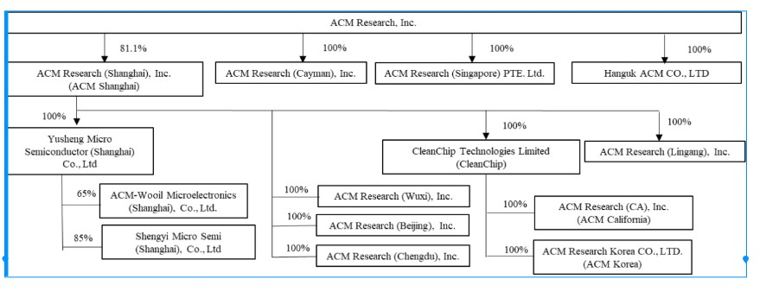A detailed description of how cash is transferred through our organization is set forth under “Note 2 – Summary of Significant Accounting Policies – Cash and Cash Equivalents” to the Condensed Consolidated Financial Statements of this report.

The U.S. Holding Foreign Companies Accountable Act, or the HFCA Act, requires that the Public Company Accounting Oversight Board, or the PCAOB, determine whether it is unable to inspect or investigate completely registered public accounting firms located in a non-U.S. jurisdiction because of a position taken by one or more authorities in any non-U.S. jurisdiction. Under current regulations, if ACM Research were to be included on the SEC's "Conclusive list of issuers identified under the HFCA Act" for two consecutive years due to our independent auditor being located in a jurisdiction that does not allow for PCAOB inspections, the SEC would prohibit trading in our securities and this ultimately could cause our securities to be delisted in the U.S., and their value may significantly decline or become worthless. See “Item 1A. Risk Factors—Risks Related to International Aspects of Our Business—We could be adversely affected if we are unable to comply with legislation and regulations regarding improved access to audit and other information and audit inspections of accounting firms, including registered public accounting firms, such as our prior and current audit firms, operating in mainland China” in our 2024 Annual Report for more information.

Effective on December 2, 2024, the U.S. Department of Commerce’s Bureau of Industry and Security (“BIS”) promulgated a final rule naming a number of companies to the BIS Entity List (the "BIS Entity List"). Among the 140 companies added to the BIS Entity List were two subsidiaries of ACM Research, ACM Shanghai, located in the People’s Republic of China, and ACM Korea, a direct subsidiary of ACM Shanghai, which is located in the Republic of Korea, and other related entities. In general terms, the new BIS Entity List designations prohibit any party worldwide from furnishing hardware, software, or technologies that are subject to U.S. export controls jurisdiction directly or indirectly to ACM Shanghai or ACM Korea without obtaining authorization. See “Item 1A. Risk Factors—Regulatory Risks—Our operations in mainland China and Korea, including the import of components, technology, and activities of U.S. personnel therein, may be further impacted by the addition of ACM Shanghai, ACM Korea and related entities to the BIS Entity List” in our 2024 Annual Report for more information.

On November 15, 2024, the U.S. Department of the Treasury published a final rule implementing a framework for the regulation of outbound foreign investment from the United States. The new program, known as the Outbound Investment Security Program (“OISP”) was codified in the United States Code of Federal Regulations at 31 C.F.R. Part 850, effective as of January 2, 2025. The OISP marks a shift in U.S. economic policy, as historically the United States government declined to restrict outbound investment from the United States for national security reasons. Going forward, the investment activities of multinational companies, including ACM Research are subject to both CFIUS and OISP requirements, which together will limit cross-border investment opportunities, especially as they relate to China. See “Item 1A. Risk Factors—Regulatory Risks—The U.S. Government has implemented an outbound investment review mechanism, which may prevent us from taking advantage of investment opportunities outside the United States that could otherwise be advantageous to our stockholders” in our 2024 Annual Report for more information.
31
Table of Contents

In addition to the matters discussed above, we are also subject to a number of legal and operational risks associated with our corporate structure, including as the result of a substantial portion of our operations being conducted in mainland China. Consequences of any of those risks could result in a material adverse change in our operations or cause the value of ACM Research Class A common stock to significantly decline in value or become worthless. Please carefully read the information included in “Item 1A. Risk Factors” in our 2024 Annual Report, in particular the risk factors addressing the following issues:

• If any mainland China central government authority were to determine that existing mainland China laws or regulations require that ACM Shanghai obtain the authority’s permission or approval to continue the listing of ACM Research’s Class A common stock in the United States or if those existing mainland China laws and regulations, or interpretations thereof, were to change to require such permission or approval, or if we inadvertently conclude that such permissions or approvals are not required, ACM Shanghai may be unable to obtain the required permission or approval or may only be able to obtain such permission or approval on terms and conditions that impose material new restrictions and limitations on operation of ACM Shanghai, either of which could have a material adverse effect on our business, financial condition, results of operations, reputation and prospects and on the trading price of ACM Research Class A common stock, which could decline in value or become worthless.
• Mainland China central government authorities may intervene in, or influence, ACM Shanghai’s mainland China-based operations at any time, and those authorities’ rules and regulations in mainland China can change quickly with little or no advance notice.
• The mainland China central government may determine to exert additional control over offerings conducted overseas or foreign investment in mainland China-based issuers, which could result in a material change in operations of ACM Shanghai and cause significant declines in the value of ACM Research Class A common stock, or make them worthless.

In addition to the matters discussed above, we are also subject to a number of legal and operational risks associated with our corporate structure, including as the result of a substantial portion of our operations being conducted in mainland China. Consequences of any of those risks could result in a material adverse change in our operations or cause the value of ACM Research Class A common stock to significantly decline in value or become worthless. Please carefully read the information included in “Item 1A. Risk Factors” in our Annual Report, in particular the risk factors addressing the following issues:
•If any mainland China central government authority were to determine that existing mainland China laws or regulations require that ACM Shanghai obtain the authority’s permission or approval to continue the listing of ACM Research’s Class A common stock in the United States or if those existing mainland China laws and regulations, or interpretations thereof, were to change to require such permission or approval, or if we inadvertently conclude that permissions or approvals are not required, ACM Shanghai may be unable to obtain the required permission or approval or may only be able to obtain such permission or approval on terms and conditions that impose material new restrictions and limitations on operation of ACM Shanghai, either of which could have a material adverse effect on our business, financial condition, results of operations, reputation and prospects and on the trading price of ACM Research Class A common stock, which could decline in value or become worthless.
•Mainland China central government authorities may intervene in, or influence, ACM Shanghai’s mainland China-based operations at any time, and those authorities’ rules and regulations in mainland China can change quickly with little or no advance notice.
•The mainland China central government may determine to exert additional control over offerings conducted overseas or foreign investment in mainland China-based issuers, which could result in a material change in operations of ACM Shanghai and cause significant declines in the value of ACM Research Class A common stock, or make them worthless.

Past statements and regulatory actions by mainland China central government authorities with respect to the use of VIEs and to data security and anti-monopoly concerns have not affected our ability to conduct our business operations in mainland China. For further information, see “Item 1A. Risk Factors —Risks Related to International Aspects of Our Business” in our Annual Report for more information.

32
Table of Contents
Overview

We supply advanced, innovative capital equipment developed for the global semiconductor industry. Fabricators of advanced integrated circuits, or chips, can use our wet-cleaning and other front-end processing tools in numerous steps to improve product yield, even at increasingly advanced process nodes. We have designed these tools for use in fabricating foundry, logic and memory chips, including dynamic random-access memory, or DRAM, and 3D NAND-flash memory chips. We also develop, manufacture and sell a range of advanced packaging tools to wafer assembly and packaging customers.

Since 2009 we have delivered more than 1,180 tools to our customers, more than 980 of which were repeat orders or acceptances upon contractual performance obligations having been met and thereby generated revenue to us. The balance of the delivered tools is subject to the customer's acceptance of the tool upon the tool's satisfaction of applicable contractual requirements or subject to the customer's subsequent discretionary commitment to purchase the tool. To date, substantially all of our sales of equipment for semiconductor-manufacturing have been to customers located in Asia, and we anticipate that a substantial majority of our revenue from these products will continue to come from customers located in this region for the foreseeable future. We have begun to add to our efforts to further address customers in North America, Western Europe and Southeast Asia, by expanding our direct sales teams and increasing our global marketing activities.

Recent Developments
ACM Shanghai Proposed Private Offering

In January 2024, ACM Research announced ACM Shanghai's intended plan to offer up to 43.6 million of its ordinary shares, subject to market conditions, the approval of ACM Shanghai’s stockholders, completion of the review process by the Shanghai Stock Exchange, completion of the registration process by the China Securities Regulatory Commission, and other factors, in a private offering to qualified buyers, in compliance with the requirements of the China Securities Regulatory Commission, which would constitute up to 10% of ACM Shanghai’s share capital prior to the transaction (the “Private Offering”).

ACM Research estimates that if consummated in full, the proposed Private Offering would generate gross proceeds of up to RMB 4.5 billion ($642.2 million) to ACM Shanghai, whose management would have broad discretion over the use of such proceeds. It is unlikely that any of such proceeds would be distributed to ACM Research. ACM Research's equity interest in ACM Shanghai, if the proposed Private Offering is consummated in full, would decline from 81.1% to approximately 74.6%. As of March 31, 2025 and the date of this report, the proposed Private Offering has not been completed.

Mainland China Government Research and Development Funding

Since 2008, ACM Shanghai has received various government grants for the development and commercialization of certain technologies, and the development of the R&D and production center in the Lingang Special Area of Shanghai (note 12).
The governmental grants contain certain operating conditions, and we are required to complete a government due diligence process once the project is complete. The grants therefore are recorded as long-term liabilities upon receipt, although we are not required to return any funds ACM Shanghai receives.
Grant amounts are recognized in our statements of comprehensive income as follows:
•Government subsidies relating to current expenses are recorded as reductions of those expenses in the periods in which the current expenses are recorded. For the three months ended March 31, 2025 and 2024, related government subsidies recognized as reductions of relevant expenses in the consolidated statements of comprehensive income were $0.3 million and $0.4 million, respectively.
•Government subsidies related to depreciable assets are credited to income over the useful lives of the related assets for which the grant was received. Government subsidies related to VAT reduction are credited to income in the period received. For the three months ended March 31, 2025 and 2024, related government subsidies recognized as other income in the consolidated statements of comprehensive income were $0.3 million and $1.8 million, respectively.

33
Table of Contents
Recent Accounting Pronouncements
A discussion of recent accounting pronouncements is included in our Annual Report and is updated in Note 2 to the condensed consolidated financial statements included in this report.

Net Income Attributable to Non-Controlling Interests
In 2019 ACM Shanghai sold a total number of shares representing 8.3% of its outstanding ACM Shanghai shares, after which ACM Research held the remaining 91.7% of ACM Shanghai’s outstanding shares. In 2021 ACM Shanghai sold a total number of shares representing an additional 10% of its outstanding ACM Shanghai shares in its STAR IPO, after which ACM Research held the remaining 82.5% of ACM Shanghai’s outstanding shares. ACM Research's ownership has since declined to 81.1% due to the exercise of stock options related to ACM Shanghai shares. As a result, we reflect the portion of our net income allocable to the minority holders of ACM Shanghai shares as net income attributable to non-controlling interests.

Critical Accounting Policies and Estimates

In preparing our condensed consolidated financial statements in conformity with GAAP, we make assumptions, judgments and estimates in applying our accounting policies that can have a significant impact on our revenue, operating income and net income, as well as on the value of certain assets and liabilities on our condensed consolidated balance sheets. We base our assumptions, judgments and estimates on historical experience and various other factors that we believe to be reasonable under the circumstances. At least quarterly, we evaluate our assumptions, judgments and estimates and make changes as deemed necessary. Actual results could differ materially from these estimates under different assumptions or conditions.

We believe that the assumptions, judgments and estimates involved in the accounting for the following accounting policies have the greatest potential impact on our condensed consolidated financial statements, and we therefore consider these to be our critical accounting estimates. For information on our significant accounting policies, see Note 2 in the notes to condensed consolidated financial statements in Part I, Item 1 of this report and in the Notes to Condensed Consolidated Financial Statements in Part II, Item 8 of our Annual Report, describe the significant accounting policies and methods used in the preparation of the Company’s condensed consolidated financial statements. There have been no material changes to the Company’s critical accounting estimates included in our Annual Report.

34
Table of Contents
Results of Operations
The following table sets forth our results of operations for the periods presented, as percentages of revenue.
 |  |  | Three Months Ended March 31,
 |  |  | 2025 |  |  |  |  |  | 2024
Revenue |  |  | 100.0 |  | % |  |  |  | 100.0 |  | %
Cost of revenue |  |  | 52.1 |  |  |  |  |  | 48.0
Gross margin |  |  | 47.9 |  |  |  |  |  | 52.0
Operating expenses:
Sales and marketing |  |  | 9.5 |  |  |  |  |  | 9.3
Research and development |  |  | 16.0 |  |  |  |  |  | 15.7
General and administrative |  |  | 7.5 |  |  |  |  |  | 10.4
Total operating expenses |  |  | 33.0 |  |  |  |  |  | 35.4
Income from operations |  |  | 14.9 |  |  |  |  |  | 16.6
Interest income, net |  |  | 1.0 |  |  |  |  |  | 0.6
Realized gain from sale of short-term investments |  |  | 0.0 |  |  |  |  |  | 0.2
Unrealized loss on short-term investments |  |  | -0.6 |  |  |  |  |  | -1.7
Other (expense) income, net |  |  | -0.2 |  |  |  |  |  | 2.0
Income (loss) from equity method investments |  |  | 0.6 |  |  |  |  |  | -0.3
Income before income taxes |  |  | 15.7 |  |  |  |  |  | 17.4
Income tax expense |  |  | -1.2 |  |  |  |  |  | -2.9
Net income |  |  | 14.5 |  |  |  |  |  | 14.5
Less: Net income attributable to non-controlling interests |  |  | 2.7 |  |  |  |  |  | 3.0
Net income attributable to ACM Research, Inc. |  |  | 11.8 |  | % |  |  |  | 11.5 |  | %
Comparison of Three Months Ended March 31, 2025 and 2024
Revenue
 |  |  | Three Months Ended March 31,
 |  |  | 2025 |  |  |  |  |  | 2024 |  |  |  |  |  | % Change  2025 v 2024 |  |  |  |  |  | Absolute Change  2025 v 2024
 |  |  | (in thousands)
Single wafer cleaning, Tahoe and semi-critical cleaning equipment |  |  | $ | 129,569 |  |  |  |  | $ | 109,470 |  |  |  |  | 18.4 |  | % |  |  |  | $ | 20,099
ECP (front-end and packaging), furnace and other technologies |  |  | 27,630 |  |  |  |  |  | 25,800 |  |  |  |  |  | 7.1 |  | % |  |  |  | 1,830
Advanced packaging (excluding ECP), services & spares |  |  | 15,148 |  |  |  |  |  | 16,921 |  |  |  |  |  | (10.5) |  | % |  |  |  | (1,773)
Total Revenue by Product Category |  |  | $ | 172,347 |  |  |  |  | $ | 152,191 |  |  |  |  | 13.2 |  | % |  |  |  | $ | 20,156
The increase in revenue for three months ended March 31, 2025 as compared to the same period in 2024 reflects higher sales of single wafer cleaning, Tahoe and semi-critical cleaning equipment, and ECP (front-end and packaging), furnace and other technologies, partly offset by lower Advanced packaging (excluding ECP), services and spares. The increased
35
Table of Contents
demand is due in part to a longer term commitment by our mainland China-based customers to increase production capacity to achieve a greater share of the global semiconductor market.
Cost of Revenue and Gross Margin
 |  |  | Three Months Ended March 31,
 |  |  | 2025 |  |  |  |  |  | 2024 |  |  |  |  |  | % Change  2025 v 2024 |  |  |  |  |  | Absolute Change  2025 v 2024
 |  |  | (in thousands)
Cost of revenue |  |  | $ | 89,797 |  |  |  |  | $ | 73,070 |  |  |  |  | 22.9 |  | % |  |  |  | $ | 16,727
Gross profit |  |  | 82,550 |  |  |  |  |  | 79,121 |  |  |  |  |  | 4.3 |  | % |  |  |  | 3,429
Gross margin |  |  | 47.9 |  | % |  |  |  | 52.0 |  | % |  |  |  | (4.1) |  | % |  |  |  | (409)bps
Cost of revenue and gross profit increased in the three months ended March 31, 2025 as compared to the corresponding period in 2024 due to the increased sales volume, partly offset by a decrease in gross margin. The decrease in gross margin versus the prior-year period was primarily due to revenue mix between product categories, and a higher provision for inventory. Gross margin may vary from period to period, primarily related to the level of utilization and the timing and mix of revenue. We expect gross margin to be between 42.0% and 48.0% for the foreseeable future.
Operating Expenses
 |  |  | Three Months Ended March 31,
 |  |  | 2025 |  |  |  |  |  | 2024 |  |  |  |  |  | % Change  2025 v 2024 |  |  |  |  |  | Absolute Change  2025 v 2024
 |  |  | (in thousands)
Sales and marketing expense |  |  | $ | 16,343 |  |  |  |  | $ | 14,173 |  |  |  |  | 15.3 |  | % |  |  |  | $ | 2,170
Research and development expense |  |  | 27,503 |  |  |  |  |  | 23,918 |  |  |  |  |  | 15.0 |  | % |  |  |  | 3,585
General and administrative expense |  |  | 12,927 |  |  |  |  |  | 15,798 |  |  |  |  |  | (18.2) |  | % |  |  |  | (2,871)
Total operating expenses |  |  | $ | 56,773 |  |  |  |  | $ | 53,889 |  |  |  |  | 5.4 |  | % |  |  |  | $ | 2,884

Sales and marketing expense increased in the three months ended March 31, 2025 as compared to the corresponding period in 2024, reflecting an increase of $2.6 million due to personnel costs, and a net increase of $0.5 million for commissions, travel & entertainment, outside services and other expenses, offset by a $0.9 million decrease in stock-based compensation.

Sales and marketing expense consists primarily of:
•compensation of personnel associated with pre-sale and after-sale services and support and other sales and marketing activities, including stock-based compensation;
•sales commissions paid to independent sales representatives;
•fees paid to sales consultants;
•cost of trade shows;
•costs of tools built for promotional purposes for potential new customers;
•travel and entertainment; and
•rent and utilities.
We expect that, for the foreseeable future, sales and marketing expenses will increase in dollars, as we incur additional costs associated with growing our customer base in mainland China and regions outside of mainland China.
Research and development expense increased in the three months ended March 31, 2025 as compared to the corresponding period in 2024, reflecting an increase of $3.9 million R&D-related personnel costs, an increase of $1.0 million in costs of
36
Table of Contents
components for tools built for product development purposes, and a net increase of $0.4 million in depreciation, outside services and other R&D-related costs, offset by a decrease of $1.7 million in stock-based compensation.
Research and development expense represented 16.0% and 15.7% of our revenue in the three months ended March 31, 2025 and 2024, respectively. Without reduction by grant amounts received from mainland China governmental authorities (see ‘–Mainland China Government Research and Development Funding’’), gross research and development expense totaled $27.8 million, or 16.1% of total revenue, in the three months ended March 31, 2025 as compared to $24.4 million, or 16.0% of revenue, in the corresponding period in 2024.
Research and development expense consists primarily of:
•compensation of personnel associated with our research and development activities, including stock based compensation;
•costs of components and other research and development supplies;
•costs of tools built for product development purposes;
•travel expense associated with the research of technical requirements for product development purposes and testing of concepts under consideration;
•amortization of costs of software used for research and development purposes; and
•rent and utilities.

We expect that, for the foreseeable future, research and development expenses will increase in dollars, as we incur additional costs to expand our product portfolio to address additional production steps and expand our research and development team to new regions.

General and administrative expense decreased in the three months ended March 31, 2025 as compared to the corresponding period in 2024, primarily reflecting a $0.9 million net increase in personnel and professional services costs, offset by a $1.9 million decrease in stock-based compensation, a $1.2 million decrease in allowance for credit losses, and a $0.7 million decrease in other costs related to general and administrative expenses.

General and administrative expense consists primarily of:
•compensation of executive, accounting and finance, human resources, information technology, and other administrative personnel, including stock-based compensation;
•professional fees, including accounting and corporate legal and defense fees;
•other corporate expenses including insurance;
•allowance for credit losses; and
•rent and utilities.
We expect that, for the foreseeable future, general and administrative expenses will increase in dollars, as we incur additional costs associated with growing our business, operating ACM Research, as a public company in the United States and operating ACM Shanghai as a public company in mainland China.
Interest income, net, Other expense, net
 |  |  | Three Months Ended March 31,
 |  |  | 2025 |  |  |  |  |  | 2024 |  |  |  |  |  | % Change  2025 v 2024 |  |  |  |  |  | Absolute Change  2025 v 2024
 |  |  | (in thousands)
Interest income |  |  | $ | 3,339 |  |  |  |  | $ | 1,774 |  |  |  |  | 88.2 |  | % |  |  |  | $ | 1,565
Interest expense |  |  | (1,558) |  |  |  |  |  | (783) |  |  |  |  |  | 99.0 |  | % |  |  |  | (775)
Interest income, net |  |  | $ | 1,781 |  |  |  |  | $ | 991 |  |  |  |  | 79.7 |  | % |  |  |  | $ | 790
Other (expense) income, net |  |  | $ | (262) |  |  |  |  | $ | 3,080 |  |  |  |  | -108.5 |  | % |  |  |  | $ | (3,342)

37
Table of Contents
Interest income, net consists of interest earned on our cash and cash equivalents, restricted cash accounts, and short-term and long-term time deposits, offset by interest expense incurred from outstanding short-term and long-term borrowings. Interest income (expense), net increased in the three months ended March 31, 2025 as compared to the corresponding period in 2024, as a result of changes in balances of cash, cash equivalents, time deposits, and debt, together with changes in interest rates earned or expensed on the respective balances.
Other income (expense), net primarily reflects (a) loss recognized from the impact of exchange rates on our working-capital which was $(0.6) million for the three months ended March 31, 2025 compared to $1.4 million recognized from the impact of exchange rates on our working capital for the three months ended March 31, 2024, and (b) government subsidies, as described under “—Mainland China Government Research and Development Funding” above, and other factors.
Realized gain and unrealized loss from short-term investment, and income (loss) from equity investments.
 |  |  | Three Months Ended March 31,
 |  |  | 2025 |  |  |  |  |  | 2024 |  |  |  |  |  | % Change  2025 v 2024 |  |  |  |  |  | Absolute Change  2025 v 2024
 |  |  | (in thousands)
Realized gain from sale of short-term investments |  |  | $ | — |  |  |  |  | $ | 273 |  |  |  |  | (100.0) |  | % |  |  |  | $ | (273)
Unrealized loss on short-term investments |  |  | (1,082) |  |  |  |  |  | (2,595) |  |  |  |  |  | (58.3) |  | % |  |  |  | $ | 1,513
Income (loss) from equity method investments |  |  | $ | 952 |  |  |  |  | $ | (520) |  |  |  |  | (283.1) |  | % |  |  |  | $ | 1,472
We recorded a realized gain from sale of short term investments of nil for the three months ended March 31, 2025 as compared to $0.3 million in the prior-year period due to a sale of short-term investments (note 14).
We recorded an unrealized loss on short term investments of $1.1 million for the three months ended March 31, 2025 as compared to an unrealized loss of $2.6 million for the same period in 2024, based on a change in market value of ACM Shanghai’s short-term investments (note 14).
Income (loss) from equity investments was $1.0 million for the three months ended March 31, 2025 as compared to loss from equity method investments of $0.5 million in the same period in 2024 due to an increase of net income from investments in affiliates (note 13).
Income Tax Expense
The following presents components of income tax expense for the indicated periods:
 |  |  | Three Months Ended March 31,
 |  |  | 2025 |  |  |  |  |  | 2024
 |  |  | (in thousands)
Income tax expense |  |  | $ | (2,153) |  |  |  |  | $ | (4,369)
We recognized a tax expense of $2.2 million for the three months ended March 31, 2025 as compared to a tax expense of $4.4 million for the prior year period. The tax expense for the three months ended March 31, 2025 primarily resulted from the tax effect of a decrease in our effective income tax rate applied to a slight increase in operating profit for the period. The decrease in our effective income tax rate for the three months ended March 31, 2025 compared to the same period of the prior year was primarily due to a lower estimated effective tax rate for ACM Shanghai and other factors.
Our effective tax rate differs from statutory rates of 21% for U.S. federal income tax purposes and 25% for mainland China income tax purposes due to the effects of the valuation allowance and certain permanent differences as it pertains to book-tax differences in the treatment of stock-based compensation and non-U.S. research expenses. Our four mainland China
38
Table of Contents
subsidiaries, ACM Shanghai, ACM Wuxi, ACM Beijing, and ACM Lingang, are liable for mainland China corporate income taxes at the rates of 15%, 25%, 25%, and 25%, respectively. Pursuant to the Corporate Income Tax Law of mainland China, our mainland China subsidiaries generally would be liable for mainland China corporate income taxes at a rate of 25%. According to Guoshuihan 2009 No. 203, an entity certified as an “advanced and new technology enterprise” is entitled to a preferential income tax rate of 15%. ACM Shanghai was certified as an “advanced and new technology enterprise” in 2012 and again in 2016, 2018, 2021,and 2024 effective until December 31, 2026.
We file income tax returns in the United States and state and foreign jurisdictions. All tax returns will remain open for examination by the federal and state authorities for three and four years, respectively, from the date of utilization of any net operating loss or credits. Certain tax years are subject to foreign income tax examinations by tax authorities until the statute of limitations expire.
Net Income Attributable to Non-Controlling Interests
 |  |  | Three Months Ended March 31,
 |  |  | 2025 |  |  |  |  |  | 2024 |  |  |  |  |  | % Change  2025 v 2024 |  |  |  |  |  | Absolute Change  2025 v 2024
 |  |  | (in thousands)
Net income attributable to non-controlling interests |  |  | $ | 4,633 |  |  |  |  | $ | 4,659 |  |  |  |  | (0.6) |  | % |  |  |  | $ | (26)
ACM Research owns 81.1% of ACM Shanghai’s (note 1) outstanding shares which is reflected in our condensed consolidated financial statements. We reflect the portion of net income allocable to the minority holders of ACM Shanghai shares as net income attributable to non-controlling interests.
Foreign currency translation adjustment
 |  |  | Three Months Ended March 31,
 |  |  | 2025 |  |  |  |  |  | 2024 |  |  |  |  |  | % Change  2025 v 2024 |  |  |  |  |  | Absolute Change  2025 v 2024
 |  |  | (in thousands)
Foreign currency translation adjustment |  |  | $ | 1,750 |  |  |  |  | $ | (6,829) |  |  |  |  | (125.6) |  | % |  |  |  | $ | 8,579
We recorded a gain of foreign currency translation adjustment of $1.8 million for the three months ended March 31, 2025, as compared to a loss of $6.8 million for the same period in 2024, primarily based on the net effect of RMB to dollar exchange rate fluctuations for the period on the converted value of ACM Shanghai’s RMB-denominated balances to U.S. dollar equivalents.
39
Table of Contents

Comprehensive income attributable to non-controlling interests

 |  |  | Three Months Ended March 31,
 |  |  | 2025 |  |  |  |  |  | 2024 |  |  |  |  |  | % Change  2025 v 2024 |  |  |  |  |  | Absolute Change  2025 v 2024
 |  |  | (in thousands)
Comprehensive income attributable to non-controlling interests |  |  | $ | 4,957 |  |  |  |  | $ | 3,406 |  |  |  |  | 45.5 |  | % |  |  |  | $ | 1,551

Comprehensive income attributable to non-controlling interests for the three months ended March 31, 2025 increased by $1.6 million as compared to the same period in 2024, reflecting a change in net income attributable to the non-controlling interests for the period together with the impact of foreign exchange rate fluctuations on the cumulative balance.

Liquidity and Capital Resources

During the first three months of 2025, we funded our technology development and operations principally through our beginning global cash balances, including the cash balances at ACM Shanghai, borrowings by ACM Shanghai from local financial institutions, our loan from China CITIC Bank, and cash flow from operations.

Cash and cash equivalents, restricted cash, short-term time deposits and long-term time deposits were $498.4 million at March 31, 2025, compared to $441.9 million at December 31, 2024. The $56.5 million increase was primarily driven by $67.2 million net cash provided by financing activities, $5.3 million of cash provided by operations, and a $0.9 million increase from the effect of exchange rate on cash, cash equivalents, restricted cash and non-cash items, offset by a $17.1 million of net cash used in investing activities, excluding the change in net cash related to time deposits.

 |  |  | March 31,  2025 |  |  |  |  |  | December 31,  2024
 |  |  | (In thousands)
Cash and cash equivalents, restricted cash, and time deposits:
Cash and cash equivalents and restricted cash |  |  | $ | 467,826 |  |  |  |  | $ | 411,310
Short-term time deposits |  |  | 17,202 |  |  |  |  |  | 17,277
Long-term time deposits |  |  | 13,393 |  |  |  |  |  | 13,275
Total |  |  | $ | 498,421 |  |  |  |  | $ | 441,862
Our future working capital needs beyond the next twelve months will depend on many factors, including the rate of our business and revenue growth, the payment schedules of our customers, the timing and magnitude of our capital expenditures, and the timing of investment in our research and development as well as sales and marketing. We believe our existing cash and cash equivalents and short-term and long-term time deposits, our cash flow from operating activities, and bank borrowings by us and ACM Shanghai will be sufficient to meet our anticipated cash needs within our longer term planning horizon.
ACM Shanghai has historically participated in certain mainland China government-sponsored grant and subsidy programs, as described under “—Mainland China Government Research and Development Funding” and “—Contractual Obligations” and we expect that ACM Shanghai will continue to take advantage of these programs when they are available and fit with our business strategy. ACM Shanghai generally applies for these grants and subsidies through the applicable mainland China government agency’s defined processes. Periodically, the public relations department researches the availability of these grants and subsidies through mainland China government agencies with whom ACM Shanghai files business surveys and taxes. Management of ACM Shanghai then assesses which grants and subsidies for which ACM Shanghai may be eligible and submits the relevant application. The decision to award the grant to ACM Shanghai is made by the relevant mainland China government agencies based on suitability and the merits of the application. Neither ACM Research, nor ACM Shanghai or any of our other subsidiaries, has any direct relationship with any mainland China
40
Table of Contents
government agency, and our anticipated cash needs for the next twelve months neither anticipate, nor require, receipt of any mainland China government grants or subsidies.
To the extent our cash and cash equivalents, cash flow from operating activities and short-term bank borrowings are insufficient to fund our future activities in accordance with our strategic plan, we may determine to raise additional funds through public or private debt or equity financings or additional bank credit arrangements. We also may need to raise additional funds in the event we determine in the future to effect one or more acquisitions of businesses, technologies and products. If additional funding is necessary or desirable, we may not be able to obtain bank credit arrangements or to obtain an equity or debt financing on terms acceptable to us or at all.
Restrictions under mainland China laws and regulations as well as restrictions under ACM Shanghai’s bank loan agreements, may significantly restrict ACM Shanghai’s ability to transfer a portion of ACM Shanghai’s net assets to ACM Research, other subsidiaries of ACM Research and to holders of ACM Research Class A common stock. See “Item 1A. Risk Factors – Regulatory Risks – Mainland China's currency exchange control and government restrictions on investment repatriation may impact our ability to transfer funds outside of mainland China, which could materially and adversely affect our ability to grow, make investments or acquisitions that could benefit our business, otherwise fund and conduct our business, or pay dividends on our common stock” in our Annual Report.

For the three months ended March 31, 2025 and 2024, with the exception of sales and services-related transfer-pricing payments in the ordinary course of business, no transfers or distributions have been made between ACM Research, and its subsidiaries, including ACM Shanghai, or to holders of ACM Research Class A common stock.
Our cash and cash equivalents at March 31, 2025 were held for working capital purposes and other potential investments. ACM Shanghai, our only direct mainland China subsidiary, is, however, subject to mainland China restrictions on distributions to equity holders. The use of proceeds raised by the STAR Market IPO, without further approvals, are limited to specific usage. Our accounts receivable balance fluctuates from period to period, which affects our cash flow from operating activities. Fluctuations vary depending on cash collections, client mix, and the timing of shipment and acceptance of our tools.
ACM Research has never declared or paid cash dividends on our capital stock. ACM Research intends to retain all available funds and any future earnings to support the operation of and to finance the growth and development of our business and do not anticipate paying any cash dividends in the foreseeable future.
Cash Flow Provided by Operating Activities. Net cash provided by operating activities of $4.9 million during the three months ended March 31, 2025 consisted of:
 |  |  | Three Months Ended March 31,
 |  |  | 2025 |  |  |  |  |  | 2024
 |  |  | (In thousands)
Net Income |  |  | $ | 25,013 |  |  |  |  | $ | 22,092
Non-cash operating lease cost |  |  | 1,086 |  |  |  |  |  | 973
Provision for inventory |  |  | 4,523 |  |  |  |  |  | 1,025
(Reversal) provision for credit losses |  |  | (9) |  |  |  |  |  | 1,171
Depreciation and amortization |  |  | 3,017 |  |  |  |  |  | 2,518
Realized gain on short-term investment |  |  | — |  |  |  |  |  | (273)
Income (loss) from equity method investments |  |  | (952) |  |  |  |  |  | 520
Unrealized loss on short-term investments |  |  | 1,082 |  |  |  |  |  | 2,595
Deferred income taxes |  |  | (1,661) |  |  |  |  |  | (1,129)
Stock-based compensation |  |  | 9,817 |  |  |  |  |  | 14,569
Net changes in operating assets and liabilities |  |  | (37,673) |  |  |  |  |  | (53,710)
Others |  |  | 1,039 |  |  |  |  |  | —
Net cash flow provided by (used in) operating activities |  |  | 5,282 |  |  |  |  |  | (9,649)
41
Table of Contents
Significant net changes in operating asset and liability accounts primarily include the following:
• uses of cash: a $23.4 million net decrease in accounts payable, a $15.1 million increase in inventories, net (note 5), a $6.6 million decrease in income taxes payable, a $3.1 million increase in prepaid expenses and other current assets, and a $2.8 million decrease in customer advances.
• sources of cash: a $7.1 million decrease in other receivables, a $2.4 million increase in other payables and accrued expenses, and a $2.2 million increase in deferred revenue.
Cash Flow Used in Investing Activities. Net cash used in investing activities, excluding the change in net cash related to time deposits, for the three months ended March 31, 2025 was ($17.1 million), primarily consisting of ($17.1 million) for purchase of property, plant and equipment, and intangible assets.
Cash Flow Provided by Financing Activities. Net cash provided by financing activities for the three months ended March 31, 2025 was $67.2 million, primarily consisting of $52.2 million in net proceeds from long-term borrowing (note 11), and $22.7 million proceeds from exercise of stock options, partly offset by ($7.9 million) net in next repayments of short-term borrowings.
We and ACM Shanghai, together with the subsidiaries of ACM Shanghai, have short-term and long-term borrowings with the following banks:
Lender |  |  |  |  |  | Agreement Date |  |  |  |  |  | Maturity Date |  |  |  |  |  | Annual  Interest Rate |  |  |  |  |  | Maximum Borrowing  Amount(1) |  |  |  |  |  | Amount Outstanding  at March 31, 2025
 |  |  |  |  |  |  |  |  |  |  |  |  |  |  |  |  |  |  |  |  |  |  |  | (in thousands)
China CITIC Bank (2) |  |  |  |  |  | July 2023 |  |  |  |  |  | Repayable by installments and the last installments repayable in December 2025 |  |  |  |  |  | 3.45% |  |  |  |  |  | RMB200,000 |  |  |  |  |  | RMB100,201
 |  |  |  |  |  |  |  |  |  |  |  |  |  |  |  |  |  |  |  |  |  |  |  | $ | 27,860 |  |  |  |  | $ | 13,958
China CITIC Bank (2) |  |  |  |  |  | January 2025 |  |  |  |  |  | Repayable by installments and the last installments repayable in January 2028 |  |  |  |  |  | 3.60% |  |  |  |  |  | RMB200,000 |  |  |  |  |  | RMB199,598
 |  |  |  |  |  |  |  |  |  |  |  |  |  |  |  |  |  |  |  |  |  |  |  | $ | 27,860 |  |  |  |  | $ | 27,804
China Everbright Bank |  |  |  |  |  | December 2024 |  |  |  |  |  | September 2027 |  |  |  |  |  | 2.60% |  |  |  |  |  | RMB600,000 |  |  |  |  |  | RMB399,297
 |  |  |  |  |  |  |  |  |  |  |  |  |  |  |  |  |  |  |  |  |  |  |  | $ | 83,580 |  |  |  |  | $ | 55,622
China Merchants Bank |  |  |  |  |  | August 2024 |  |  |  |  |  | August 2025 |  |  |  |  |  | 2.28%~2.6% |  |  |  |  |  | RMB200,000 |  |  |  |  |  | RMB139,089
 |  |  |  |  |  |  |  |  |  |  |  |  |  |  |  |  |  |  |  |  |  |  |  | $ | 27,860 |  |  |  |  | $ | 19,375
Bank of China |  |  |  |  |  | September 2024 |  |  |  |  |  | September 2025 |  |  |  |  |  | 2.50%-2.75% |  |  |  |  |  | RMB400,000 |  |  |  |  |  | RMB243,174
 |  |  |  |  |  |  |  |  |  |  |  |  |  |  |  |  |  |  |  |  |  |  |  | $ | 55,720 |  |  |  |  | $ | 33,874
Shanghai Pudong Development Bank |  |  |  |  |  | December 2024 |  |  |  |  |  | September 2025 |  |  |  |  |  | 2.60% |  |  |  |  |  | RMB300,000 |  |  |  |  |  | NIL
 |  |  |  |  |  |  |  |  |  |  |  |  |  |  |  |  |  |  |  |  |  |  |  | $ | 41,790 |  |  |  |  | $ | —
Industrial and Commercial Bank of China |  |  |  |  |  | November 2024 |  |  |  |  |  | November 2027 |  |  |  |  |  | 2.35% |  |  |  |  |  | RMB300,000 |  |  |  |  |  | RMB150,098
42
Table of Contents
 |  |  |  |  |  |  |  |  |  |  |  |  |  |  |  |  |  |  |  |  |  |  |  | $ | 41,790 |  |  |  |  | $ | 20,909
China Merchants Bank |  |  |  |  |  | August 2024 |  |  |  |  |  | August 2034 |  |  |  |  |  | 2.95% |  |  |  |  |  | RMB1,000,000 |  |  |  |  |  | RMB21,525
 |  |  |  |  |  |  |  |  |  |  |  |  |  |  |  |  |  |  |  |  |  |  |  | $ | 139,300 |  |  |  |  | $ | 2,998
Bank of China |  |  |  |  |  | November 2024 |  |  |  |  |  | November 2035 |  |  |  |  |  | 2.70% |  |  |  |  |  | RMB1,000,000 |  |  |  |  |  | RMB6,825
 |  |  |  |  |  |  |  |  |  |  |  |  |  |  |  |  |  |  |  |  |  |  |  | $ | 139,300 |  |  |  |  | $ | 951
China Merchants Bank |  |  |  |  |  | November 2020 |  |  |  |  |  | Repayable by installments and the last installments repayable in November 2030 |  |  |  |  |  | 3.65% |  |  |  |  |  | RMB128,500 |  |  |  |  |  | RMB79,353
 |  |  |  |  |  |  |  |  |  |  |  |  |  |  |  |  |  |  |  |  |  |  |  | $ | 17,900 |  |  |  |  | $ | 11,054
Agricultural Bank of China |  |  |  |  |  | April 2024 |  |  |  |  |  | Repayable by installments and the last installments repayable in April 2034 |  |  |  |  |  | 2.53%-2.78% |  |  |  |  |  | RMB300,000 |  |  |  |  |  | RMB93,604
 |  |  |  |  |  |  |  |  |  |  |  |  |  |  |  |  |  |  |  |  |  |  |  | $ | 41,790 |  |  |  |  | $ | 13,040
Bank of Shanghai |  |  |  |  |  | December 2022 |  |  |  |  |  | April 2025 |  |  |  |  |  | 2.85% |  |  |  |  |  | RMB100,000 |  |  |  |  |  | RMB100,079
 |  |  |  |  |  |  |  |  |  |  |  |  |  |  |  |  |  |  |  |  |  |  |  | $ | 13,930 |  |  |  |  | $ | 13,941
China CITIC Bank |  |  |  |  |  | August 2023 |  |  |  |  |  | Repayable by installments and the last installments repayable in August 2025 |  |  |  |  |  | 3.10% |  |  |  |  |  | RMB100,000 |  |  |  |  |  | RMB99,786
 |  |  |  |  |  |  |  |  |  |  |  |  |  |  |  |  |  |  |  |  |  |  |  | $ | 13,930 |  |  |  |  | $ | 13,900
 |  |  |  |  |  |  |  |  |  |  |  |  |  |  |  |  |  | Total |  |  |  |  |  | $ | 672,610 |  |  |  |  | $ | 227,426
(1)Converted from RMB to dollars as of March 31, 2025. The loan from China Merchants Bank is secured by a pledge of the property of ACM Lingang and guaranteed by ACM Shanghai, as described above under “—Contractual Obligations.”
(2)This China CITIC bank facility agreement is with ACM Research, Inc.
Loan Covenants
In January 2025, ACM Shanghai secured a long-term loan facility with China Merchants Bank (note 11) for ACM Shanghai’s project expenditures. The facility contains certain covenants, which requires ACM Shanghai to either repay 50% of the outstanding principal within two months, or repay the loan in accordance with an accelerated payment schedule, if ACM Shanghai does not complete, within three years after then initial drawdown, or before January 2028, a Private Offering with more than RMB900 million of proceeds.

In February 2025, ACM Shanghai secured a long-term loan facility with the Bank of China (note 11) for ACM Shanghai’s project expenditures. The facility requires ACM Shanghai’s year-end outstanding interest-bearing debt not to exceed five times of its annual EBITDA, and to comply with other non-financial covenants, or Bank of China has the right to suspend the facility, or request ACM Shanghai to accelerate repayment or provide credit enhancement.
Effect of exchange rate changes on cash, cash equivalents and restricted cash. The effect of exchange rate cash, and cash equivalents was $0.9 million during the first three months ended March 31, 2025. The impact of fluctuations of the RMB to U.S. dollar currency exchange rate on a significant balance of these items held in RMB-denominated accounts (note 2) contributed to the change.

43
Table of Contents
Contractual Obligations
Grant Contract for State-owned Construction Land Use Right in Shanghai City

In 2020 ACM Shanghai, through its wholly-owned subsidiary ACM Lingang, entered into a Grant Contract for State-owned Construction Land Use Right in Shanghai City (Category of R&D Headquarters and Industrial Projects), or the Grant Agreement, with the China (Shanghai) Pilot Free Trade Zone Lin-gang Special Area Administration, or the Grantor. ACM Lingang obtained rights to use approximately 43,000 square meters (10.6 acres) of land in the East China Silicon Hub of Lin-gang Special Area of China (Shanghai) Pilot Free Trade Zone, or the Land Use Right, for a period of fifty years, commencing on the date of delivery of the land in July 2020, which we refer to as the Delivery Date.

In exchange for its land use rights, ACM Lingang paid aggregate grant fees of RMB 61.7 million ($9.5 million), or the Grant Fees, and a performance deposit of RMB 12.3 million ($1.9 million), which is equal to 20% of the aggregate grant fees, to secure its achievement of the certain performance milestones. As of March 31, 2025, ACM Lingang had not yet officially achieved the Construction Completion Milestone and the Production Start Milestones, however the performance deposit has been refunded in full (note 7). ACM Lingang has been notified that the Lin-gang Special Area Administration plans to enter into supplementary land grant agreements to adjust the performance terms, including the extension of Construction Completion and Production Start Milestones. Based on current expectations, ACM Lingang believes it will meet the updated requirements and no penalties will be incurred. We cannot guarantee that ACM Lingang will achieve the missed milestones in 2025, or even if it does achieve the milestones in 2025, that it will not face penalties related to the original or updated agreements.
In addition to the milestones, covenants in the Grant Agreement require that, among other things, ACM Lingang will be required to pay liquidated damages in the event that within seven years after the Delivery Date, or prior to July 9, 2027, it does not (i) generate a minimum specified amount of annual sales of products manufactured on the granted land or (ii) pay at least RMB 157.6 million ($22.2 million) in annual total taxes (including value-added taxes, corporate income tax, personal income taxes, urban maintenance and construction taxes, education surcharges, stamp taxes, and vehicle and shipping taxes) as a result of operations in connection with the granted land.
If the total tax revenue of the project fails to reach but is no less than 80% of the standard agreed under the Grant Agreement, ACM Lingang shall pay 20% of the actual shortfall amount of the tax revenue as liquidated damages. If the total tax revenue of the project fails to reach 80% of the standard agreed under the Grant Agreement within 1 month after the agreed date of reaching target production, the Grantor is entitled to terminate the Grant Agreement, take back the Land Use Right, and shall refund the Grant Fees for the remaining land use term to ACM Lingang.
If the Grant Agreement is terminated because of breach of any terms above, the Grantor shall take back the buildings, fixtures and auxiliary facilities on the land area and provide ACM Lingang with corresponding compensation according to the residual value of the buildings, fixtures and auxiliary facilities when they are taken back.

How We Evaluate Our Operations
We present information below with respect to four measures of financial performance:
•We define shipments of tools to include (a) a repeat shipment to a customer of a type of tool that the customer has previously accepted, for which we recognize revenue upon shipment or delivery, and (b) a first-time shipment of a first tool to a customer on an approval basis, for which we may recognize revenue in the future if contractual conditions are met, or if a purchase order is received.
•We define “adjusted EBITDA” as net income excluding interest expense (net), income tax benefit (expense), depreciation and amortization, unrealized (gain) loss on short-term investments, and stock-based compensation. We define adjusted EBITDA to also exclude restructuring costs, although we have not incurred any such costs to date.
•We define “free cash flow” as net cash provided by operating activities less purchases of property and equipment (net of proceeds from disposals) and purchase of short-term and long-term investments.
•We define “adjusted operating income (loss)” as our income (loss) from operations excluding stock-based compensation.
44
Table of Contents
These financial measures are not based on any standardized methodologies prescribed by accounting principles generally accepted in the United States, or GAAP, and are not necessarily comparable to similarly titled measures presented by other companies.
We have presented shipments, adjusted EBITDA, free cash flow and adjusted operating income (loss) because they are key measures used by our management and board of directors to understand and evaluate our operating performance, to establish budgets and to develop operational goals for managing our business. We believe that these financial measures help identify underlying trends in our business that could otherwise be masked by the effect of the expenses that we exclude. In particular, we believe that the exclusion of the expenses eliminated in calculating adjusted EBITDA and adjusted operating income (loss) can provide useful measures for period-to-period comparisons of our core operating performance and that the exclusion of property and equipment purchases from operating cash flow can provide a usual means to gauge our capability to generate cash. Accordingly, we believe that these financial measures provide useful information to investors and others in understanding and evaluating our operating results, enhancing the overall understanding of our past performance and future prospects, and allowing for greater transparency with respect to key financial metrics used by our management in its financial and operational decision-making.
Shipments, adjusted EBITDA, free cash flow and adjusted operating income (loss) are not prepared in accordance with GAAP, and should not be considered in isolation of, or as an alternative to, measures prepared in accordance with GAAP.
Shipments
We consider shipments a key operating metric as it reflects the total value of products delivered to customers and prospective customers by our productive assets.
Shipments consist of two components:
•a shipment to a customer of a type of tool that the customer has previously accepted, for which we recognize revenue when the tool is delivered; and
•a shipment to a customer of a type of tool that the customer is receiving and evaluating for the first time, in each case a first tool, for which we may recognize revenue at a later date, subject to the customer’s acceptance of the tool upon the tool’s satisfaction of applicable contractual requirements or subject to the customer’s subsequent discretionary commitment to purchase the tool.
First tool shipments can be made to either an existing customer that has not previously accepted that specific type of tool in the past ─ for example, a delivery of a SAPS V tool to a customer that previously had received only SAPS II tools ─ or to a new customer that has never purchased any tool from us.
Shipments in the three months ended March 31, 2025 totaled $156.7 million, as compared to $245.6 million for the same periods in 2024. Repeat tool shipments in the three months ended March 31, 2025 totaled $60.8 million, as compared to $118.6 million for same periods in 2024. First tool shipments in the three months ended March 31, 2025 totaled $95.9 million, as compared to $127.0 million for the same periods in 2024.
The dollar amount attributed to a first tool shipment is equal to the consideration we expect to receive if any and all contractual requirements are satisfied and the customer accepts the tool, or if the customer subsequently determines in its discretion to purchase the tool. There are a number of limitations related to the use of shipments in evaluating our business, including that customers have significant, or in some cases total, discretion in determining whether to accept or purchase our tools after evaluation and their decision not to accept or purchase delivered tools is likely to result in our inability to recognize revenue from the delivered tools. “First tool” shipments reflect the value of incremental new products under evaluation delivered to our customers or prospective customers for a given period and is used as an internal key metric to reflect future potential revenue opportunity. The cumulative cost of “first tool” shipments under evaluation at customers which have not been accepted by the customer is carried at cost and reflected in finished goods inventory (see Note 5 to the condensed consolidated financial statements included in this report). “First tool” shipments exclude deliveries to customers for which ACM Research does not have a basis to expect future revenue.
45
Table of Contents
Adjusted EBITDA
There are a number of limitations related to the use of adjusted EBITDA rather than net income (loss), which is the nearest GAAP equivalent. Some of these limitations are:
•adjusted EBITDA excludes depreciation and amortization and, although these are non-cash expenses, the assets being depreciated or amortized may have to be replaced in the future;
•we exclude stock-based compensation expense from adjusted EBITDA and adjusted operating income (loss), although (a) it has been, and will continue to be for the foreseeable future, a significant recurring expense for our business and an important part of our compensation strategy and (b) if we did not pay out a portion of our compensation in the form of stock-based compensation, the cash salary expense included in operating expenses would be higher, which would affect our cash position;
•the expenses and other items that we exclude in our calculation of adjusted EBITDA may differ from the expenses and other items, if any, that other companies may exclude from adjusted EBITDA when they report their operating results;
•adjusted EBITDA does not reflect changes in, or cash requirements for, working capital needs;
•adjusted EBITDA does not reflect interest expense, or the requirements necessary to service interest or principal payments on debt;
•adjusted EBITDA does not reflect income tax expense (benefit) or the cash requirements to pay taxes;
•adjusted EBITDA does not reflect historical cash expenditures or future requirements for capital expenditures or contractual commitments; and
•adjusted EBITDA includes expense reductions and non-operating other income attributable to mainland China governmental grants, which may mask the effect of underlying developments in net income, including trends in current expenses and interest expense, and free cash flow includes mainland China governmental grants, the amount and timing of which can be difficult to predict and are outside our control.
The following table reconciles net income, the most directly comparable GAAP financial measure, to adjusted EBITDA:
 |  |  | Three Months Ended March 31,
 |  |  | 2025 |  |  |  |  |  | 2024 |  |  |  |  |  | % Change  2025 v 2024 |  |  |  |  |  | Absolute Change  2025 v 2024
 |  |  | (in thousands)
Adjusted EBITDA Data:
Net Income |  |  | $ | 25,013 |  |  |  |  | $ | 22,092 |  |  |  |  | 13.2 |  | % |  |  |  | $ | 2,921
Interest income, net |  |  | (1,781) |  |  |  |  |  | (991) |  |  |  |  |  | 79.7 |  | % |  |  |  | (790)
Income tax expense |  |  | 2,153 |  |  |  |  |  | 4,369 |  |  |  |  |  | -50.7 |  | % |  |  |  | (2,216)
Depreciation and amortization |  |  | 3,017 |  |  |  |  |  | 2,518 |  |  |  |  |  | 19.8 |  | % |  |  |  | 499
Stock based compensation |  |  | 9,817 |  |  |  |  |  | 14,569 |  |  |  |  |  | -32.6 |  | % |  |  |  | (4,752)
Unrealized loss on short-term investments |  |  | 1,082 |  |  |  |  |  | 2,595 |  |  |  |  |  | -58.3 |  | % |  |  |  | (1,513)
Adjusted EBITDA |  |  | $ | 39,301 |  |  |  |  | $ | 45,152 |  |  |  |  | (13.0 |  | %) |  |  |  | $ | (5,851)

We do not exclude from adjusted EBITDA expense reductions and non-operating other income attributable to mainland China governmental grants because we consider and incorporate the expected amounts and timing of those grants in incurring expenses and capital expenditures. If we did not receive the grants, our cash expenses therefore would be lower, and our cash position would not be affected, to the extent we have accurately anticipated the amounts of the grants. For additional information regarding our mainland China grants, please see “—Mainland China Government Research and Development Funding.”
46
Table of Contents
Free Cash Flow
The following table reconciles net cash provided by (used in) operating activities, the most directly comparable GAAP financial measure, to free cash flow:
 |  |  | Three Months Ended March 31,
 |  |  | 2025 |  |  |  |  |  | 2024 |  |  |  |  |  | % Change  2025 v 2024 |  |  |  |  |  | Absolute Change  2025 v 2024
 |  |  | (in thousands)
Free Cash Flow Data:
Net cash provided by (used in) operating activities |  |  | $ | 5,282 |  |  |  |  | $ | (9,649) |  |  |  |  | (154.7 |  | %) |  |  |  | $ | 14,931
Purchase of property and equipment |  |  | (16,726) |  |  |  |  |  | (25,419) |  |  |  |  |  | (34.2 |  | %) |  |  |  | 8,693
Purchase of short-term and long-term investments |  |  | — |  |  |  |  |  | (7,397) |  |  |  |  |  | (100.0 |  | %) |  |  |  | 7,397
Free cash flow |  |  | $ | (11,444) |  |  |  |  | $ | (42,465) |  |  |  |  | (73.0 |  | %) |  |  |  | $ | 31,021
The improvement in free cash flow for the three months ended March 31, 2025 as compared to the same period in 2024 reflected the factors driving net cash used in operating activities, an increase of purchases of property and equipment, and long-term investment. Consistent with our methodology for calculating adjusted EBITDA, we do not adjust free cash flow for the effects of mainland China government subsidies, because we take those subsidies into account in incurring expenses and capital expenditures. We do not adjust free cash flow for the effects of time-deposits, which for our internal purposes are considered as largely similar to cash.
Adjusted Operating Income
Adjusted operating income excludes stock-based compensation from income from operations. Although stock-based compensation is an important aspect of the compensation of our employees and executives, determining the fair value of certain of the stock-based instruments we utilize involves judgment and estimation and the expense recorded may bear little resemblance to the actual value realized upon the vesting or future exercise of the related stock-based awards. Furthermore, unlike cash compensation, the value of stock options, which is an element of our ongoing stock-based compensation expense, is determined using a complex formula that incorporates factors. Management believes it is useful to exclude stock-based compensation in order to better understand the long-term performance of our core business and to facilitate comparison of our results to those of peer companies. The use of non-GAAP financial measures excluding stock-based compensation has limitations, however. If we did not pay out a portion of our compensation in the form of stock-based compensation, the cash salary expense included in operating expenses would be higher and our cash holdings would be
47
Table of Contents
less. The following tables reflect the exclusion of stock-based compensation, or SBC, from line items comprising income from operations:
 |  |  | Three Months Ended March 31,
 |  |  | 2025 |  |  |  |  |  |  |  |  |  |  |  |  |  |  |  |  |  | 2024
 |  |  | Actual  (GAAP) |  |  |  |  |  | SBC |  |  |  |  |  | Adjusted  (Non-  GAAP) |  |  |  |  |  | Actual  (GAAP) |  |  |  |  |  | SBC |  |  |  |  |  | Adjusted  (Non-GAAP)
 |  |  | (in thousands)
Revenue |  |  | $ | 172,347 |  |  |  |  | $ | - |  |  |  |  | $ | 172,347 |  |  |  |  | $ | 152,191 |  |  |  |  | $ | - |  |  |  |  | $ | 152,191
Cost of revenue |  |  | (89,797) |  |  |  |  |  | (529) |  |  |  |  |  | (89,268) |  |  |  |  |  | (73,070) |  |  |  |  |  | (781) |  |  |  |  |  | (72,289)
Gross profit |  |  | 82,550 |  |  |  |  |  | (529) |  |  |  |  |  | 83,079 |  |  |  |  |  | 79,121 |  |  |  |  |  | (781) |  |  |  |  |  | 79,902
Operating expenses:
Sales and marketing |  |  | (16,343) |  |  |  |  |  | (2,157) |  |  |  |  |  | (14,186) |  |  |  |  |  | (14,173) |  |  |  |  |  | (3,027) |  |  |  |  |  | (11,146)
Research and development |  |  | (27,503) |  |  |  |  |  | (2,775) |  |  |  |  |  | (24,728) |  |  |  |  |  | (23,918) |  |  |  |  |  | (4,503) |  |  |  |  |  | (19,415)
General and administrative |  |  | (12,927) |  |  |  |  |  | (4,356) |  |  |  |  |  | (8,571) |  |  |  |  |  | (15,798) |  |  |  |  |  | (6,258) |  |  |  |  |  | (9,540)
Income (loss) from operations |  |  | $ | 25,777 |  |  |  |  | $ | (9,817) |  |  |  |  | $ | 35,594 |  |  |  |  | $ | 25,232 |  |  |  |  | $ | (14,569) |  |  |  |  | $ | 39,801

Item 3. Quantitative and Qualitative Disclosures About Market Risks
Our market risks and the ways we manage them are summarized in the section captioned “Part II, Item 7A. Quantitative and Qualitative Disclosures About Market Risk” in our Annual Report. There have been no material changes in the first three months of 2024 to our market risks or to our management of such risks.

Item 4. Controls and Procedures

Evaluation of Disclosure Controls and Procedures

Our management, with the participation of our Chief Executive Officer and Chief Financial Officer, evaluated the effectiveness of our disclosure controls and procedures pursuant to Rule 13a-15 under the Securities Exchange Act of 1934, or the Exchange Act, as of March 31, 2025. In designing and evaluating the disclosure controls and procedures, our management recognizes that any controls and procedures, no matter how well designed and operated, can provide only reasonable assurance of achieving the desired control objectives. In addition, the design of disclosure controls and procedures must reflect the fact that there are resource constraints and that our management is required to apply its judgment in evaluating the benefits of possible controls and procedures relative to their costs.

Based on such evaluation, our Chief Executive Officer and Chief Financial Officer concluded that, as of March 31, 2025, our disclosure controls and procedures were effective to provide reasonable assurance that information we are required to disclose in reports that we file or submit under the Exchange Act is recorded, processed, summarized and reported within the time periods specified in the Securities and Exchange Commission rules and forms, and that such information is accumulated and communicated to our management, including our Chief Executive Officer and Chief Financial Officer, as appropriate, to allow timely decisions regarding required disclosure.

Changes in Internal Control Over Financial Reporting

There were no changes in our internal control over financial reporting that occurred during the quarter ended March 31, 2025, that have materially affected, or are reasonably likely to materially affect, our internal control over financial reporting.

PART II. OTHER INFORMATION

48
Table of Contents
Item 1. Legal Proceedings
From time to time, we may become involved in legal proceedings or may be subject to claims arising in the ordinary course of our business. Although the results of these proceedings and claims cannot be predicted with certainty, we currently believe that the final outcome of these ordinary course matters will not have a material adverse effect on our business, operating results, financial condition or cash flows. Regardless of the outcome, litigation can have an adverse impact on us because of defense and settlement costs, diversion of management resources and other factors.

Item 1A. Risk Factors
Except as set forth below, there were no material changes to the risk factors discussed in Item 1A. “Risk Factors” of Part I in our Annual Report. In addition to the other information set forth in this report, you should carefully consider those risk factors, which could materially affect our business, financial condition and future operating results. Those risk factors are not the only risks facing our company. Additional risks and uncertainties not currently known to us or that we currently deem to be immaterial also may have a material adverse effect on our business, financial condition and operating results.

We may be subject to risks related to recent U.S. tariffs on the semiconductor industry

On April 5, 2025, the Trump administration imposed sweeping new “reciprocal” tariffs on most imported items, including a “baseline” rate of 10% on most countries. This baseline 10% rate was scheduled to increase on various countries on April 9, 2025, but was subject to a 90-day “pause” for the administration to negotiate agreements with affected countries. However, full reciprocal tariffs did go into effect on China, which currently stand at 125%. Earlier 20% tariffs against China imposed under an executive order targeting the fentanyl import trade “stack” on top of the reciprocal tariffs, such that China is subject to 145% tariffs. Additional 25% tariffs may also apply to goods from China that are subject to earlier duties imposed by the first Trump Administration under Section 301 of the Trade Act of 1974.

Semiconductors are currently exempted from coverage of the reciprocal tariffs (including the 125% reciprocal tariffs on China). This exemption was later clarified to include certain electronic items incorporating semiconductors. However, this exemption may be temporary as the U.S. Department of Commerce on April 1, 2025, initiated an investigation under Section 232 of the Trade Expansion Act of 1962 to assess the national security implication of imports of semiconductors, semiconductor manufacturing equipment, and derivative products. Under Section 232, the Department of Commerce has 270 days (by December 27, 2025) to complete its investigation, although the Trump administration has indicated a desire to finish on a timeline of a few months. After that, the administration may take measures to address national security concerns, such as imposing specific tariffs on semiconductors or taking other actions to curtail imports.

As a company that designs and manufactures equipment and products used in the semiconductor industry, we are exposed to risks arising from these proposed tariffs due to our reliance on global supply chains. Tariffs may also disrupt the global electronics supply chain, as semiconductors are critical components in products such as servers, smartphones, and automotive systems. Increased costs for our customers could lead to reduced demand for our products, particularly in price-sensitive markets, which may adversely affect our revenue and market share. Furthermore, the Section 232 national security investigation into semiconductors (as well as the overall tariff regime) introduces additional uncertainty, as it could result in broader trade restrictions or changes to import policies that further impact our ability to source raw materials and sell our products efficiently.

The uncertainty surrounding the current semiconductor Section 232 investigation, its implementation timeline, and other issues, combined with the potential for retaliatory trade actions from key markets like China, poses a significant risk to our financial condition, results of operations, and competitive position in the global market.

Item 2. Unregistered Sales of Equity Securities and Use of Proceeds

During the three months ended March 31, 2025, 2024, ACM Research issued, pursuant to the exercise of stock options at a per share exercise price of $0.50 per share, an aggregate of 312,903 shares of Class A common stock that were not registered under the Securities Act of 1933, as amended. We believe the offer and sale of those shares were exempt from registration under the Securities Act of 1933, as amended, by virtue of Section 4(a)(2) thereof (or Regulation D promulgated thereunder) because they did not involve a public offering. The recipients of the shares acquired the securities for investment only and not with a view to or for sale in connection with any distribution thereof, and appropriate legends
49
Table of Contents
were recorded with respect to the shares. The recipients of the shares were accredited investors under Rule 501 of Regulation D.

Sale Date |  |  |  |  |  | Exercised Shares (Net)
11/3/2025 |  |  |  |  |  | 26,884
22/4/2025 |  |  |  |  |  | 18,525
22/26/2025 |  |  |  |  |  | 9,782
33/3/2025 |  |  |  |  |  | 27,241
33/3/2025 |  |  |  |  |  | 24,519
33/3/2025 |  |  |  |  |  | 205,952
TTotal |  |  |  |  |  | 312,903

Item 3. Defaults Upon Senior Securities

None

Item 4. Mine Safety Disclosures

None

Item 5. Other Information

On March 6, 2025, Tracy Liu, a member of the Board of Directors of ACM Research, adopted a Rule 10b5-1 trading arrangement (the "Liu Plan") that is intended to satisfy the affirmative defense of Rule 10b5-1(c) of the Exchange Act. The Liu Plan allows for the contemporaneous exercise of options and sale of up to 30,000 shares of Class A Common Stock, at specific market prices, commencing on June 9, 2025, and continuing until (i) all such options are exercised and the underlying shares are sold, (ii) March 13, 2026, or (iii) such date that the Liu Plan is otherwise terminated according to its terms, whichever comes first.

On March 12, 2025, Lisa Yi Lu Feng, Chief Financial Officer of ACM Research (Shanghai), Inc., adopted a Rule 10b5-1 trading arrangement (the “Feng Plan”) that is intended to satisfy the affirmative defense of Rule 10b5-1(c) of the Exchange Act. The Feng Plan allows for the contemporaneous exercise of options and sale of up to 30,000 shares of Class A Common Stock, at specific market prices, commencing on June 12, 2025, and continuing until (i) all such options are exercised and the underlying shares are sold, (ii) June 15, 2026, or (iii) such date that the Feng Plan is otherwise terminated according to its terms, whichever comes first.

50
Table of Contents
Item 6. Exhibits
The following exhibits are filed as part of this report:
Exhibit  No. |  |  |  |  |  | Description
10.01 |  |  |  |  |  | Unofficial English Translation of RMB Working Capital Loan Contract, entered into in January 2025, between ACM Research, Inc. and China CITIC Bank
31.01 |  |  |  |  |  | Certification of Principal Executive Officer Pursuant to Rules 13a-14(a) and 15d-14(a) under the Securities Exchange Act of 1934, as Adopted Pursuant to Section 302 of the Sarbanes-Oxley Act of 2002
31.02 |  |  |  |  |  | Certification of Principal Financial Officer Pursuant to Rules 13a-14(a) and 15d-14(a) under the Securities Exchange Act of 1934, as Adopted Pursuant to Section 302 of the Sarbanes-Oxley Act of 2002
32.01 |  |  |  |  |  | Certification of Principal Executive Officer and Principal Financial Officer Pursuant to 18 U.S.C. Section 1350, as Adopted Pursuant to Section 906 of the Sarbanes-Oxley Act of 2002
101.INS |  |  |  |  |  | Inline XBRL Instance Document (the instance document does not appear in the Interactive Data File because its XBRL tags are embedded within the Inline XBRL document)
101.SCH |  |  |  |  |  | Inline XBRL Taxonomy Extension Schema Document
101.CAL |  |  |  |  |  | Inline XBRL Taxonomy Extension Calculation Linkbase Document
101.DEF |  |  |  |  |  | Inline XBRL Taxonomy Extension Definition Linkbase Document
101.LAB |  |  |  |  |  | Inline XBRL Taxonomy Extension Label Linkbase Document
101.PRE |  |  |  |  |  | Inline XBRL Taxonomy Extension Presentation Linkbase Document
104 |  |  |  |  |  | Cover Page Interactive Data File (formatted as inline XBRL and contained in exhibit 101)

51
Table of Contents
SIGNATURES
Pursuant to the requirements of the Securities Exchange Act of 1934, the registrant has duly caused this report to be signed on its behalf by the undersigned, thereunto duly authorized.
 |  |  | ACM RESEARCH, INC.
Date: May 12, 2025 |  |  | By: |  |  | /s/ Mark McKechnie
 |  |  |  |  |  | Mark McKechnie
Chief Financial Officer, Executive Vice President and
Treasurer
(Principal Financial Officer)
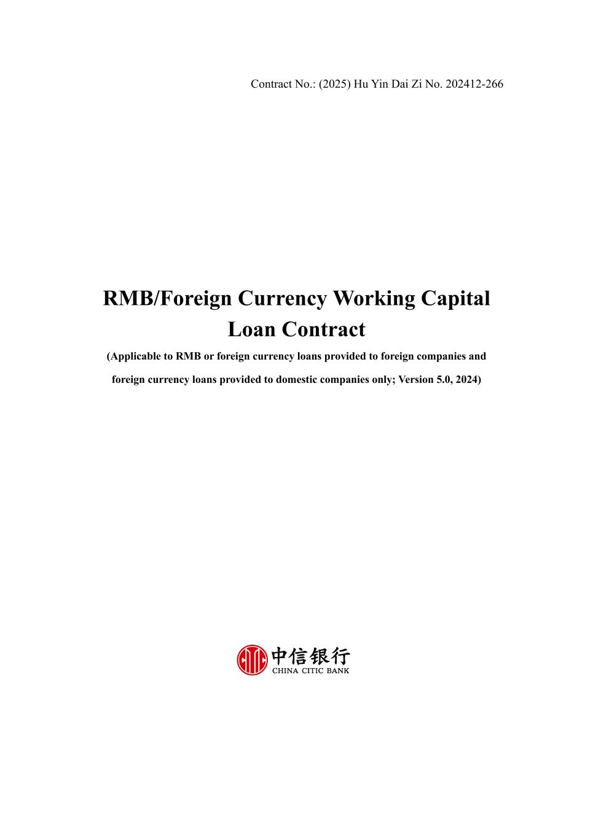
52
Contract No.: (2025) Hu Yin Dai Zi No. 202412-266 RMB/Foreign Currency Working Capital Loan Contract (Applicable to RMB or foreign currency loans provided to foreign companies and foreign currency loans provided to domestic companies only; Version 5.0, 2024)

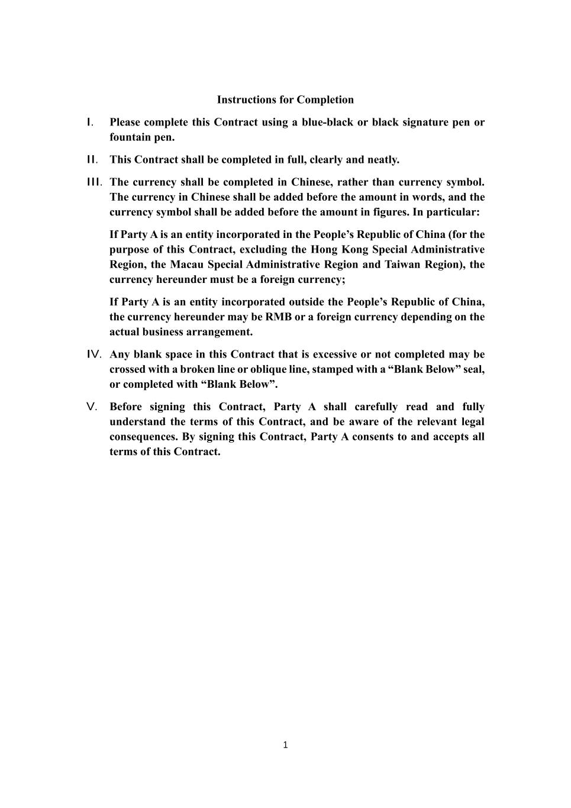
1 Instructions for Completion I. Please complete this Contract using a blue-black or black signature pen or fountain pen. II. This Contract shall be completed in full, clearly and neatly. III. The currency shall be completed in Chinese, rather than currency symbol. The currency in Chinese shall be added before the amount in words, and the currency symbol shall be added before the amount in figures. In particular: If Party A is an entity incorporated in the People’s Republic of China (for the purpose of this Contract, excluding the Hong Kong Special Administrative Region, the Macau Special Administrative Region and Taiwan Region), the currency hereunder must be a foreign currency; If Party A is an entity incorporated outside the People’s Republic of China, the currency hereunder may be RMB or a foreign currency depending on the actual business arrangement. IV. Any blank space in this Contract that is excessive or not completed may be crossed with a broken line or oblique line, stamped with a “Blank Below” seal, or completed with “Blank Below”. V. Before signing this Contract, Party A shall carefully read and fully understand the terms of this Contract, and be aware of the relevant legal consequences. By signing this Contract, Party A consents to and accepts all terms of this Contract.

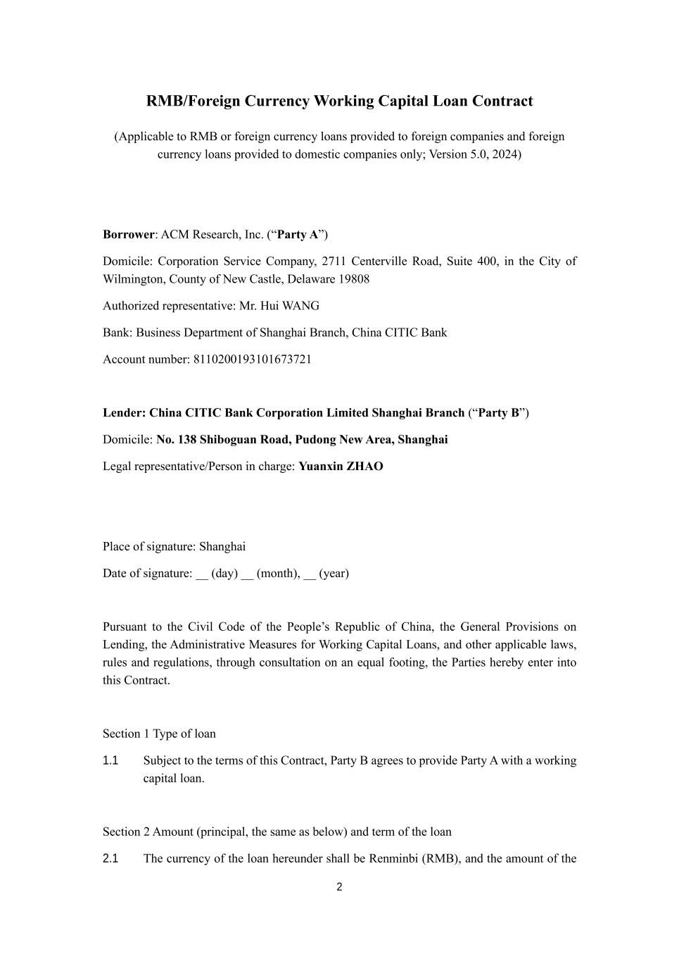
2 RMB/Foreign Currency Working Capital Loan Contract (Applicable to RMB or foreign currency loans provided to foreign companies and foreign currency loans provided to domestic companies only; Version 5.0, 2024) Borrower: ACM Research, Inc. (“Party A”) Domicile: Corporation Service Company, 2711 Centerville Road, Suite 400, in the City of Wilmington, County of New Castle, Delaware 19808 Authorized representative: Mr. Hui WANG Bank: Business Department of Shanghai Branch, China CITIC Bank Account number: 8110200193101673721 Lender: China CITIC Bank Corporation Limited Shanghai Branch (“Party B”) Domicile: No. 138 Shiboguan Road, Pudong New Area, Shanghai Legal representative/Person in charge: Yuanxin ZHAO Place of signature: Shanghai Date of signature: __ (day) __ (month), __ (year) Pursuant to the Civil Code of the People’s Republic of China, the General Provisions on Lending, the Administrative Measures for Working Capital Loans, and other applicable laws, rules and regulations, through consultation on an equal footing, the Parties hereby enter into this Contract. Section 1 Type of loan 1.1 Subject to the terms of this Contract, Party B agrees to provide Party A with a working capital loan. Section 2 Amount (principal, the same as below) and term of the loan 2.1 The currency of the loan hereunder shall be Renminbi (RMB), and the amount of the

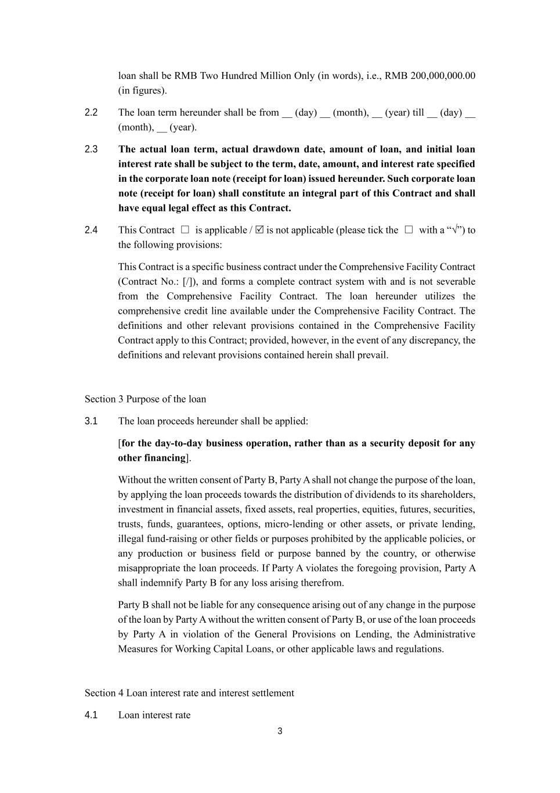
3 loan shall be RMB Two Hundred Million Only (in words), i.e., RMB 200,000,000.00 (in figures). 2.2 The loan term hereunder shall be from __ (day) __ (month), __ (year) till __ (day) __ (month), __ (year). 2.3 The actual loan term, actual drawdown date, amount of loan, and initial loan interest rate shall be subject to the term, date, amount, and interest rate specified in the corporate loan note (receipt for loan) issued hereunder. Such corporate loan note (receipt for loan) shall constitute an integral part of this Contract and shall have equal legal effect as this Contract. 2.4 This Contract □ is applicable /  is not applicable (please tick the □ with a “√”) to the following provisions: This Contract is a specific business contract under the Comprehensive Facility Contract (Contract No.: [/]), and forms a complete contract system with and is not severable from the Comprehensive Facility Contract. The loan hereunder utilizes the comprehensive credit line available under the Comprehensive Facility Contract. The definitions and other relevant provisions contained in the Comprehensive Facility Contract apply to this Contract; provided, however, in the event of any discrepancy, the definitions and relevant provisions contained herein shall prevail. Section 3 Purpose of the loan 3.1 The loan proceeds hereunder shall be applied: [for the day-to-day business operation, rather than as a security deposit for any other financing]. Without the written consent of Party B, Party A shall not change the purpose of the loan, by applying the loan proceeds towards the distribution of dividends to its shareholders, investment in financial assets, fixed assets, real properties, equities, futures, securities, trusts, funds, guarantees, options, micro-lending or other assets, or private lending, illegal fund-raising or other fields or purposes prohibited by the applicable policies, or any production or business field or purpose banned by the country, or otherwise misappropriate the loan proceeds. If Party A violates the foregoing provision, Party A shall indemnify Party B for any loss arising therefrom. Party B shall not be liable for any consequence arising out of any change in the purpose of the loan by Party A without the written consent of Party B, or use of the loan proceeds by Party A in violation of the General Provisions on Lending, the Administrative Measures for Working Capital Loans, or other applicable laws and regulations. Section 4 Loan interest rate and interest settlement 4.1 Loan interest rate

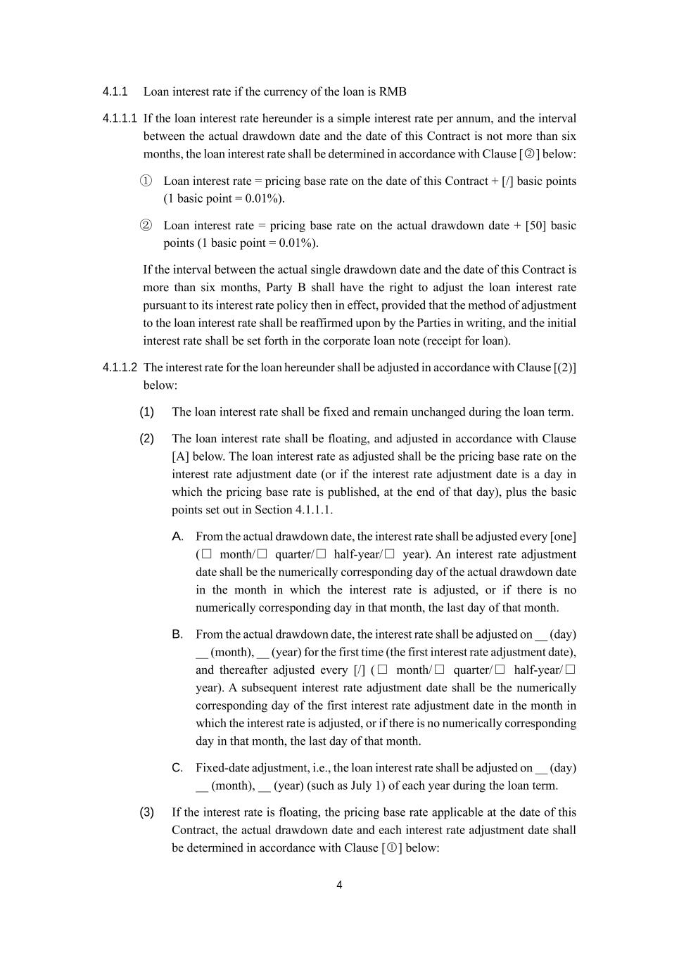
4 4.1.1 Loan interest rate if the currency of the loan is RMB 4.1.1.1 If the loan interest rate hereunder is a simple interest rate per annum, and the interval between the actual drawdown date and the date of this Contract is not more than six months, the loan interest rate shall be determined in accordance with Clause [○2 ] below: ① Loan interest rate = pricing base rate on the date of this Contract + [/] basic points (1 basic point = 0.01%). ② Loan interest rate = pricing base rate on the actual drawdown date + [50] basic points (1 basic point = 0.01%). If the interval between the actual single drawdown date and the date of this Contract is more than six months, Party B shall have the right to adjust the loan interest rate pursuant to its interest rate policy then in effect, provided that the method of adjustment to the loan interest rate shall be reaffirmed upon by the Parties in writing, and the initial interest rate shall be set forth in the corporate loan note (receipt for loan). 4.1.1.2 The interest rate for the loan hereunder shall be adjusted in accordance with Clause [(2)] below: (1) The loan interest rate shall be fixed and remain unchanged during the loan term. (2) The loan interest rate shall be floating, and adjusted in accordance with Clause [A] below. The loan interest rate as adjusted shall be the pricing base rate on the interest rate adjustment date (or if the interest rate adjustment date is a day in which the pricing base rate is published, at the end of that day), plus the basic points set out in Section 4.1.1.1. A. From the actual drawdown date, the interest rate shall be adjusted every [one] (□ month/□ quarter/□ half-year/□ year). An interest rate adjustment date shall be the numerically corresponding day of the actual drawdown date in the month in which the interest rate is adjusted, or if there is no numerically corresponding day in that month, the last day of that month. B. From the actual drawdown date, the interest rate shall be adjusted on __ (day) __ (month), __ (year) for the first time (the first interest rate adjustment date), and thereafter adjusted every [/] (□ month/□ quarter/□ half-year/□ year). A subsequent interest rate adjustment date shall be the numerically corresponding day of the first interest rate adjustment date in the month in which the interest rate is adjusted, or if there is no numerically corresponding day in that month, the last day of that month. C. Fixed-date adjustment, i.e., the loan interest rate shall be adjusted on __ (day) __ (month), __ (year) (such as July 1) of each year during the loan term. (3) If the interest rate is floating, the pricing base rate applicable at the date of this Contract, the actual drawdown date and each interest rate adjustment date shall be determined in accordance with Clause [○1 ] below:

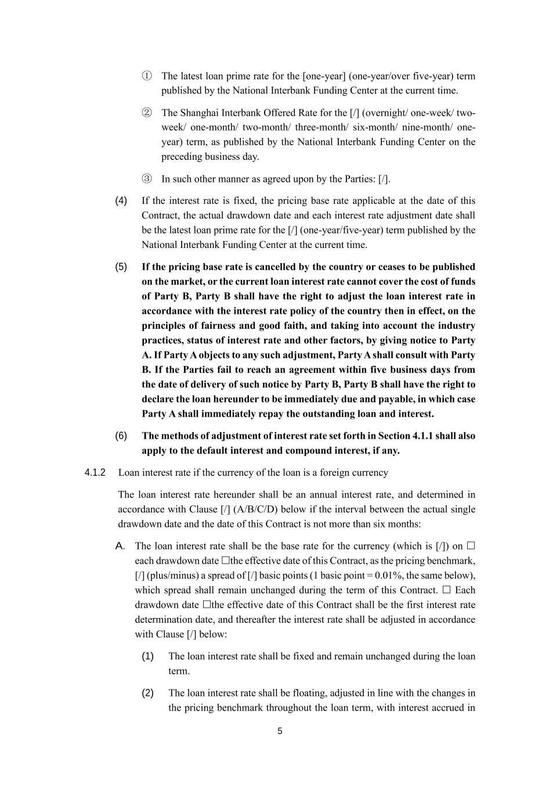
5 ① The latest loan prime rate for the [one-year] (one-year/over five-year) term published by the National Interbank Funding Center at the current time. ② The Shanghai Interbank Offered Rate for the [/] (overnight/ one-week/ two- week/ one-month/ two-month/ three-month/ six-month/ nine-month/ one- year) term, as published by the National Interbank Funding Center on the preceding business day. ③ In such other manner as agreed upon by the Parties: [/]. (4) If the interest rate is fixed, the pricing base rate applicable at the date of this Contract, the actual drawdown date and each interest rate adjustment date shall be the latest loan prime rate for the [/] (one-year/five-year) term published by the National Interbank Funding Center at the current time. (5) If the pricing base rate is cancelled by the country or ceases to be published on the market, or the current loan interest rate cannot cover the cost of funds of Party B, Party B shall have the right to adjust the loan interest rate in accordance with the interest rate policy of the country then in effect, on the principles of fairness and good faith, and taking into account the industry practices, status of interest rate and other factors, by giving notice to Party A. If Party A objects to any such adjustment, Party A shall consult with Party B. If the Parties fail to reach an agreement within five business days from the date of delivery of such notice by Party B, Party B shall have the right to declare the loan hereunder to be immediately due and payable, in which case Party A shall immediately repay the outstanding loan and interest. (6) The methods of adjustment of interest rate set forth in Section 4.1.1 shall also apply to the default interest and compound interest, if any. 4.1.2 Loan interest rate if the currency of the loan is a foreign currency The loan interest rate hereunder shall be an annual interest rate, and determined in accordance with Clause [/] (A/B/C/D) below if the interval between the actual single drawdown date and the date of this Contract is not more than six months: A. The loan interest rate shall be the base rate for the currency (which is [/]) on  each drawdown date the effective date of this Contract, as the pricing benchmark, [/] (plus/minus) a spread of [/] basic points (1 basic point = 0.01%, the same below), which spread shall remain unchanged during the term of this Contract.  Each drawdown date the effective date of this Contract shall be the first interest rate determination date, and thereafter the interest rate shall be adjusted in accordance with Clause [/] below: (1) The loan interest rate shall be fixed and remain unchanged during the loan term. (2) The loan interest rate shall be floating, adjusted in line with the changes in the pricing benchmark throughout the loan term, with interest accrued in

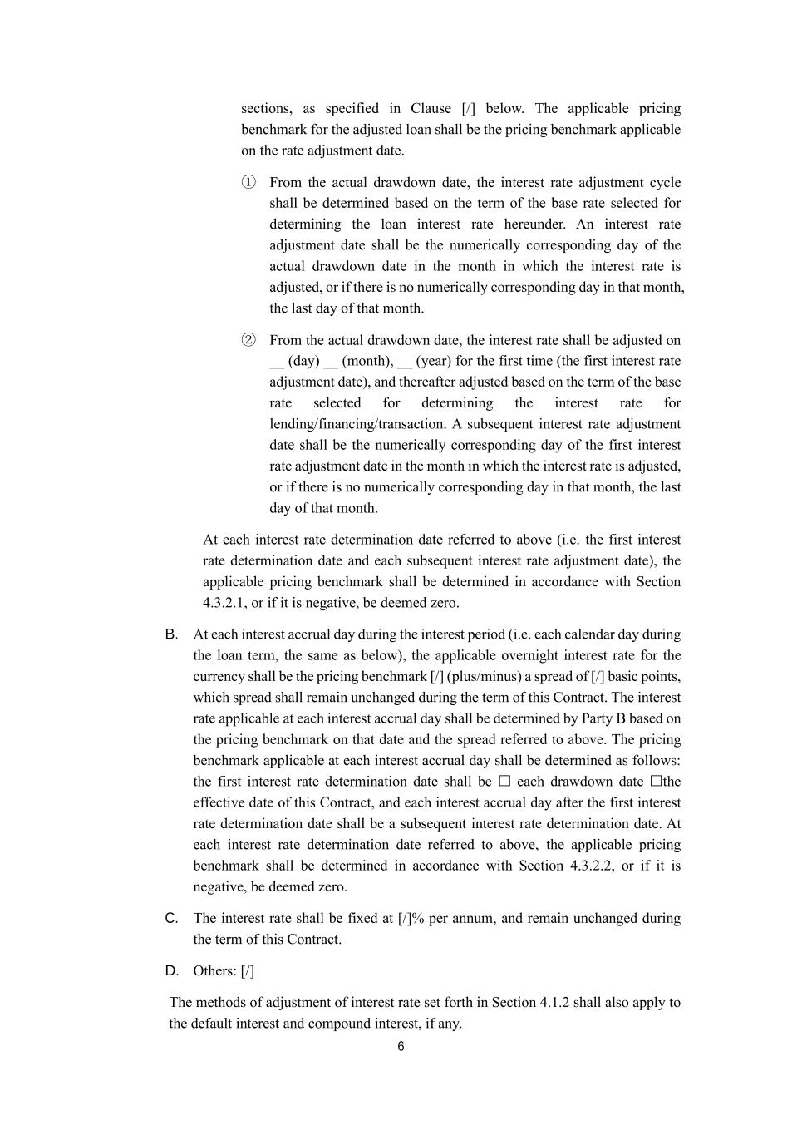
6 sections, as specified in Clause [/] below. The applicable pricing benchmark for the adjusted loan shall be the pricing benchmark applicable on the rate adjustment date. ① From the actual drawdown date, the interest rate adjustment cycle shall be determined based on the term of the base rate selected for determining the loan interest rate hereunder. An interest rate adjustment date shall be the numerically corresponding day of the actual drawdown date in the month in which the interest rate is adjusted, or if there is no numerically corresponding day in that month, the last day of that month. ② From the actual drawdown date, the interest rate shall be adjusted on __ (day) __ (month), __ (year) for the first time (the first interest rate adjustment date), and thereafter adjusted based on the term of the base rate selected for determining the interest rate for lending/financing/transaction. A subsequent interest rate adjustment date shall be the numerically corresponding day of the first interest rate adjustment date in the month in which the interest rate is adjusted, or if there is no numerically corresponding day in that month, the last day of that month. At each interest rate determination date referred to above (i.e. the first interest rate determination date and each subsequent interest rate adjustment date), the applicable pricing benchmark shall be determined in accordance with Section 4.3.2.1, or if it is negative, be deemed zero. B. At each interest accrual day during the interest period (i.e. each calendar day during the loan term, the same as below), the applicable overnight interest rate for the currency shall be the pricing benchmark [/] (plus/minus) a spread of [/] basic points, which spread shall remain unchanged during the term of this Contract. The interest rate applicable at each interest accrual day shall be determined by Party B based on the pricing benchmark on that date and the spread referred to above. The pricing benchmark applicable at each interest accrual day shall be determined as follows: the first interest rate determination date shall be  each drawdown date the effective date of this Contract, and each interest accrual day after the first interest rate determination date shall be a subsequent interest rate determination date. At each interest rate determination date referred to above, the applicable pricing benchmark shall be determined in accordance with Section 4.3.2.2, or if it is negative, be deemed zero. C. The interest rate shall be fixed at [/]% per annum, and remain unchanged during the term of this Contract. D. Others: [/] The methods of adjustment of interest rate set forth in Section 4.1.2 shall also apply to the default interest and compound interest, if any.

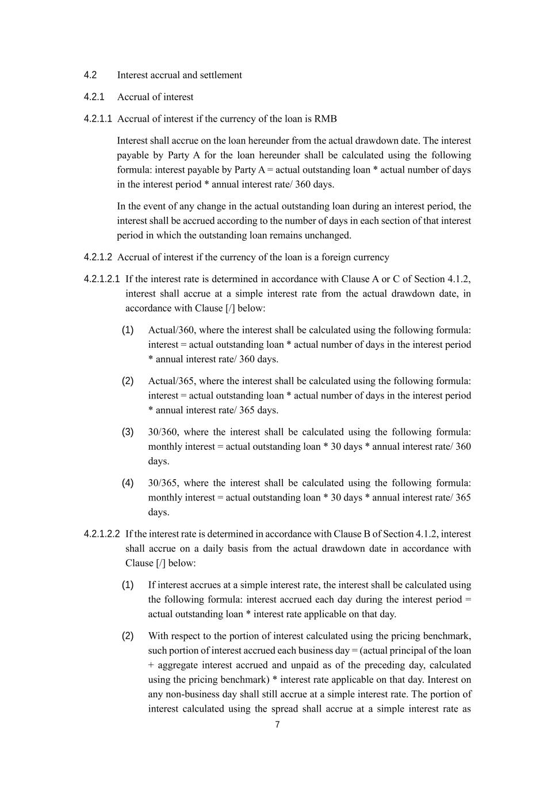
7 4.2 Interest accrual and settlement 4.2.1 Accrual of interest 4.2.1.1 Accrual of interest if the currency of the loan is RMB Interest shall accrue on the loan hereunder from the actual drawdown date. The interest payable by Party A for the loan hereunder shall be calculated using the following formula: interest payable by Party A = actual outstanding loan * actual number of days in the interest period * annual interest rate/ 360 days. In the event of any change in the actual outstanding loan during an interest period, the interest shall be accrued according to the number of days in each section of that interest period in which the outstanding loan remains unchanged. 4.2.1.2 Accrual of interest if the currency of the loan is a foreign currency 4.2.1.2.1 If the interest rate is determined in accordance with Clause A or C of Section 4.1.2, interest shall accrue at a simple interest rate from the actual drawdown date, in accordance with Clause [/] below: (1) Actual/360, where the interest shall be calculated using the following formula: interest = actual outstanding loan * actual number of days in the interest period * annual interest rate/ 360 days. (2) Actual/365, where the interest shall be calculated using the following formula: interest = actual outstanding loan * actual number of days in the interest period * annual interest rate/ 365 days. (3) 30/360, where the interest shall be calculated using the following formula: monthly interest = actual outstanding loan * 30 days * annual interest rate/ 360 days. (4) 30/365, where the interest shall be calculated using the following formula: monthly interest = actual outstanding loan * 30 days * annual interest rate/ 365 days. 4.2.1.2.2 If the interest rate is determined in accordance with Clause B of Section 4.1.2, interest shall accrue on a daily basis from the actual drawdown date in accordance with Clause [/] below: (1) If interest accrues at a simple interest rate, the interest shall be calculated using the following formula: interest accrued each day during the interest period = actual outstanding loan * interest rate applicable on that day. (2) With respect to the portion of interest calculated using the pricing benchmark, such portion of interest accrued each business day = (actual principal of the loan + aggregate interest accrued and unpaid as of the preceding day, calculated using the pricing benchmark) * interest rate applicable on that day. Interest on any non-business day shall still accrue at a simple interest rate. The portion of interest calculated using the spread shall accrue at a simple interest rate as

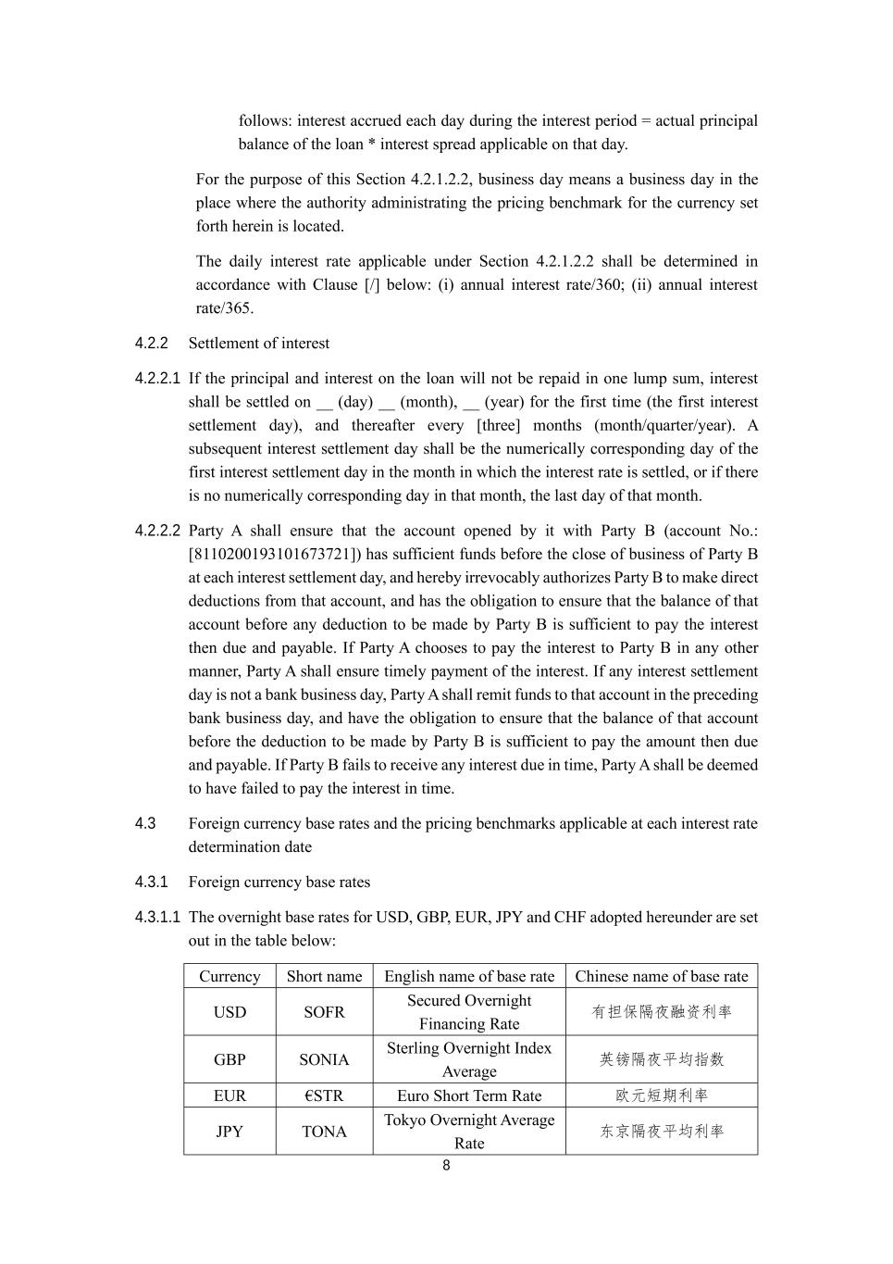
8 follows: interest accrued each day during the interest period = actual principal balance of the loan * interest spread applicable on that day. For the purpose of this Section 4.2.1.2.2, business day means a business day in the place where the authority administrating the pricing benchmark for the currency set forth herein is located. The daily interest rate applicable under Section 4.2.1.2.2 shall be determined in accordance with Clause [/] below: (i) annual interest rate/360; (ii) annual interest rate/365. 4.2.2 Settlement of interest 4.2.2.1 If the principal and interest on the loan will not be repaid in one lump sum, interest shall be settled on __ (day) __ (month), __ (year) for the first time (the first interest settlement day), and thereafter every [three] months (month/quarter/year). A subsequent interest settlement day shall be the numerically corresponding day of the first interest settlement day in the month in which the interest rate is settled, or if there is no numerically corresponding day in that month, the last day of that month. 4.2.2.2 Party A shall ensure that the account opened by it with Party B (account No.: [8110200193101673721]) has sufficient funds before the close of business of Party B at each interest settlement day, and hereby irrevocably authorizes Party B to make direct deductions from that account, and has the obligation to ensure that the balance of that account before any deduction to be made by Party B is sufficient to pay the interest then due and payable. If Party A chooses to pay the interest to Party B in any other manner, Party A shall ensure timely payment of the interest. If any interest settlement day is not a bank business day, Party A shall remit funds to that account in the preceding bank business day, and have the obligation to ensure that the balance of that account before the deduction to be made by Party B is sufficient to pay the amount then due and payable. If Party B fails to receive any interest due in time, Party A shall be deemed to have failed to pay the interest in time. 4.3 Foreign currency base rates and the pricing benchmarks applicable at each interest rate determination date 4.3.1 Foreign currency base rates 4.3.1.1 The overnight base rates for USD, GBP, EUR, JPY and CHF adopted hereunder are set out in the table below: Currency Short name English name of base rate Chinese name of base rate USD SOFR Secured Overnight Financing Rate 有担保隔夜融资利率 GBP SONIA Sterling Overnight Index Average 英镑隔夜平均指数 EUR €STR Euro Short Term Rate 欧元短期利率 JPY TONA Tokyo Overnight Average Rate 东京隔夜平均利率

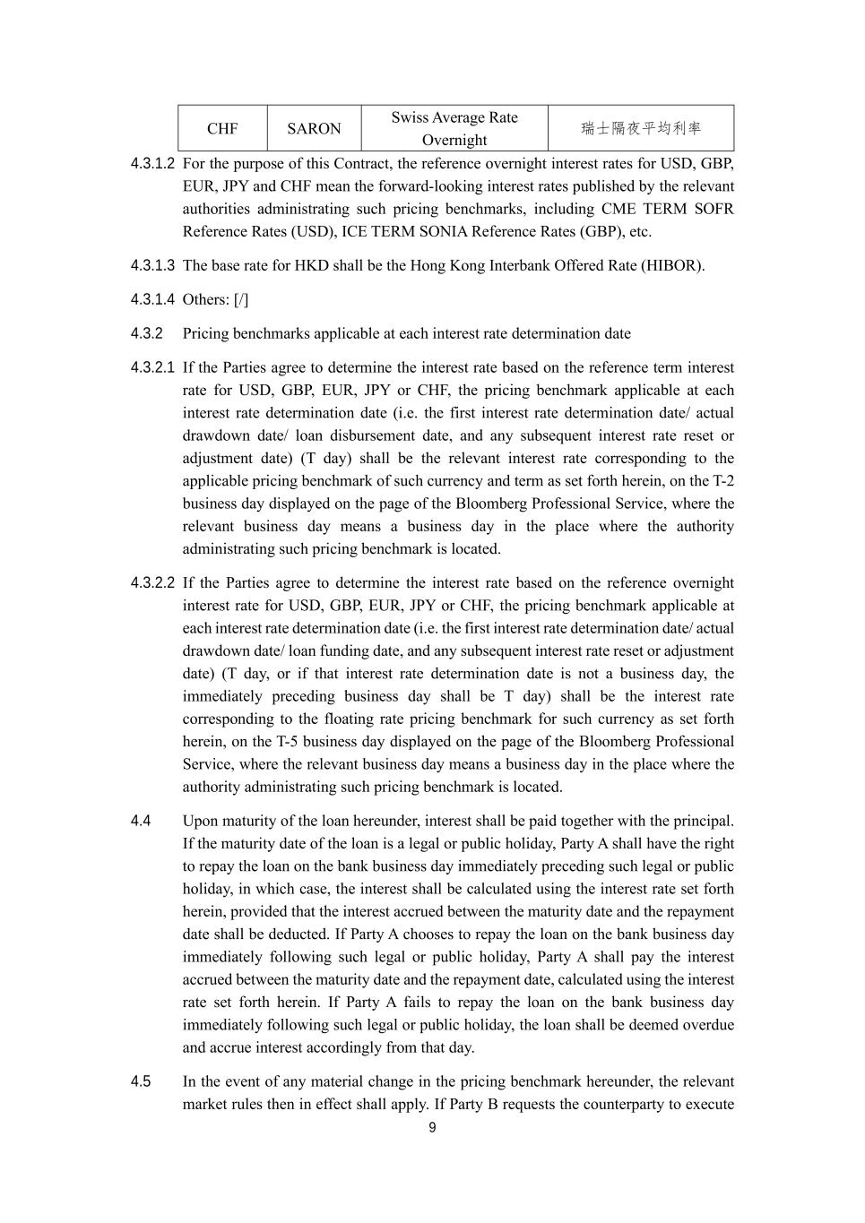
9 CHF SARON Swiss Average Rate Overnight 瑞士隔夜平均利率 4.3.1.2 For the purpose of this Contract, the reference overnight interest rates for USD, GBP, EUR, JPY and CHF mean the forward-looking interest rates published by the relevant authorities administrating such pricing benchmarks, including CME TERM SOFR Reference Rates (USD), ICE TERM SONIA Reference Rates (GBP), etc. 4.3.1.3 The base rate for HKD shall be the Hong Kong Interbank Offered Rate (HIBOR). 4.3.1.4 Others: [/] 4.3.2 Pricing benchmarks applicable at each interest rate determination date 4.3.2.1 If the Parties agree to determine the interest rate based on the reference term interest rate for USD, GBP, EUR, JPY or CHF, the pricing benchmark applicable at each interest rate determination date (i.e. the first interest rate determination date/ actual drawdown date/ loan disbursement date, and any subsequent interest rate reset or adjustment date) (T day) shall be the relevant interest rate corresponding to the applicable pricing benchmark of such currency and term as set forth herein, on the T-2 business day displayed on the page of the Bloomberg Professional Service, where the relevant business day means a business day in the place where the authority administrating such pricing benchmark is located. 4.3.2.2 If the Parties agree to determine the interest rate based on the reference overnight interest rate for USD, GBP, EUR, JPY or CHF, the pricing benchmark applicable at each interest rate determination date (i.e. the first interest rate determination date/ actual drawdown date/ loan funding date, and any subsequent interest rate reset or adjustment date) (T day, or if that interest rate determination date is not a business day, the immediately preceding business day shall be T day) shall be the interest rate corresponding to the floating rate pricing benchmark for such currency as set forth herein, on the T-5 business day displayed on the page of the Bloomberg Professional Service, where the relevant business day means a business day in the place where the authority administrating such pricing benchmark is located. 4.4 Upon maturity of the loan hereunder, interest shall be paid together with the principal. If the maturity date of the loan is a legal or public holiday, Party A shall have the right to repay the loan on the bank business day immediately preceding such legal or public holiday, in which case, the interest shall be calculated using the interest rate set forth herein, provided that the interest accrued between the maturity date and the repayment date shall be deducted. If Party A chooses to repay the loan on the bank business day immediately following such legal or public holiday, Party A shall pay the interest accrued between the maturity date and the repayment date, calculated using the interest rate set forth herein. If Party A fails to repay the loan on the bank business day immediately following such legal or public holiday, the loan shall be deemed overdue and accrue interest accordingly from that day. 4.5 In the event of any material change in the pricing benchmark hereunder, the relevant market rules then in effect shall apply. If Party B requests the counterparty to execute

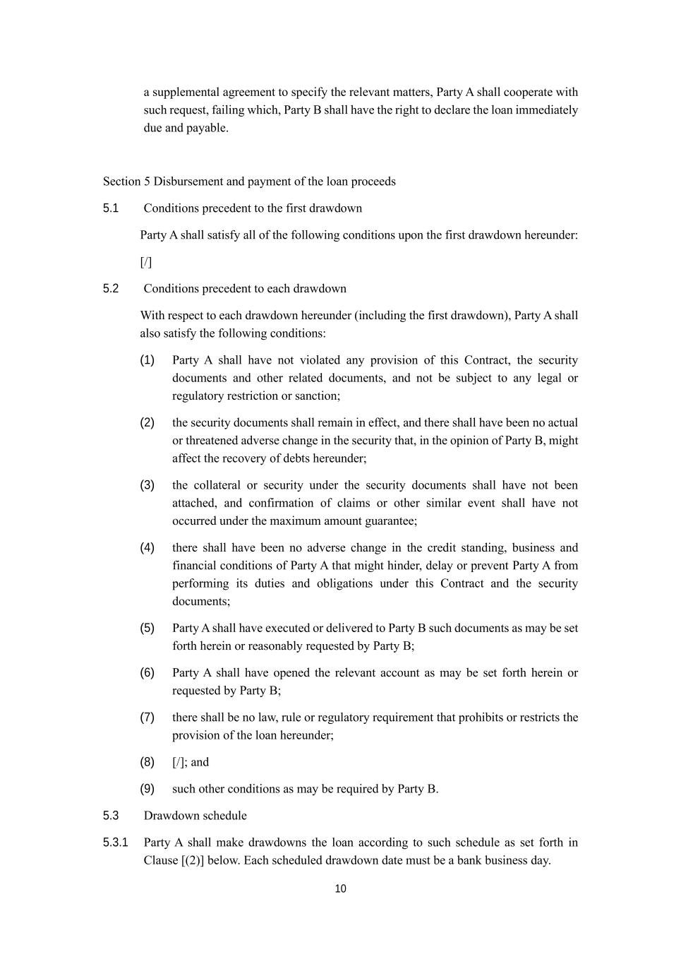
10 a supplemental agreement to specify the relevant matters, Party A shall cooperate with such request, failing which, Party B shall have the right to declare the loan immediately due and payable. Section 5 Disbursement and payment of the loan proceeds 5.1 Conditions precedent to the first drawdown Party A shall satisfy all of the following conditions upon the first drawdown hereunder: [/] 5.2 Conditions precedent to each drawdown With respect to each drawdown hereunder (including the first drawdown), Party A shall also satisfy the following conditions: (1) Party A shall have not violated any provision of this Contract, the security documents and other related documents, and not be subject to any legal or regulatory restriction or sanction; (2) the security documents shall remain in effect, and there shall have been no actual or threatened adverse change in the security that, in the opinion of Party B, might affect the recovery of debts hereunder; (3) the collateral or security under the security documents shall have not been attached, and confirmation of claims or other similar event shall have not occurred under the maximum amount guarantee; (4) there shall have been no adverse change in the credit standing, business and financial conditions of Party A that might hinder, delay or prevent Party A from performing its duties and obligations under this Contract and the security documents; (5) Party A shall have executed or delivered to Party B such documents as may be set forth herein or reasonably requested by Party B; (6) Party A shall have opened the relevant account as may be set forth herein or requested by Party B; (7) there shall be no law, rule or regulatory requirement that prohibits or restricts the provision of the loan hereunder; (8) [/]; and (9) such other conditions as may be required by Party B. 5.3 Drawdown schedule 5.3.1 Party A shall make drawdowns the loan according to such schedule as set forth in Clause [(2)] below. Each scheduled drawdown date must be a bank business day.

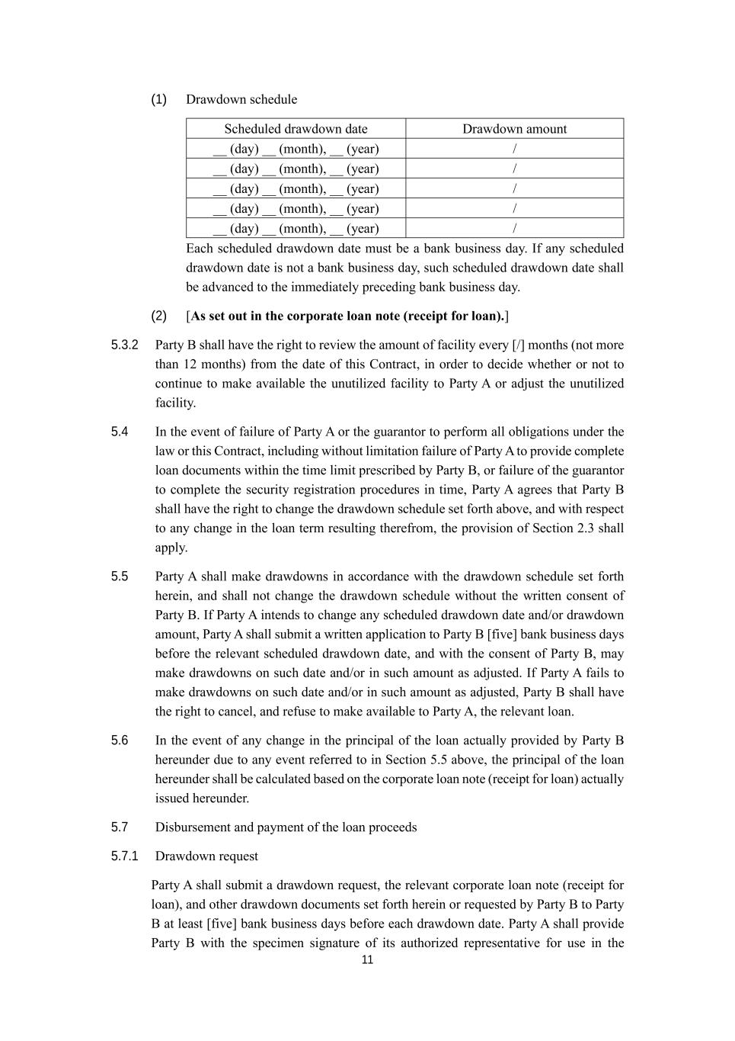
11 (1) Drawdown schedule Scheduled drawdown date Drawdown amount __ (day) __ (month), __ (year) / __ (day) __ (month), __ (year) / __ (day) __ (month), __ (year) / __ (day) __ (month), __ (year) / __ (day) __ (month), __ (year) / Each scheduled drawdown date must be a bank business day. If any scheduled drawdown date is not a bank business day, such scheduled drawdown date shall be advanced to the immediately preceding bank business day. (2) [As set out in the corporate loan note (receipt for loan).] 5.3.2 Party B shall have the right to review the amount of facility every [/] months (not more than 12 months) from the date of this Contract, in order to decide whether or not to continue to make available the unutilized facility to Party A or adjust the unutilized facility. 5.4 In the event of failure of Party A or the guarantor to perform all obligations under the law or this Contract, including without limitation failure of Party A to provide complete loan documents within the time limit prescribed by Party B, or failure of the guarantor to complete the security registration procedures in time, Party A agrees that Party B shall have the right to change the drawdown schedule set forth above, and with respect to any change in the loan term resulting therefrom, the provision of Section 2.3 shall apply. 5.5 Party A shall make drawdowns in accordance with the drawdown schedule set forth herein, and shall not change the drawdown schedule without the written consent of Party B. If Party A intends to change any scheduled drawdown date and/or drawdown amount, Party A shall submit a written application to Party B [five] bank business days before the relevant scheduled drawdown date, and with the consent of Party B, may make drawdowns on such date and/or in such amount as adjusted. If Party A fails to make drawdowns on such date and/or in such amount as adjusted, Party B shall have the right to cancel, and refuse to make available to Party A, the relevant loan. 5.6 In the event of any change in the principal of the loan actually provided by Party B hereunder due to any event referred to in Section 5.5 above, the principal of the loan hereunder shall be calculated based on the corporate loan note (receipt for loan) actually issued hereunder. 5.7 Disbursement and payment of the loan proceeds 5.7.1 Drawdown request Party A shall submit a drawdown request, the relevant corporate loan note (receipt for loan), and other drawdown documents set forth herein or requested by Party B to Party B at least [five] bank business days before each drawdown date. Party A shall provide Party B with the specimen signature of its authorized representative for use in the

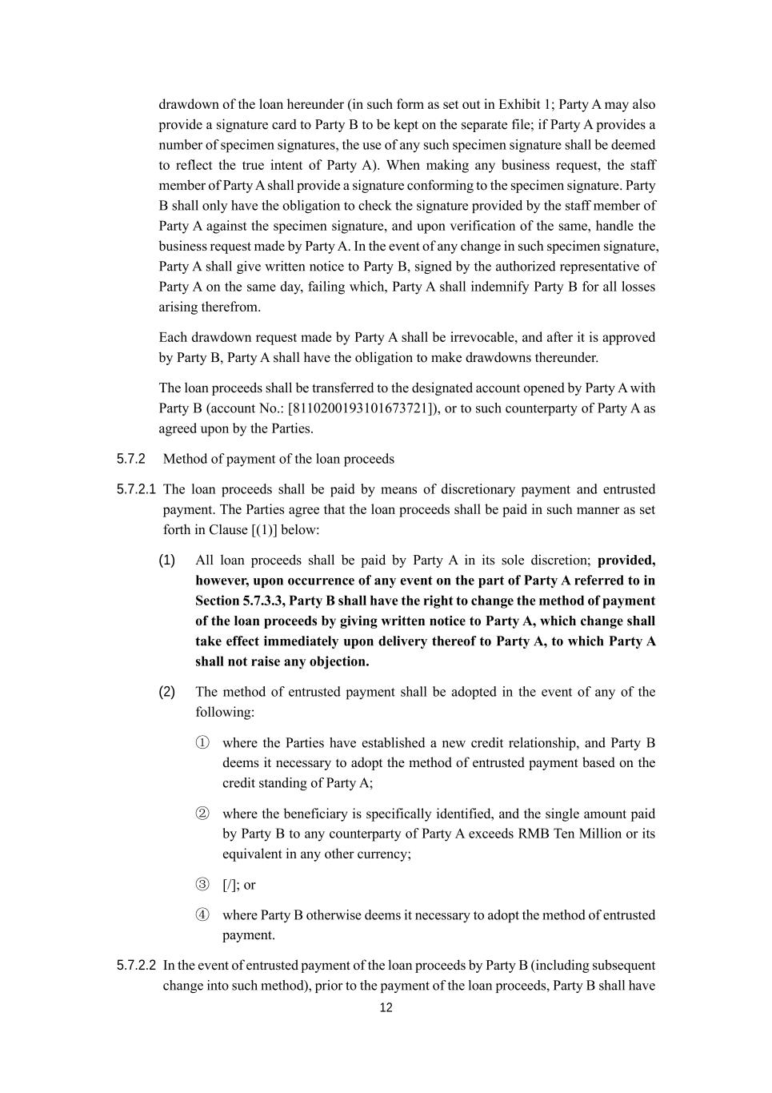
12 drawdown of the loan hereunder (in such form as set out in Exhibit 1; Party A may also provide a signature card to Party B to be kept on the separate file; if Party A provides a number of specimen signatures, the use of any such specimen signature shall be deemed to reflect the true intent of Party A). When making any business request, the staff member of Party A shall provide a signature conforming to the specimen signature. Party B shall only have the obligation to check the signature provided by the staff member of Party A against the specimen signature, and upon verification of the same, handle the business request made by Party A. In the event of any change in such specimen signature, Party A shall give written notice to Party B, signed by the authorized representative of Party A on the same day, failing which, Party A shall indemnify Party B for all losses arising therefrom. Each drawdown request made by Party A shall be irrevocable, and after it is approved by Party B, Party A shall have the obligation to make drawdowns thereunder. The loan proceeds shall be transferred to the designated account opened by Party A with Party B (account No.: [8110200193101673721]), or to such counterparty of Party A as agreed upon by the Parties. 5.7.2 Method of payment of the loan proceeds 5.7.2.1 The loan proceeds shall be paid by means of discretionary payment and entrusted payment. The Parties agree that the loan proceeds shall be paid in such manner as set forth in Clause [(1)] below: (1) All loan proceeds shall be paid by Party A in its sole discretion; provided, however, upon occurrence of any event on the part of Party A referred to in Section 5.7.3.3, Party B shall have the right to change the method of payment of the loan proceeds by giving written notice to Party A, which change shall take effect immediately upon delivery thereof to Party A, to which Party A shall not raise any objection. (2) The method of entrusted payment shall be adopted in the event of any of the following: ① where the Parties have established a new credit relationship, and Party B deems it necessary to adopt the method of entrusted payment based on the credit standing of Party A; ② where the beneficiary is specifically identified, and the single amount paid by Party B to any counterparty of Party A exceeds RMB Ten Million or its equivalent in any other currency; ③ [/]; or ④ where Party B otherwise deems it necessary to adopt the method of entrusted payment. 5.7.2.2 In the event of entrusted payment of the loan proceeds by Party B (including subsequent change into such method), prior to the payment of the loan proceeds, Party B shall have

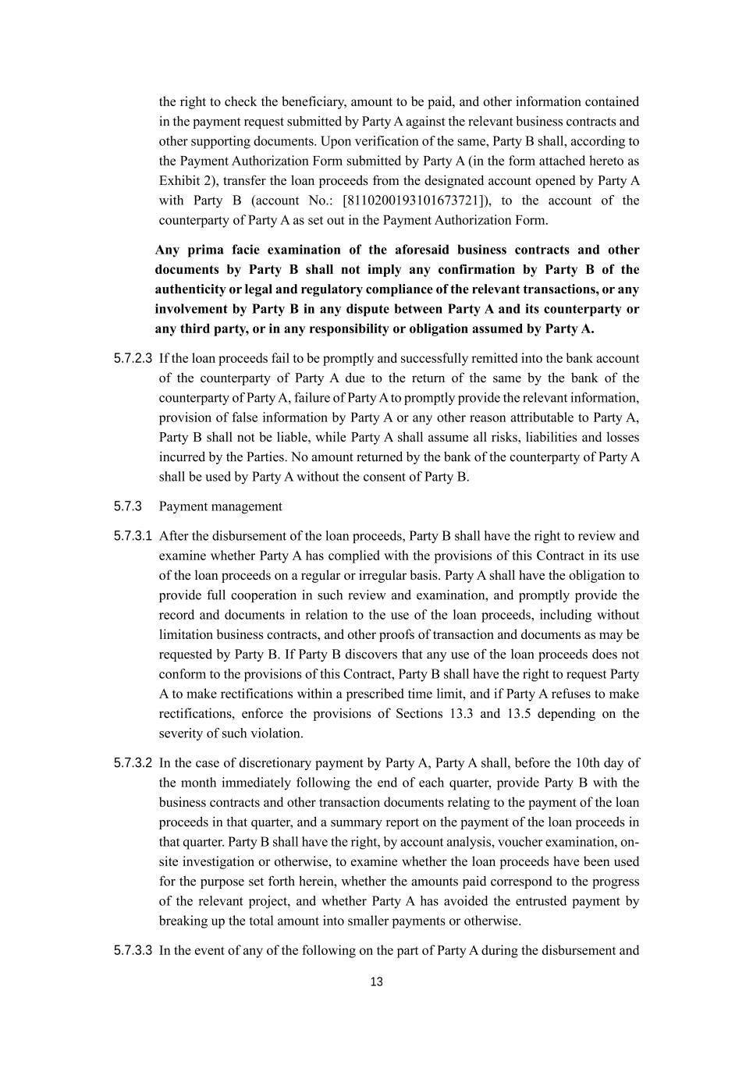
13 the right to check the beneficiary, amount to be paid, and other information contained in the payment request submitted by Party A against the relevant business contracts and other supporting documents. Upon verification of the same, Party B shall, according to the Payment Authorization Form submitted by Party A (in the form attached hereto as Exhibit 2), transfer the loan proceeds from the designated account opened by Party A with Party B (account No.: [8110200193101673721]), to the account of the counterparty of Party A as set out in the Payment Authorization Form. Any prima facie examination of the aforesaid business contracts and other documents by Party B shall not imply any confirmation by Party B of the authenticity or legal and regulatory compliance of the relevant transactions, or any involvement by Party B in any dispute between Party A and its counterparty or any third party, or in any responsibility or obligation assumed by Party A. 5.7.2.3 If the loan proceeds fail to be promptly and successfully remitted into the bank account of the counterparty of Party A due to the return of the same by the bank of the counterparty of Party A, failure of Party A to promptly provide the relevant information, provision of false information by Party A or any other reason attributable to Party A, Party B shall not be liable, while Party A shall assume all risks, liabilities and losses incurred by the Parties. No amount returned by the bank of the counterparty of Party A shall be used by Party A without the consent of Party B. 5.7.3 Payment management 5.7.3.1 After the disbursement of the loan proceeds, Party B shall have the right to review and examine whether Party A has complied with the provisions of this Contract in its use of the loan proceeds on a regular or irregular basis. Party A shall have the obligation to provide full cooperation in such review and examination, and promptly provide the record and documents in relation to the use of the loan proceeds, including without limitation business contracts, and other proofs of transaction and documents as may be requested by Party B. If Party B discovers that any use of the loan proceeds does not conform to the provisions of this Contract, Party B shall have the right to request Party A to make rectifications within a prescribed time limit, and if Party A refuses to make rectifications, enforce the provisions of Sections 13.3 and 13.5 depending on the severity of such violation. 5.7.3.2 In the case of discretionary payment by Party A, Party A shall, before the 10th day of the month immediately following the end of each quarter, provide Party B with the business contracts and other transaction documents relating to the payment of the loan proceeds in that quarter, and a summary report on the payment of the loan proceeds in that quarter. Party B shall have the right, by account analysis, voucher examination, on- site investigation or otherwise, to examine whether the loan proceeds have been used for the purpose set forth herein, whether the amounts paid correspond to the progress of the relevant project, and whether Party A has avoided the entrusted payment by breaking up the total amount into smaller payments or otherwise. 5.7.3.3 In the event of any of the following on the part of Party A during the disbursement and

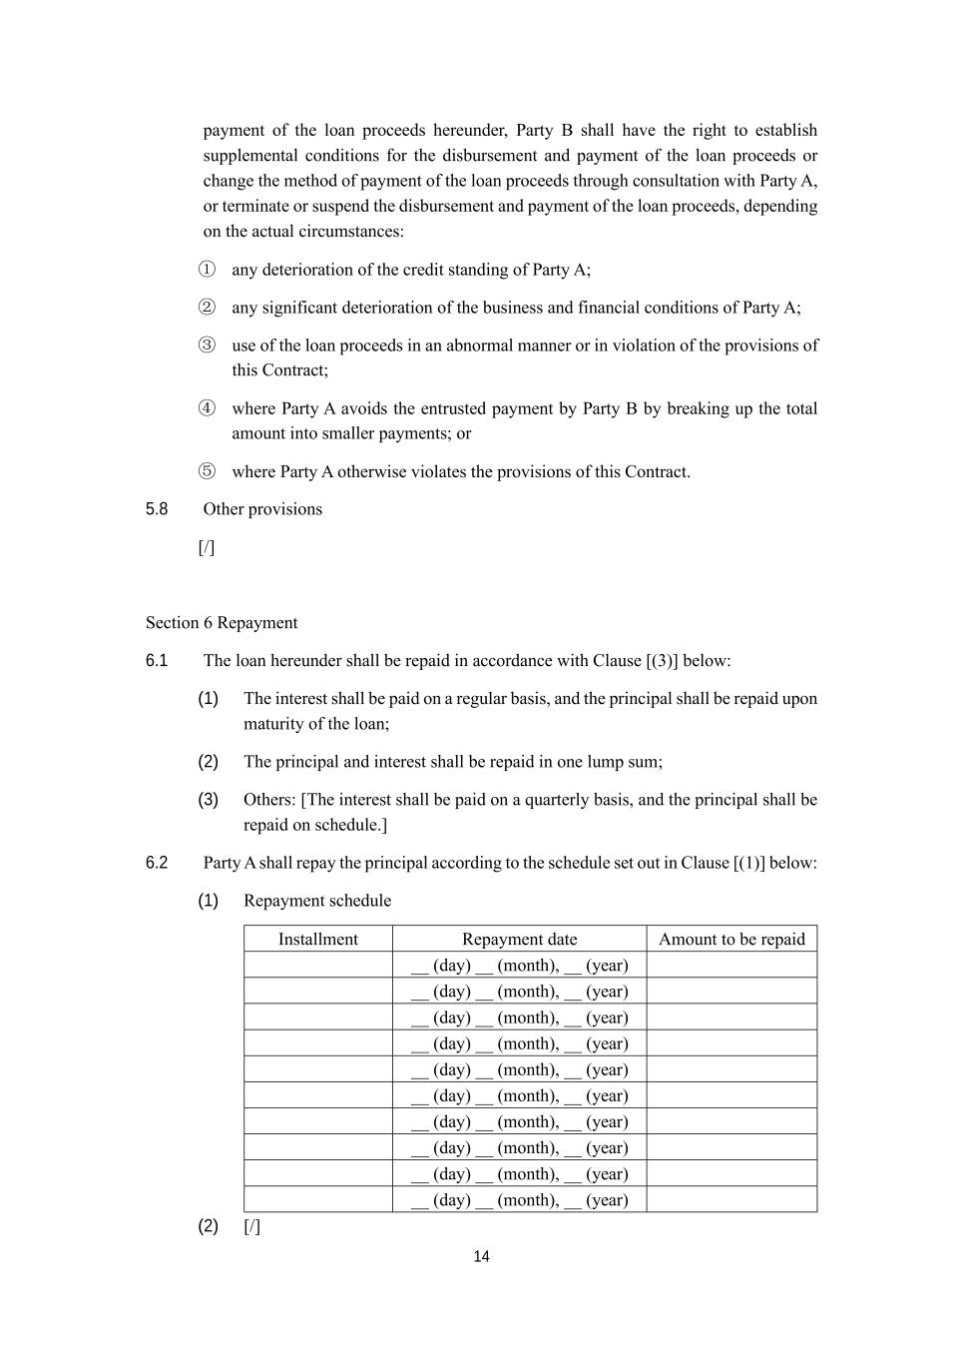
14 payment of the loan proceeds hereunder, Party B shall have the right to establish supplemental conditions for the disbursement and payment of the loan proceeds or change the method of payment of the loan proceeds through consultation with Party A, or terminate or suspend the disbursement and payment of the loan proceeds, depending on the actual circumstances: ① any deterioration of the credit standing of Party A; ② any significant deterioration of the business and financial conditions of Party A; ③ use of the loan proceeds in an abnormal manner or in violation of the provisions of this Contract; ④ where Party A avoids the entrusted payment by Party B by breaking up the total amount into smaller payments; or ⑤ where Party A otherwise violates the provisions of this Contract. 5.8 Other provisions [/] Section 6 Repayment 6.1 The loan hereunder shall be repaid in accordance with Clause [(3)] below: (1) The interest shall be paid on a regular basis, and the principal shall be repaid upon maturity of the loan; (2) The principal and interest shall be repaid in one lump sum; (3) Others: [The interest shall be paid on a quarterly basis, and the principal shall be repaid on schedule.] 6.2 Party A shall repay the principal according to the schedule set out in Clause [(1)] below: (1) Repayment schedule Installment Repayment date Amount to be repaid __ (day) __ (month), __ (year) __ (day) __ (month), __ (year) __ (day) __ (month), __ (year) __ (day) __ (month), __ (year) __ (day) __ (month), __ (year) __ (day) __ (month), __ (year) __ (day) __ (month), __ (year) __ (day) __ (month), __ (year) __ (day) __ (month), __ (year) __ (day) __ (month), __ (year) (2) [/]

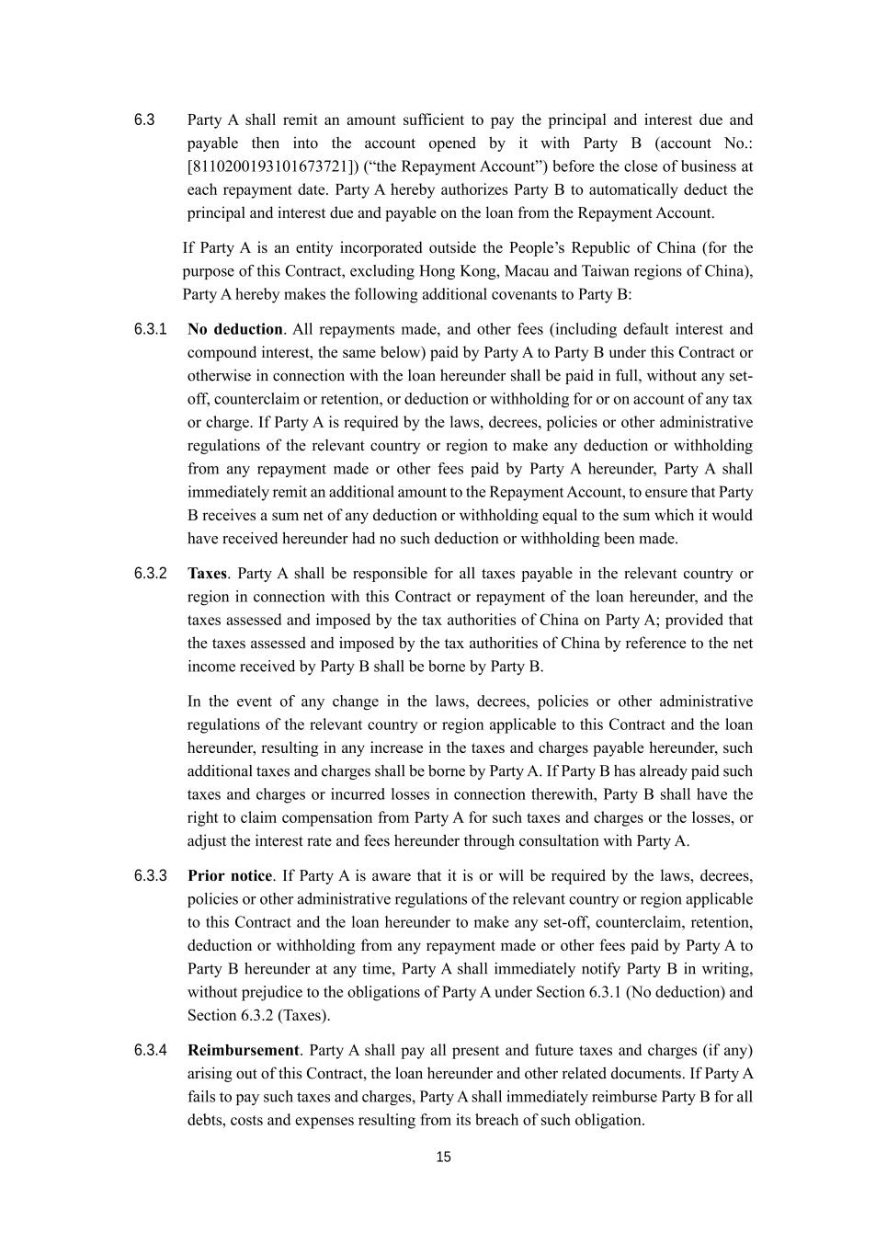
15 6.3 Party A shall remit an amount sufficient to pay the principal and interest due and payable then into the account opened by it with Party B (account No.: [8110200193101673721]) (“the Repayment Account”) before the close of business at each repayment date. Party A hereby authorizes Party B to automatically deduct the principal and interest due and payable on the loan from the Repayment Account. If Party A is an entity incorporated outside the People’s Republic of China (for the purpose of this Contract, excluding Hong Kong, Macau and Taiwan regions of China), Party A hereby makes the following additional covenants to Party B: 6.3.1 No deduction. All repayments made, and other fees (including default interest and compound interest, the same below) paid by Party A to Party B under this Contract or otherwise in connection with the loan hereunder shall be paid in full, without any set- off, counterclaim or retention, or deduction or withholding for or on account of any tax or charge. If Party A is required by the laws, decrees, policies or other administrative regulations of the relevant country or region to make any deduction or withholding from any repayment made or other fees paid by Party A hereunder, Party A shall immediately remit an additional amount to the Repayment Account, to ensure that Party B receives a sum net of any deduction or withholding equal to the sum which it would have received hereunder had no such deduction or withholding been made. 6.3.2 Taxes. Party A shall be responsible for all taxes payable in the relevant country or region in connection with this Contract or repayment of the loan hereunder, and the taxes assessed and imposed by the tax authorities of China on Party A; provided that the taxes assessed and imposed by the tax authorities of China by reference to the net income received by Party B shall be borne by Party B. In the event of any change in the laws, decrees, policies or other administrative regulations of the relevant country or region applicable to this Contract and the loan hereunder, resulting in any increase in the taxes and charges payable hereunder, such additional taxes and charges shall be borne by Party A. If Party B has already paid such taxes and charges or incurred losses in connection therewith, Party B shall have the right to claim compensation from Party A for such taxes and charges or the losses, or adjust the interest rate and fees hereunder through consultation with Party A. 6.3.3 Prior notice. If Party A is aware that it is or will be required by the laws, decrees, policies or other administrative regulations of the relevant country or region applicable to this Contract and the loan hereunder to make any set-off, counterclaim, retention, deduction or withholding from any repayment made or other fees paid by Party A to Party B hereunder at any time, Party A shall immediately notify Party B in writing, without prejudice to the obligations of Party A under Section 6.3.1 (No deduction) and Section 6.3.2 (Taxes). 6.3.4 Reimbursement. Party A shall pay all present and future taxes and charges (if any) arising out of this Contract, the loan hereunder and other related documents. If Party A fails to pay such taxes and charges, Party A shall immediately reimburse Party B for all debts, costs and expenses resulting from its breach of such obligation.

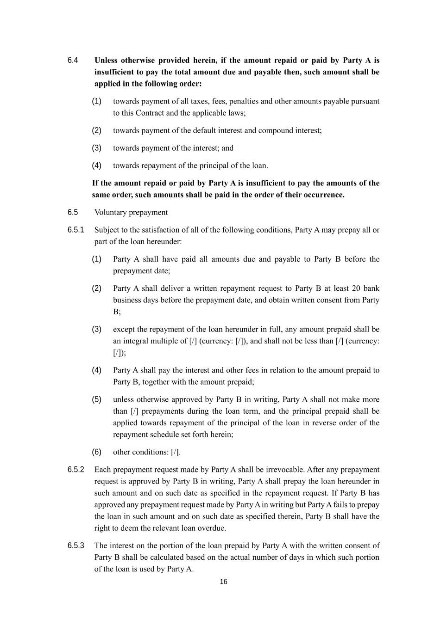
16 6.4 Unless otherwise provided herein, if the amount repaid or paid by Party A is insufficient to pay the total amount due and payable then, such amount shall be applied in the following order: (1) towards payment of all taxes, fees, penalties and other amounts payable pursuant to this Contract and the applicable laws; (2) towards payment of the default interest and compound interest; (3) towards payment of the interest; and (4) towards repayment of the principal of the loan. If the amount repaid or paid by Party A is insufficient to pay the amounts of the same order, such amounts shall be paid in the order of their occurrence. 6.5 Voluntary prepayment 6.5.1 Subject to the satisfaction of all of the following conditions, Party A may prepay all or part of the loan hereunder: (1) Party A shall have paid all amounts due and payable to Party B before the prepayment date; (2) Party A shall deliver a written repayment request to Party B at least 20 bank business days before the prepayment date, and obtain written consent from Party B; (3) except the repayment of the loan hereunder in full, any amount prepaid shall be an integral multiple of [/] (currency: [/]), and shall not be less than [/] (currency: [/]); (4) Party A shall pay the interest and other fees in relation to the amount prepaid to Party B, together with the amount prepaid; (5) unless otherwise approved by Party B in writing, Party A shall not make more than [/] prepayments during the loan term, and the principal prepaid shall be applied towards repayment of the principal of the loan in reverse order of the repayment schedule set forth herein; (6) other conditions: [/]. 6.5.2 Each prepayment request made by Party A shall be irrevocable. After any prepayment request is approved by Party B in writing, Party A shall prepay the loan hereunder in such amount and on such date as specified in the repayment request. If Party B has approved any prepayment request made by Party A in writing but Party A fails to prepay the loan in such amount and on such date as specified therein, Party B shall have the right to deem the relevant loan overdue. 6.5.3 The interest on the portion of the loan prepaid by Party A with the written consent of Party B shall be calculated based on the actual number of days in which such portion of the loan is used by Party A.

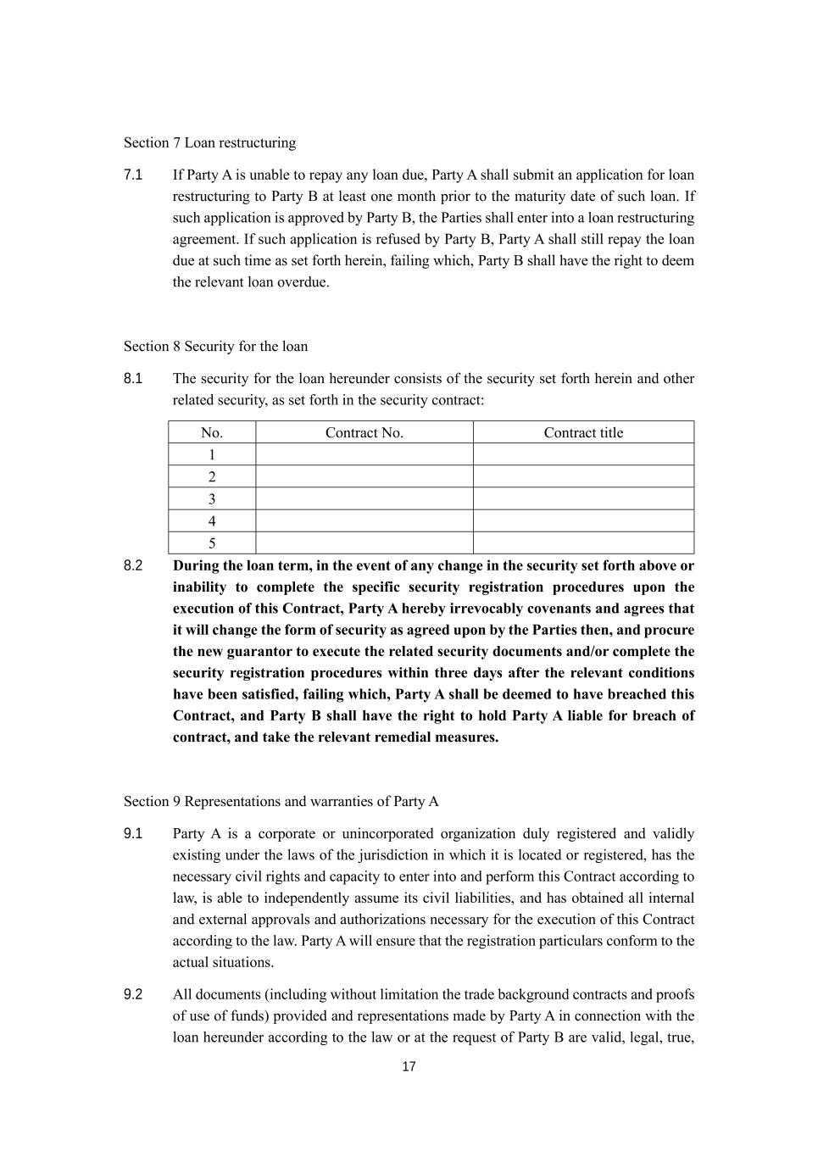
17 Section 7 Loan restructuring 7.1 If Party A is unable to repay any loan due, Party A shall submit an application for loan restructuring to Party B at least one month prior to the maturity date of such loan. If such application is approved by Party B, the Parties shall enter into a loan restructuring agreement. If such application is refused by Party B, Party A shall still repay the loan due at such time as set forth herein, failing which, Party B shall have the right to deem the relevant loan overdue. Section 8 Security for the loan 8.1 The security for the loan hereunder consists of the security set forth herein and other related security, as set forth in the security contract: No. Contract No. Contract title 1 2 3 4 5 8.2 During the loan term, in the event of any change in the security set forth above or inability to complete the specific security registration procedures upon the execution of this Contract, Party A hereby irrevocably covenants and agrees that it will change the form of security as agreed upon by the Parties then, and procure the new guarantor to execute the related security documents and/or complete the security registration procedures within three days after the relevant conditions have been satisfied, failing which, Party A shall be deemed to have breached this Contract, and Party B shall have the right to hold Party A liable for breach of contract, and take the relevant remedial measures. Section 9 Representations and warranties of Party A 9.1 Party A is a corporate or unincorporated organization duly registered and validly existing under the laws of the jurisdiction in which it is located or registered, has the necessary civil rights and capacity to enter into and perform this Contract according to law, is able to independently assume its civil liabilities, and has obtained all internal and external approvals and authorizations necessary for the execution of this Contract according to the law. Party A will ensure that the registration particulars conform to the actual situations. 9.2 All documents (including without limitation the trade background contracts and proofs of use of funds) provided and representations made by Party A in connection with the loan hereunder according to the law or at the request of Party B are valid, legal, true,

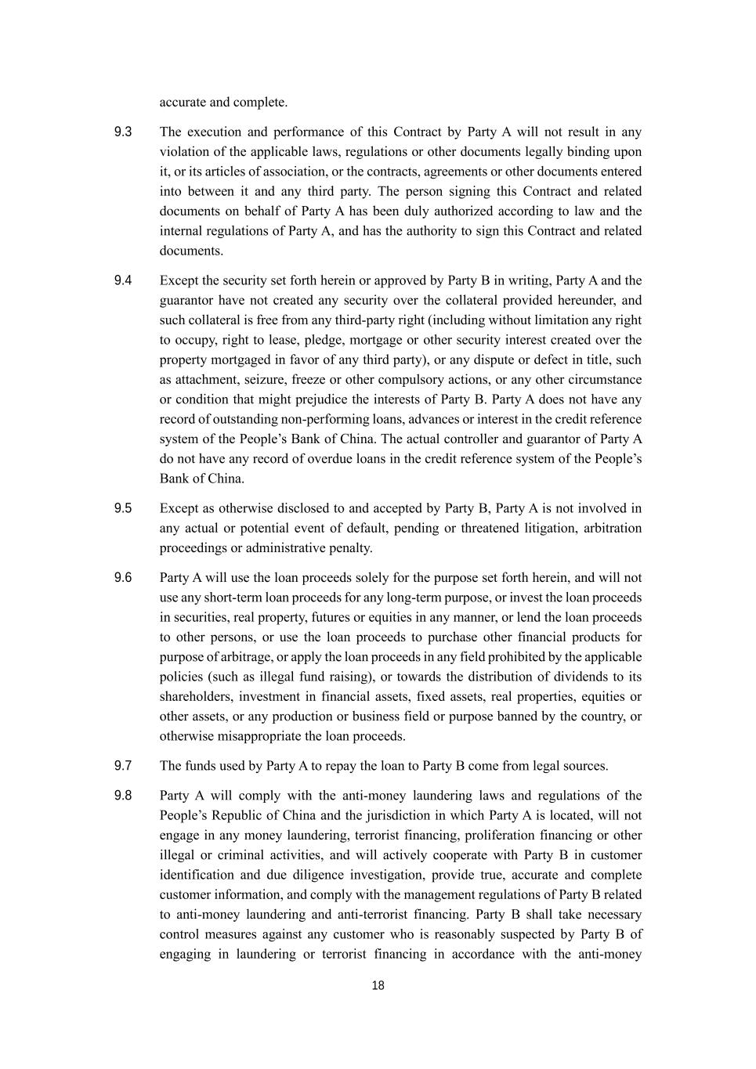
18 accurate and complete. 9.3 The execution and performance of this Contract by Party A will not result in any violation of the applicable laws, regulations or other documents legally binding upon it, or its articles of association, or the contracts, agreements or other documents entered into between it and any third party. The person signing this Contract and related documents on behalf of Party A has been duly authorized according to law and the internal regulations of Party A, and has the authority to sign this Contract and related documents. 9.4 Except the security set forth herein or approved by Party B in writing, Party A and the guarantor have not created any security over the collateral provided hereunder, and such collateral is free from any third-party right (including without limitation any right to occupy, right to lease, pledge, mortgage or other security interest created over the property mortgaged in favor of any third party), or any dispute or defect in title, such as attachment, seizure, freeze or other compulsory actions, or any other circumstance or condition that might prejudice the interests of Party B. Party A does not have any record of outstanding non-performing loans, advances or interest in the credit reference system of the People’s Bank of China. The actual controller and guarantor of Party A do not have any record of overdue loans in the credit reference system of the People’s Bank of China. 9.5 Except as otherwise disclosed to and accepted by Party B, Party A is not involved in any actual or potential event of default, pending or threatened litigation, arbitration proceedings or administrative penalty. 9.6 Party A will use the loan proceeds solely for the purpose set forth herein, and will not use any short-term loan proceeds for any long-term purpose, or invest the loan proceeds in securities, real property, futures or equities in any manner, or lend the loan proceeds to other persons, or use the loan proceeds to purchase other financial products for purpose of arbitrage, or apply the loan proceeds in any field prohibited by the applicable policies (such as illegal fund raising), or towards the distribution of dividends to its shareholders, investment in financial assets, fixed assets, real properties, equities or other assets, or any production or business field or purpose banned by the country, or otherwise misappropriate the loan proceeds. 9.7 The funds used by Party A to repay the loan to Party B come from legal sources. 9.8 Party A will comply with the anti-money laundering laws and regulations of the People’s Republic of China and the jurisdiction in which Party A is located, will not engage in any money laundering, terrorist financing, proliferation financing or other illegal or criminal activities, and will actively cooperate with Party B in customer identification and due diligence investigation, provide true, accurate and complete customer information, and comply with the management regulations of Party B related to anti-money laundering and anti-terrorist financing. Party B shall take necessary control measures against any customer who is reasonably suspected by Party B of engaging in laundering or terrorist financing in accordance with the anti-money

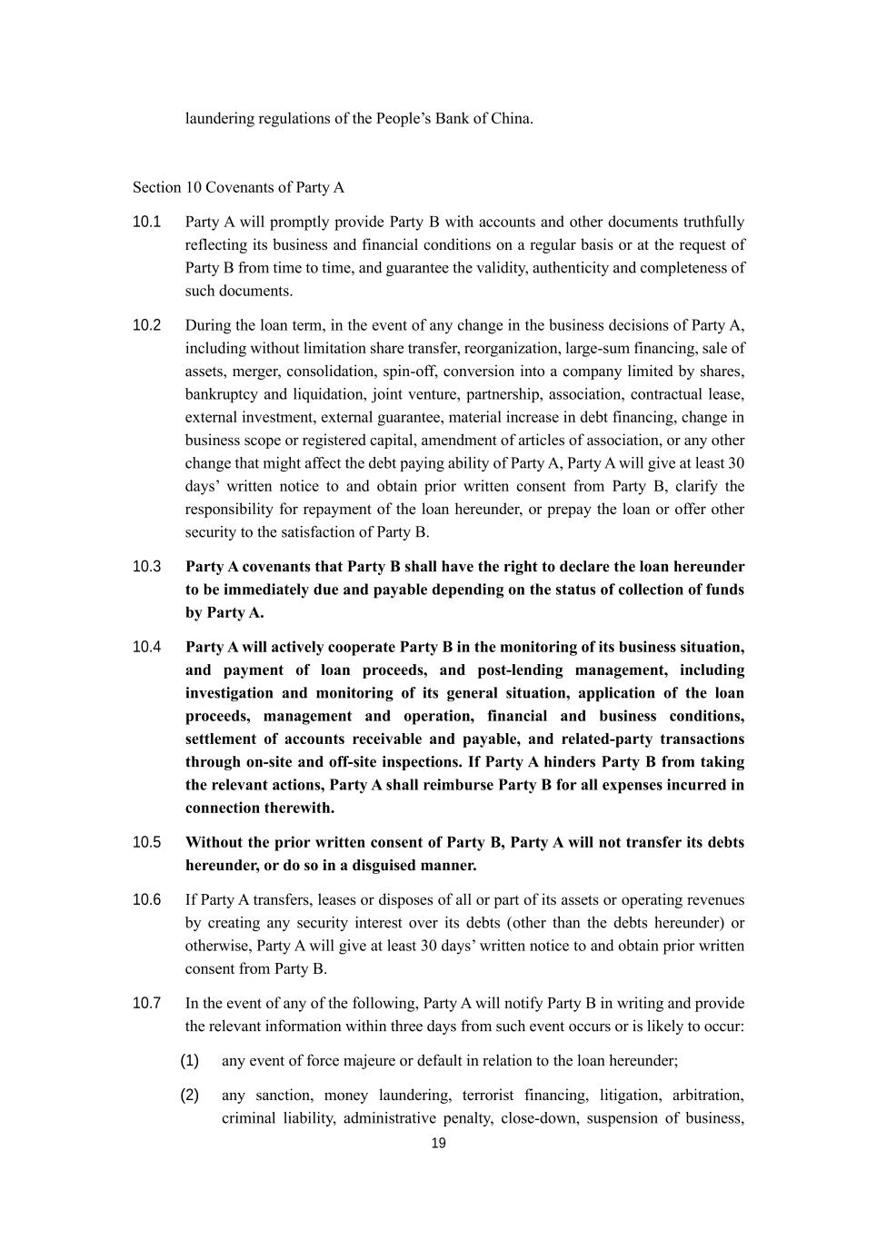
19 laundering regulations of the People’s Bank of China. Section 10 Covenants of Party A 10.1 Party A will promptly provide Party B with accounts and other documents truthfully reflecting its business and financial conditions on a regular basis or at the request of Party B from time to time, and guarantee the validity, authenticity and completeness of such documents. 10.2 During the loan term, in the event of any change in the business decisions of Party A, including without limitation share transfer, reorganization, large-sum financing, sale of assets, merger, consolidation, spin-off, conversion into a company limited by shares, bankruptcy and liquidation, joint venture, partnership, association, contractual lease, external investment, external guarantee, material increase in debt financing, change in business scope or registered capital, amendment of articles of association, or any other change that might affect the debt paying ability of Party A, Party A will give at least 30 days’ written notice to and obtain prior written consent from Party B, clarify the responsibility for repayment of the loan hereunder, or prepay the loan or offer other security to the satisfaction of Party B. 10.3 Party A covenants that Party B shall have the right to declare the loan hereunder to be immediately due and payable depending on the status of collection of funds by Party A. 10.4 Party A will actively cooperate Party B in the monitoring of its business situation, and payment of loan proceeds, and post-lending management, including investigation and monitoring of its general situation, application of the loan proceeds, management and operation, financial and business conditions, settlement of accounts receivable and payable, and related-party transactions through on-site and off-site inspections. If Party A hinders Party B from taking the relevant actions, Party A shall reimburse Party B for all expenses incurred in connection therewith. 10.5 Without the prior written consent of Party B, Party A will not transfer its debts hereunder, or do so in a disguised manner. 10.6 If Party A transfers, leases or disposes of all or part of its assets or operating revenues by creating any security interest over its debts (other than the debts hereunder) or otherwise, Party A will give at least 30 days’ written notice to and obtain prior written consent from Party B. 10.7 In the event of any of the following, Party A will notify Party B in writing and provide the relevant information within three days from such event occurs or is likely to occur: (1) any event of force majeure or default in relation to the loan hereunder; (2) any sanction, money laundering, terrorist financing, litigation, arbitration, criminal liability, administrative penalty, close-down, suspension of business,

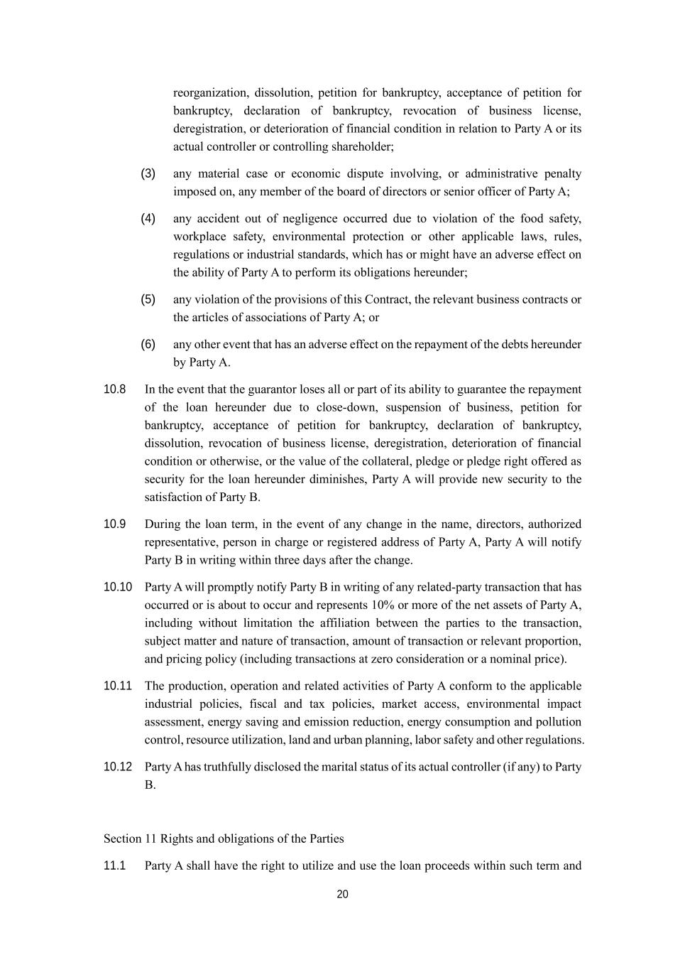
20 reorganization, dissolution, petition for bankruptcy, acceptance of petition for bankruptcy, declaration of bankruptcy, revocation of business license, deregistration, or deterioration of financial condition in relation to Party A or its actual controller or controlling shareholder; (3) any material case or economic dispute involving, or administrative penalty imposed on, any member of the board of directors or senior officer of Party A; (4) any accident out of negligence occurred due to violation of the food safety, workplace safety, environmental protection or other applicable laws, rules, regulations or industrial standards, which has or might have an adverse effect on the ability of Party A to perform its obligations hereunder; (5) any violation of the provisions of this Contract, the relevant business contracts or the articles of associations of Party A; or (6) any other event that has an adverse effect on the repayment of the debts hereunder by Party A. 10.8 In the event that the guarantor loses all or part of its ability to guarantee the repayment of the loan hereunder due to close-down, suspension of business, petition for bankruptcy, acceptance of petition for bankruptcy, declaration of bankruptcy, dissolution, revocation of business license, deregistration, deterioration of financial condition or otherwise, or the value of the collateral, pledge or pledge right offered as security for the loan hereunder diminishes, Party A will provide new security to the satisfaction of Party B. 10.9 During the loan term, in the event of any change in the name, directors, authorized representative, person in charge or registered address of Party A, Party A will notify Party B in writing within three days after the change. 10.10 Party A will promptly notify Party B in writing of any related-party transaction that has occurred or is about to occur and represents 10% or more of the net assets of Party A, including without limitation the affiliation between the parties to the transaction, subject matter and nature of transaction, amount of transaction or relevant proportion, and pricing policy (including transactions at zero consideration or a nominal price). 10.11 The production, operation and related activities of Party A conform to the applicable industrial policies, fiscal and tax policies, market access, environmental impact assessment, energy saving and emission reduction, energy consumption and pollution control, resource utilization, land and urban planning, labor safety and other regulations. 10.12 Party A has truthfully disclosed the marital status of its actual controller (if any) to Party B. Section 11 Rights and obligations of the Parties 11.1 Party A shall have the right to utilize and use the loan proceeds within such term and

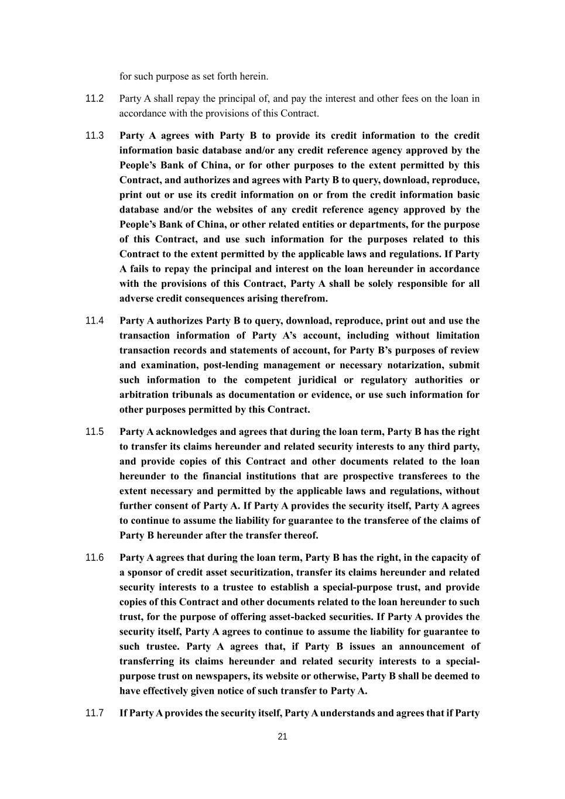
21 for such purpose as set forth herein. 11.2 Party A shall repay the principal of, and pay the interest and other fees on the loan in accordance with the provisions of this Contract. 11.3 Party A agrees with Party B to provide its credit information to the credit information basic database and/or any credit reference agency approved by the People’s Bank of China, or for other purposes to the extent permitted by this Contract, and authorizes and agrees with Party B to query, download, reproduce, print out or use its credit information on or from the credit information basic database and/or the websites of any credit reference agency approved by the People’s Bank of China, or other related entities or departments, for the purpose of this Contract, and use such information for the purposes related to this Contract to the extent permitted by the applicable laws and regulations. If Party A fails to repay the principal and interest on the loan hereunder in accordance with the provisions of this Contract, Party A shall be solely responsible for all adverse credit consequences arising therefrom. 11.4 Party A authorizes Party B to query, download, reproduce, print out and use the transaction information of Party A’s account, including without limitation transaction records and statements of account, for Party B’s purposes of review and examination, post-lending management or necessary notarization, submit such information to the competent juridical or regulatory authorities or arbitration tribunals as documentation or evidence, or use such information for other purposes permitted by this Contract. 11.5 Party A acknowledges and agrees that during the loan term, Party B has the right to transfer its claims hereunder and related security interests to any third party, and provide copies of this Contract and other documents related to the loan hereunder to the financial institutions that are prospective transferees to the extent necessary and permitted by the applicable laws and regulations, without further consent of Party A. If Party A provides the security itself, Party A agrees to continue to assume the liability for guarantee to the transferee of the claims of Party B hereunder after the transfer thereof. 11.6 Party A agrees that during the loan term, Party B has the right, in the capacity of a sponsor of credit asset securitization, transfer its claims hereunder and related security interests to a trustee to establish a special-purpose trust, and provide copies of this Contract and other documents related to the loan hereunder to such trust, for the purpose of offering asset-backed securities. If Party A provides the security itself, Party A agrees to continue to assume the liability for guarantee to such trustee. Party A agrees that, if Party B issues an announcement of transferring its claims hereunder and related security interests to a special- purpose trust on newspapers, its website or otherwise, Party B shall be deemed to have effectively given notice of such transfer to Party A. 11.7 If Party A provides the security itself, Party A understands and agrees that if Party

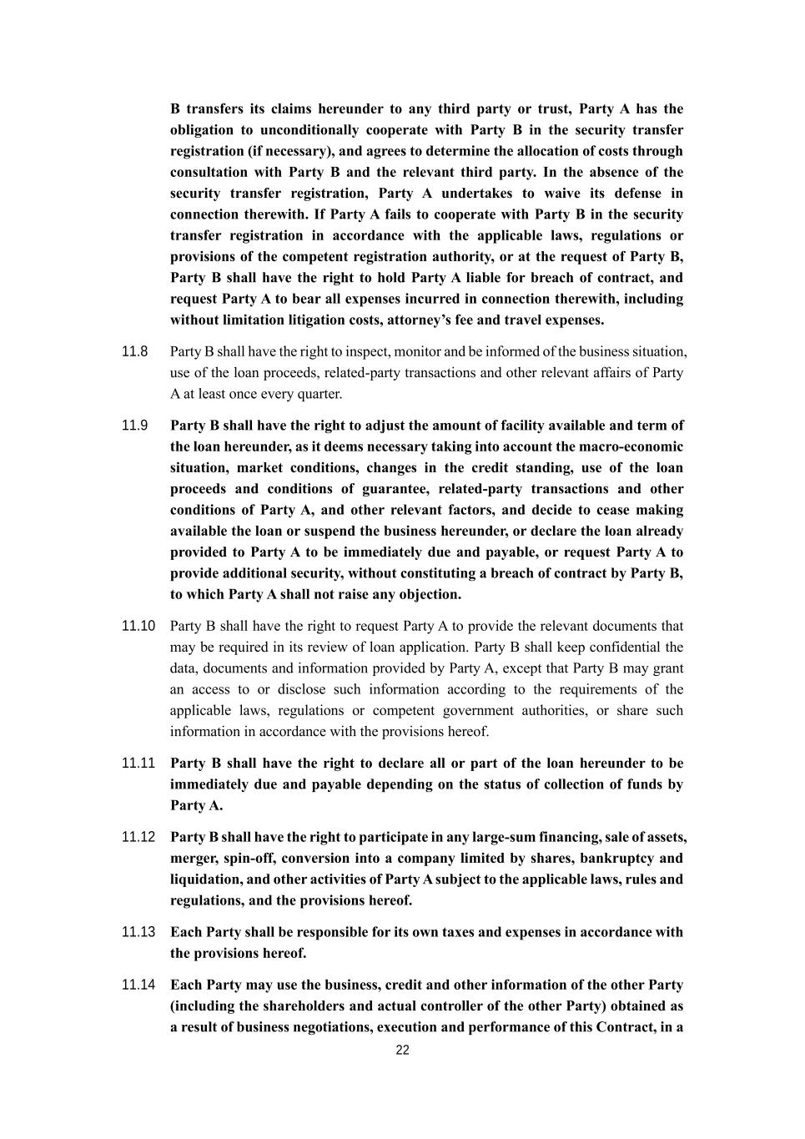
22 B transfers its claims hereunder to any third party or trust, Party A has the obligation to unconditionally cooperate with Party B in the security transfer registration (if necessary), and agrees to determine the allocation of costs through consultation with Party B and the relevant third party. In the absence of the security transfer registration, Party A undertakes to waive its defense in connection therewith. If Party A fails to cooperate with Party B in the security transfer registration in accordance with the applicable laws, regulations or provisions of the competent registration authority, or at the request of Party B, Party B shall have the right to hold Party A liable for breach of contract, and request Party A to bear all expenses incurred in connection therewith, including without limitation litigation costs, attorney’s fee and travel expenses. 11.8 Party B shall have the right to inspect, monitor and be informed of the business situation, use of the loan proceeds, related-party transactions and other relevant affairs of Party A at least once every quarter. 11.9 Party B shall have the right to adjust the amount of facility available and term of the loan hereunder, as it deems necessary taking into account the macro-economic situation, market conditions, changes in the credit standing, use of the loan proceeds and conditions of guarantee, related-party transactions and other conditions of Party A, and other relevant factors, and decide to cease making available the loan or suspend the business hereunder, or declare the loan already provided to Party A to be immediately due and payable, or request Party A to provide additional security, without constituting a breach of contract by Party B, to which Party A shall not raise any objection. 11.10 Party B shall have the right to request Party A to provide the relevant documents that may be required in its review of loan application. Party B shall keep confidential the data, documents and information provided by Party A, except that Party B may grant an access to or disclose such information according to the requirements of the applicable laws, regulations or competent government authorities, or share such information in accordance with the provisions hereof. 11.11 Party B shall have the right to declare all or part of the loan hereunder to be immediately due and payable depending on the status of collection of funds by Party A. 11.12 Party B shall have the right to participate in any large-sum financing, sale of assets, merger, spin-off, conversion into a company limited by shares, bankruptcy and liquidation, and other activities of Party A subject to the applicable laws, rules and regulations, and the provisions hereof. 11.13 Each Party shall be responsible for its own taxes and expenses in accordance with the provisions hereof. 11.14 Each Party may use the business, credit and other information of the other Party (including the shareholders and actual controller of the other Party) obtained as a result of business negotiations, execution and performance of this Contract, in a

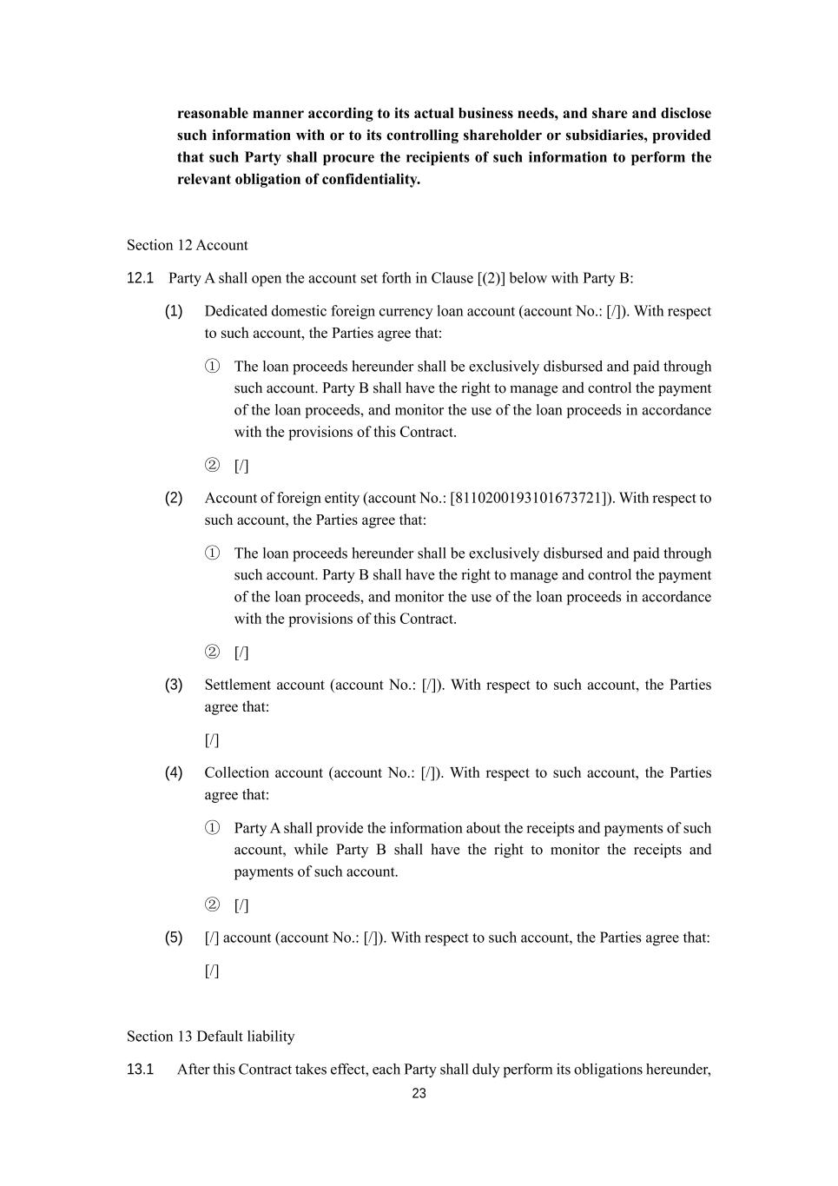
23 reasonable manner according to its actual business needs, and share and disclose such information with or to its controlling shareholder or subsidiaries, provided that such Party shall procure the recipients of such information to perform the relevant obligation of confidentiality. Section 12 Account 12.1 Party A shall open the account set forth in Clause [(2)] below with Party B: (1) Dedicated domestic foreign currency loan account (account No.: [/]). With respect to such account, the Parties agree that: ① The loan proceeds hereunder shall be exclusively disbursed and paid through such account. Party B shall have the right to manage and control the payment of the loan proceeds, and monitor the use of the loan proceeds in accordance with the provisions of this Contract. ② [/] (2) Account of foreign entity (account No.: [8110200193101673721]). With respect to such account, the Parties agree that: ① The loan proceeds hereunder shall be exclusively disbursed and paid through such account. Party B shall have the right to manage and control the payment of the loan proceeds, and monitor the use of the loan proceeds in accordance with the provisions of this Contract. ② [/] (3) Settlement account (account No.: [/]). With respect to such account, the Parties agree that: [/] (4) Collection account (account No.: [/]). With respect to such account, the Parties agree that: ① Party A shall provide the information about the receipts and payments of such account, while Party B shall have the right to monitor the receipts and payments of such account. ② [/] (5) [/] account (account No.: [/]). With respect to such account, the Parties agree that: [/] Section 13 Default liability 13.1 After this Contract takes effect, each Party shall duly perform its obligations hereunder,

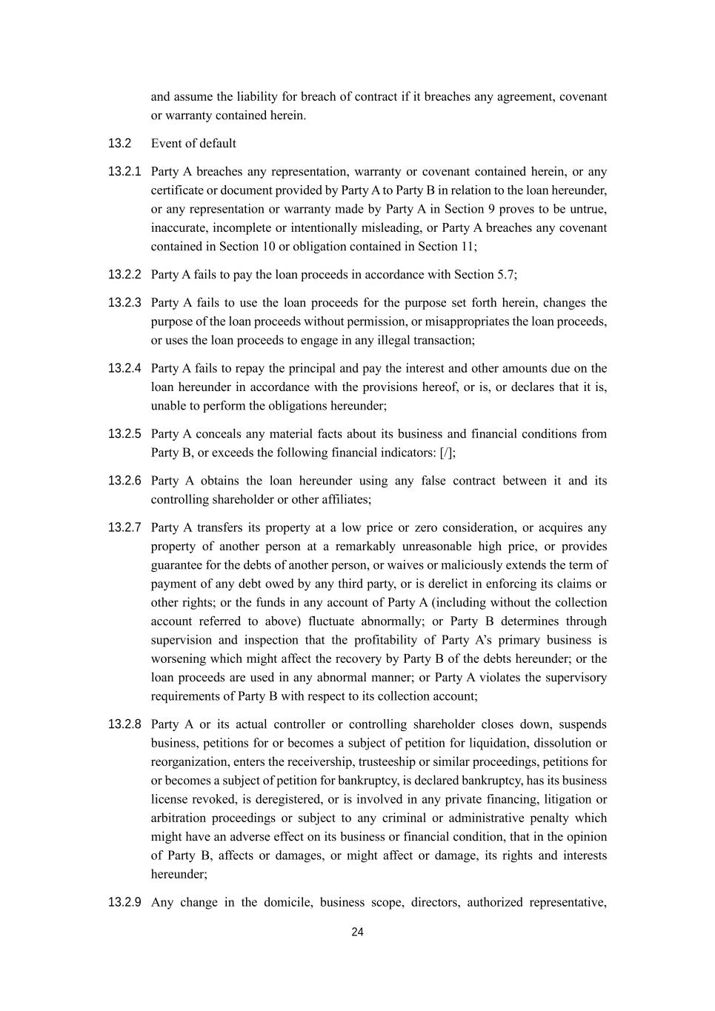
24 and assume the liability for breach of contract if it breaches any agreement, covenant or warranty contained herein. 13.2 Event of default 13.2.1 Party A breaches any representation, warranty or covenant contained herein, or any certificate or document provided by Party A to Party B in relation to the loan hereunder, or any representation or warranty made by Party A in Section 9 proves to be untrue, inaccurate, incomplete or intentionally misleading, or Party A breaches any covenant contained in Section 10 or obligation contained in Section 11; 13.2.2 Party A fails to pay the loan proceeds in accordance with Section 5.7; 13.2.3 Party A fails to use the loan proceeds for the purpose set forth herein, changes the purpose of the loan proceeds without permission, or misappropriates the loan proceeds, or uses the loan proceeds to engage in any illegal transaction; 13.2.4 Party A fails to repay the principal and pay the interest and other amounts due on the loan hereunder in accordance with the provisions hereof, or is, or declares that it is, unable to perform the obligations hereunder; 13.2.5 Party A conceals any material facts about its business and financial conditions from Party B, or exceeds the following financial indicators: [/]; 13.2.6 Party A obtains the loan hereunder using any false contract between it and its controlling shareholder or other affiliates; 13.2.7 Party A transfers its property at a low price or zero consideration, or acquires any property of another person at a remarkably unreasonable high price, or provides guarantee for the debts of another person, or waives or maliciously extends the term of payment of any debt owed by any third party, or is derelict in enforcing its claims or other rights; or the funds in any account of Party A (including without the collection account referred to above) fluctuate abnormally; or Party B determines through supervision and inspection that the profitability of Party A’s primary business is worsening which might affect the recovery by Party B of the debts hereunder; or the loan proceeds are used in any abnormal manner; or Party A violates the supervisory requirements of Party B with respect to its collection account; 13.2.8 Party A or its actual controller or controlling shareholder closes down, suspends business, petitions for or becomes a subject of petition for liquidation, dissolution or reorganization, enters the receivership, trusteeship or similar proceedings, petitions for or becomes a subject of petition for bankruptcy, is declared bankruptcy, has its business license revoked, is deregistered, or is involved in any private financing, litigation or arbitration proceedings or subject to any criminal or administrative penalty which might have an adverse effect on its business or financial condition, that in the opinion of Party B, affects or damages, or might affect or damage, its rights and interests hereunder; 13.2.9 Any change in the domicile, business scope, directors, authorized representative,

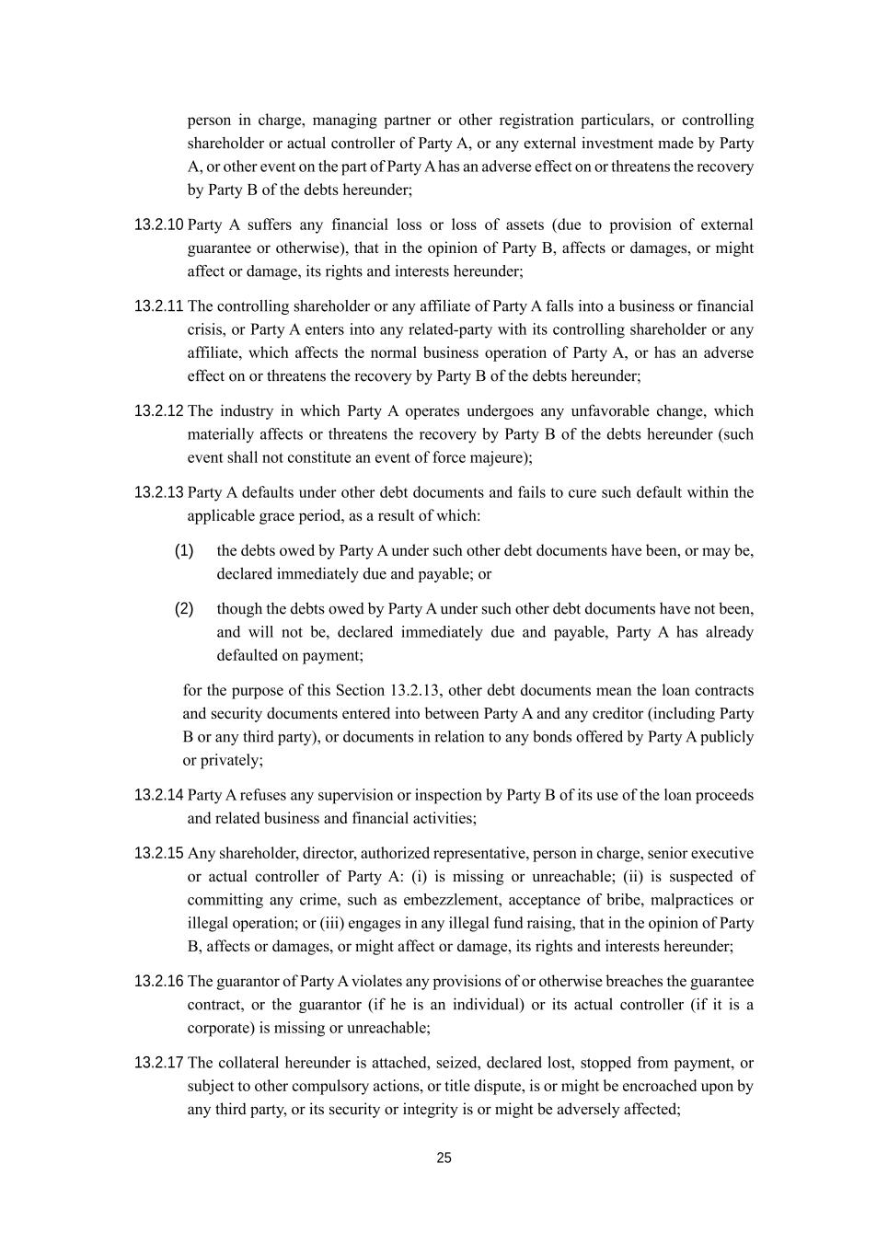
25 person in charge, managing partner or other registration particulars, or controlling shareholder or actual controller of Party A, or any external investment made by Party A, or other event on the part of Party A has an adverse effect on or threatens the recovery by Party B of the debts hereunder; 13.2.10 Party A suffers any financial loss or loss of assets (due to provision of external guarantee or otherwise), that in the opinion of Party B, affects or damages, or might affect or damage, its rights and interests hereunder; 13.2.11 The controlling shareholder or any affiliate of Party A falls into a business or financial crisis, or Party A enters into any related-party with its controlling shareholder or any affiliate, which affects the normal business operation of Party A, or has an adverse effect on or threatens the recovery by Party B of the debts hereunder; 13.2.12 The industry in which Party A operates undergoes any unfavorable change, which materially affects or threatens the recovery by Party B of the debts hereunder (such event shall not constitute an event of force majeure); 13.2.13 Party A defaults under other debt documents and fails to cure such default within the applicable grace period, as a result of which: (1) the debts owed by Party A under such other debt documents have been, or may be, declared immediately due and payable; or (2) though the debts owed by Party A under such other debt documents have not been, and will not be, declared immediately due and payable, Party A has already defaulted on payment; for the purpose of this Section 13.2.13, other debt documents mean the loan contracts and security documents entered into between Party A and any creditor (including Party B or any third party), or documents in relation to any bonds offered by Party A publicly or privately; 13.2.14 Party A refuses any supervision or inspection by Party B of its use of the loan proceeds and related business and financial activities; 13.2.15 Any shareholder, director, authorized representative, person in charge, senior executive or actual controller of Party A: (i) is missing or unreachable; (ii) is suspected of committing any crime, such as embezzlement, acceptance of bribe, malpractices or illegal operation; or (iii) engages in any illegal fund raising, that in the opinion of Party B, affects or damages, or might affect or damage, its rights and interests hereunder; 13.2.16 The guarantor of Party A violates any provisions of or otherwise breaches the guarantee contract, or the guarantor (if he is an individual) or its actual controller (if it is a corporate) is missing or unreachable; 13.2.17 The collateral hereunder is attached, seized, declared lost, stopped from payment, or subject to other compulsory actions, or title dispute, is or might be encroached upon by any third party, or its security or integrity is or might be adversely affected;

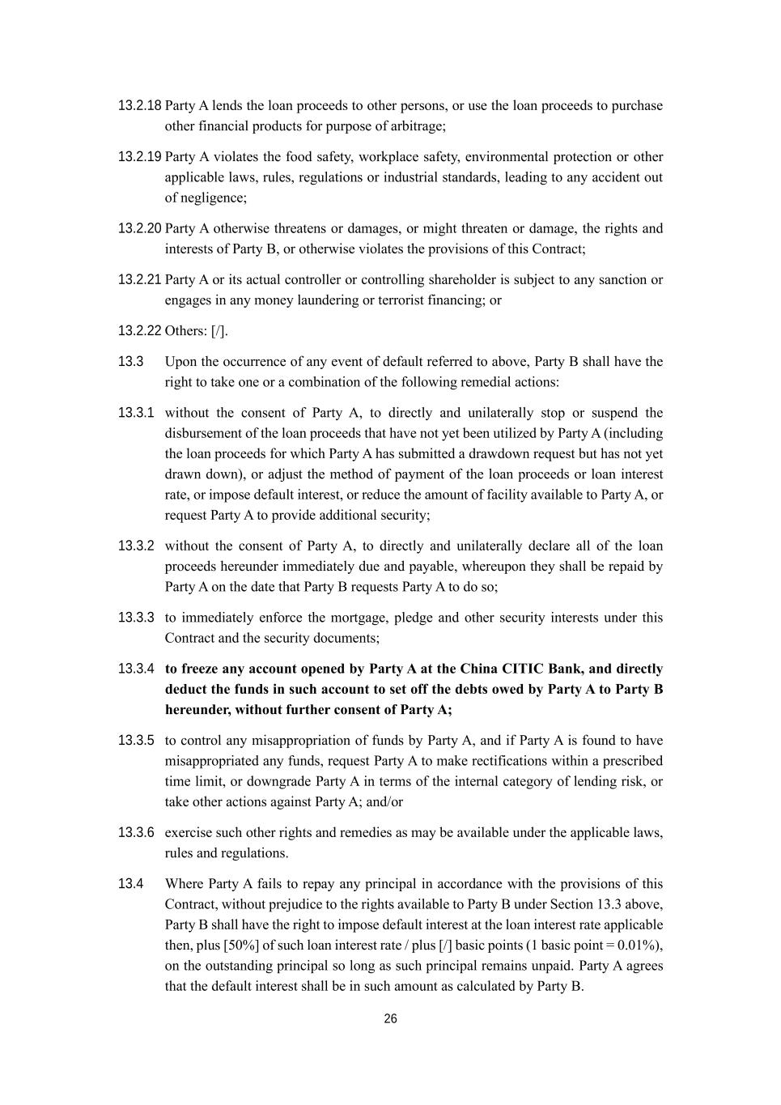
26 13.2.18 Party A lends the loan proceeds to other persons, or use the loan proceeds to purchase other financial products for purpose of arbitrage; 13.2.19 Party A violates the food safety, workplace safety, environmental protection or other applicable laws, rules, regulations or industrial standards, leading to any accident out of negligence; 13.2.20 Party A otherwise threatens or damages, or might threaten or damage, the rights and interests of Party B, or otherwise violates the provisions of this Contract; 13.2.21 Party A or its actual controller or controlling shareholder is subject to any sanction or engages in any money laundering or terrorist financing; or 13.2.22 Others: [/]. 13.3 Upon the occurrence of any event of default referred to above, Party B shall have the right to take one or a combination of the following remedial actions: 13.3.1 without the consent of Party A, to directly and unilaterally stop or suspend the disbursement of the loan proceeds that have not yet been utilized by Party A (including the loan proceeds for which Party A has submitted a drawdown request but has not yet drawn down), or adjust the method of payment of the loan proceeds or loan interest rate, or impose default interest, or reduce the amount of facility available to Party A, or request Party A to provide additional security; 13.3.2 without the consent of Party A, to directly and unilaterally declare all of the loan proceeds hereunder immediately due and payable, whereupon they shall be repaid by Party A on the date that Party B requests Party A to do so; 13.3.3 to immediately enforce the mortgage, pledge and other security interests under this Contract and the security documents; 13.3.4 to freeze any account opened by Party A at the China CITIC Bank, and directly deduct the funds in such account to set off the debts owed by Party A to Party B hereunder, without further consent of Party A; 13.3.5 to control any misappropriation of funds by Party A, and if Party A is found to have misappropriated any funds, request Party A to make rectifications within a prescribed time limit, or downgrade Party A in terms of the internal category of lending risk, or take other actions against Party A; and/or 13.3.6 exercise such other rights and remedies as may be available under the applicable laws, rules and regulations. 13.4 Where Party A fails to repay any principal in accordance with the provisions of this Contract, without prejudice to the rights available to Party B under Section 13.3 above, Party B shall have the right to impose default interest at the loan interest rate applicable then, plus [50%] of such loan interest rate / plus [/] basic points (1 basic point = 0.01%), on the outstanding principal so long as such principal remains unpaid. Party A agrees that the default interest shall be in such amount as calculated by Party B.

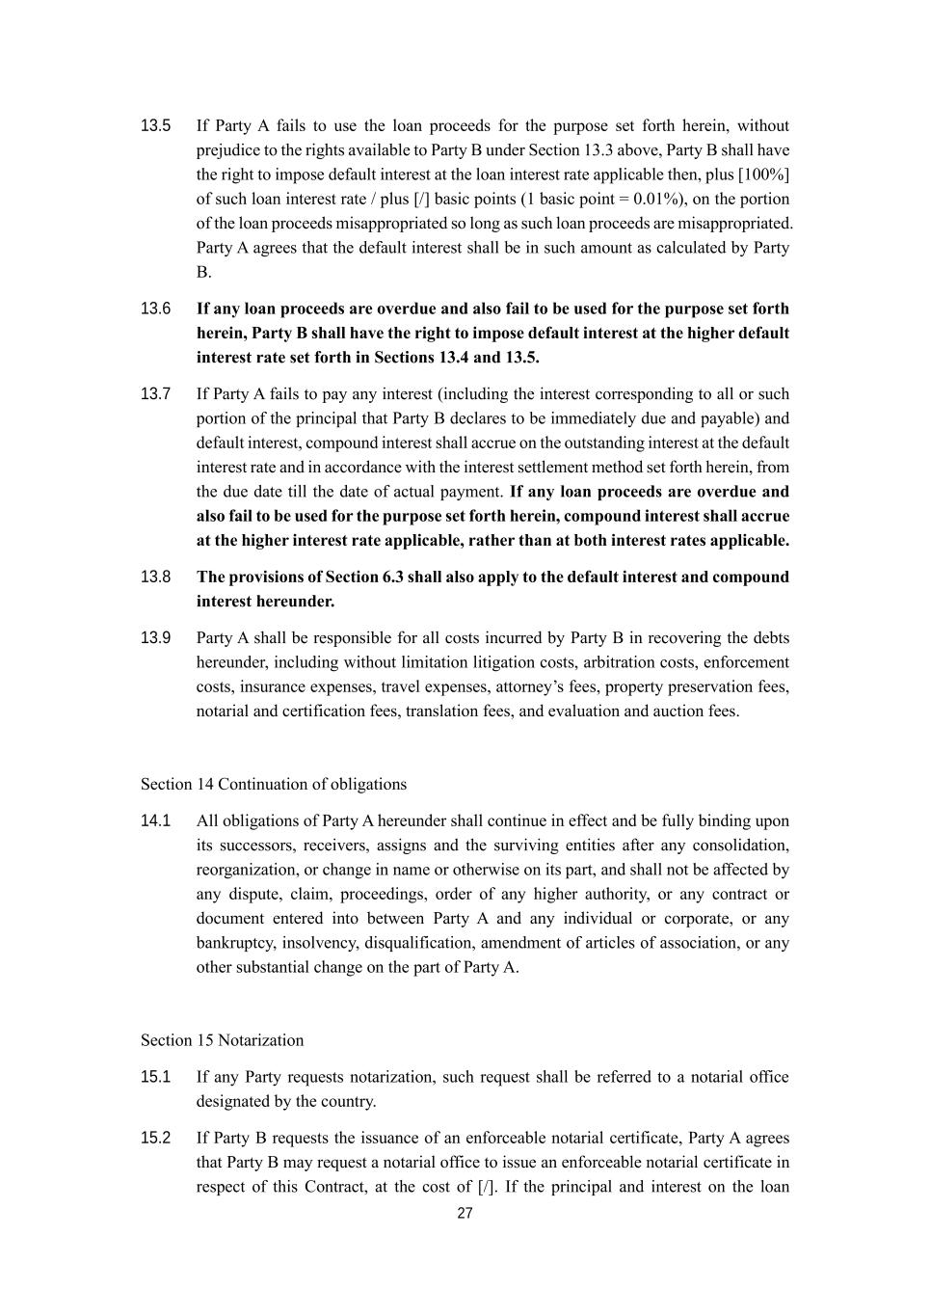
27 13.5 If Party A fails to use the loan proceeds for the purpose set forth herein, without prejudice to the rights available to Party B under Section 13.3 above, Party B shall have the right to impose default interest at the loan interest rate applicable then, plus [100%] of such loan interest rate / plus [/] basic points (1 basic point = 0.01%), on the portion of the loan proceeds misappropriated so long as such loan proceeds are misappropriated. Party A agrees that the default interest shall be in such amount as calculated by Party B. 13.6 If any loan proceeds are overdue and also fail to be used for the purpose set forth herein, Party B shall have the right to impose default interest at the higher default interest rate set forth in Sections 13.4 and 13.5. 13.7 If Party A fails to pay any interest (including the interest corresponding to all or such portion of the principal that Party B declares to be immediately due and payable) and default interest, compound interest shall accrue on the outstanding interest at the default interest rate and in accordance with the interest settlement method set forth herein, from the due date till the date of actual payment. If any loan proceeds are overdue and also fail to be used for the purpose set forth herein, compound interest shall accrue at the higher interest rate applicable, rather than at both interest rates applicable. 13.8 The provisions of Section 6.3 shall also apply to the default interest and compound interest hereunder. 13.9 Party A shall be responsible for all costs incurred by Party B in recovering the debts hereunder, including without limitation litigation costs, arbitration costs, enforcement costs, insurance expenses, travel expenses, attorney’s fees, property preservation fees, notarial and certification fees, translation fees, and evaluation and auction fees. Section 14 Continuation of obligations 14.1 All obligations of Party A hereunder shall continue in effect and be fully binding upon its successors, receivers, assigns and the surviving entities after any consolidation, reorganization, or change in name or otherwise on its part, and shall not be affected by any dispute, claim, proceedings, order of any higher authority, or any contract or document entered into between Party A and any individual or corporate, or any bankruptcy, insolvency, disqualification, amendment of articles of association, or any other substantial change on the part of Party A. Section 15 Notarization 15.1 If any Party requests notarization, such request shall be referred to a notarial office designated by the country. 15.2 If Party B requests the issuance of an enforceable notarial certificate, Party A agrees that Party B may request a notarial office to issue an enforceable notarial certificate in respect of this Contract, at the cost of [/]. If the principal and interest on the loan

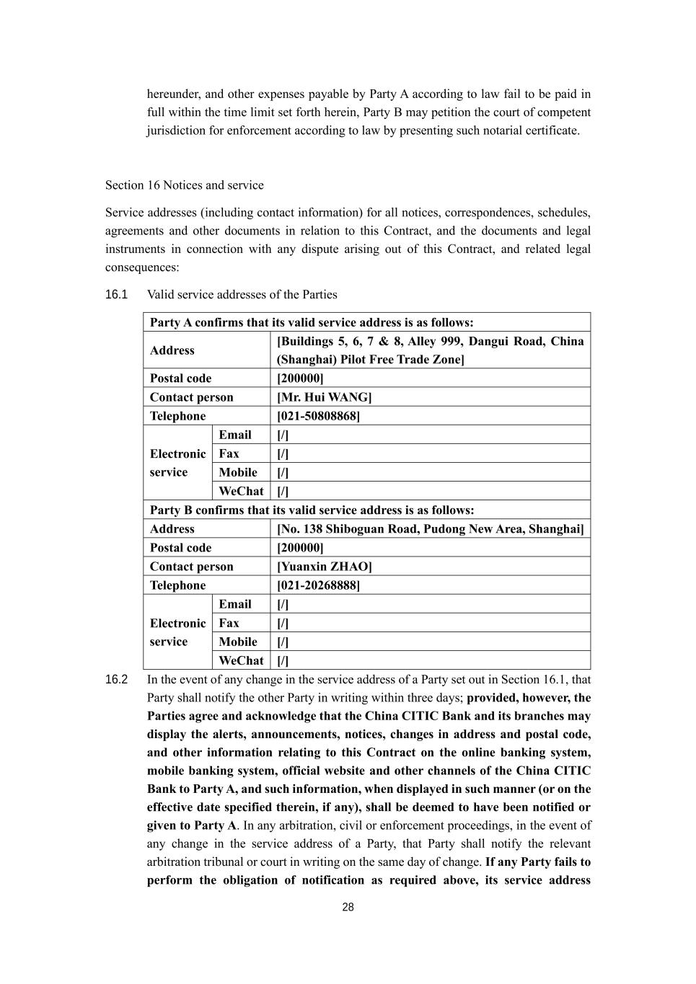
28 hereunder, and other expenses payable by Party A according to law fail to be paid in full within the time limit set forth herein, Party B may petition the court of competent jurisdiction for enforcement according to law by presenting such notarial certificate. Section 16 Notices and service Service addresses (including contact information) for all notices, correspondences, schedules, agreements and other documents in relation to this Contract, and the documents and legal instruments in connection with any dispute arising out of this Contract, and related legal consequences: 16.1 Valid service addresses of the Parties Party A confirms that its valid service address is as follows: Address [Buildings 5, 6, 7 & 8, Alley 999, Dangui Road, China (Shanghai) Pilot Free Trade Zone] Postal code [200000] Contact person [Mr. Hui WANG] Telephone [021-50808868] Electronic service Email [/] Fax [/] Mobile [/] WeChat [/] Party B confirms that its valid service address is as follows: Address [No. 138 Shiboguan Road, Pudong New Area, Shanghai] Postal code [200000] Contact person [Yuanxin ZHAO] Telephone [021-20268888] Electronic service Email [/] Fax [/] Mobile [/] WeChat [/] 16.2 In the event of any change in the service address of a Party set out in Section 16.1, that Party shall notify the other Party in writing within three days; provided, however, the Parties agree and acknowledge that the China CITIC Bank and its branches may display the alerts, announcements, notices, changes in address and postal code, and other information relating to this Contract on the online banking system, mobile banking system, official website and other channels of the China CITIC Bank to Party A, and such information, when displayed in such manner (or on the effective date specified therein, if any), shall be deemed to have been notified or given to Party A. In any arbitration, civil or enforcement proceedings, in the event of any change in the service address of a Party, that Party shall notify the relevant arbitration tribunal or court in writing on the same day of change. If any Party fails to perform the obligation of notification as required above, its service address

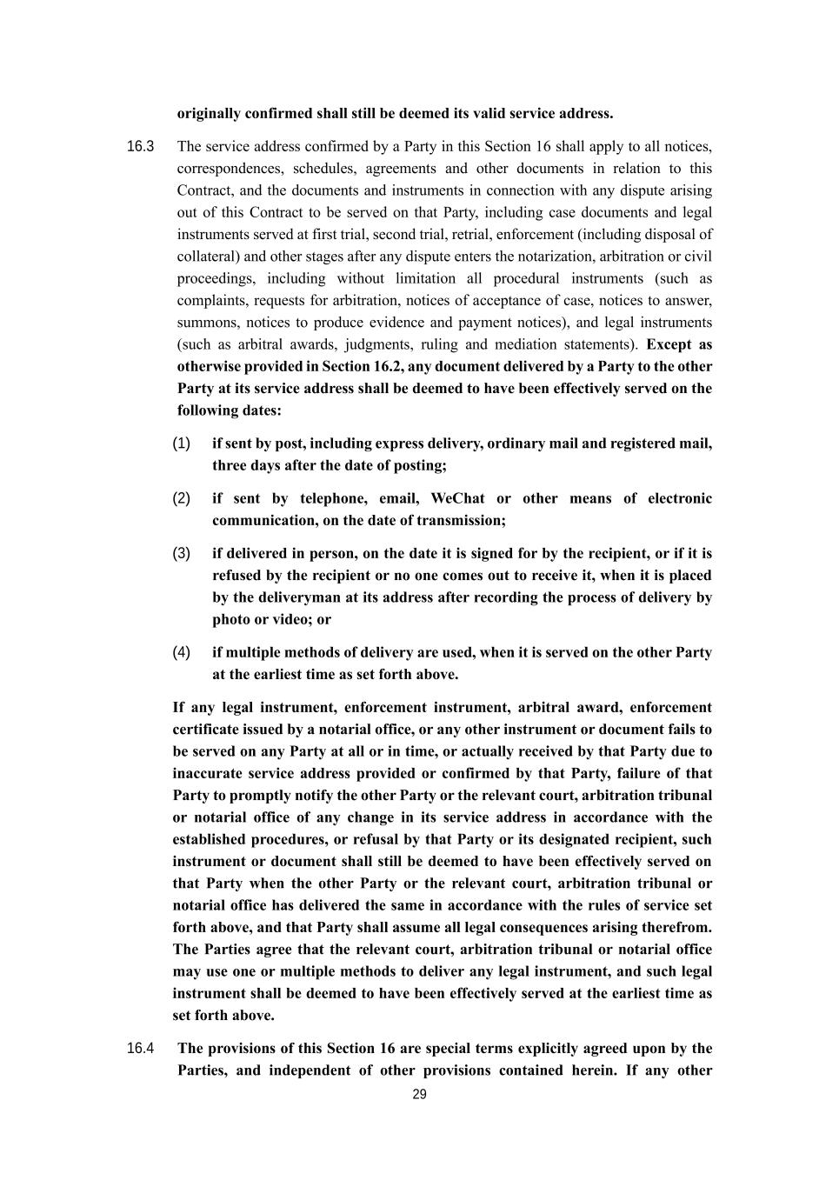
29 originally confirmed shall still be deemed its valid service address. 16.3 The service address confirmed by a Party in this Section 16 shall apply to all notices, correspondences, schedules, agreements and other documents in relation to this Contract, and the documents and instruments in connection with any dispute arising out of this Contract to be served on that Party, including case documents and legal instruments served at first trial, second trial, retrial, enforcement (including disposal of collateral) and other stages after any dispute enters the notarization, arbitration or civil proceedings, including without limitation all procedural instruments (such as complaints, requests for arbitration, notices of acceptance of case, notices to answer, summons, notices to produce evidence and payment notices), and legal instruments (such as arbitral awards, judgments, ruling and mediation statements). Except as otherwise provided in Section 16.2, any document delivered by a Party to the other Party at its service address shall be deemed to have been effectively served on the following dates: (1) if sent by post, including express delivery, ordinary mail and registered mail, three days after the date of posting; (2) if sent by telephone, email, WeChat or other means of electronic communication, on the date of transmission; (3) if delivered in person, on the date it is signed for by the recipient, or if it is refused by the recipient or no one comes out to receive it, when it is placed by the deliveryman at its address after recording the process of delivery by photo or video; or (4) if multiple methods of delivery are used, when it is served on the other Party at the earliest time as set forth above. If any legal instrument, enforcement instrument, arbitral award, enforcement certificate issued by a notarial office, or any other instrument or document fails to be served on any Party at all or in time, or actually received by that Party due to inaccurate service address provided or confirmed by that Party, failure of that Party to promptly notify the other Party or the relevant court, arbitration tribunal or notarial office of any change in its service address in accordance with the established procedures, or refusal by that Party or its designated recipient, such instrument or document shall still be deemed to have been effectively served on that Party when the other Party or the relevant court, arbitration tribunal or notarial office has delivered the same in accordance with the rules of service set forth above, and that Party shall assume all legal consequences arising therefrom. The Parties agree that the relevant court, arbitration tribunal or notarial office may use one or multiple methods to deliver any legal instrument, and such legal instrument shall be deemed to have been effectively served at the earliest time as set forth above. 16.4 The provisions of this Section 16 are special terms explicitly agreed upon by the Parties, and independent of other provisions contained herein. If any other

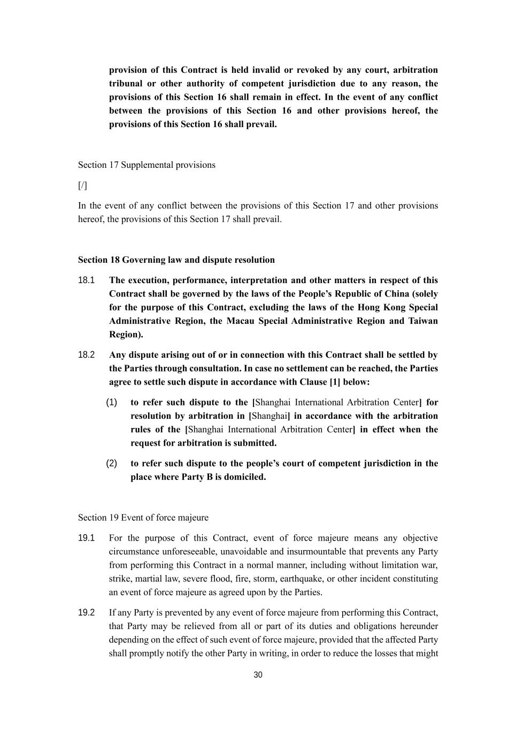
30 provision of this Contract is held invalid or revoked by any court, arbitration tribunal or other authority of competent jurisdiction due to any reason, the provisions of this Section 16 shall remain in effect. In the event of any conflict between the provisions of this Section 16 and other provisions hereof, the provisions of this Section 16 shall prevail. Section 17 Supplemental provisions [/] In the event of any conflict between the provisions of this Section 17 and other provisions hereof, the provisions of this Section 17 shall prevail. Section 18 Governing law and dispute resolution 18.1 The execution, performance, interpretation and other matters in respect of this Contract shall be governed by the laws of the People’s Republic of China (solely for the purpose of this Contract, excluding the laws of the Hong Kong Special Administrative Region, the Macau Special Administrative Region and Taiwan Region). 18.2 Any dispute arising out of or in connection with this Contract shall be settled by the Parties through consultation. In case no settlement can be reached, the Parties agree to settle such dispute in accordance with Clause [1] below: (1) to refer such dispute to the [Shanghai International Arbitration Center] for resolution by arbitration in [Shanghai] in accordance with the arbitration rules of the [Shanghai International Arbitration Center] in effect when the request for arbitration is submitted. (2) to refer such dispute to the people’s court of competent jurisdiction in the place where Party B is domiciled. Section 19 Event of force majeure 19.1 For the purpose of this Contract, event of force majeure means any objective circumstance unforeseeable, unavoidable and insurmountable that prevents any Party from performing this Contract in a normal manner, including without limitation war, strike, martial law, severe flood, fire, storm, earthquake, or other incident constituting an event of force majeure as agreed upon by the Parties. 19.2 If any Party is prevented by any event of force majeure from performing this Contract, that Party may be relieved from all or part of its duties and obligations hereunder depending on the effect of such event of force majeure, provided that the affected Party shall promptly notify the other Party in writing, in order to reduce the losses that might

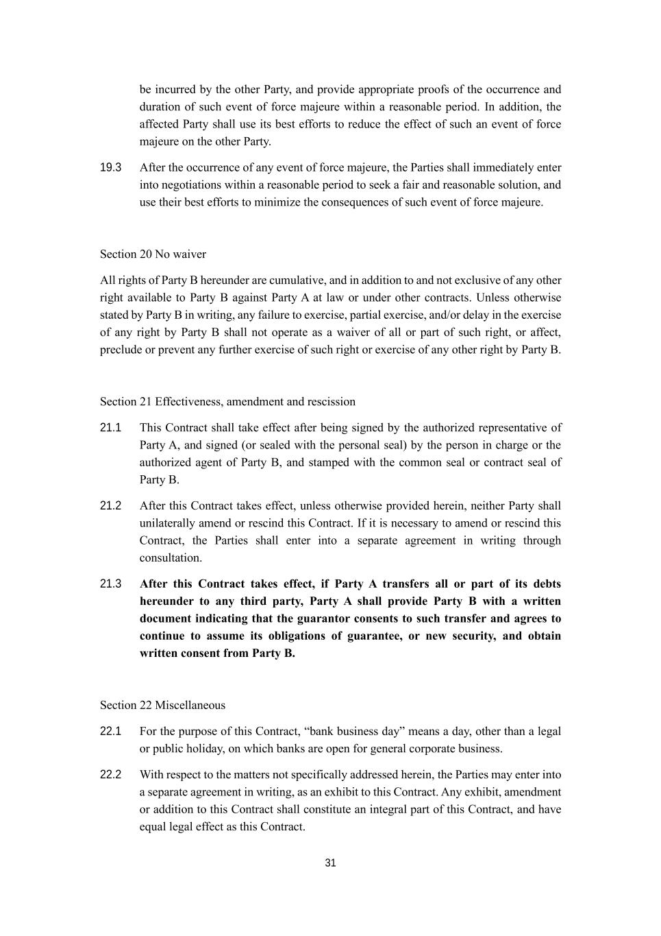
31 be incurred by the other Party, and provide appropriate proofs of the occurrence and duration of such event of force majeure within a reasonable period. In addition, the affected Party shall use its best efforts to reduce the effect of such an event of force majeure on the other Party. 19.3 After the occurrence of any event of force majeure, the Parties shall immediately enter into negotiations within a reasonable period to seek a fair and reasonable solution, and use their best efforts to minimize the consequences of such event of force majeure. Section 20 No waiver All rights of Party B hereunder are cumulative, and in addition to and not exclusive of any other right available to Party B against Party A at law or under other contracts. Unless otherwise stated by Party B in writing, any failure to exercise, partial exercise, and/or delay in the exercise of any right by Party B shall not operate as a waiver of all or part of such right, or affect, preclude or prevent any further exercise of such right or exercise of any other right by Party B. Section 21 Effectiveness, amendment and rescission 21.1 This Contract shall take effect after being signed by the authorized representative of Party A, and signed (or sealed with the personal seal) by the person in charge or the authorized agent of Party B, and stamped with the common seal or contract seal of Party B. 21.2 After this Contract takes effect, unless otherwise provided herein, neither Party shall unilaterally amend or rescind this Contract. If it is necessary to amend or rescind this Contract, the Parties shall enter into a separate agreement in writing through consultation. 21.3 After this Contract takes effect, if Party A transfers all or part of its debts hereunder to any third party, Party A shall provide Party B with a written document indicating that the guarantor consents to such transfer and agrees to continue to assume its obligations of guarantee, or new security, and obtain written consent from Party B. Section 22 Miscellaneous 22.1 For the purpose of this Contract, “bank business day” means a day, other than a legal or public holiday, on which banks are open for general corporate business. 22.2 With respect to the matters not specifically addressed herein, the Parties may enter into a separate agreement in writing, as an exhibit to this Contract. Any exhibit, amendment or addition to this Contract shall constitute an integral part of this Contract, and have equal legal effect as this Contract.

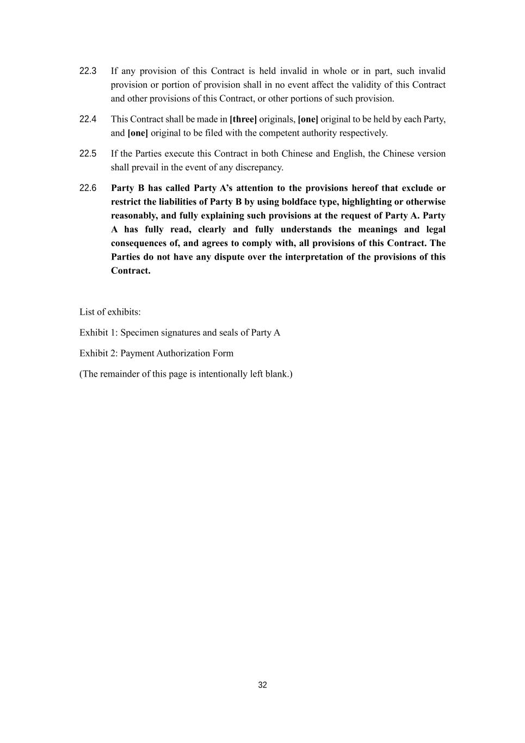
32 22.3 If any provision of this Contract is held invalid in whole or in part, such invalid provision or portion of provision shall in no event affect the validity of this Contract and other provisions of this Contract, or other portions of such provision. 22.4 This Contract shall be made in [three] originals, [one] original to be held by each Party, and [one] original to be filed with the competent authority respectively. 22.5 If the Parties execute this Contract in both Chinese and English, the Chinese version shall prevail in the event of any discrepancy. 22.6 Party B has called Party A’s attention to the provisions hereof that exclude or restrict the liabilities of Party B by using boldface type, highlighting or otherwise reasonably, and fully explaining such provisions at the request of Party A. Party A has fully read, clearly and fully understands the meanings and legal consequences of, and agrees to comply with, all provisions of this Contract. The Parties do not have any dispute over the interpretation of the provisions of this Contract. List of exhibits: Exhibit 1: Specimen signatures and seals of Party A Exhibit 2: Payment Authorization Form (The remainder of this page is intentionally left blank.)

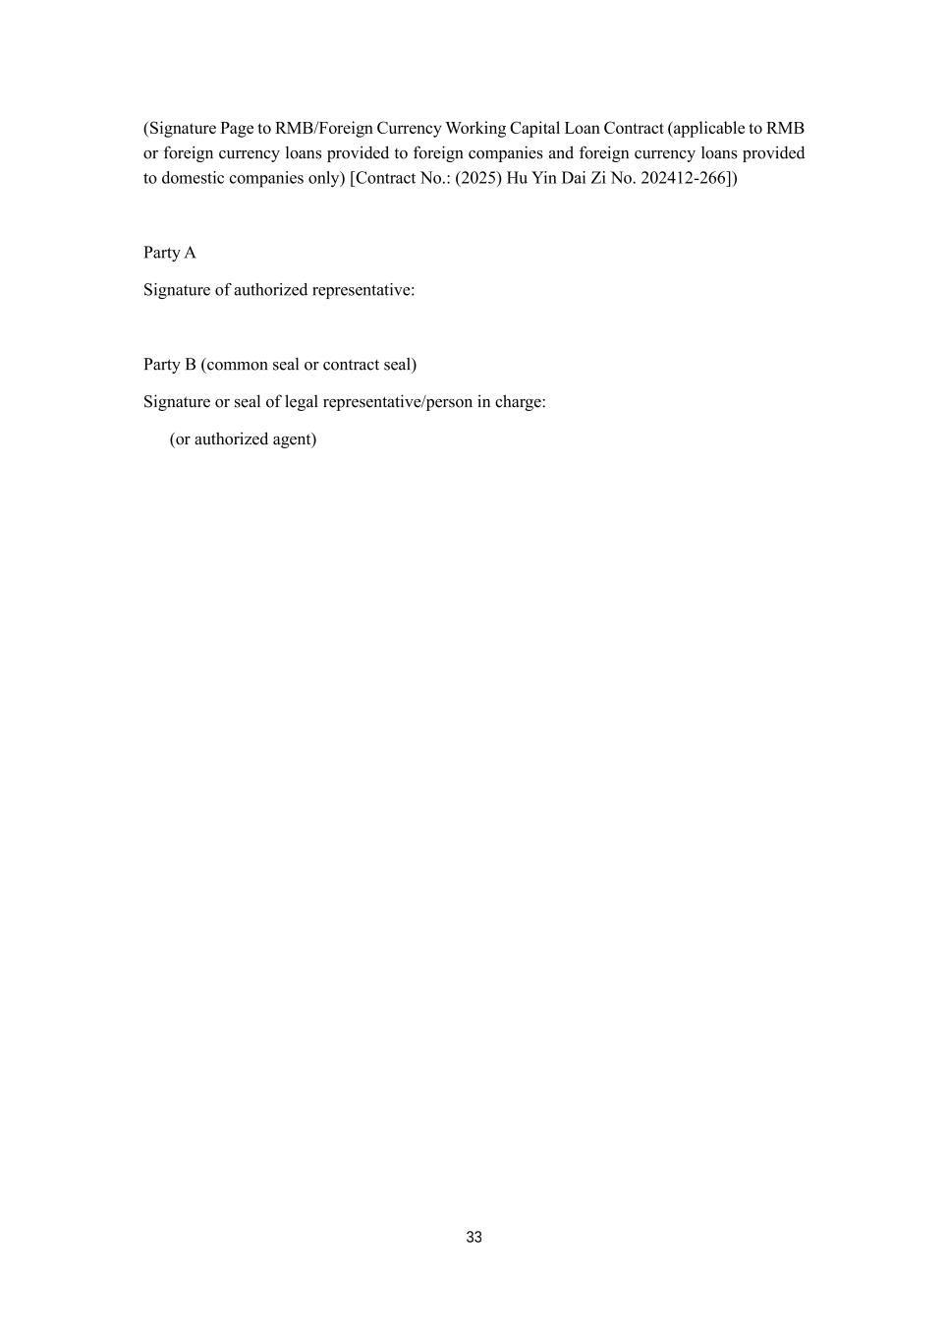
33 (Signature Page to RMB/Foreign Currency Working Capital Loan Contract (applicable to RMB or foreign currency loans provided to foreign companies and foreign currency loans provided to domestic companies only) [Contract No.: (2025) Hu Yin Dai Zi No. 202412-266]) Party A Signature of authorized representative: Party B (common seal or contract seal) Signature or seal of legal representative/person in charge: (or authorized agent)

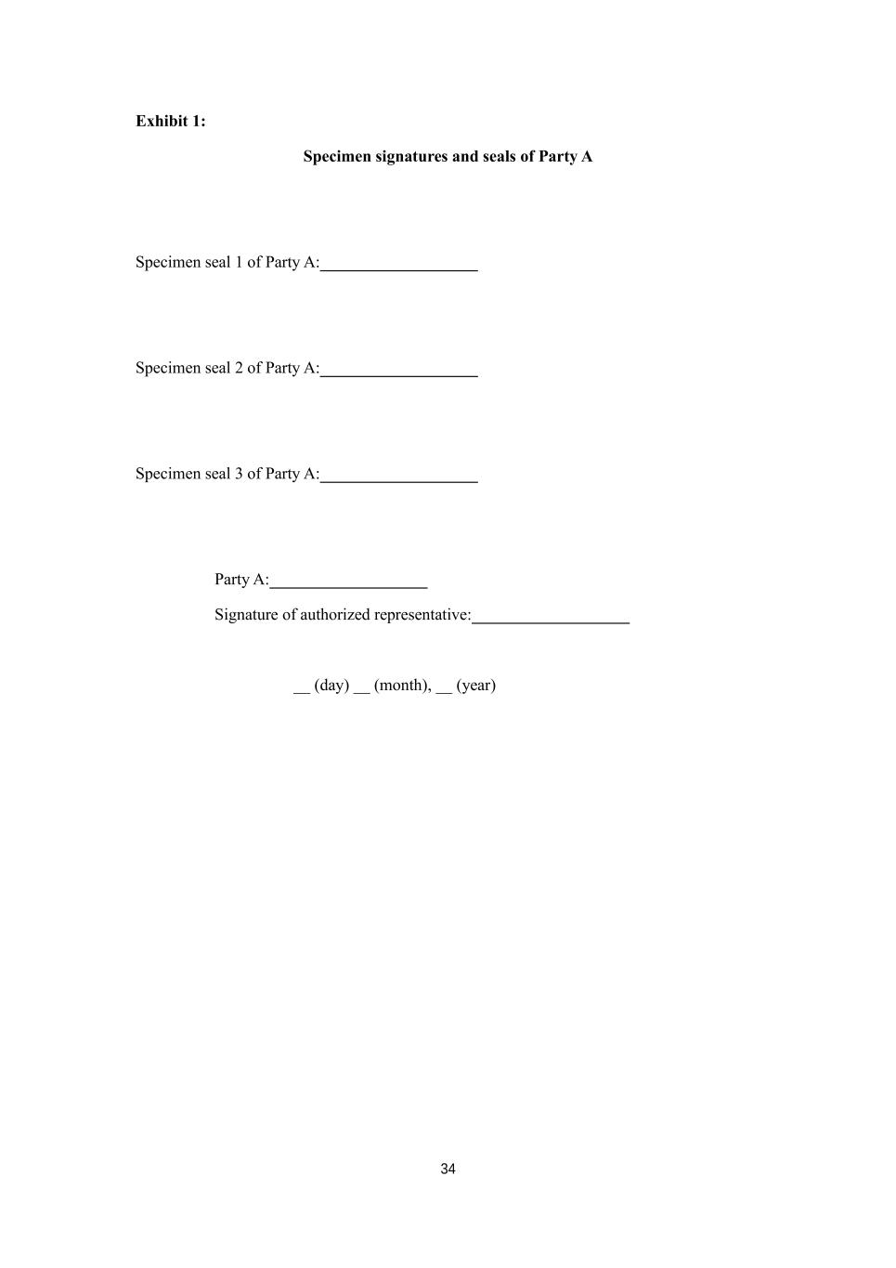
34 Exhibit 1: Specimen signatures and seals of Party A Specimen seal 1 of Party A: Specimen seal 2 of Party A: Specimen seal 3 of Party A: Party A: Signature of authorized representative: __ (day) __ (month), __ (year)

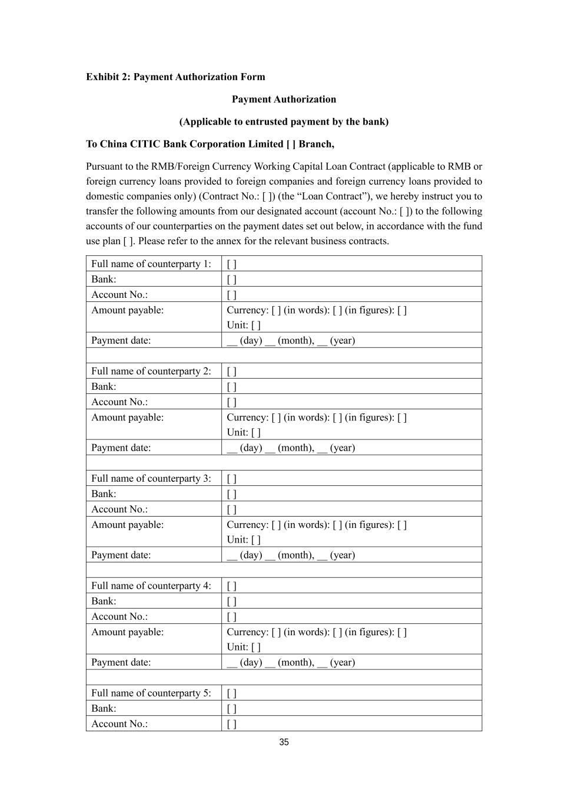
35 Exhibit 2: Payment Authorization Form Payment Authorization (Applicable to entrusted payment by the bank) To China CITIC Bank Corporation Limited [ ] Branch, Pursuant to the RMB/Foreign Currency Working Capital Loan Contract (applicable to RMB or foreign currency loans provided to foreign companies and foreign currency loans provided to domestic companies only) (Contract No.: [ ]) (the “Loan Contract”), we hereby instruct you to transfer the following amounts from our designated account (account No.: [ ]) to the following accounts of our counterparties on the payment dates set out below, in accordance with the fund use plan [ ]. Please refer to the annex for the relevant business contracts. Full name of counterparty 1: [ ] Bank: [ ] Account No.: [ ] Amount payable: Currency: [ ] (in words): [ ] (in figures): [ ] Unit: [ ] Payment date: __ (day) __ (month), __ (year) Full name of counterparty 2: [ ] Bank: [ ] Account No.: [ ] Amount payable: Currency: [ ] (in words): [ ] (in figures): [ ] Unit: [ ] Payment date: __ (day) __ (month), __ (year) Full name of counterparty 3: [ ] Bank: [ ] Account No.: [ ] Amount payable: Currency: [ ] (in words): [ ] (in figures): [ ] Unit: [ ] Payment date: __ (day) __ (month), __ (year) Full name of counterparty 4: [ ] Bank: [ ] Account No.: [ ] Amount payable: Currency: [ ] (in words): [ ] (in figures): [ ] Unit: [ ] Payment date: __ (day) __ (month), __ (year) Full name of counterparty 5: [ ] Bank: [ ] Account No.: [ ]

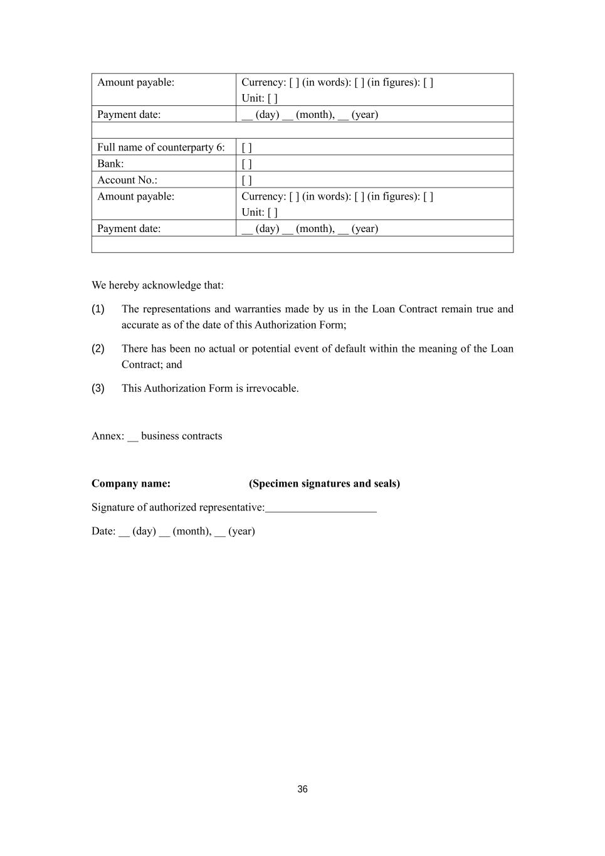
36 Amount payable: Currency: [ ] (in words): [ ] (in figures): [ ] Unit: [ ] Payment date: __ (day) __ (month), __ (year) Full name of counterparty 6: [ ] Bank: [ ] Account No.: [ ] Amount payable: Currency: [ ] (in words): [ ] (in figures): [ ] Unit: [ ] Payment date: __ (day) __ (month), __ (year) We hereby acknowledge that: (1) The representations and warranties made by us in the Loan Contract remain true and accurate as of the date of this Authorization Form; (2) There has been no actual or potential event of default within the meaning of the Loan Contract; and (3) This Authorization Form is irrevocable. Annex: __ business contracts Company name: (Specimen signatures and seals) Signature of authorized representative: Date: __ (day) __ (month), __ (year)

Exhibit 31.01
CERTIFICATION OF PRINCIPAL EXECUTIVE OFFICER
PURSUANT TO SECTION 302 OF THE SARBANES-OXLEY ACT OF 2002
I, David H. Wang, certify that:
1.I have reviewed this Quarterly Report on Form 10-Q of ACM Research, Inc.
2.Based on my knowledge, this report does not contain any untrue statement of a material fact or omit to state a material fact necessary to make the statements made, in light of the circumstances under which such statements were made, not misleading with respect to the period covered by this quarterly report.
3.Based on my knowledge, the financial statements, and other financial information included in this report, fairly present in all material respects the financial condition, results of operations and cash flows of the registrant as of, and for, the periods presented in this report.
4.The registrant’s other certifying officer and I are responsible for establishing and maintaining disclosure controls and procedures (as defined in Exchange Act Rules 13a-15(e) and 15d-15(e)) and internal control over financial reporting (as defined in Exchange Act Rules 13a-15(f) and 15d-15(f)), for the registrant and have:
(a)designed such disclosure controls and procedures, or caused such disclosure controls and procedures to be designed under our supervision, to ensure that material information relating to the registrant, including its consolidated subsidiaries, is made known to us by others within those entities, particularly during the period in which this report is being prepared;
(b)designed such internal control over financial reporting, or caused such internal control over financial reporting to be designed under our supervision, to provide reasonable assurance regarding the reliability of financial reporting and the preparation of financial statements for external purposes in accordance with generally accepted accounting principles;
(c)evaluated the effectiveness of the registrant’s disclosure controls and procedures and presented in this report our conclusions about the effectiveness of the disclosure controls and procedures, as of the end of the period covered by this report based on such evaluation; and
(d)disclosed in this report any change in the registrant’s internal control over financial reporting that occurred during the registrant’s most recent fiscal quarter (the registrant’s fourth fiscal quarter in the case of an annual report) that has materially affected, or is reasonably likely to materially affect, the registrant’s internal control over financial reporting.
5.The registrant’s other certifying officer and I have disclosed, based on our most recent evaluation of internal control over financial reporting, to the registrant’s auditors and the audit committee of the registrant’s board of directors (or persons performing the equivalent functions):
(a)all significant deficiencies and material weaknesses in the design or operation of internal control over financial reporting which are reasonably likely to adversely affect the registrant’s ability to record, process, summarize and report financial information; and

(b)any fraud, whether or not material, that involves management or other employees who have a significant role in the registrant’s internal control over financial reporting.
Date: May 12, 2025
David H. Wang
Chief Executive Officer and President
(Principal Executive Officer)

Exhibit 31.02
CERTIFICATION OF PRINCIPAL FINANCIAL OFFICER
PURSUANT TO SECTION 302 OF THE SARBANES-OXLEY ACT OF 2002
I, Mark McKechnie, certify that:
1.I have reviewed this Quarterly Report on Form 10-Q of ACM Research, Inc.
2.Based on my knowledge, this report does not contain any untrue statement of a material fact or omit to state a material fact necessary to make the statements made, in light of the circumstances under which such statements were made, not misleading with respect to the period covered by this quarterly report.
3.Based on my knowledge, the financial statements, and other financial information included in this report, fairly present in all material respects the financial condition, results of operations and cash flows of the registrant as of, and for, the periods presented in this report.
4.The registrant’s other certifying officer and I are responsible for establishing and maintaining disclosure controls and procedures (as defined in Exchange Act Rules 13a-15(e) and 15d-15(e)) and internal control over financial reporting (as defined in Exchange Act Rules 13a-15(f) and 15d-15(f)), for the registrant and have:
(a)designed such disclosure controls and procedures, or caused such disclosure controls and procedures to be designed under our supervision, to ensure that material information relating to the registrant, including its consolidated subsidiaries, is made known to us by others within those entities, particularly during the period in which this report is being prepared;
(b)designed such internal control over financial reporting, or caused such internal control over financial reporting to be designed under our supervision, to provide reasonable assurance regarding the reliability of financial reporting and the preparation of financial statements for external purposes in accordance with generally accepted accounting principles;
(c)evaluated the effectiveness of the registrant’s disclosure controls and procedures and presented in this report our conclusions about the effectiveness of the disclosure controls and procedures, as of the end of the period covered by this report based on such evaluation; and
(d)disclosed in this report any change in the registrant’s internal control over financial reporting that occurred during the registrant’s most recent fiscal quarter (the registrant’s fourth fiscal quarter in the case of an annual report) that has materially affected, or is reasonably likely to materially affect, the registrant’s internal control over financial reporting.
5.The registrant’s other certifying officer and I have disclosed, based on our most recent evaluation of internal control over financial reporting, to the registrant’s auditors and the audit committee of registrant’s board of directors (or persons performing the equivalent functions):
(a)all significant deficiencies and material weaknesses in the design or operation of internal control over financial reporting which are reasonably likely to adversely affect the registrant’s ability to record, process, summarize and report financial information; and

(b)any fraud, whether or not material, that involves management or other employees who have a significant role in the registrant’s internal control over financial reporting.
Date: May 12, 2025
Mark McKechnie
Chief Financial Officer, Executive Vice President and Treasurer
(Principal Financial Officer)

Exhibit 32.01
CERTIFICATION PURSUANT TO 18 U.S.C. 1350,
AS ADOPTED PURSUANT TO SECTION 906 OF THE SARBANES-OXLEY ACT OF 2002
In connection with the Quarterly Report on Form 10-Q of ACM Research, Inc. for the quarterly period ended March 31, 2025, as filed with the Securities and Exchange Commission on the date hereof (the “Report”), each of the undersigned certifies, pursuant to 18 U.S.C. Section 1350, as adopted pursuant to Section 906 of the Sarbanes-Oxley Act of 2002, that, to his or her knowledge on the date hereof:
1.The Report fully complies with the requirements of Section 13(a) or 15(d) of the Securities Exchange Act of 1934; and
2.The information contained in the Report fairly presents, in all material respects, the financial condition and results of operations of ACM Research, Inc. for the period presented therein.
Date: May 12, 2025
David H. Wang
Chief Executive Officer and President
(Principal Executive Officer)
Date: May 12, 2025
Mark McKechnie
Chief Financial Officer, Executive Vice President and Treasurer
(Principal Financial Officer)
The foregoing certification is being furnished solely pursuant to 18 U.S.C. § 1350 and is not being filed as part of the Report or as a separate disclosure document.

